**ROTARY CLUB OF KIRRIEMUIR**

Website <https://www.rotary-ribi.org/clubs/homepage.php?ClubID=42>

**ROTARY INTERNATIONAL**

Website <https://www.rotary.org/en>

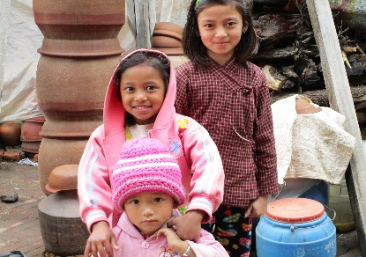Nepal Project 2018

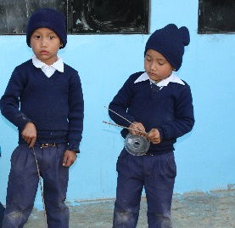  
The Rotary Club of Kirriemuir is embarking on an ambitious programme of fund raising to build toilet blocks in schools in the Syangja District of Nepal. Some of our club members self-funded a visit to Nepal in 2017 and had the opportunity to visit a number of schools whilst there. The Shree Jiwan Jyoti Secondary school where we had funded the rebuilding of classrooms and the building of a toilet block had two toilets for the school prior to our funding. The school had 562 pupils and one of the toilets was in the headmaster's office! Most schools have a similar lack of toilets. What does this mean for the children? Many do not attend, particularly girls when they reach puberty. Those who persist restrict their fluid intake with resultant health problems. We have a plan for making sure that all schools in the Syangja District with more than 200 pupils have a toilet block with water and sanitation facilities. The Rotary Club of the Himalayan Gurkhas(RCHG) are our partners.  
Whilst toilet facilities might encourage children to attend school, we realised there was another equally big and important issue...many of the teachers are poorly trained or have no training at all and where learning does take place it is by rote. Often the children are left in the classrooms on their own. This posed a greater problem for us. What help encouraging the children to attend school if the teaching methods are archaic?   
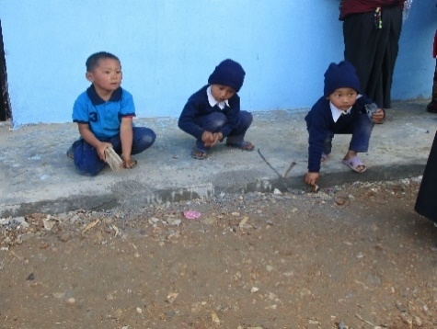 There is an enormous need to bring about substantial and long lasting changes in the educational provision in rural Nepal. Working with the RCHG and another charity, First Steps Himalaya (FSH) we would like to introduce an Early Years Education Support Programme to the schools in Syangja District. We propose that 8 schools be involved and classes from preschool to level 3. FSH will consult with the headmasters, the teachers and the local communities. They will introduce teachers to modern child centred teaching methods. They will fit out classrooms and provide a stimulating environment in which to learn. They will train the teachers and regularly visit the schools and they will supervise and monitor the project. The project will last 2 years with follow up for a further 3 years.  
FSH have already completed a successful project in the Sindhupalock District where the children now benefit from motivated teachers who are supportive of children's learning. FSH will work with RCHG in implementing the programme with the RCHG responsible for the construction of the toilet blocks.   
This is an exciting project to be involved with but it will cost a lot of money! The sum we need to raise to implement the whole programme is approximately £120,000 (USD$160k) but we are confident that with your help we will achieve it!  
We have a number of fund raising events planned over the next few months including a Quiz Night in the Northmuir Hall on 24 March, our annual Duck Race on Easter Sunday in Kirriemuir Den, a Ladies only Afternoon Tea in June, a golf tournament (date to be fixed), and a Dinner in the Town Hall Kirriemuir on 22 September. We also hope to set up a crowdfunding site for other donors to make donations to. To date we are well on our way to our target.

Barbara Lovegrove Rotary Club of Kirriemuir

*barbara.lovegrove@gmail.com*

**THE NEPAL PROJECT 2018 – 2020**

**Update to November 2018**

Rotary's motto for the last 100 years and more has been "Service above self". The primary mission statement is to relieve poverty, promote health and education and support those in our community both at home and overseas. Our 6 avenues of service are - Promoting Peace; Fighting Disease; Providing Clean Water; Supporting Education; Saving Mothers and Children; and Growing Local Economies both at home and abroad.

The current project we wish to carry out, with Rotary colleagues in Nepal, for which we are seeking help and financial support is i) to provide water and sanitation facilities in 7 schools, and ii) to introduce an early learning support program in 8 schools. The total project is $160k.

**Water and Sanitation facilities.**

We are providing water and sanitation facilities, including for the disabled, in 7 schools mainly in the Syangja District in Nepal. We are partnering with the Rotarians from the Rotary Club of the Himalayan Gurkhas who will oversee the work and manage the project which they did in 2016/17. The schools are located in a remote area and used by a vulnerable population.

We helped rebuild classrooms at one of these schools after the earthquakes of 2015 in that region. We also put in a water supply to another village and built the first new toilet block at another school. The schools have basic water but they have no, or inadequate, facilities at present which means the children themselves restrict their fluid intake so that they don't need to go to the toilet. The girls do not attend school if they are menstruating. The Rotary Club of the Himalayan Gurkhas is regularly providing these girls with hygiene kits (paid for by others) which are produced locally meaning the production is both sustainable and economical. There are no hand washing facilities although there is a water supply to the villages. This project will greatly improve the attendance at school and the aim is to improve health and well-being and to encourage the children to do likewise.

We also wish to address the inequality issues and encourage the children to enjoy learning and stay on at school. They will be taught the correct hygiene procedures, regular operation and maintenance of the new facilities and keep them cleaned properly.

**Early Learning Support Program.**

We will introduce an early learning support program in 8 schools - pre-school classes to class 3 (ages from 4 to 8) - with the aim of providing educational opportunities to children in the Syangja District, through the provision of teacher training and greatly improved learning environments that serve as models for the area. The schools have been selected where the head teacher was receptive to the introduction of the program. The schools are also located in a geographical area that makes it possible to carry out the programme. The teachers do not have impossible travel to attend the teaching centre and the supervisor will be able to travel to the schools. They will be beacons of light for others in the area. The provision of these skills will be delivered by another charity working in this field of learning support. Teachers often have little or no training and this programme will aim to provide help to improve their teaching skills as well. This will bring a big improvement now and leave a legacy of appropriate teaching skills which will help benefit themselves and successive generations of children.

The whole program will take about one to two years to complete with the sanitation work to be completed well within the first year. The local District Government has been consulted and will assist where it can. This program falls into our areas of focus for water and sanitation as well as basic education and literacy.

We continue to raise funds ourselves but need a wider catchment of possible donors. We have raised over $100,000 from our own fundraising and grants from Rotary International and other trusts and are looking to raise a further $60,000 to complete this project. In the instance where we achieve our funding aims then any extra will be put to the same use in more schools in this area as we us the skills of the Rotary Club of the Himalayan Gurkhas and the other learning support training provider, First Steps Himalaya.

**CURRENT BUDGET FOR 2019 - 20**

