Solar Project for Schools at Choma, Northern Region, Malawi

Summary

Rural Areas in Malawi are not all served by grid electricity connection. This makes life very difficult for local residents and schoolchildren who have to operate after the hours of darkness with only low powered battery lights or kerosene lamps.

Recent exam results for the schools have been disappointing and the community has decided that for 2 months prior to the Standard 8 exams the children will have to camp out at schools to get extra tuition in the evenings. As it is then dark the children are required to bring torches to read by but that only works for those families that can afford a torch. Presently there is a light powered by a car battery in only one of the 6 classrooms where the children are gathered and the battery has to be carried miles for recharging.

This Rotary Project is intended to provide solar-charged battery lighting for school classrooms, offices and the Girl’s Hostel. It will use a combination of fixed lights installed with roof-mounted solar panels for the classrooms and portable rechargeable lamps that are carried out into sunlight by day to light the rooms of the Girl’s Hostel and smaller offices.

The project will be overseen by the Turing Trust (www.turingtrust.co.uk a charity run by the family of Alan Turing) which already carries out successful projects in Africa sponsored by Rotary. The Choma community already benefits from installation of a solar-powered computer lab designed by Rotarians and built and installed by the Trust in an upcycled shipping container.

Project Costs

Costs for the two types of lamp as shown in Appendix 2including supply, delivery and installation in Malawi are estimated as follows (all costs converted to pounds Sterling) :-

Set 1
Home 120 Solar Lighting System (or similar dependent on availability) 180
For a large classroom 8 such lamps @ 180 will cost 1440

For 6 Classrooms @1440 will cost 8640

Set 2

Pico Plus Portable Lantern (or similar dependent on availability) 23

Allow 20 Lanterns for the 10-room Girl’s Hostel 20@23 460

Allow 10 Lanterns for the Offices and Staff Room 10@23 230

Appendix 1

Message and pictures from Yewo Msiska, Local Project Manager
I was in Choma this week to meet the school committee and discuss the possibility of providing solar installation at the school (classrooms and the girls’ hostel). Led by the Headteacher of Choma CDSS, the school is in full support of the idea and has since urged TT/CYD to go ahead and develop the proposal. In fact, the deputy Headteacher, Mr Nyirenda, recapped appealing to the Turing Trust UK Project Manager to consider the same and later submitted a formal written request to him during the Solar Berry handover ceremony. At the moment, they use a car battery to generate light which barely lights a single class, this poses a challenge as it forces them to combine and put all the students in one class during evening reading time, this creates an environment unfavourable for students preparing for national examinations.
For your information, Choma CDSS has 2 blocks and each block has 2 classrooms. Then there is also a small building with 2 small rooms used as Headteacher office and staff room respectively. Behind this building, about 20m away is the girls’ hostel which has 10 separate rooms.
I also had a chat with the Deputy Headteacher of Choma Primary School, Mr. H.C Kamanga , to find out if the school may also need solar power. He said for the past 2 years, results for standard 8 national examinations have been very poor to the extent that the school’s Parents-Teachers Association resolved that 2 months prior to national examinations, all standard 8 pupils must camp at the school to enable them undergo intensive reading sessions. However, the challenge is that each pupil is supposed to bring his/her torch for reading and most torches are not good enough to produce enough light to enable students read properly. And for the students whose parents cannot afford to buy a torch they opt to remain at home. For this reason, he believes we should seriously consider extending our hand to them as well.
The deputy head teacher also made mention that the Headteacher's Office shares the same roof with the Teacher Development Centre (TDC) office being used by the Primary Education Advisor for all schools around the Choma area, and for this reason it would be imperative to consider it as well.
Attached are the pictures showing Choma CDSS (Classrooms and the Girls Hostel) and the Standard 8 classroom block and Headteacher's office at Choma Primary School.
Regards,
Yewo Msiska,
Project Coordinator, Improving Access to ICT Project
Turing Trust/Centre for Youth and Development

Choma Community Secondary Schools Campus
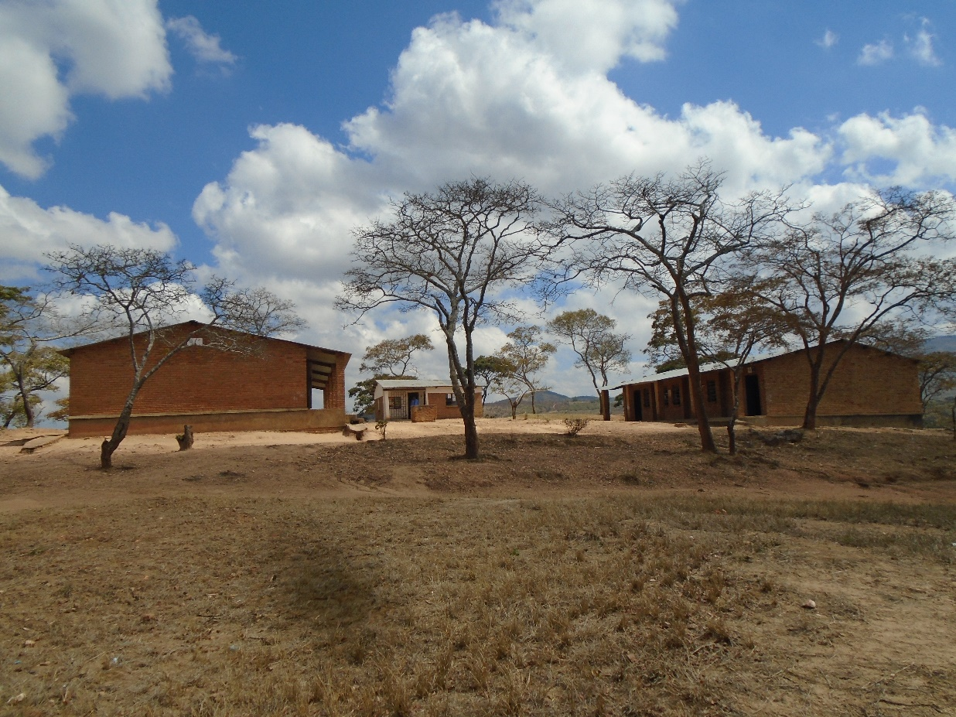
Choma Girls Hostel
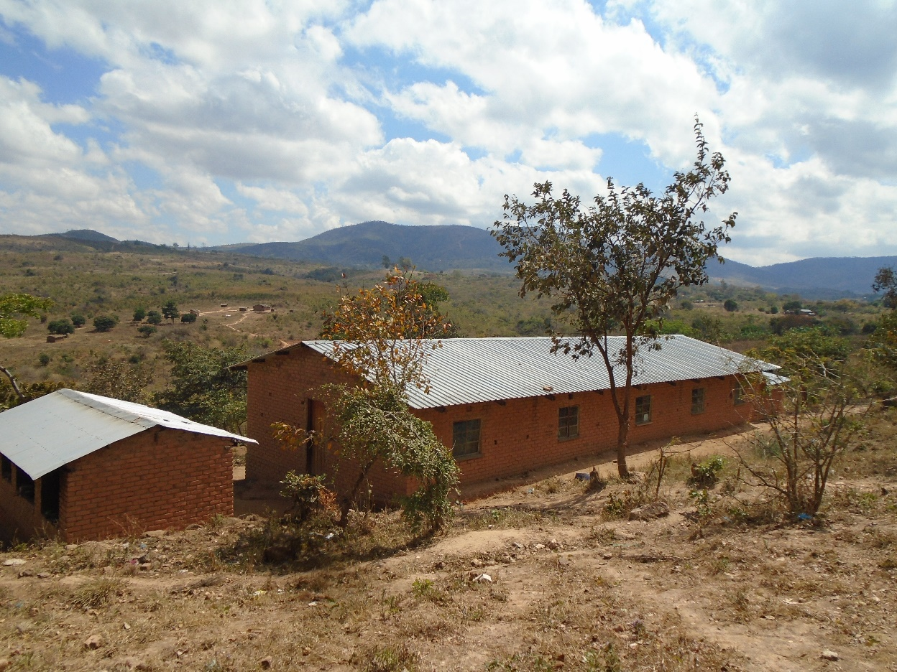

Headmasters Office and Staff Room
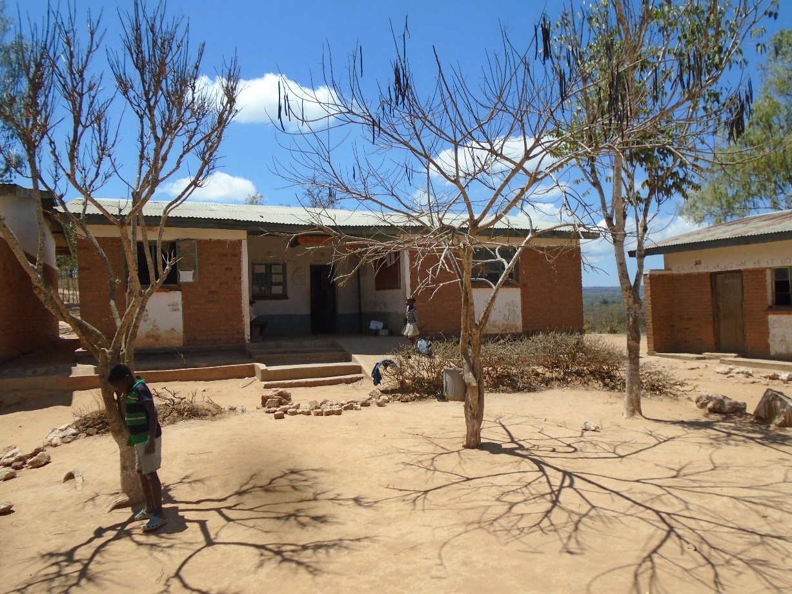
Choma Primary School – Standard 8 Block
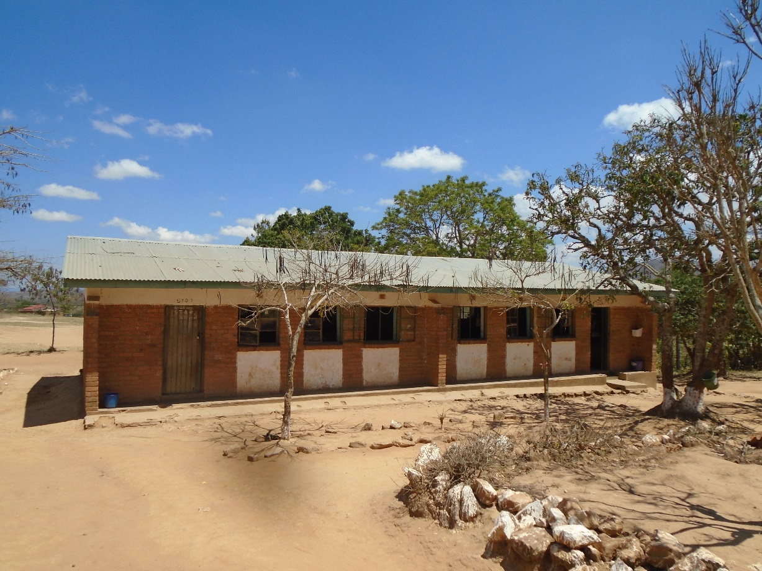

Appendix 2

Set 1
Greenlight Planet Home 120 Solar Lighting System Plus USB Charger
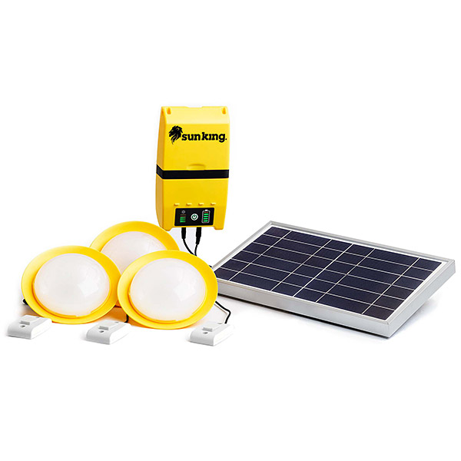

- Charges - USB and DC power with 3 wall-mountable switches for all your devices and needs
- 200 Lumens - 200 lumen per lamp multi-room lighting
- Durable - rugged and ready for any activity in any place
- 24 Hours of charge - up to 24 hours of run time a day's charge
- Global impact - each purchase helps us get greenlight planet to millions of off-grid families around the world

Set 2
Portable Rechargeable Lanterns
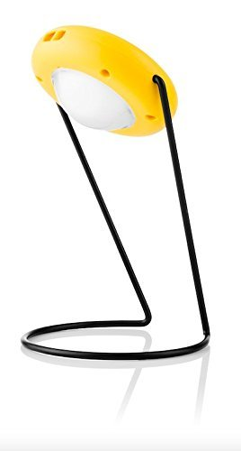

The Sun King™ Pico Plus strikes the perfect balance between durability, performance and affordability. Designed to meet basic lighting needs in households around the world, Sun King™ Pico Plus is five times brighter than kerosene lamps. It features a long-lasting battery and the iconic, durable design that Sun King™ customers love. With its 50 lumen, neutral LED light, Sun King™ Pico Plus yields up to 72 hours of light from a single sunny day of solar charging.

