Transform children’s lives through Engaging caregivers at Hope for Children’s Health Foundation
28/12/2021
Background
Hope for Children’s Health Foundation is currently implementing Health and Education programs among the nationals in Kyangwali Subcounty and so far we have supported 53 orphans and vulnerable children and their families. Supporting rural community vulnerable children to access better education and health is one of the key activities of Hope for Children’s Health Foundation in Uganda.

Health services provide a unique opportunity to support positive living. Health care can reach caregivers and their children across a life course from pregnancy to birth, through childhood, adolescence, and adulthood. Regular contact during pregnancy, and during children’s early years, present unparalleled opportunity to reach caregivers with critical Early Childhood (ECD) interventions. In addition to providing health (ART care services) and nutrition interventions critical to child health and development.
Integrating these ECD messages into the caregiver’s meetings will create opportunities to identify vulnerable children and build the capacity of caregivers to support the children and adolescents in building positive relationship with their children and better provide responsive caregiving and nurturing care to enhance adherence, retention and viral load suppression.
Achievement
Between May and October 2021, we reached out to over 124 caregivers of orphans and vulnerable children in Kyangwali village discussed on how to improve on how to improve on parenting skills for our beneficiaries and hence be in position to support them access better health care and education. However due to limited funds we were not able to reach all the households and we hope we shall do so someday.
Challenge
- We have been under stick gathering limit numbers which means it was hard to meet all the caregivers at once during the meetings
- Limited funds to implement all our activities on the work plan.
We thank our Donors and friends for their support which has enabled us reach this far and we call upon for more support because every donation counts.

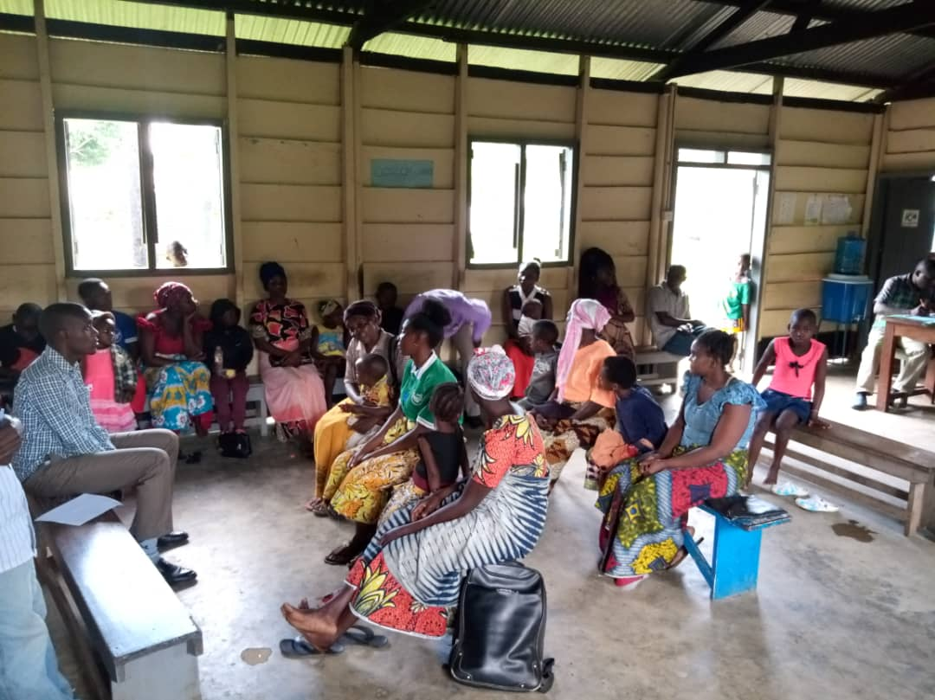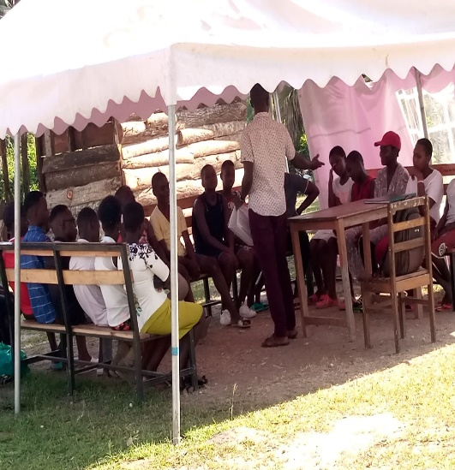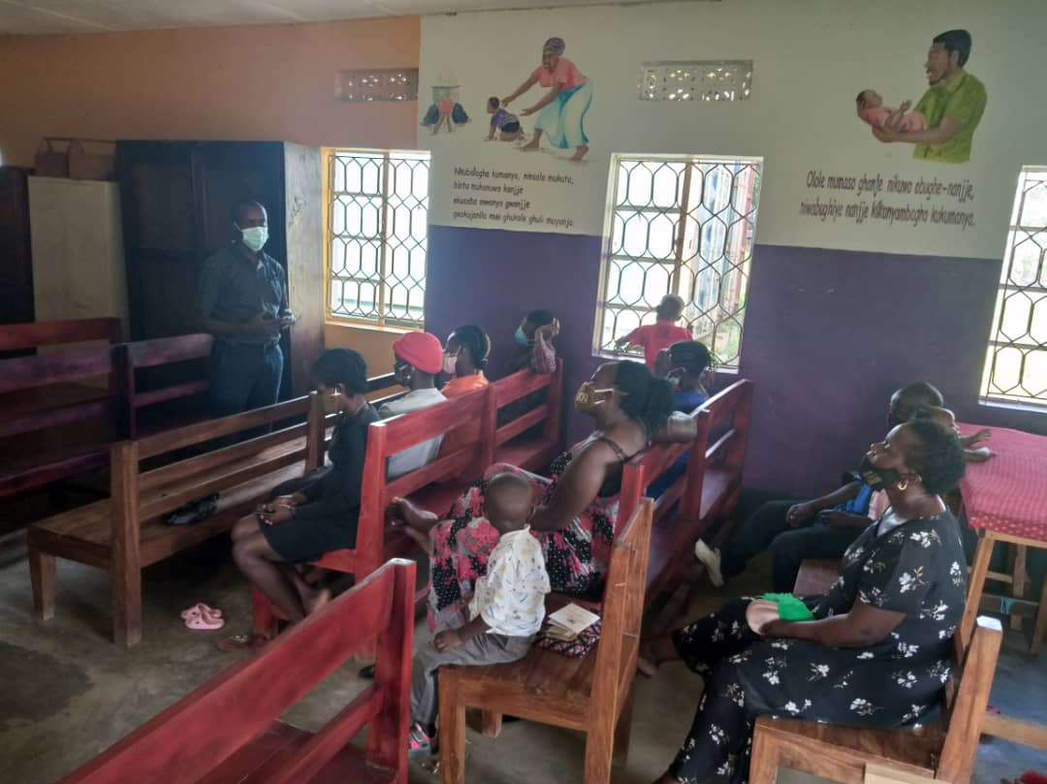
Caregivers meetings ongoing in different communities
Prepared by John Mwesigwa-Project Leader
YOUR LEGACY IS EVERY LIFE THAT YOU TOUCH-OPRAH WINFREY

