TRANSFORMATIONAL MEDIATION IN PRISON PROGRESS REPORT
Who are we?
We are a faith based organization
Our vision:
To see Rwandese people living together in good relationship with one another in healthy, well-developed communities.
Our mission:
To promote peace, unity, and reconciliation among the people of Rwanda and to holistically contribute to the development of the Rwandan society.
Our values:
Peace (Shalom), Integrity, Forgiveness, Reconciliation, Unity, Transparency, Openness and Discernment.
Background:
Following the Tutsi Genocide in 1994, the Friends Church in Rwanda took part in the rehabilitation of the disunited and destabilized Rwandese society. This effort began with the care of orphans and widows. The endeavour grew into the opening of a centre for peace, in order to have a central location through which peace-building activities could take place.
NARRATIVE REPORT OF THE PROJECT ENTITLED “HELP 450 RWANDAN PRISONERS TO BECOME PEACEBUILDERS”
This project intends to help 450 inmates to become mediators with a purpose of creating peacebuilders within Rwandan prisons. $8,804 raised of $22,500 goal.
For the first workshop Christine Curci PHD trained the mediators of Friends Peace House (FPH) who are serving as trainers of mediation at the same time mediators, and for this session eleven mediators were trained, for the second workshop the FPH mediators conducted a free day long workshop, they trained twenty-five inmates under Christine Curci PHD facilitation, and to strengthen the capacities of the latter the third workshop was organised and took place it was a refresher training and was facilitated by mediators under Friends Peace House Facilitation .
The table below shows the total number of individuals that have been trained:
Table 1: Number of Persons trained
Participants | Male | Female | Total
Friends Peace House Mediators | 6 | 5 | 11
Inmates | 0 | 25 | 25
Grand Total | 6 | 30 | 36
Figure 1: Total number of persons who received mediation training
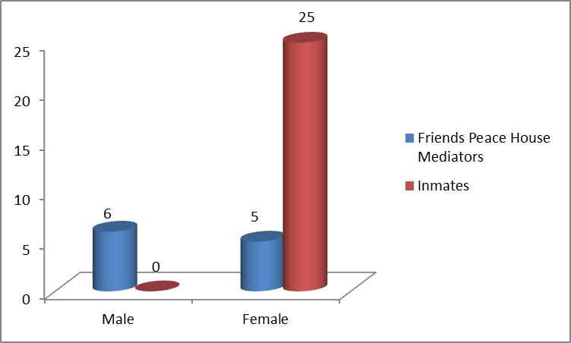
The purpose of the refresher training was to analyse the impact, feasibility and challenges encountered by inmates when they were putting into action the mediation. We are very pleased that our program is having positive impacts in Ngoma prison. From the report given by the trained inmates there are six conflicting cases handled in a satisfactory manner.
We are convinced that prisons are good places to learn and practice mediation, because it is a troubled society, even if it is not easy to serve as a mediator between prisoners who often feel indifferent, but is also a place where there is a need to provide the effort to have people capable of dealing with conflicts. And the experience that anyone can have in a prison would really be a powerful tool for dealing with conflicts everywhere
Among the challenges presented by the inmates, they mentioned: lack of an extended and free space for mediation, there is also the lack of will for mediation for some prisoners to and inadequate experience to treat and deal with some cases.
TESTIMONIES:
One of the inmates said
"We are delighted that we benefit doubly: firstly, our life is positively affected and secondly we have a luggage of knowledge useful to help our society, we are capable to help people to discover themselves their role in a conflict and also to make them understand each other, the training has equipped us with the knowledge necessary for interpersonal skills more precisely in the field of communication, we are able to communicate effectively and also we know how to live in peace with others. Our co-prisoners are often interested to read our handouts and they are excited to know how to mediate, we are confident to help our community.

The prison guard told us that there is a positive change in these words:
Before the arrival of this program, we received many conflicting cases, we received reports from inmates that there are cases handled by FPH mediators, I am aware that there are six disputes mediated by the mediators trained by the Friends Peace House (FPH); this indicates the success of the transformative mediation program, there are some concepts of mediation that are frequently used by our prisoners like "He needs empowerment" and “he needs to be recognized” I asked the prisoners and they told me that these are the terms of mediation, it means that mediation is not only useful to mediate but also to avoid conflict. We are very grateful that Friends Peace House and their partners are active in peace building and in the process of rebuilding our Rwandan society”

Actually we noticed that many of the prisoners are thirsty to know what mediation is. This is due to the fact that they have a lot of time to browse our documents, and on the fact that they are always closed each other. Another observation is that the inmates trained have willing and courage to be competent and teamwork, and this was possible because they find time for experience sharing.
We also noticed that the prisoners are engaged a lot in mediation practices and research, which make them experienced and strong when it comes to mediation.
Among our twenty-five prisoners trained, four of them have been released, and they are ready to help the community and to help people to solve their conflict peacefully, we had the chance to meet 2 of the 4 released inmates and that was a way of integrating them into the network of our Mediators
We also want to inform readers that on May 20, 2019 we participated in a conference organized by GlobalGiving that brought together members of the platform to exchange experience and also learn together how to step forward.
We want to have an open heart for our donors, you are our strengths and companions to our success, and we thank you very much and stay blessed.

