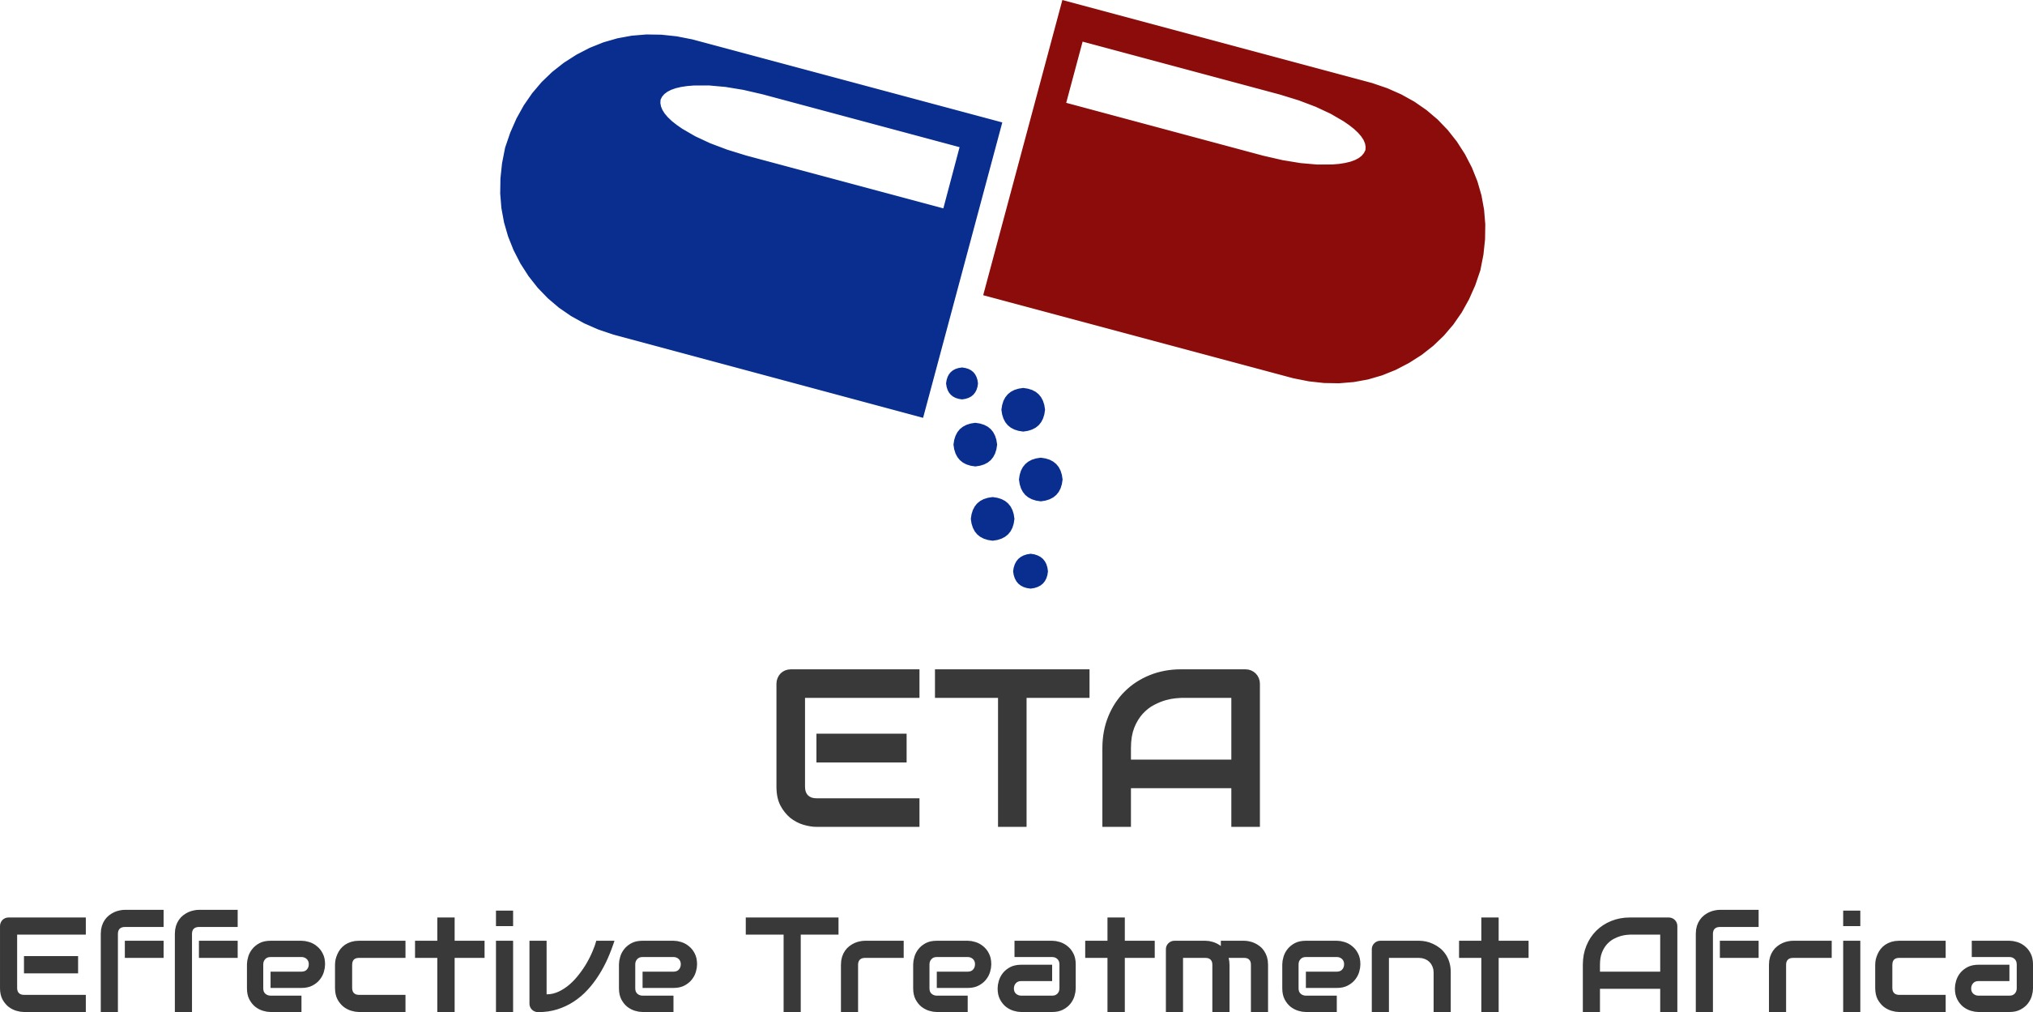
TPE = ETA
By: Niles Hemming

www.facebook.com/nileshiv

It was June 2017, and my friend had sent me an invite to the opening of an exhibition in Cape Town called Through Positive Eyes. I had been positive for nearly 18 years. This event appealed to me if nothing else than a free glass of wine and some snacks! Who would have thought that this one evening was about to change my life irrevocably?! We were led into a large hall at the Cape Town Slave Lodge where Professor David Gere spoke briefly, and I knew I had to have his business card. I imagined he could be a useful contact for my 23-year old daughter who, having just finished her law degree and her master’s in human Rights with a focus on HIV awareness, was now considering a Doctorate. As it turned out, it was I who benefited from his contact. We had a conversation about my status and he asked me if I would be interested in being a part of Through Positive Eyes.

After this brief conversation, we were led into an amazing space with bean bags, amazing photographic art surrounding us, and a large screen. The room was packed! One by one the artivists told their story of living with HIV while photographs representing their journey came on the screen behind them. I was able to really resonate with their stories as it wasn’t so unfamiliar to my own. It was very thought-provoking and touching to my heart. Being both gay, positive myself, and tired of the stigma in South Africa, it was liberating to not feel alone in my diagnosis. I am now one of the TPE artivists. My first talk at TPE felt terrifying but now I could shout "Stigma? Not in my name – I’M POSITIVE!” from the roof tops. I really don’t care what anyone thinks. If you carry stigma, I’ll change your mind. My life has been changed and there is no going back.

In addition to joining the Through Positive Eyes Cape Town team, as a direct result of that evening, I founded Effective Treatment Africa, an organization that directly targets groups across Africa and addresses the special needs of diverse communities. Our main presence is online with currently well over 6000 members in our Facebook group, “HIV & AIDS, End Stigma & Educate.” I work with clinics, local politicians and organisations supporting those with HIV. We are now also starting programs such as our support group for individuals in the LGBT community, who unfortunately carry a double stigma.

Why ETA Effective Treatment Africa?

I have always been involved in philanthropy. Having been HIV positive for nearly 18 years, it just went hand in hand to get involved and help the positive community. I moved to South Africa in 2007, and I found that my willingness to get involved with organizations had wavered. Sadly, when you are surrounded by poverty, crime, social devastation and injustices, I found myself
getting used to it. I feel guilty saying this but it’s the truth. I reached a point where suddenly I realized that even as one person, I, Niles Hemming, could make a difference. A famous anthropologist, Dame Anita Roddick, once said, "If you think something small can’t make a difference then share a tent with a mosquito.”

I wanted to start with an online platform to provide education and support, and my “HIV& AIDS, End Stigma & Educate” Facebook page began. I posted my story and my journey living with HIV, and the page dedicates different days to related issues including disclosure and stigma.

35 million people are living with HIV. And I asked myself, what do we have in common? Then it hit me. It’s a secret. Every single one of us, those who have passed and those of us surviving started our journey with a secret. You walk out of that clinic with a terrible, frightening secret. Then you need courage. Once you speak your truth, the shame you feel dissipates and you can become resilient. The power does not just lie with the stigmatiser but also the stigmatised. As the stigmatized, there is a way forward.

However, the stigmatiser must listen to someone’s truth, acknowledge that person’s courage,
understand what is causing shame, and then stand side by side with the person’s resilience. This will cure the secret ILLNESS of stigma. I had to really dig deep and try to think of stigma as an illness and then think about what treatment could be offered. No one has the right to sit in judgement of others or to make assumptions about a person’s morale character – this is how I define stigma.

I have researched many websites globally, mainly American and European groups with large numbers of members. Aside from the amount of misinformation being given, I also realized how African members would ask questions and would receive Western responses with impractical information. This is how ETA – Effective Treatment Africa was born, and it solely focuses on those living across Africa. We now have well over 6000 members from six African countries: South Africa, Kenya, Uganda, Botswana, Nigeria, and Lesotho and we are continuing to expand daily. 80% of our members are African and of those, 80% are woman. We have a strong following from the highest risk group, age 16 to 24 years, and we continue to receive messages from people all over Africa telling us how each day we are making a difference to their lives.

One stark example of why Africa needed its own platform for finding solutions here in Africa is a story about a lady who found us, very distraught in Botswana. She had been diagnosed HIV-positive and for weeks had not left her home. She had disabilities that stopped her from getting to the closest clinic and had therefore not sought treatment. Also, her fear of community stigma kept her house-bound. We posted to all our members in Botswana about her plight, and within 3 hours of this message, we had a group of ladies at her home for support. She has since left her home, has returned to church, has friends in her community, and is on treatment. She is now one of our most passionate members and is often giving support to others in Botswana. This is an African solution to an African problem at its best where we are simply, yet necessarily, the vehicle for connection.

We have set up an online counseling system where members can speak directly with a counselor who works for us. From providing basic HIV/AIDS health advice to supporting newly diagnosed individuals and those coming to terms with their diagnosis, the strength of our organization is rapidly gaining momentum. Counselor and now co-founder, Barbara Kingsley, also a well-known activist reached over 55,000 people this week alone, and 250,000 in the previous month. Many of these individuals seek private one on one counselling with Barbara, who has a special touch with these members while sharing her knowledge and experiences.

Through this forum, we are literally saving lives. Around the world, people don’t always comprehend how stigma is so ingrained in HIV Treatment in Africa. It’s easy for someone from a Western-based site to advise going to a clinic, getting medication or suggesting a particular drug but there are many considerations e.g. distance to the clinic, clinical response by the nurses and doctors, affordability of drugs, etc. In other parts of the world, nurses and doctors are learning to be more patient-focused, considering not only the physical needs but the emotional needs of their patients, including the importance of privacy. Here in South Africa, dignity is being taken away by a medical hierarchy, where patients can feel looked down upon. It’s time for people to empower themselves, stand up to the clinics and medical service providers, and demand the respect they deserve as human beings so they can bring their status into a medical forum without fear. With its conveyer belt of patients going through the system, it is understandable that the clinics are under immense pressure, but even in the short visits, the nurses or community workers are not very sympathetic. We have many people approach us daily, requesting more information on their medication or diagnosis since the nurse or doctor was so quick, they felt disempowered to ask for more information. We have chosen to take a different approach.

Soon after launching ETA, the international U = U campaign flooded HIV/AIDS news and websites. The campaign promoted that if the virus in an HIV-positive individual is undetectable then he/she cannot transmit the virus. However, for me, U = U felt more like a branding than an educational campaign, and it didn’t seem to provide what is needed here in Africa. And so, I decided to take a different approach to the U= U ethos.

After much thought, I decided to set up our own program under ETA called "5 Steps to HIV Success.”

- Status! Get tested and know your status
- Test! Get your blood results ASAP including CD4 count and viral load
- Ensure you start treatment straight away, stay consistent without default
- Positive life choices will help you live a healthy life
- Succeed in achieving an undetectable viral load level for 6 months
Now that we know that being undetectable means a PLWHA cannot transmit the virus to someone else is scientific fact, ETA Effective Treatment Africa stands by these five steps. Of course, ETA would continue to encourage safe practices and individual responsibility.

Now that the online presence of ETA is growing, we have had more time to go into communities and assess some of the members’ complaints about their clinics. I had a meeting with our local parliamentary leader, and she asked me to visit a clinic to explore the needs of the PLWHA community there. It was through my contact with members on our Facebook team and the knowledge of stigma that I was able to determine where the clinics could improve. For example, a person going in for an HIV test would be given a green card and told to sit in a certain area. This automatically advertised to everyone in the clinic why they were there. Or imagine having to sit in a packed clinic, waiting for your name to be called, and you’re told to go to room number 5. Everyone knows what room #5 is for, and so from that moment on, the person is labelled. This is a starting point for stigma. They were not afforded any privacy, and I knew this had to change. Living with HIV for so many years, it’s easy for me to draw on my own past experiences. One of the changes we’ve made to the system so far is that all individuals are required to wear masks in the waiting room so the TB patients don’t jump out in the crowd, and then they aren’t labelled with TB since often TB and HIV go together. I visit each week to monitor if the system has increased the numbers of people willing to take HIV tests. After 4 weeks, I was thrilled to see the improvements had made a difference. Another space where there was no privacy was at the pharmacy. A patient in the queue could see what the patient in front of them was collecting since the pharmacist has to show the medication to the person collecting to ensure it’s correct, which could reveal their status to others. We arranged to install privacy booths, and the pharmacy was supportive and delighted.

These are some of the many examples why I decided to launch ETA to bring members from various African nations together, to join forces and resolve to fight stigma together as a united front.
I can honestly say that Through Positive Eyes has had a huge impact on myself, and therefore the launch of this initiative. We have touched so many people, and I mean this in a physical sense too. Only when one sees the exhibition can one understand its power. I love hugs, and we hug so many people each and every day, sometimes because we are reaching out and sometimes because they come to us. It is this genuine way of educating that is so important. It has to be seen to be believed. And I plan to carry this with me as the work with Effective Treatment Africa continues and grows and ignites.

