SUKRITI Social Foundation
Activities Report for 1st April 2016-31st March 2017
Impairment is defined as long-term limitation of a person’s physical, mental or sensory function. These barriers are not just physical. Attitudes found in society based on prejudice or stereotype, also disable people from having equal opportunities to be part of society.
SUKRITI Social Foundation is a Chennai, India based cross-disability organisation which focuses more on persons with mobility impairment. Sukriti, Started in the year 2006. We have initiatives in prevention, rehabilitation, training, self-employment and advocacy.
- Four pronged strategy of SUKRITI to address the diverse needs of the disabled, are :
        - Prevention,
        - Rehabilitation,
        - Advocacy,
        - Employability,
Institute of Child Health Project
Transforming children with Limits to children with No Limits
As a part of prevention strategy, during the year 2014, Surkiti has focused its attention on child disability. In collaboration with government Institute of child health, Egmore, Chennai. Surkiti has assisted more than 500 children by providing mobility appliance and aid which has changed life of many children. We focus quality of appliance and delivery on time.
Sukrity team comprising of Social Worker and Ortho technician camp at the outpatient clinic four times in a week, every Monday, Wednesday, Thursday and Saturday. Measurements are taken and children are given corrective appliances within two days free of cost. Wearing these appliances may be cumbersome for the children and pain to see their pain for the parents. But the results of test are always sweet; it is so heartwarming to see the children start walking.
The toddlers having limb problems are supplied with AFOs, FAOs and Tube splints the primary care givers are given necessary instructions to use the appliances as per the duration prescribed by the medical practitioners of the institute. Mostly new born having disability related problems are supplied with Pavelic harnesses within a week time of birth. The infant need to use the appliance for duration of five to six weeks to keep the infant’s hip joint in position and strengthen the same, which would prevent disability at later period. Pre and post operative care including casting and physiotherapy are the major preventive activities carried out by the Institute towards the process of Managing Clubfoot. Sukriti Social Foundation Plays a key role in providing necessary appliances as per the prescription of the doctors at ICH premises itself.
Comprehensive Intervention: Role by Sukriti
Cure / Rehabilitation measures involve four major comprehensive interventions for the child:
  - Plaster
  - Surgery
  - Mobility/correction aid
  - Physiotherapy
  - Parental counseling

The above intervention can be in any order, but any three interventions without mobility aid will not yield the required results.

The following types of appliances were distributed during the year April 2016-March 2017
 | Appliance | SEPT TO Nov
1 | AFO & hinged AFO | 179
2 | Pavelic harness | 17
3 | FAO | 103
4 | Skin traction kit | 7
5 | FRO | 11
6 | Walkers | 9
7 | KAFO | 8
8 | Sandal, MCR Chappel & shoes | 27
9 | Cock up splint | 3
10 | Knee brace | 6
11 | Body mould | 7
12 | UCBL | 11
13 | Foot drop splint | 9
14 | Wrist splint | 11
15 | Ext. Prosthetic | 1
16 | Weight Releiving Calipers | 1
17 | Cervical collar | 9
18 | AK splint | 11
19 | Hip abduction splint | 15
20 | Others | 61
 | Total | 516

Impact of the Project
516 mobility aids distributed
Age range on 45 days to 14 years
10% of children's problem was cleared
50% had show gradual improvements
20% had not much improvement
8% did not use
12% are migrants

Surkiti changed the life for the Little boy / girl who has to sit all life in a corner eagerly watching his friends play and looked at with pitiful eyes of all”

A man / women who can stand tall on his /her two feet with self esteem and pride, apart from being able to walk, run and also become worthy of employment and much more !!.

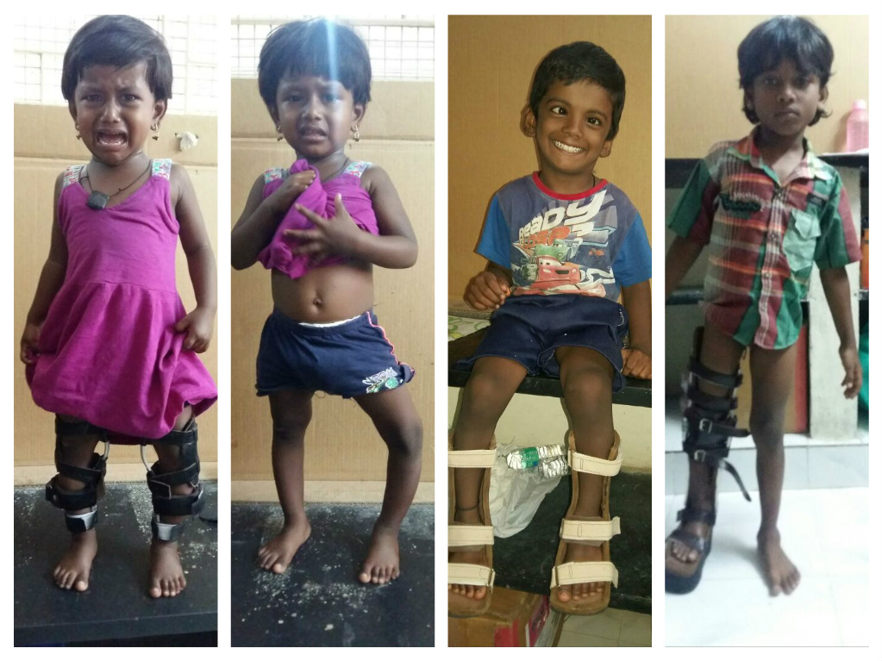
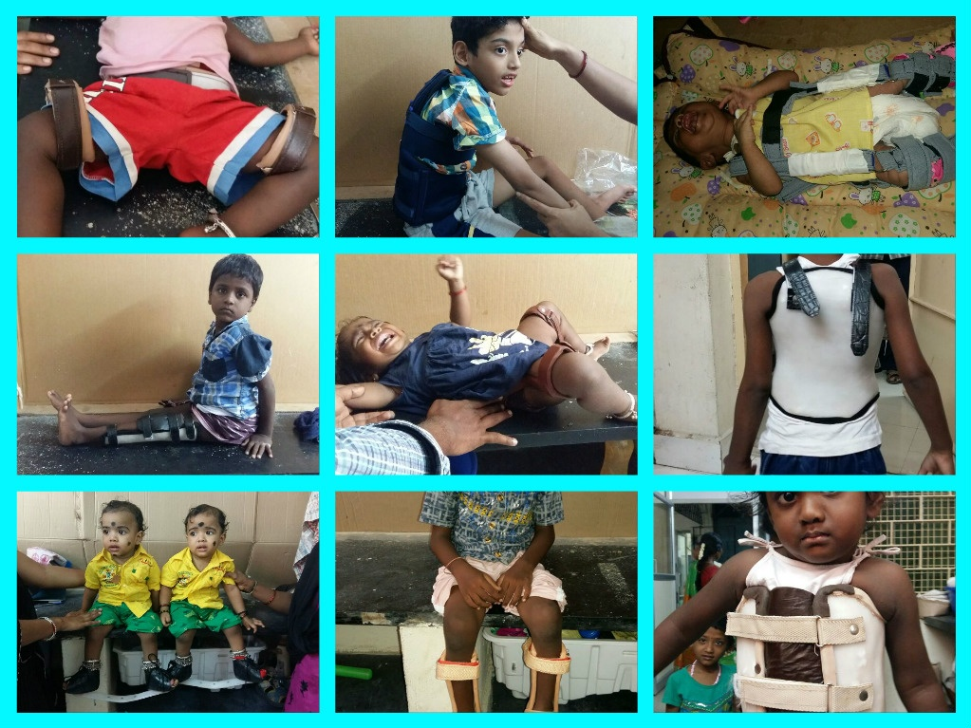

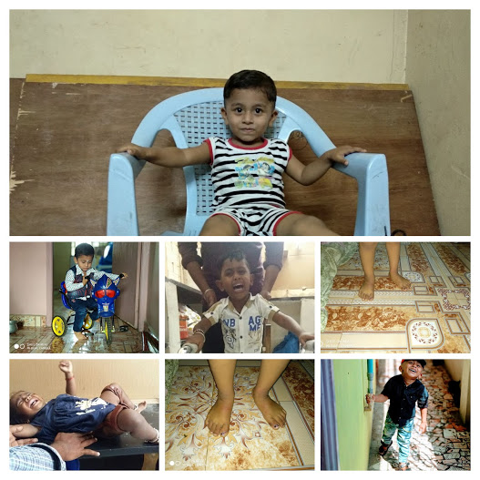
The change …..
Young children with multiple disabilities have unique needs and challenges. The parents of these have to make changes in their social life and did expressed high levels of frustration and dissatisfaction, though many try to maintain their routine life. The majority expressed a strong belief in the child and in the child's future, an optimistic outlook, and a realistic view and acceptance of the disability and also trust in out effective programs of intervention.
Here are a few case study that brought joy to us, the parents and children who now have No Limits.
Mohamed Sajid : from Pattukotai ,Was born with Club foot and was being treated from the age of 2. Though it was joy to have Sajid, the parents concern of his club foot was a barrier to enjoy the child. His father Tasleem says they were worried about his mobility and cam to Baby hospital. The doctors referred him the mobility aid which sukriti supplied which he used diligently for the past 9 months with great hope and trust. Now he says that the doctors have certified 90% improvement ., The child’s leg had a great bend, but now because of using t aid regularly the child is able to walk and it is a big relief to the parents and a joy to see the child walk on his own. They immensely thank Sukriti for such a gesture. (video attached)
Shanmuga Sundaram : is a little boy from Dharmapuri, he was born with deformity and right from 10 days of his birth he has been undergoing treatment . He has undergone 9 operations and received 5 corrective shoes form surkiti. His mother Kounsla says that his child is able to walk well after all the operations and shoes which was supplied by surkiti. The shoe has been a great help in making her child walk. She is overjoyed at the improvement and feels her child would walk even better in days to come. She profusely thanks sukriti in understanding the need and helping her son walk.
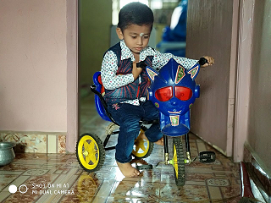
Sarvesh : Sarvesh is a 2½ year old child from Chennai. He was born with a club foot and had been undergoing treatment at Baby hospital from day 4. He was operated and also given corrective shoes from surkiti for the past 2 years, he has been using the shoes and received 3 shoes from us. Presently they use the shoes only in the night. Now Sarvesh is almost normal and can walk, run ride a tricycle, he will be ready to go to school this academic year. His parents are overwhelmed and are filled with gratitude.

International Day of persons with disability
The observance of International Day of persons with disability aims to promote an understanding of disability issues and mobilize support for the dignity, rights and well-being of persons with disabilities. It also seeks to increase awareness of gains to be derived from the integration of persons with disabilities in every aspect of political, social, economic and cultural life.

Surkiti observed the International Day of persons with disabilities on January28, 2017. Mr Ram Gopal, Executive Director , Indian Oil Corporation Ltd and Mr S.Iyyapppan , Founder, Sri Arunodayam, graced the occasion.

This program of Sukriti aims to show persons with disabilities, as both beneficiaries and agents of change, who fast track the process towards inclusive and sustainable development and promote resilient society for all. The event started with light music program by First Melody- Music band. Mobility aids were distributed to children with limb deformities. Success stories of beneficiaries were shared, hurdles face by them was portrayed as challenges which they fought with ease and self confidents, though had barriers to face.

The hall was filled with children of NGOs working with special children, differently abled children and adults. Sewing machines, scholarship for children’s education of differently abled parents, mobility aids for children with limb deformities were distributed that day. It was a day of togetherness, a small inclusive society and great entertainment and good snacks to eat and great life lessons were observed. The day ended with distribution of gifts to each and every participant from the NGOs, the kids and the adults left with great sense of belonging and happiness.

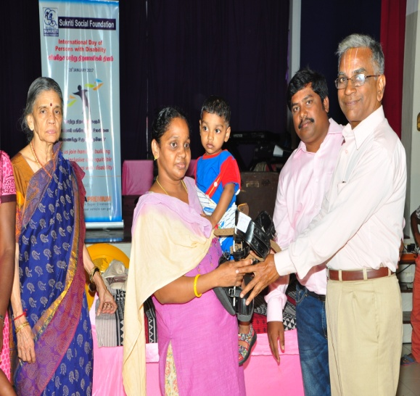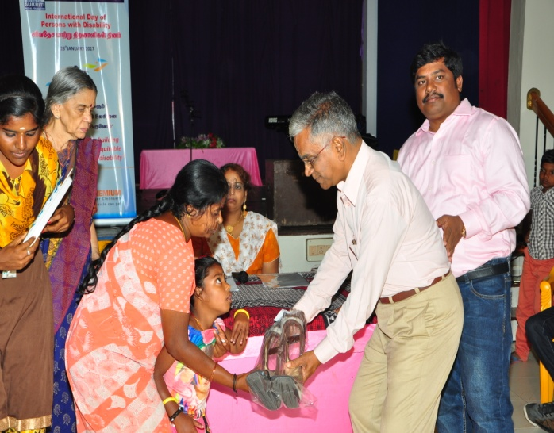

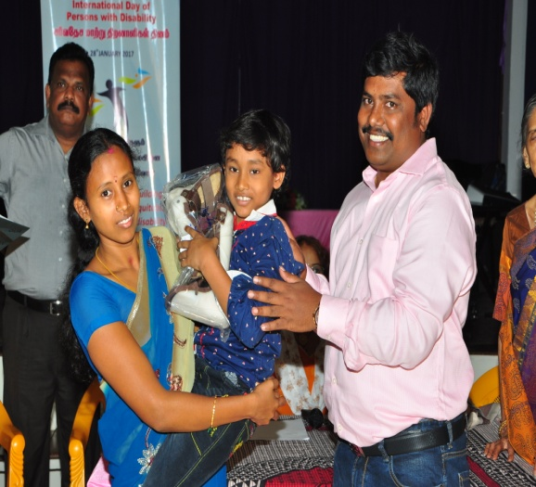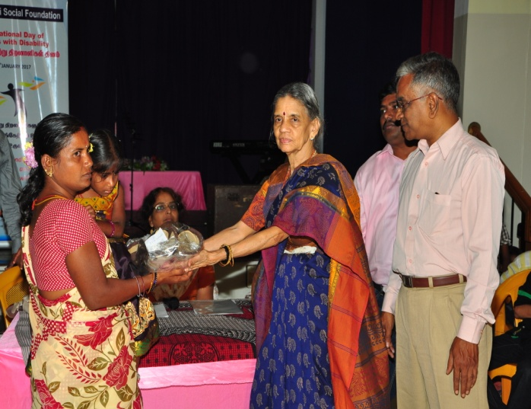

Thank you
****************************

