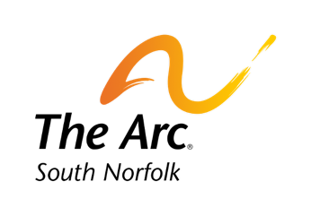
Equine Therapy Pilot Testimonials 2019

This Horseback Riding Program has been one that is near and dear to my heart. With the support of my team in the Family Autism Center, we have been able to successfully partner with a reputable and PATH accredited equine therapy facility called Horse SenseAbility. Working in collaboration with the Owner and staff has been exceptional and very educational. It has been a couple months in the making to figure out logistics, but when it came down to it we decided to advertise to our families back in the beginning of this fall a 60-minute program for ages 5-18. It would consist of 30 minutes of mounted horseback riding and 30 minutes of horsemanship. Within 24 hours of open registration, we had 24 people sign up for a 12 spot opening. We currently have a large waitlist for this program in hopes that we will be able to do another to serve more clients.

Equine therapy has been known to benefit many different populations exception individuals with disabilities. Now that sessions have been running for a few weeks I have noticed strong improvements in individuals' behaviors while working on mounted riding, as well as, the horsemanship portion of the program. Individuals who are participating in this program are working on social skills, sensory integration, fine and gross motor skills, listening and directional skills, safety skills, and so much more. It is truly incredible to see these individuals, who struggle from day to day, interact with these horses and know that the horses are interacting back with them and not only that but understanding them and exactly what they need. This program has provided our participants with such a great opportunity and I have been told by many that they wish they could go every day.

Hi Susan,
All the clients where so excited about horseback riding! I had one client that I never heard sing, but once on the horse begin to sing. Another client who expressed being nervous before riding, when finished expressed how happy and comfortable she felt on the horse and didn't want it to end. All the parents seemed to love the program. We had 24 clients sign up within 48 hours and could only take 6 each in 2 different sessions.

Nancy Borr
Program Assistant, FAC
nborr@arcsouthnorfolk.org
789 Clapboardtree Street
Westwood, MA 02090
1-781-762-4001 x412

