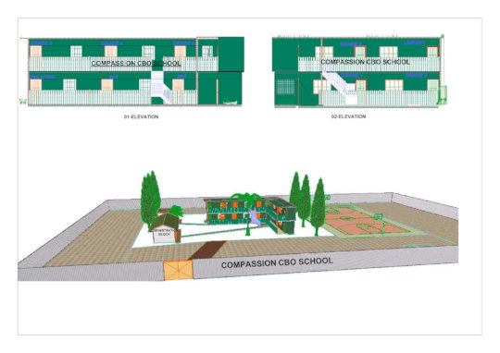
Compassion CBO School Architectural.
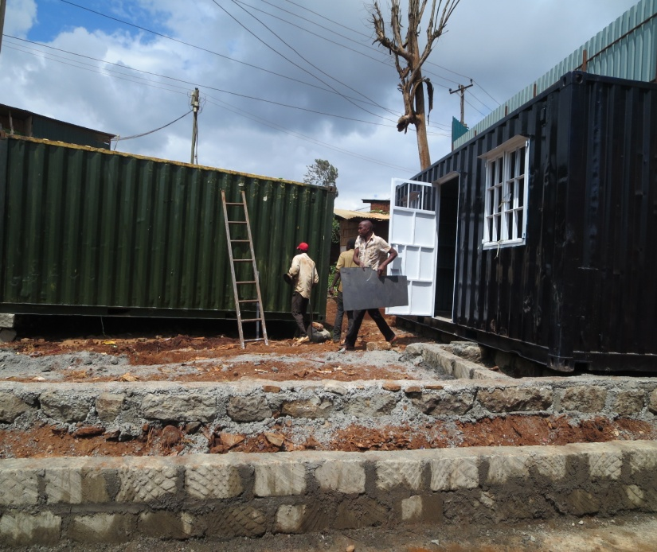
We thank you for donating to Compassion CBO "Help Build a Free Primary School in Nairobi Slums". https://www.globalgiving.org/projects/help-construct-container-school-in-githogoro-slum/
We have raised $10,111 of $96,982 goal. Feeding program is going on in the school.
We have bought 2 containers 200 text books and 30 lockable tables for the children in quarter 1 of 2020 and containers are being converted to classrooms. We still need to raise $24245.5 (25%) to bring more containers in quarter 2 of 2020. We have raised $10,111 for the last one year. .
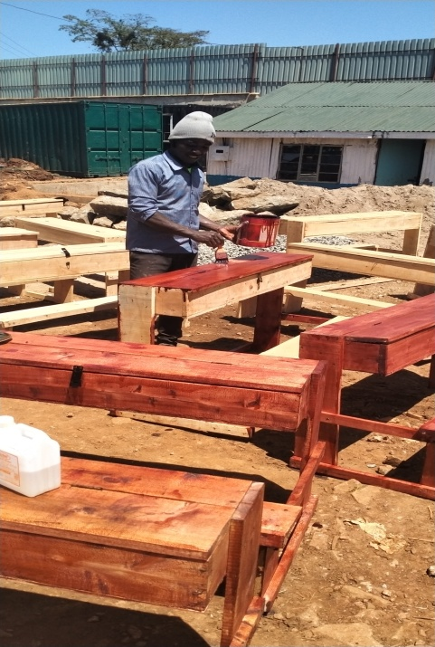
Thank so much for donating to this noble project.
Help Build a Free Primary School in Nairobi Slums
by Compassion Community Based Organisation
We are building a high standard modern Container primary school suitable for an informal settlement (slum) in Githogoro, Nairobi, Kenya - to provide high quality education for needy families living below $365 per year. Our aim is to give free access to education for children who otherwise have no education, so they can break out of the vicious cycle of extreme poverty. Since 2005 we have given access to education for over 1,000 children from the slum and we want to increase the number to 3,000 Children.

