**GIRLS HOPE EDUCATION PROJECT**

Project Goal: To save the Hope of 6,800 Girls from dropping out of school in Uganda

**QUARTERLY REPORT – MAY – JULY 2024**

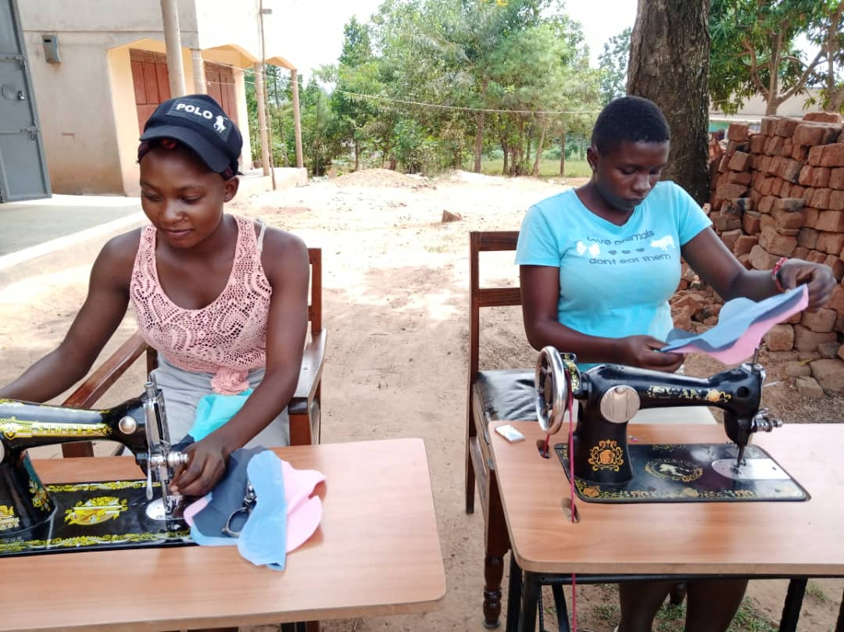 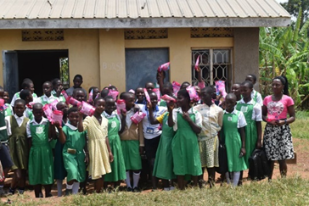

**1.0. PROJECT SUMMARY:**

This project is designed to save over 6,800 vulnerable girls from dropping out of school in rural communities in Uganda. The project empowers girls to be active in school by providing all scholastic materials, training on life skills and hygiene management.

**Scholastic materials support Girls:** In this reporting period 24 schools were reached and 280 girls were supported with scholastic materials (Exercise Books, Pens, Pencils, Mathematical sets, rulers and Uniforms), these assorted items are meant to boost the girl’s education and retention in school to complete education cycle.

**Awareness campaigns on back to school:** A total of 320 girls have been reached directly through awareness campaigns. This has created and this has led to improvements in attendance of learners while the dropout rates are getting reduced through the joint stakeholder’s involvement in mobilization of children to attend school and complete school.

**Education empowerment:** Empower girls and increasing rural girl's access to education while reducing their vulnerability to external shocks and can drastically improve their decision making, resist pressure from cultural practices which has eventually provided for their family’s health and economic well-being.

**Skilling Girls on sanitary pad making:** 83 girls were identified and trained on how to make re-useable sanitary pads in their schools and eventually rollout to other schools using available resources within education sector.