NARRATIVE REPORT FOR SAVE 6800 GIRLS EDUCATION PROJECT BY GLOBAL GIVING PARTNERSHIP

Summary of the project
The project will save 6,800 vulnerable girls from dropping out of school by providing a Package of scholastic materials, Uniforms, school fees and training on sanitary pads making as Menstrual Hygiene and management approach for girl child school retention in Eastern and Northern Uganda. The project targets 24 schools to boost education of girls affected by Poverty, war trauma, and cultural practices including early marriage. 12 boreholes will be drilled in 12 schools and nearby communities.
Achieved activities this reporting period
Conduct community and school outreaches to change attitudes.
APPCO this reporting period has reached to Twelve (12) schools in the five(5) subcounty and division target locations, youth leaders through the support of staff were able to mobilize women into their groups equip them with necessary information on stigma reduction, draw plans for reaching to other groups and get involved in community activism.
APPCO conducted a community and school assessment. While discussions with children during school club peer sessions, they highlighted locations where they felt safe and unsafe; they felt safe in the church but felt unsafe in areas including the roadside (due to risks of weapons, accidents or abduction), at waterpoints where fights break out and sometimes at home because they don’t have a father present (with a sense of self stigma attached to this).
APPCO was able to distribute basic scholastic materials to vulnerable girls in 12 supported schools. This activity was carried out by the field staff in consultation with the head teachers and teachers of all the 12 mapped schools. In each school the activity targeted 115 girls (51 in P1$P2, 33 in P3$P4 and 31 in P5, P6, P7). Pens, Books, pencils and mathematical sets were distributed to1.032 pupil’s (female =512, male =520). During the distribution, the staff would have a discussion with them and share basic relevant information on Value, retention and completion of Education, provide sessions on life skills and positive attitude change for all children in schools.
The teachers and parents supported the team especially in mobilizing children and always have continued to participate in go back to school campaigns in different fora’s while changing attitudes related to sexual violence. Reduced level of stigmatization against women who have been abandoned by their husbands of whom some men have been re-united with their women. A few women reported that their husbands have taken up family responsibility.

Successfully APPCO held Menstrual Hygiene and Management (MHM) training for staff and 20 selected girl mentors in the 12 schools identified. They were taken through a unique our girl model. This training that also attracted 5 mothers as education advocates who always work with staff ,senior women teachers and sexual reproductive health practioners specifically to support girls, identify those dropped out of school, refer and model their behaviors .the skills acquired enabled women to make pads locally using available resources which include pieces of clothes, sowing Needles and threads and also came up with what they can use during their Menstruation. Trainees were able to make pads packs made were distributed to school going and drop outs during a joint partner go back to school campaign.
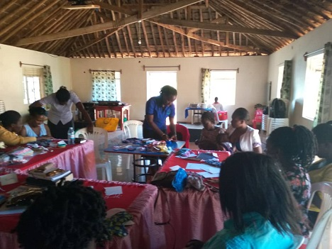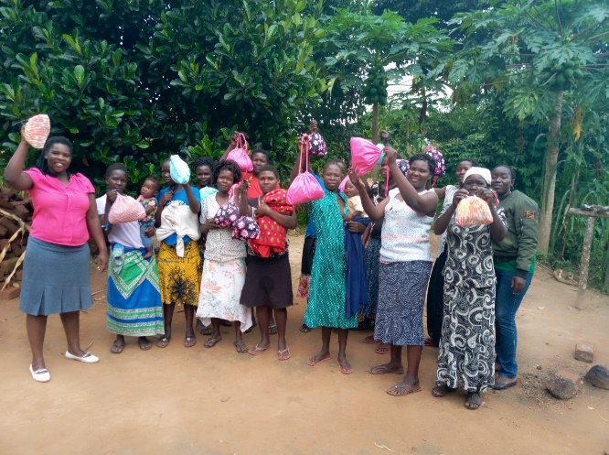
APPCO staff and selected girl mothers during resusable pads trainning
Distribution of re-useable pads
APPCO through the packs made also received additional 30 packs from district partners and each pack contains 6 re-usable pads,5 wooden pegs,3 cotton ladies underwear’s, Drying string,1 small towel,2 safety pins, Sowing needle and threads meaning 30 women and girls benefited from these kits purposely to support their girls stay and complete school.
Through the discussion’s girls were able to articulate a number of issues that affect their education and stay in schools. Some said, Girls who have blood on their clothes are often teased by teachers, boys or other girls scaring them and they end up dropping out of school. Social norms may lead women and girls to feel that menstruation is dirty, shameful or unhealthy. These issues mainly result to girls dropping out of school but because of this project most girls already are hopeful that they can stand stigma through their peers and access to sanitary pads.
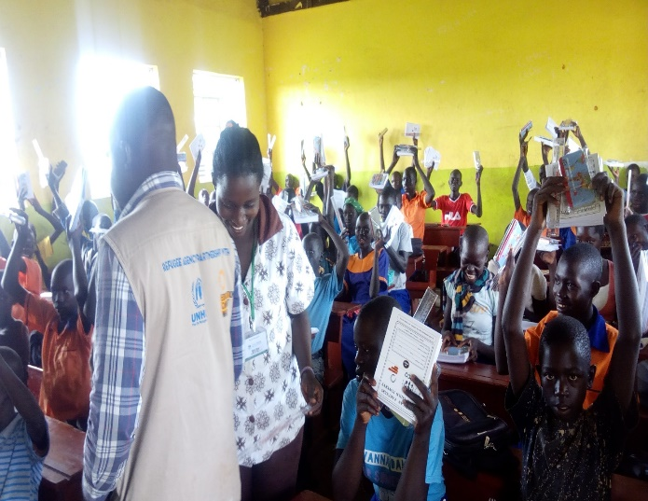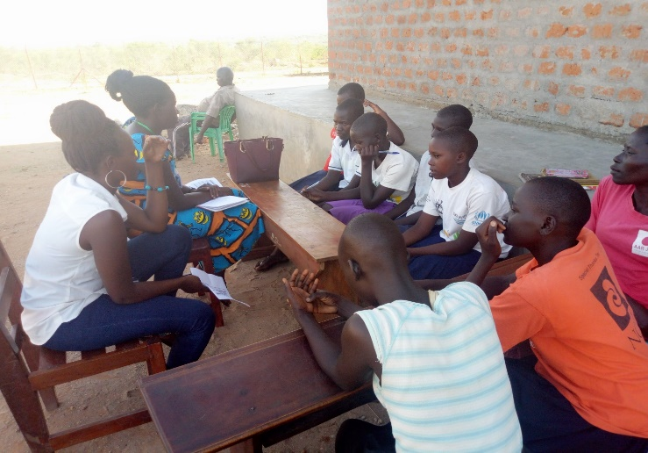
Distribution of assorted scholastic materials and girls during club discussions on MHM
The project is saving poverty-stricken girls from dropping out of school and giving them chance to rescue their families from poverty for improved well-being. Increasing rural girl's access to education reduces their vulnerability to external shocks and can drastically improve their decision making, resist pressure from cultural practices and free from violence and abuse.
Compiled by
Michael Anyeko Enyakoit – Executive Director - APPCO

