Project: Save Hope of 6,800 Girls drop out of school in Uganda

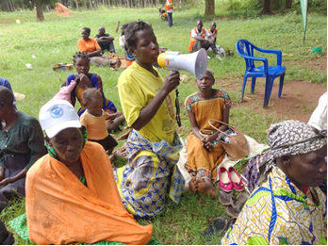
1.0. PROJECT SUMMARY ACTIVITIES:
APPCO this time has reached to a number of vulnerable girls and boys with a number of interventions including; community dialogues on GBV prevention and response, referral and advocacy, support transitioning and graduation of nursery girls into primary, interactive learning sessions planned, peer to peer support sessions, school assessments and coordination meetings with district partners as detailed below.

2.0. ACHIEVEMENTS;
- Supported 3 dialogue meetings with parents and community leaders on inclusive education and ECD concept for increased enrollment of marginalized children into school. The dialogue aimed at getting the opinions from the key stakeholders on how inclusive education can be achieved among the CWDs with major focus on pre-primary levels. The community leaders have confirmed that the major challenge is lack of trained teachers to handle the children with complex disabilities and this makes parents resort to keeping them at home because sending them to school and they are not being attended to as wasting time.
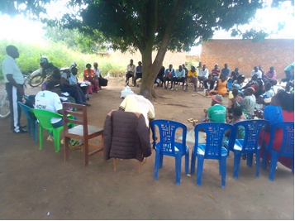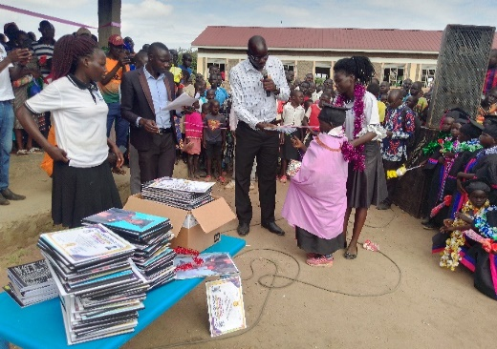
During a community dialogue while children supported with scholastic materials
- Supported the transition of 268 project beneficiaries (153 ,115M) children from kindergarten level 3(ECD upper class) into the primary level (elementary level 1) where among the graduands included 61 (34M,27F) children with different forms disabilities.
- APPCO promoted household health, feeding and nutrition by training 87 parents and 35 caregivers on establishment and management of kitchen gardens and with this training, 43 household established kitchen Gardens and 5 schools centers established kitchen gardens which got rolled out to a total of 87 households and 8 schools which improved both household and school nutrition feeding by having greens in the diet in every meal this reporting period.
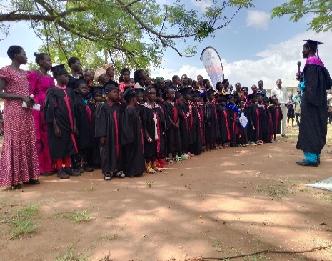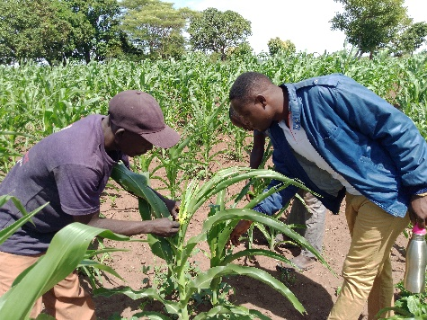
Children who graduated to join primary and APPCO Staff support garden work
- Conducted 83 home visit to marginalized children (M 30, F 53) where they have been followed up to monitor their progress and how their parents are implementing action plans drawn during Psychosocial support sessions using our journey of life model.
- Conducted 19 psychosocial support sessions across 15 schools reaching a total of 194 children (M- 89, F-105), tis was to support girls and children develop resilence and positive coping abilities with life challenges in safe spaces .
- With the help of teachers/ caregivers and facilitators, conducted 20 plays up sessions both in the communities and in 15 ECD centers reaching 423 average participants (M-192, F-231) To ensure children’s learning through different types of plays are conducted to promote children’s interaction with others through plays for enhanced social interaction and to identify children with PSS needs that needs to be followed up by the staff.

- CHALLENGES.
- Over congestion in class rooms and learning spaces due to inadequate number of teachers caregivers to handle big number of children but through lobbying for support from other partners to raise some classrooms once funding allows
- Low parents’ attendance of parent’s meeting during farming season however SMCs/ CMCs have been advised to come up with strong guidelines to govern parents’ participation in school meetings because issues usually deliberated in the meeting are of great value to the ECD and primary schools
- Still limited funding for some project interventions holistically and this poses a challenge to realize impact while meeting beneficiary needs.
4.0. LESSONS LEARNT
- Use of drama through our play up model has great impact as a mobilization strategy for communities to participate in development activities.
- Routine monitoring (follow ups, joint supportive supervision, review meetings and coordination) are key for the success of the project involving parents and guardians of girls to participate in project and schools’ initiatives.
- Parents involvement in community and school development programmes has changed their perceptions towards education for both girls and boys.
5.0. RECOMMENDATIONS.
- Plans to document success stories and create a broader forum for experience sharing
- Joint advocacy for increased funding for ECD education and primary education
- Support vocational skilling for girls to regain hope and be able to meet their socio-economic needs
Report submitted by
Martin osuwat
Emergency Response Manager
African partners for child poverty-APPCO

