# Project: Save Hope of 6,800 Girls drop out of school in Uganda

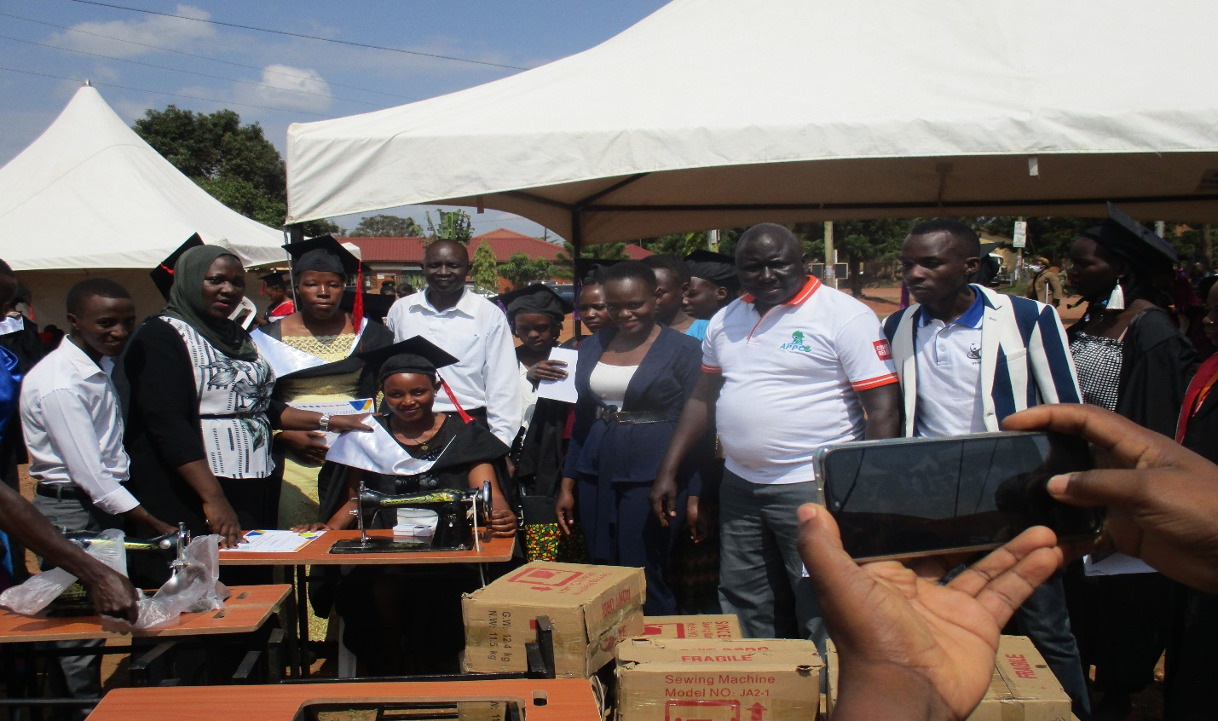

**PROJECT NARRATIVE REPORT**

**August 2022**

**1.0. PROJECT SUMMARY:**

The girls hope education project is being implemented by APPCO with support from global giving targeting saving 6,800 vulnerable girls from dropping out of school through the provision of scholastic materials and training on menstrual hygiene and management, provision of psychosocial support and creating socio economic opportunities for girls to provide other school and home basic needs.

APPCO in this reporting period identified the most vulnerable girls in the target communities with the help of local council leaders considering those with disability impairments, orphans, child mothers, exposed to GBV, GBV victims, single mothers, pregnant teenagers, school drop outs due to lack of fees and girls from poor family back ground. The identified girls suggested to be supported with specific skills i.e., tailoring, hair dressing, bakery and liquid soap making which the project supported to train girls including making of reusable pads using locally available resources so as to address period poverty among vulnerable adolescent girls.

**2.0. ACHIEVEMENTS**

|  |  |  |
| --- | --- | --- |
| Action | Target | Achievement |
| **Peer mentorship session** | 1. girls. | Again 20 trained girl mentors were identified and trained to lead the mobilization and participation in various play-up activities in safe spaces. APPCO also identified and equipped 8 safe spaces that have become a center of play-up activities and peer mentorship sessions for adolescent girls., APPCO also did mobilize and created 10 groups of out-of-school and school-going girls in the five (5) communities of Gulu district that are now participating in mentorship and life skills training sessions.  Trained girl mentors pause for a group pic ready to mobilize girls who dropped out of school for skills training |
| Skills training on Tailoring and Bakery | 25 girls and boys | This reporting period APPCO was able to support 20 girls who went through toileting skills training with 20 sewing machines to enhance their socio-economic wellbeing. 5 other girls benefitted from bakery skills and APPCO also supported them with startup kits. these are girls who specifically dropped out of school and some got pregnant while at home during covid 19. The girls supported will now be able to make a living and provide for themselves while saving with greater encouragement to go back to school as a result their parents applauded the support and committed to ensure girls are monitored, supported and encouraged to have life skills to know and live with people and earn meaningful lives, go back to school and complete their education.  C:\Users\Appco\Desktop\attachments\IMG_4234.JPGC:\Users\Appco\Desktop\attachments\IMG_4306.JPG  **Tailoring and bakery skilled adolescent girls receiving start up kits** |
| Conducted peer mentorship sessions on reusable pads | 500 girls | APPCO with technical support from health workers, 370 adolescent girls through the girl hope project have been mentored on various aspects of health education including healthy relationships, reproductive health, menstrual hygiene management, and other vital health topics for adolescents. 465 vulnerable adolescent girls have been trained on reusable pads and are championing rollout of trainings to their peers in making similar affordable yet efficient sanitary pads. This has been very vital in fighting period poverty among over 500 girls in the target districts of Gulu northern Uganda **Girls in practice sessions making reusable pads in safe spaces** |
| Conducted psychosocial counselling sessions with vulnerable girls. | 212 vulnerable girls and 10 boys | APPCO project staff this reporting period provided psychosocial sessions to 10 supported groups of girls reaching to a total of 222(212f, 10m) by helping girls be aware of themselves and identify their strength such that they can be in position to cope well with life challenging s. As a result, girls were able to recognize the need to have support sessions with the peers who live and experience difficult circumstances. the project staff noted that this will improve performance, retention and completion especially for girls in school if supported to understand the situations they are in. they were also taken through to understand their lives as a journey. From birth to what they are now, and relate with the journeys they have taken. while drawing their journeys of life, this provided better reflections to girls and boys that in life we go through a number of challenges. its therefore themselves to develop strong strategies to avoid and improve there way of living. |
| Community awareness sessions through role plays on sexual violence for girls | Communities | Empowered GBV activists have greatly mobilized and sensitized communities this reporting period including men on the causes and effects of GBV through role play. Considering the GBV project, considering sustaining of efforts supported and results is greatly registered given the ability of project structures to continue with the implementation of local activities aimed at reducing violence and abuse perpetrated towards girls. GBV activists are championing message delivery among their peers which has greatly contributed to a communal acknowledgment of VAW/G being rampant in the targeted communities. In Unyama for instance 7 in 10 people are aware of the causes and effects of GBV. And this has led to the development of sustainable actions joined by local authorities, parents and girls themselves to eliminate the happenings and mobilize for girls to go back to school or enrol for skills trainings for self-reliance.  **A community awareness on GBV through play and Drama.** |
| Review meetings with stakeholders to document best practices, and communicate progress | Community Stakeholders | APPCO conducted two (2) review meetings jointly with the district and sub counties stakeholders this was to check progress against output delivery, quality and impact of the project.A one-day review meeting was attended by different stakeholders ranging from CDOs, SPWO, OC, structures, survivors and staff. Participants discussed what has been done, what can be done better. Actions for continuity were developed including supporting girls out of school through basic skilling and socio-economic empowerment (VSLA) for girls in community safe spaces and linking them to opportunities around them was a sustainable strategy. Provision of pycho social support in and out of school was also taken into considerations. |
| **3.0. CHALL**  **ENGES** |  | * Overwhelming expectation by girls and their parents for other skills startup kits even after they received what was budgeted for them however with the support being provided, we anticipate supporting more girls through skills as funds are being raised * Still limited funding for some project interventions holistically and this poses a challenge to realize impact while meeting beneficiary needs. * Changing whether partners with too much rainfall which poses a challenge and disrupts planned activities. APPCO has revised its plans and adjusted the time for meetings not to take much longer. |
| **4.0. LESSONS**  **LEARNT** |  | * Working jointly with the district leadership, plays a tremendous aspect in sustaining the projects interventions through monitoring and linkage to existing opportunities. * Girls get excited when directly supported and encouraged to make life better through socio economic interventions and skills acquired. * Girl mentors trained have done a great job by mobilizing a number of girls and as peers they are respected and girls accept their views. |
| **5.0. RECOMM**  **ENDATIO** |  | * Increased funding to support many more vulnerable girls out in communities but also to boost up girls’ initiatives started. * Integrating the initiatives into government existing programmes and investment plans for sustainability * Scale up monitoring of girls’ initiatives to benchmark progress * Parents to continue providing necessary support to girls emotionally, socially, spiritually and financially to keep them protected and safe from abuse and violence |

**Report submitted by**

**Martin Osuwat**

**Emergency Response Manager**

**African partners for child poverty-APPCO**