Project: Save Hope of 6,800 Girls drop out of school in Uganda
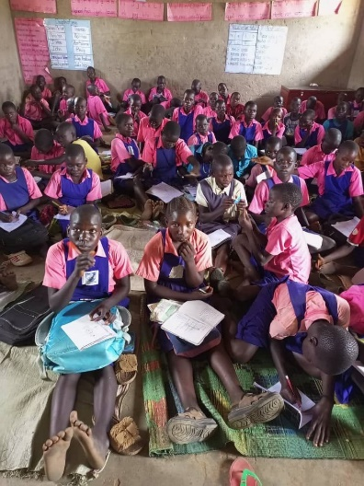
PROJECT NARRATIVE REPORT

AUGUST 2023

1.0. PROJECT SUMMARY:
In the period ending August 2023, through the girls hope education project APPCO participated in the support of seven schools with different project interventions. Girl Education hope project is an important aspect in nurturing these girls to pursue their goals in life, the girls hope education project being implemented by APPCO with support from Global Giving with a purpose of saving 6,800 vulnerable girls from dropping out of school through the provision of school basic needs.

APPCO this time has reached to a number of vulnerable girls and boys with a number of interventions including; capacity building of staff on GBV prevention and response, referral and advocacy, interactive learning sessions planned, peer to peer support sessions, school assessments and coordination meetings with district partners as detailed below.
2.0. ACHIEVEMENTS
Action | Target | Achievement
Staff training on SGBV case Management | 8 APPCO staff | Training on SGBV case management processes and referral systems  - Build the capacity of staff to have knowledge and skills on protection against Sexual exploitation and abuse (PSEA)  Guiding Principles  - Ensure the safety of the victim/survivor and his/her family at all times.  - Respect the confidentiality of the affected person(s) and their families at all times.  - Respect the wishes, rights, and dignity of the victim(s)/ survivor(s) when making any decision on the most appropriate course of action to prevent or respond to an GBV incident, while also bearing in mind the safety of the wider community as well as the individual concerned.  - Ensure non-discrimination in the provision of services.  - Apply all the principles to children, including their right to participate in decisions that will affect them. If a decision is taken on behalf of the child, the best interests of the child shall be the overriding guide and the appropriate procedures should be followed.  Reporting and Referral Mechanisms  - The survivor has the freedom and the right to report an incident to anyone. S/he may report to:  - Anyone whom the victim/survivor perceives can be of assistance.  - Community leaders.  - School teachers, parents, peers, friends, health workers.  - UNHCR and NGOs; and  - Police or security personnel in and around the settlement.  - All the actors who become aware of a survivor of SGBV have a responsibility to advise the survivor of the services available. An actor who becomes aware of an SGBV case is obligated to bring this immediately to the attention of the UNHCR office or the designated responsible staff member of the GBV implementing partner.  How can the PSEA Principles be Implemented?  - Creation of PSEA focal points and alternates in in each DLG.  - Ensure that complaints / reporting mechanisms that are known and easily accessible are in place.  - Raise staff awareness and ensure proper supervision.  - Continuous PSEA training of staff, partners, contractors and other key stakeholders especially new recruits.  - Outreach to communities.  - Recruitment and vetting process (public service application processes insert requirements for PSEA awareness in respect to applicant’s history.  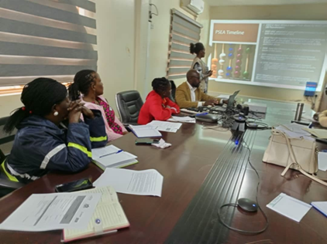  Staff participating in child Safeguarding training.
Interactive learning sessions in the safe spaces | 160 girls and boys | APPCO has embraced using safe spaces model as an approach which creates a conducive environment for all survivors to speak up on issues affecting them and seek more Psychosocial support at household level.  GBV sexual abuse survivors shared their experiences freely, conducted group and individual counselling, promoted interactive sharing and they themselves developed plans for reporting and supporting their peers. this approach coupled with our girl model for the target group was helpful for girls and boys to engage in play and discuss meaningful thoughts towards ending the vice.  The play up our girl model in safe spaces was based on a Survivor centred approach which creates a supportive environment in which the survivor’s rights and wishes were respected, their safety ensured and treated with respect and dignity.  During the session, survivors for case management are identified and appointments made. The community structures continuously mobilize these survivors for the safer space. Experience sharing is greatly emphasized so that other survivors are able to identify the strengths and weaknesses of other survivors and also identify their own strengths and weaknesses. During the secession, a suggestion came from a survivor on holding the safer space activity every fortnight because it’s a rainy season. The other participants were in support of this idea.  All safer space activities start with team building activity recreational activities of singing worship songs and play, then learning by responding.
  Month | Male | Female | Total
  June | 02 | 10 | 12
  July | 08 | 18 | 26
  August | 04 | 07 | 11
  Cumulative Total | 14 | 35 | 49
Conducted peer to peer sessions | 120 children | APPCO this reporting period facilitated peer to peer community and school peer sessions a total of 5 weekly peer to peer sessions were held with 120(boys and girls participating in the peer sessions.  During the peer sessions which were dominated by deliberations on SRH such Menstrual Hygiene Management, Puberty management and Adolescent, etc. Participants expressed delight with the information shared as it is key in shaping positive behavioural change among adolescents and groom them into citizens desired by our communities.  Key to note that during this peer sessions children opened up and told their stories of exposure to violence inform of sexual, physical, emotional which the openly shared with their peers and project staff facilitating the sessions.  All inclusive, the peer sessions through pictorial stories told, were positive in providing room for participants to openly share their experiences and seek for solutions from a wider community of peers.  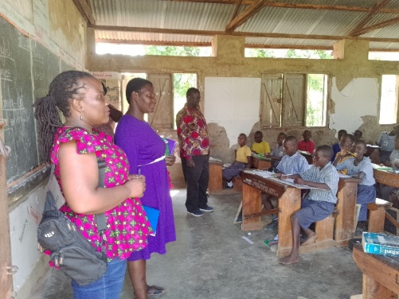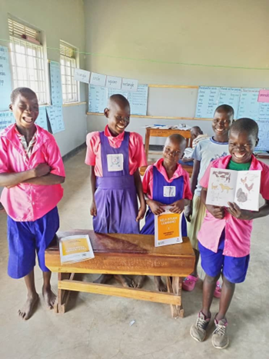  Peer-to-peer Sessions in Community and School Safe Spaces
Support schools hold parents’ meetings for school feeding program | 100 vulnerable girls | Seven (7) primary schools have been supported to hold parents meeting and these include:  In this reporting period, APPCO was able to organize parents’ meetings in Likiliki, Padwat, Kapetta, Labworoyeng, Holy Trinity Dii cwinyi, St. Andrew and Unity primary schools. In all the 7 schools a total of 289 parents M-87 F- 202 attended the meetings respectively  The key action points raised were  Parents to have positive attitudes towards supporting children go to school, by providing and contributing to the needs of children in school.  The school feeding programs play a vital role in preventing children from dropping out of school, parents therefore agreed to bring food items meant for school feeding by 2nd week of the term, when the rain season starts, all parents must report to prepare the school garden,  Parents to provide the seed for planting in the school gardens since to contribute to school feeding plans and Children diet at school should comprise of green vegetables.  Parents also agreed to establish nursery beds and kitchen gardens should respond actively.  Parents should keep going to school and interact with teachers on how their children are coping up with learning etc.  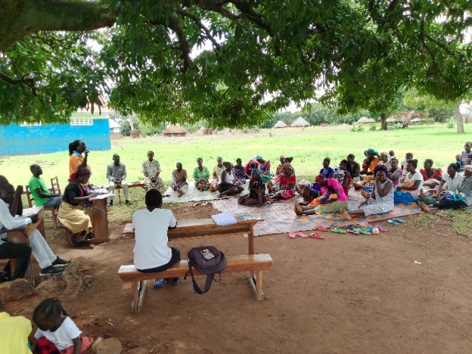  Parents meeting in Likiliki primary school
District coordination meetings | Education, GBV and child Protection Stakeholders | Purposes of the meeting;  - The purpose for the coordination meeting was to deliberating on what affects children  - Discuss emerging issues that need attention of partners  - Get to know who does what and where  Action Points:  - Submit reports in soft copy to the chair person and coped to the secretary  - There was going to be a meeting for child well-being committees in the district  - There was need for support for training of child wellbeing committees in the 8 sub counties  - CDOs should attend coordination meetings  - All partners who haven’t updated the inventory should do it immediately  - Communication was to be made to the DPC about the disco hall in Palaro where there is nude dancing.  - Continue with mass awareness raising to the communities to change attitude.
  - CHALLENGES.

- Still limited funding for some project interventions holistically and this poses a challenge to realize impact while meeting beneficiary needs.

4.0. LESSONS LEARNT
- Routine monitoring (follow ups, joint supportive supervision, review meetings and coordination) are key for the success of the project involving parents and guardians of girls to participate in project and schools’ initiatives.
- Strengthened external support and proven interventions this reporting time, communities have been empowered to identify and solve their own problems and challenges.
- Socio economic support and life skills provided to girls has strong assurance to influence girls be able to meet their basic needs.
- Parents involvement in community and school development programmes has changed their perceptions towards education for both girls and boys.
5.0. RECOMMENDATIONS.
- Joint review of school plans and budgets to fit school-based needs
- Provide adequate guidance to schools in re reintegrating child mothers back to school and minimize stigma and discrimination.
- Plans to document success stories and create a broader forum for experience sharing
6.0: CONCLUSION:
In conclusion therefore, this reporting period has been coupled with APPCO engaging communities, girls and boys to participate intensively in project work and utilize the opportunities to meet their needs. We will continue developing education actions and deliver the needed support to vulnerable girls in their localities.
Report submitted by
Martin osuwat
Emergency Response Manager
African partners for child poverty-APPCO

