**GIRLS HOPE EDUCATION PROJECT REPORT**

Progress Report Jan – April 2023:

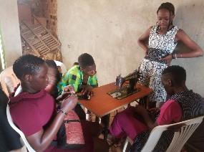 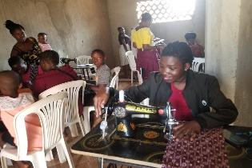

**Brief about the project:**

The project will save 6,800 vulnerable girls from dropping out of school by providing a Package of scholastic materials, Uniforms, school fees and training on sanitary pads making as Menstrual Hygiene and management approach for girl child school retention in Eastern and Northern Uganda. The project targets 24 schools to boost education of girls affected by Poverty, war trauma, and cultural practices including early marriage. 12 boreholes will be drilled in 12 schools and nearby communities.

**Project progress this quarter April 2023:**

In the month of February, we undertook a scholastic material distribution exercise for vulnerable girls and boys in 4 schools of Namakwa p/s, St. Jude p/s, Namuyenje p/s, and Kyetume p/s all found in the slum communities of Mukono district where 563 girls and boys received branded mathematical sets and exercise books as represented below; -

|  |  |  |
| --- | --- | --- |
| Description | Boys | Girls |
| Pupils | 284 | 272 |
| PWDs | 2 | 6 |
| Total | **286** | **277** |

The above scholastic materials have been pivotal in enhancing the active learning and participation of these vulnerable children as observed from the previous similar exercise where attendance among beneficiaries was reported by one of the teachers to have improved.

We have also been able to undertake monitoring and tracking of roll-out pieces of training being carried out by the initially trained project-trained girls who have taken the responsibility of training more of their peers at the community level where in the month of September the following numbers of beneficiaries had participated and benefited from such training initiatives on various skills as listed below; -

|  |  |
| --- | --- |
| Skill | Indirectly Trained Girls |
| Bag Making | 16 |
| Hairdressing | 21 |
| Pad Making | 25 |
| Tailoring | 19 |
| Total | **81** |

In the same sense, we are delighted to report that so far this month from our beneficiary monitoring visits we were able to establish that 22 girls previously trained and equipped with start-up kits have been able to establish their businesses and are training and employing their peers as below; -

|  |  |  |
| --- | --- | --- |
| Skill Obtained | No; Of Self-Employed Girls | No. Of Apprentice Peers |
| Bag Making | 08 | 4 |
| Hairdressing | 07 | 14 |
| Tailoring | 07 | 23 |
| Bakery | 05 | 4 |
| Total | **27** | **47** |

Continued capacity development of cluster partner CBOs has been one of our major outputs where this month our staff engaged our partners in capacity development on areas of evidenced weakness such as financial management processes. Despite that, we have also evidenced the capacity growth of our partners evidenced by the growing number of partnerships being registered with other CSOs as a result of their strengthened capacity for project implementation and management. A clear example is that of vision Bags which has been engaged in a partnership with SHED, a CSO supporting vulnerable women.

We have also been indulged in continued mentorship and career guidance of lower primary and candidate pupils respectively in 4 schools of St. Jude p/s, Namakwa p/s, Namuyenje p/s, Kyetume p/s on the topic of SRHR for other primary classes and career guidance for P.7 candidates as they prepare for their Primary leaving exams. In this engagement, we were able to ensure the active participation of 556 (284M,272F) pupils.

Finally, interactive monitoring sessions were held with 6 VSLA groups currently enrolled in the project where we discussed progress and challenges faced by the VSLA groups as well as provided a heads up for an on-coming transition from rudimentary saving practices to the digital savings innovation that is bound to be introduced using the digital agricultural suite platform to further strengthen the performance and management of the VSLAs to which pronouncement the group members were so much glad to hear.

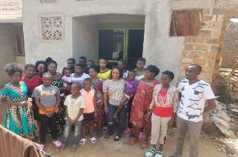 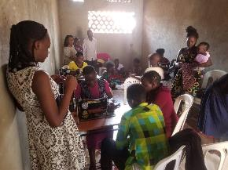

Girls in APPCO skills training center Actual skills training for girls