Project: Save Hope of 6,800 Girls drop out of school in Uganda
PROJECT NARRATIVE QURTERLY REPORT
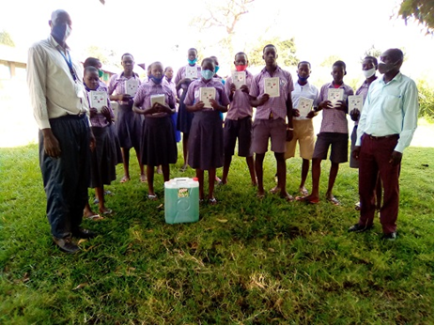
1.0. PROJECT SUMMARY:
Uganda seems to still struggling to cope with the coronavirus pandemic than most countries. 290 deaths and just over 36,407 confirmed cases with 12,387 recoveries in a nation of more than 40 million people. But scratch under the top-line statistics and you'll find evidence of growing hardship, loss and fear especially for girls and women. Uganda's economy was devastated during lockdown and the World Bank says the effects will throw more than three million extra people into poverty.
Schools have been closed since early March for 15 million students. The East African nation has taken the first tentative steps out of its Covid-19 measures but there is uncertainty about when classrooms will be able to reopen safely and fully. That has led to fears of increased numbers of girls dropping out of education.
In connection still with the school closures imposed by the Government of Uganda to reduce the spread of COVID-19, the report underlines the challenges to the education of refugee boys and girls. Forty per cent of children did not have materials for distance education or had to stop learning altogether. The need to carry out household chores affected the learning of 27 per cent of girls and 13 per cent of boys. Interviews with key informants highlighted a strong correlation between the closures of school and the increase in teenage pregnancies (21 per cent of respondents) and child marriage (18 per cent of respondents), leading to school dropout and other devasting health and social consequences for girls.

Findings indicate that women aged 18-24 years most often report knowledge of GBV incidents in the community (36.5 per cent) compared to others (29.2 per cent). Moreover, the report highlights that boys and men are safer at home and in the community compared to girls and women. Ensuring a safe environment for all, irrespective of age and sex is key. The need to proactively engage cultural and community leaders in addressing the social and cultural factors that make homes and communities unsafe for girls is paramount.
APPCO is saving 6,800 vulnerable girls from dropping out of school by providing a Package of scholastic materials, Uniforms, school fees and training on sanitary pads making as Menstrual Hygiene and management approach for girl child school retention in Eastern and Northern Uganda. The project targets 24 schools to boost education of girls affected by Poverty, war trauma, and cultural practices including early marriage, 12 boreholes will be drilled in 12 schools and nearby communities.
"When girls are in school, they are busy and their minds are doing something. But this pandemic has delayed the girls studying and acquiring knowledge," said, the Emergency Response Manager APPCO. "Now we have girls saying they are facing challenges in terms of early marriage. We have communities where parents are very traditional and once a girl has grown to age, they think about marrying her off and getting a dowry in exchange."
APPCO empowers girls by providing scholastic materials to boost their education, support rural girls with school fees to resist financial pressures from parents and training on making re-usable sanitary pads as Menstrual Hygiene Management. We will construct girls changing rooms and latrines in rural schools to reduce time spent in walking back home to change during periods. Those rural girls walking long distance will be provided with Bicycles to reduce risks of sexual abuse and training girl Clubs (GEM).
This project is using an integrated and holistic model of interventions that combines strategies to
Provision of psychosocial support aims at working closely support community support structures activities including household economic strengthening, parenting education and Strengthen community-based child protection mechanisms, and mobilize communities to support and monitor children’s wellbeing and parenting skills.
2.0. ACHIEVEMENTS
Action | Target | Achievement
Provision of scholastic materials exercise books to primary pupils | 516 Primary seven pupils | The activity started with staff sharing on career guidance with the pupil who are preparing themselves for PLE which will qualify them to pass to secondary level. Some of the topics discussed included Observing the Set SOPs by ministry of health to avoid contracting COVID 19 which can lead to missing school because of being put on isolation and treatment, concentrating on reading books at all times, avoid loitering in the trading centers to which can expose them to bad peer pressure, Consulting teachers at all times on the topics they have not understood during class hours, respect of elders at all times, Avoid absenteeism which can lead to missing of important topics which can easily be examined by UNEB etc. Four (4) exercise books (96) pages were provided each to help them during their learning.  During the discussion pupils shared their experiences at home which has contributed to some of their poor performance in the previous terms but however they have promised and determined to make it during UNEB  “My parents always fight at home and being the eldest daughter, I have to be the comforter of my siblings. Every time my parents pick up a fight, I feel like walking away from home but when I remember of siblings, I have no option but to say and be the shoulder they need to leaning on. Sometimes I end up not attending school because iam traumatized and feel at this time my siblings need me the more” “One of the pupils from Pakwelo P/S shared  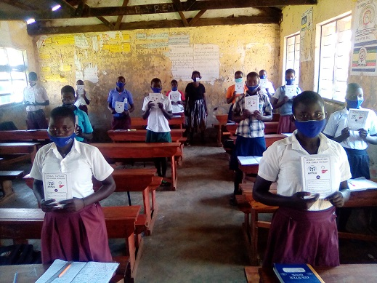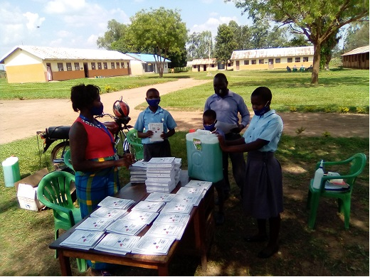  Gilrs of Bungatira P7 Receive scholastic materials and hand washing liquid soap
Conducted community awareness assemblies to dialogue on WASH selected issues  and COVID 19 pandemic campaign within the communities | Vulnerable girls in 12 School communities | This quarter 30 children’s clubs were supported to raise WASH awareness in schools and neighboring communities. School clubs raised awareness through games, sports, poems, songs, music, dance and drama. A strong impact of mindset change is witnessed over the course of this reporting period as pupils became less resistant and rebellious to WASH activities.  School clubs also organized sports competitions and debates, inviting other children to attend. The event is started by introducing a specific topic on WASH practices and concluded with more messages on different WASH practices. The fun ensured that children grasped the message better that classroom lecture mode of delivery. Parents, teachers and school management committee members participated too in these activities with a desire to change attitude, practices and promote COVID 19 prevention among girls in schools.  APPCO was able to reach to over 870(487 f, 383 m) both girls and boys in the targeted respective 12 schools this reporting period.  “Hand washing is one of the best and cheapest way to get rid of germs and prevent the spread of COVID 19. It is a simple, primary preventive measure that children have adopted independently. The best technique for hand washing is 1.wet hands and apply soap to form lather,2. Rub the front and back of the hands and this should be done thoroughly for 20 seconds because hands carry and transmit germs which cause infection,3. Rinse the hands with clean running water 4. Dry the hands” a pupil had this to say.  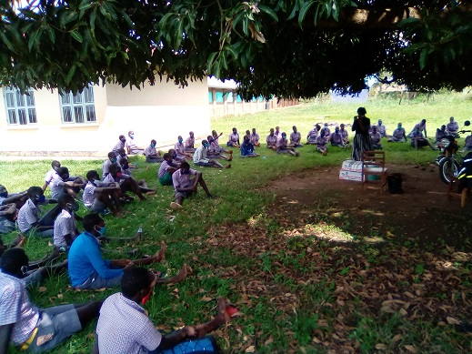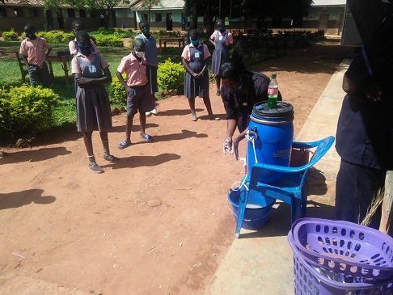  Awareness and handwashing with soap demonstration to peers in katakwi school.
Follow ups of Trained girls on basic Menstrual Hygiene management and making of reusable Pads | 20 Girls in 6 schools. | The component of Menstrual hygiene management remains a crucial challenge in schools and community for girls leading to school dropouts and poor performance. The outcome of the training is the practical skills gained by the trained pupils and their patrons/matrons. These skills gave girls more confidence during their menstrual cycles, reduce school absenteeism, dropouts leading to improved academic performance in schools. Proper MHM will also reduce infections that arise due to poor management of menstruation.  APPCO this reporting period did made a follow up support to girl mentors trained in schools and involved boys participation to ensure that they support their female counterparts during these times instead of increasing stigma associated with menstruation hygiene management, giving more confidence to the girl child to be more involved in school activities when they are menstruating and considering a meaningful support provided to girls by trained boys  At least 20 girls followed up showed confidence and courage to have been supportive to their peers even when in their homes.  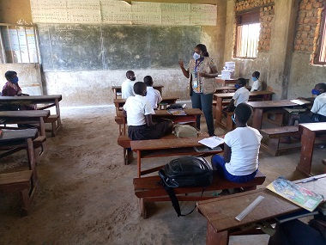  Trained girls show off made re-usable MHM pads
Review meetings with stakeholders to document best practices, communicate progress while girls are at school | SMCs, PTAs, parents, teachers and district education department. | Two education sector working group and coordination meetings were held to review how primary schools are adhering to the COVID-19 standard operating procedures as one of the ways to reduce and contain the spread of the virus. The meetings were also aimed at updating partners on the on-going registration of candidates aimed at beating UNEB deadline of 30th November to avoid pupils from missing final examinations. A total of 46(21m, 25f) Officials attended this meeting  APPCO took this opportunity to update partners and district officials on the activities already implemented in the targeted schools especially in the areas of community sensitization an aspect which is very important in providing a foundation for community participation in project activities  - At least children and girls at school are observing COVID-19 measures,  - Handwashing behavior has improved among the students.  - Parents are supportive to girls and cooperative to mobilize them go back and complete primary seven.  - Rehabilitation of facilities would highly improve the general wash practices in the schools including bore halls and provision of soap for washing.  - The school health clubs are working well and pass on WASH messages to others (e.g. during general assemblies).  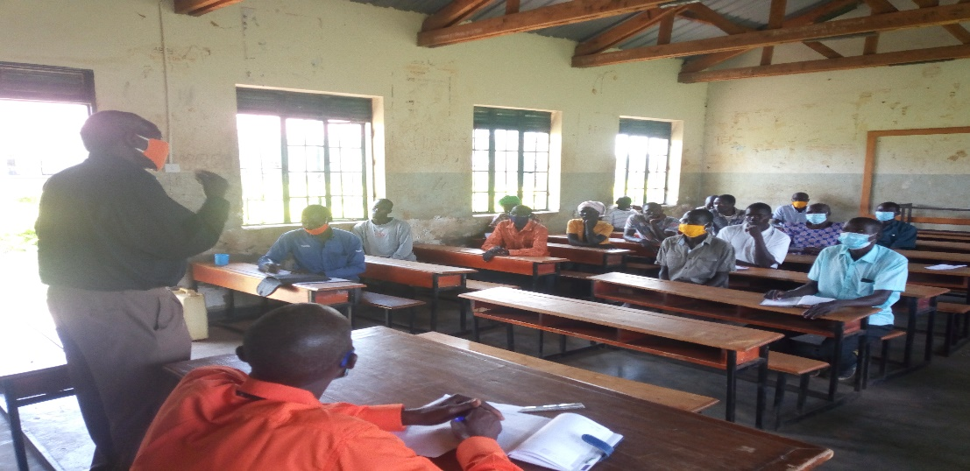  Parents and school management authorities in a review meeting
3.0. CHALLENGES.
- The outbreak of COVID 19 with with its associated challenges of observing the standard operating procedures remains a challenge to girls and the community at large.
- Limited time scheduled for some project activities due to school COVID 19 learning catch up Programme
- High expectations from the schools for instance St. Martin P/S and Lukodi P/S were asking for more facemasks and temperature guns for instance St, Marti P/s is sharing the temperature gun with the church
- Funding support per project respective output areas including COVID 19 prevention interventions is minimal this hinders meeting their respective needs. However, APPCO has advocacy and lobbying strategy for the wellbeing of a child.
- Incidence of early-childhood marriage is also on the rise as poverty caused by the pandemic has forced families to marry off their daughters to help alleviate financial burdens. In katakwi district, at least 128 school-age girls have been married.
- In addition to early marriage, many girls are also having to enter the workforce at a young age to help provide for their families. In some communities, girls are also forced to take on much of the domestic work at home, keeping them from seeing their friends and joining community-building activities. many of these girls have not gone back to school
“Having been impregnated, this has not only ruined my future but also the trust that my parents had in me,” says Jane, who is facing a pregnancy at just 14 years old. Now, she finds herself out of school and afraid for her future.
- It should be noted that Covid-19 has also resulted in a secondary health crisis in Uganda. In the project communities, girls have tried to remove their unborn babies themselves to terminate their pregnancies. They are also at increased risk of violence, abuse, exploitation and neglect.
- The pandemic has also resulted in limited access to health services for girls and prescription medication has been very limited. And, the effects on girls’ mental health is equally as troubling. Without their support systems, many girls have no outlet for the stress they are feeling during this devastating time.

4.0. LESSONS LEARNT
- The government has been providing some learning materials but they can’t reach everyone. Because some parents are really broke, they cannot afford internet. Some are also saying the government content is very complicated and hard to understand.
- Community assembly provide a platform for community members to generate their own ideas and small doable actions which are incorporated into their action plans. This is guided by their local leaders and facilitated by the project staffs.
- Some of the learning materials distributed by APPCO was prepared by the ministry of education, which are printed booklets with questions and the kids put in the answers." While before the pandemic, many vulnerable families struggled to pay school fees and the cost of books and uniforms.
- That will be an even bigger challenge when children return to classrooms: "Most of the parents we see have lost their jobs, so they will not be able to support their children through school. They will not even be able to afford the costs, so many vulnerable children will drop out of school.
- Male child involvement in trainings of making reusable pads has helped reduce stigma in girls because they feel the boys are part and parcel of their challenges.
- Involving parents and teachers during discussion of issues that affect children in schools enable them to identify areas of their responsibility and action. This process also allows children to openly express their issues to parents and teachers and for teachers to learn more about how children are treated at home.
- Strengthened referral mechanisms to address this issue of school dropout. With increasing go back to school, handwashing campaigns.
5.0. RECOMMENDATIONS.
- Embark on increasing engagements with adolescent girls in their community, and making it their priority to reach even more girls as this pandemic rolls on.
- Providing alternative access to online and printed educational materials to more primary school learners in rural communities through door-to-door outreach and giving them through their teachers' courier guidance and support while schools are closed.
- Giving digital training to teachers to be able to monitor and supervise learners while at home
- Supporting school dropouts with in-person classes that focus on how to stay safe during Covid-19 and equip them with key entrepreneurship skills
- Continue having more community sensitizations on child protection integrated into Menstrual hygiene management and education campaigns.
- Form Psychosocial support groups and parenting groups to support girls and families identified with psychosocial problems and support their families and care takers care and protect them through life skills sessions with children and peers at home.

Report submitted by
Martin osuwat
Emergency Response Manager
African partners for child poverty-APPCO

