Project: Save Hope of 6,800 Girls drop out of school in Uganda
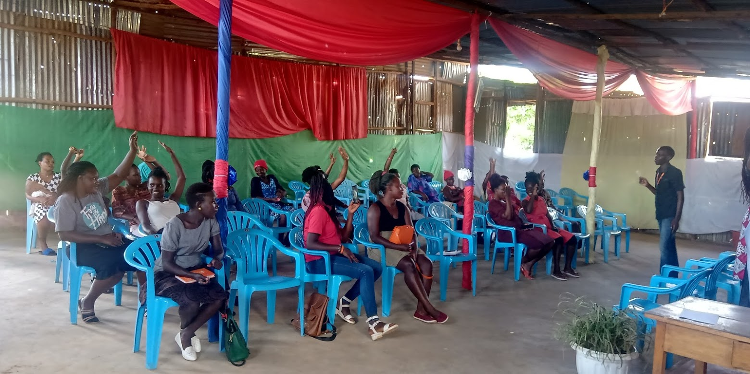

PROJECT NARRATIVE PROGRESS REPORT

1.0. PROJECT SUMMARY:
Girl Education hope project is an important aspect in nurturing these children to pursue their goals in life, the girls hope education project being implemented by APPCO with support from global giving is targeted towards saving 6,800 vulnerable girls from dropping out of school through the provision of scholastic materials and training on menstrual hygiene and management.

Despite the challenges attributed to COVID-19, APPCO was able to conduct sensitizations on the benefit of girl child education given that communities in most cases attributed girl child education to a wastage of resources but rather looked at their dropping off from school for marriage as a resource gain to dowry paid.

The sensitizations worked in ensuring the return of this girls to schools’ once announcement for resumption given that there was an outburst in communities with cases of early pregnancies brought about the long periods of out of school stay due to the pandemic that exposed the young girls to conditions facilitating early pregnancy.

In the period ending May 2021, through the girls hope education project APPCO also participated in the support of 8 schools with PPEs from liquid soap for hand washing and masks for protection against the deadly COVID-19 pandemic as well as supporting the girls in the candidate classes with scholastic materials such as books and pens for their study.
2.0. ACHIEVEMENTS
Action | Target | Achievement
Conducted organized drama sessions on MHM | 210 girls  - boys | Drama sessions were conducted to increase the level of knowledge on MHM, attitude change and practices among women, men, boys and girls; a total of 210 girls and 175 boys were trained on MHM (puberty, menstruation, hygiene during periods, hygienic and non-hygienic materials used, and health risks associated with poor menstrual hygiene and use of un-hygienic menstrual pads, the menstrual cycle, school sanitation in relation to MHM, myths and culture on MHM). This is aimed at equipping them with the knowledge to demand for their rights and practice good hygiene. However, 600 female and 407 males were reached through drama and dialogues in the target district of katakwi and Gulu. This built the capacity of communities to support girls and women during menstruation and also increased on their knowledge on MHM plus improving on the bad practices during menstruation among women and girls. 33 teachers trained on MHM, teachers cascade information and offered support to other pupils to improve their menstrual hygiene standards and attitudes towards menstruation  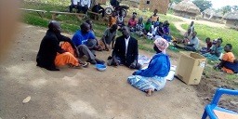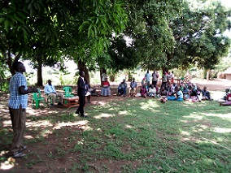  Community Dramas in action being presented
Conducted interactive learning sessions through our girl model clubs | Vulnerable girls in 8 school communities | APPCO implemented our girl clubs model for girls both in and out of school ,through the clubs APPCO worked with health providers and trained mentors to provide menstrual hygiene management with critical health and social services such as gender based violence response services ,family planning and sexual reproductive health information and services ,life skills ,training such as career development and goal setting and linkages to economic strengthening programs .the goal of these girls empowerment activities was to encourage the adoption of healthy behaviours,reduce violence and instill long term behavior change.
Conducted community outreaches on WASH selected issues  and COVID 19 pandemic campaign within the communities | 6 project targeted communities | Six (6) community outreaches conducted as part of celebrations of the international water day with a focus on cleaning of water sources with the message of “clean water =good health” while relating to the days theme of “water and climate change  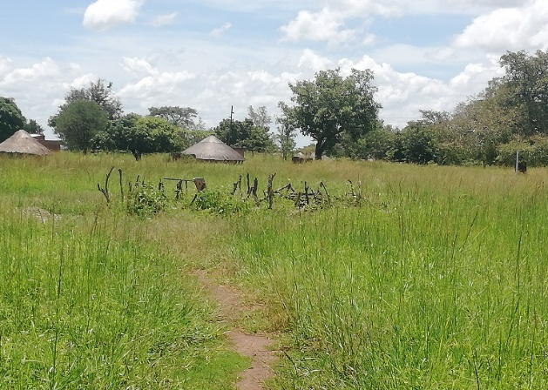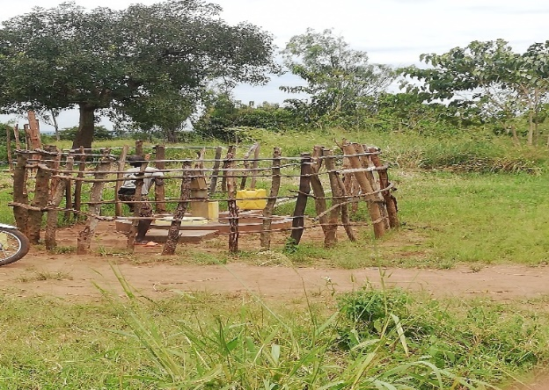  Before and after protection of a water source
Development of school opening action plans with parents and teachers | Teachers and parents | Four (4) School opening action planning sessions conducted with teachers, parents and pupils where action plans were developed in areas of challenge with a focus on agitating for the return to school for the school going girls as well as those who had fallen victims of early pregnancy alluding to the fact that government mention called for pregnant girls in candidate classes be allowed to sit for their final exams in their respective classes including primary six and four  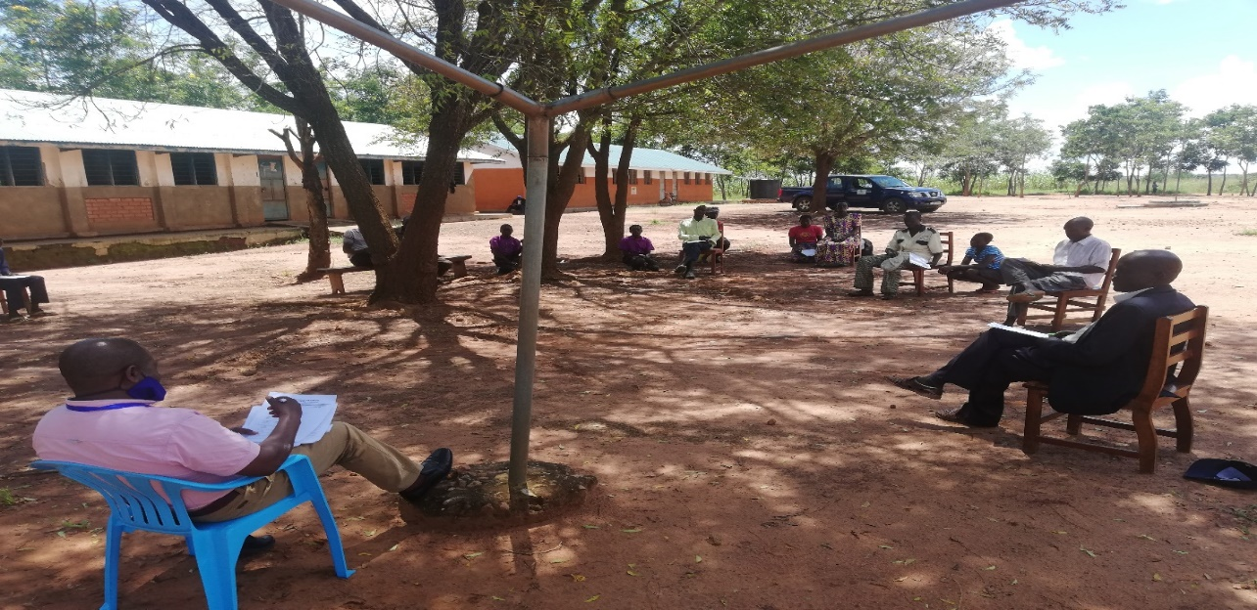  Parents and teachers developing school opening action plans jointly
Review meetings with stakeholders to document best practices, communicate progress while girls are at school | Community Stakeholders | At least three (3) Review meetings were conducted with stakeholders (head teachers, girls and boys, Village health teams members (VHTs), Health workers, political leaders, men and women in order to review progress against output delivery, quality and sustainability.6 school health clubs were monitored and given support in terms of roles and need to have systems in each school for sustainability. This enables students to implement action plans developed on MHM and other health issues.
3.0. CHALLENGES.
- Still outbreak of COVID 19 with with its associated challenges of observing the standard operating procedures remains an issue for girls and the community at large.
- Bushy school environments especially which doesn’t provide for safety and protection of girls while at school, however school communities dialogued to have school compound clearing days planned and supported
- High expectations from the schools for especially now during reopening of primary six and four asking for more facemasks and temperature guns and hand washing equipment and soap
- Funding support per project respective output areas including COVID 19 prevention interventions is minimal this hinders meeting their respective needs. However, APPCO has advocacy and lobbying strategy for the wellbeing of a girl child go to school and finish school.
4.0. LESSONS LEARNT
- Engaging all relevant stakeholders (relevant sector offices, community leaders, partners and community members) in project implementation and monitoring creates sense of ownership as we have seen in these particular methodology interventions. This also helps to sustain initiative and changes observed.
- Strong and regular monitoring system (follow ups, joint supportive supervision, review meetings) are key for the success of community development initiatives. In this our girl model implementation in girls’ groups had better follow ups and support had seen better changes in girls’ lives.
- With minimal external support and proven interventions this reporting time, community have been empowered to identify and solve their own problems and challenges. MHM among girls has shown awareness, attitudinal and behavioral changes in girls with the support from different stakeholder.
- Access to information is the gate way to attitudinal and behavior change in the community. The project has helped most girls and communities to access information and challenge on different socio-cultural barriers of girls’ education. Also helped them to get opportunity to discuss their issues with their male counter parts which was not the practice before the project.
- Having both a demand and supply side interventions in a single project would address multiple challenges at a time. The girls hope project is unique in this respect that it has community component such as dialogues and outreaches which helps to create demand and supply side interventions such as provision of school materials which helps to have access to school once the demand is created. Hence, this complimentary helped the community to send more girls to schools.
5.0. RECOMMENDATIONS.
- Continue the joint monitoring and follow up visit on a more regular and frequent to schools and community house holds
- Provide refresher training on community project design and implementation for members so that the community designs more projects that can address their felt needs supporting girl’s education
- Continue documenting success stories and create a broader forum for experience sharing
- Providing alternative access to online and printed educational materials to more primary school learners in rural communities through door-to-door outreach and giving them through their teachers' courier guidance and support while schools are closed.
- Continue having more community Dialogues on child protection integrated into Menestrual hygiene management and education campaigns for girls who got pregnant at home during covid 19

Report submitted by
Martin osuwat
Emergency Response Manager
African partners for child poverty-APPCO

