Project: Save Hope of 6,800 Girls drop out of school in Uganda
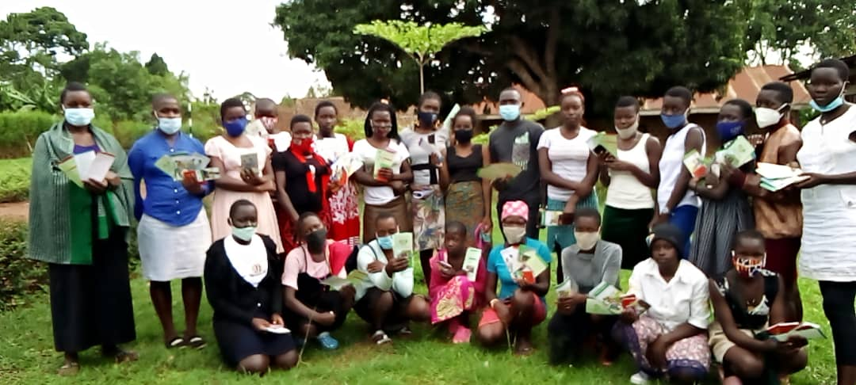

PROJECT NARRATIVE REPORT

1.0. PROJECT SUMMARY:
In the period ending December 2021, through the girls hope education project APPCO participated in the support of five schools with different project interventions. Girl Education hope project is an important aspect in nurturing these girls to pursue their goals in life, the girls hope education project being implemented by APPCO with support from global giving is targeted towards saving 6,800 vulnerable girls from dropping out of school through the provision of scholastic materials and training on menstrual hygiene and management.

With emerging of COVID-19 coupled with traditional issues that marginalized girls and women across the globe including Uganda from March 2020; the vulnerability of girls and women has increased to the greatest extent. The sensitizations worked in ensuring the return of this girls to schools’ once announcement for resumption given that there was an outburst in communities with cases of early pregnancies brought about the long periods of out of school stay due to the pandemic that exposed the young girls to conditions facilitating early pregnancy.
In many communities, traditional gender norms require women to be responsible for family health. As primary caretakers, women are most vulnerable to contracting diseases like COVID-19 when it spreads. Women are also suffering in this pandemic due to a sharp uptick in gender-based violence, and those residing in the villages targeted for this project are no exception.

2.0. ACHIEVEMENTS
Action | Target | Achievement
Training on Child participation | 40 girls. | APPCO being one of the partners so passionate about working for the wellbeing of children in Northern Uganda, we facilitated a three (3) days training on meaningful child participation which means A child has a voice and are heard in a meaningful way and this was organized by save the children with the objectives of  - To review both national and international legal standards in child protection  - To increase awareness and understanding of Uganda’s Children Act  - To differentiate between rights and needs  - To review key rights and responsibilities  - To strengthen skills in the application of both the CRC and Uganda Children Act  - To enhance understanding of the key actors in Uganda and their responsibilities in upholding the legal aspects of child participation  The training was very participatory and participants shared their various experiences of working with children  Some of the topics discussed included the principles of child participation which include  Best interest of the child, Ethical Consideration, Transparency, Honoring, Equal opportunity, Care and safety, Appreciation, Upholding nondiscrimination and Staff effectiveness. Another emphasis was put on the Rules of engaging children which included  Getting permission from the Adult/Care giver, getting permission from the child, Establish and build rapport first with the child, Use child friendly technics of communication e.g. drama, storytelling and pictures, Use cultural, age appropriate and gender sensitive communication techniques, All children should be given a chance to participate, Do not undermined the children’s views  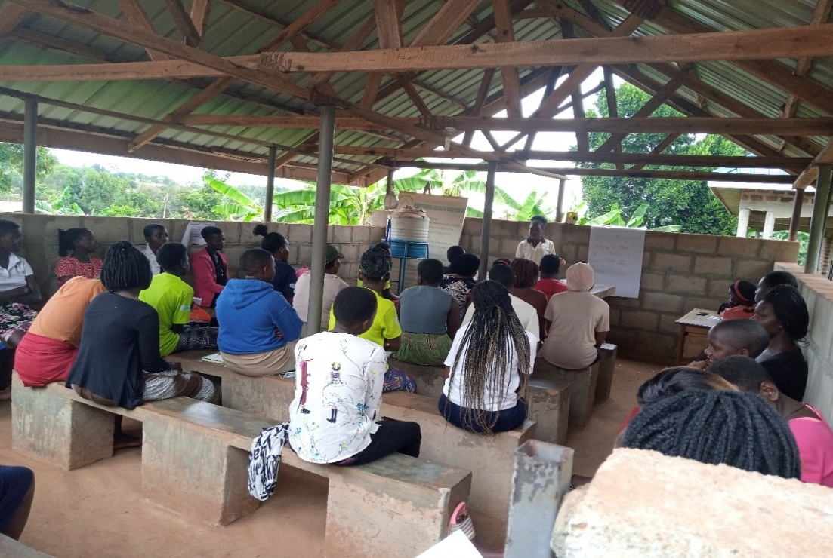  Girls participate in child participation training.
Interactive activities in the safer spaces | 260 girls and boys | Safer space approach was one of the new approaches adopted which created a conducive environment for all survivors to speak up on issues affecting them and seek more Psychosocial support at household level. Survivors shared their experiences freely, conducted group and individual counselling, promoted interactive sharing etc. The target group is survivors and children though its only survivors of SGBV.  This approach was based on a Survivor centred approach which created a supportive environment in which the survivor’s rights and wishes were respected, their safety ensured and treated with respect and dignity.  Safer space activities were piloted in Layibi division (every Monday) and Bungatira (every Friday). The target group was GBV survivors (Male, Female and Children).  During the session, survivors for case management are identified and appointments made. The community structures continuously mobilize these survivors for the safer space. Experience sharing is greatly emphasized so that other survivors are able to identify the strengths and weaknesses of other survivors and also identify their own strengths and weaknesses. During the secession, a suggestion came from a survivor on holding the safer space activity every fortnight because it’s a rainy season. The other participants were in support of this idea. All safer space activities start with team building activity recreational activities of singing worship songs.
  Month | Male | Female | Total
  April | 01 | 60 | 61
  May | 05 | 159 | 164
  June | 02 | 17 | 19
  July | 08 | 08 | 16
  Cumulative Total | 16 | 244 | 260
Conducted peer to peer sessions with girls. | 187 girls | Following the project work plan, the project facilitates weekly peer to peer sessions in which sessions a lot of information is shared among participants ranging from challenges and solutions to such challenges as experienced and solved by the girls. During the month of November, nine peer sessions were held in total in the eight project safe spaces with 187 girls participating in the peer sessions.  During the peer sessions which were dominated by deliberations on SRH such Menstrual Hygiene Management, Puberty management and Adolescent, etc. Participants expressed delight with the information shared as it is key in shaping positive behavioural change among adolescents and groom them into citizens desired by our communities.  Key to note that during this peer sessions girls open up and tell their stories and many have been exposed to violence inform of sexual, physical, emotional which the openly shared with their peers and project staff facilitating the sessions.  All inclusive, the peer sessions were positive in providing room for participants to openly share their challenges and seek for solutions from a wider community of peers.  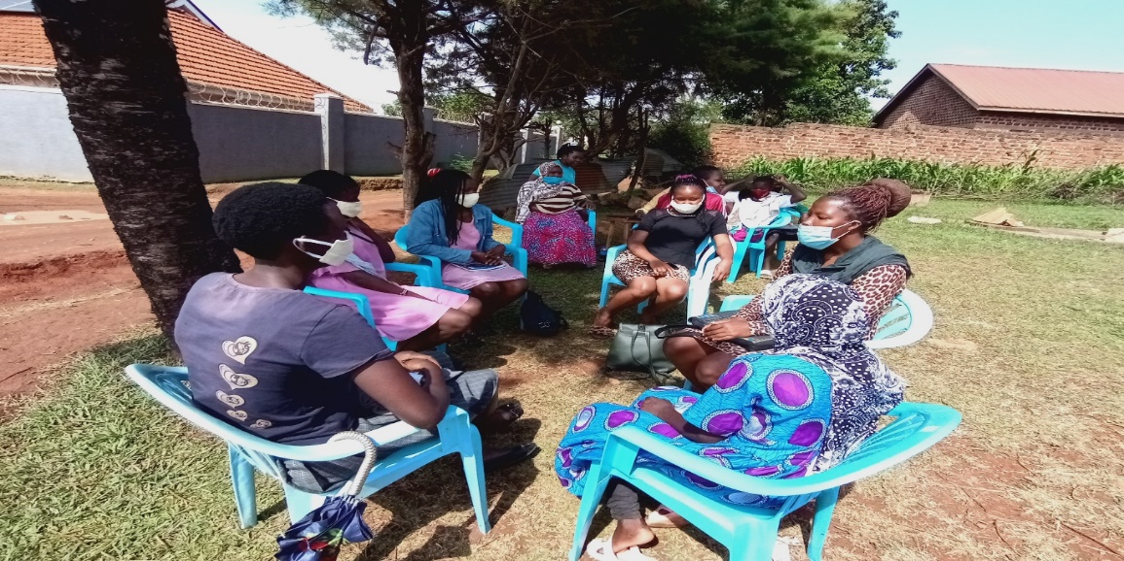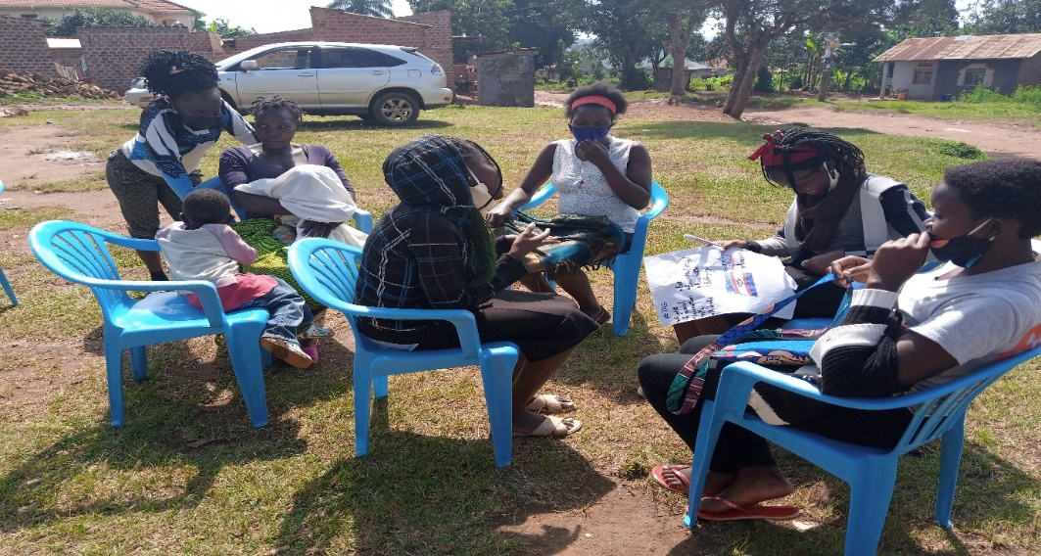  Girls in peer-to-peer sessions in community safe spaces
Conducted psychosocial counselling sessions with vulnerable girls. | 100 vulnerable girls | With the background set by the pandemic, communities are exposed to various challenges that have led to rising stress levels and as such have seen the project staff with the support from girl mentors engaged in numerous counselling sessions as the adolescent are always approaching for counselling at individual level as well as during peer sessions.  In this reporting period, we have been able to offer counselling services to 100 girls as well as providing general motivation to all the girls during activity sessions where APPCO staff gets to share their various experiences and challenges growing up and urge the girls not to give up because of challenges but rather strive to ensure that they overcome the challenges. Girls are now able to share openly their experiences, challenges relating to health and take up meaningful decisions  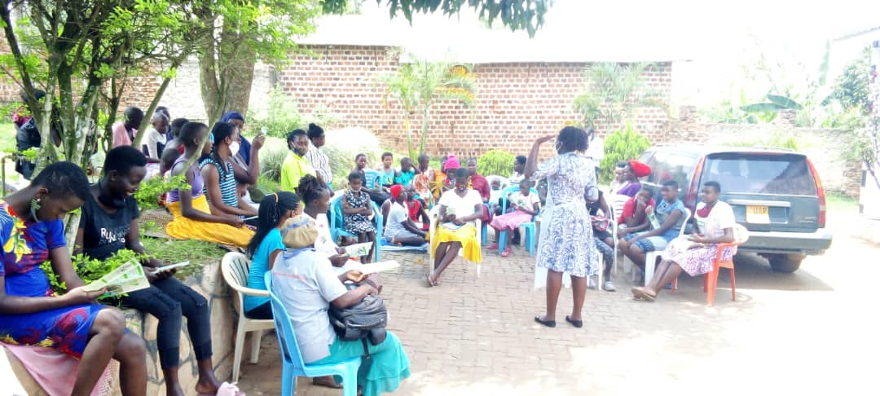Psychosocial session with selected girls
Development of school opening action plans with parents and teachers | Teachers and parents and children | Still this reporting period, APPCO jointly with community leadership, school management committees, parents teachers associations held School opening action planning meetings conducted with teachers, parents and pupils where action plans were developed in areas of challenge with a focus on agitating for the return to school for the school going girls as well as those who had fallen victims of early pregnancy suggesting to the fact that government reopened schools starting from the 10th /01/2022.  Key actions for considerations included;  - Clean all study room surfaces with water  - Social distance should be applied  - Correct wearing of masks all the time  - Disinfecting of all surfaces  - Symptom screening  - Safe disposal of waste and avoid dumping  - School feeding in shifts  - Recommend one learner per bed  - Provide security for areas of danger  - Early reporting and early detection as surveillance action  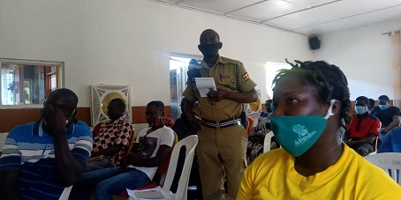  Officer emphasizes some key actions for considerations during the meeting held
Review meetings with stakeholders to document best practices, and communicate progress | Community Stakeholders | At least three (3) Review meetings were conducted with stakeholders (head teachers, girls and boys, Village health teams members (VHTs), Health workers, political leaders, men and women in order to review progress against output delivery, quality and sustainability. A one-day review meeting was attended by different stakeholders ranging from CDOs, SPWO, OC, structures, survivors and staff. Participants reviewed what has been done, what can be done better. Even without guidance we can move alone. Actions for continuity were developed including supporting girls out of school through basic skilling and socio-economic empowerment (VSLA) for girls in community safe spaces.

3.0. CHALLENGES.
- With the anticipated reopening of schools, parents and girls have gotten high expectations with challenges noted to meet them. like school fees, scholastic materials, feeding among others.
- Omicron and COVID 19 virus continue to worry people with their associated challenges of observing the standard operating procedures remains an issue for girls in schools and in their communities at large.
- Still limited funding for some project interventions holistically and this poses a challenge to realize impact while meeting beneficiary needs.

4.0. LESSONS LEARNT
- Routine monitoring (follow ups, joint supportive supervision, review meetings and coordination) are key for the success of the project involving parents and guardians of girls to participate in project and schools’ initiatives.
- Strengthened external support and proven interventions this reporting time, communities have been empowered to identify and solve their own problems and challenges. MHM among girls has shown awareness, attitudinal and behavioral changes in girls with the support from different stakeholder.
- Access to information is the gate way to attitudinal and behavior change in the community. The project has helped most girls and communities to access information and challenge on different socio-cultural barriers of girls’ education. Also helped them to get opportunity to discuss their issues with their male counter parts which was not the practice before the project.
- Socio economic support and life skills provided to girls has strong assurance to influence girls be able to meet their basic needs.
5.0. RECOMMENDATIONS.
- Embark on joint monitoring and follow up visit on a more regular and frequent to schools and community house holds
- Review annual workplans and place budgets to fit school-based needs since girls are reporting back to school
- Equip girls with necessary covid 19 management materials (face masks, sanitizers) for adequate prevention of covid 19.
- Provide adequate guidance to schools in re reintegrating child mothers back to school and minimize stigma and discrimination.
- Continue documenting success stories and create a broader forum for experience sharing
- Continue having more community Dialogues on child protection integrated into Menstrual hygiene management and education campaigns for girls who got pregnant at home during covid 19 and strengthen school health clubs to promote sex education and life skills for girls in school.
Report submitted by
Martin osuwat
Emergency Response Manager
African partners for child poverty-APPCO

