Date: 15th Oct, 2019

Project: Save Hope of 6,800 Girls drop out of school Uganda

PROJECT NARRATIVE PROGRESSIVE REPORT
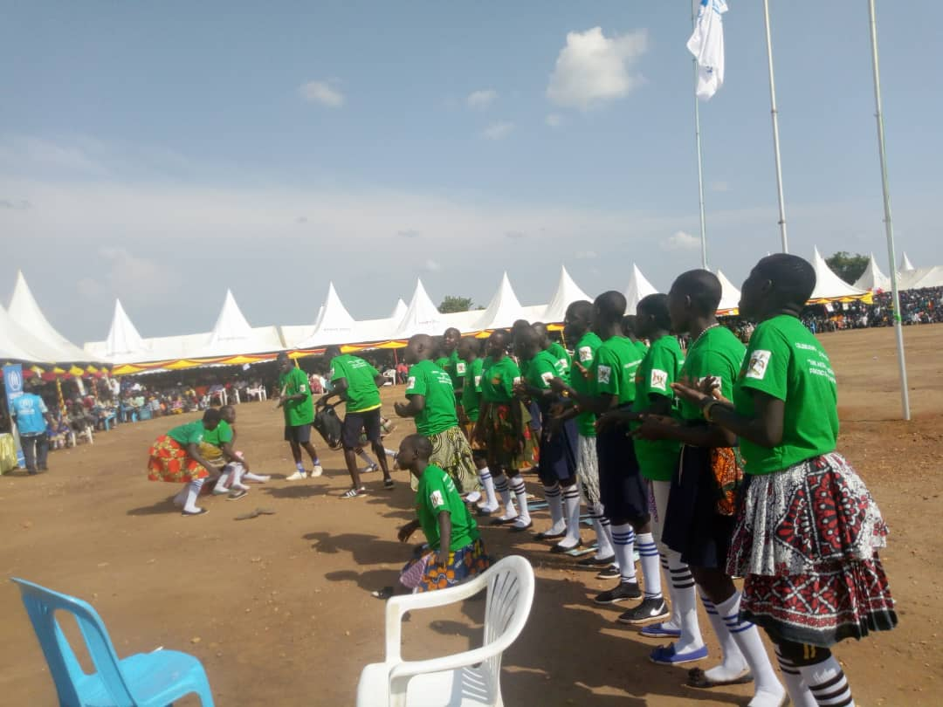
Celebration on the day of girl child – empowered girls in drama play

1.0. PROJECT SUMMARY:
This project is designed to save over 6,800 vulnerable girls from dropping out of school in rural communities in Uganda. The project empowers girls to be active in school by providing all scholastic materials, training on life skills and hygiene management.
In this reporting period 24 schools were reached and 280 girls were supported with scholastic materials (Exercise Books, Pens, Pencils, Mathematical sets, rulers and Uniforms), these assorted items are meant to boost the girl’s education and retention in school to complete education cycle.
2.0. ACHIEVEMENTS
Action | Target | Achievement
Rollout Training of girl Mentors | 180 School girls | APPCO identified a total of 130 girls in 24 schools and trained in Menstrual Hygiene and Management, life skills and psychosocial support using peer to peer approach.  • APPCO procured and distributed to 3 schools an assortment of hygiene sanitary materials like pads, pampers for babies, and liquid soap. It was observed that attendance of girls during menstrual period has improved. 1,84 girls have been supported through MHM activities.  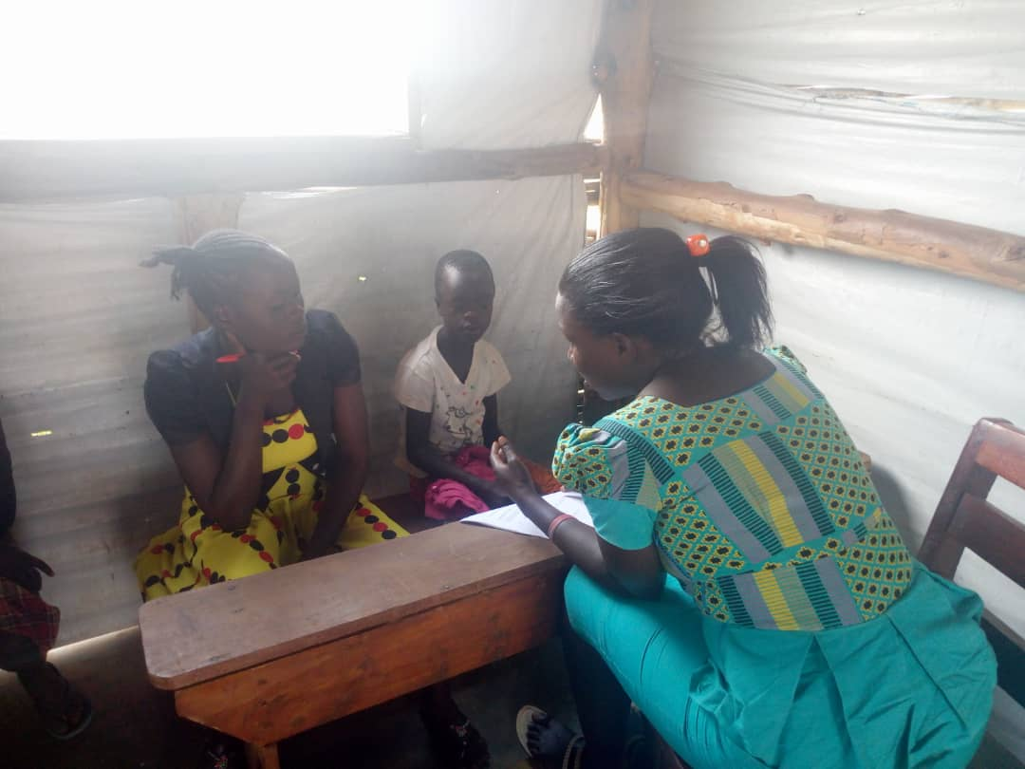  Trained Social Workers having psychosocial session
Awareness creation on support a girl go back to school campaign within the school communities | School girls | This activity is still continuing especially in refugee affected communities in Westnile region. A total of 320 girls have been reached directly through awareness campaigns. This has created and this has led to improvements in attendance of learners while the dropout rates are getting reduced through the joint stakeholder’s involvement in mobilization of children to attend school and complete school.
To provide school fees to identified vulnerable girls | School girls | A total of 22 girls have been successfully paid of their school fees for the third term studies in 4 schools. The payment of tuition will enable girls to complete their end of year examination and graduate to next class level next year.  We have noted that girls whose school fees/tuition has been paid early improve their performance and motivate other girls to stay in school and concentrate.
Provision of scholastic materials | Girls | A total of 280 girls were identified and supported with assorted scholastic materials (Exercise Books, Pens, Pencils, Mathematical sets, rulers and Uniforms) which has enabled them to stay in school peacefully.  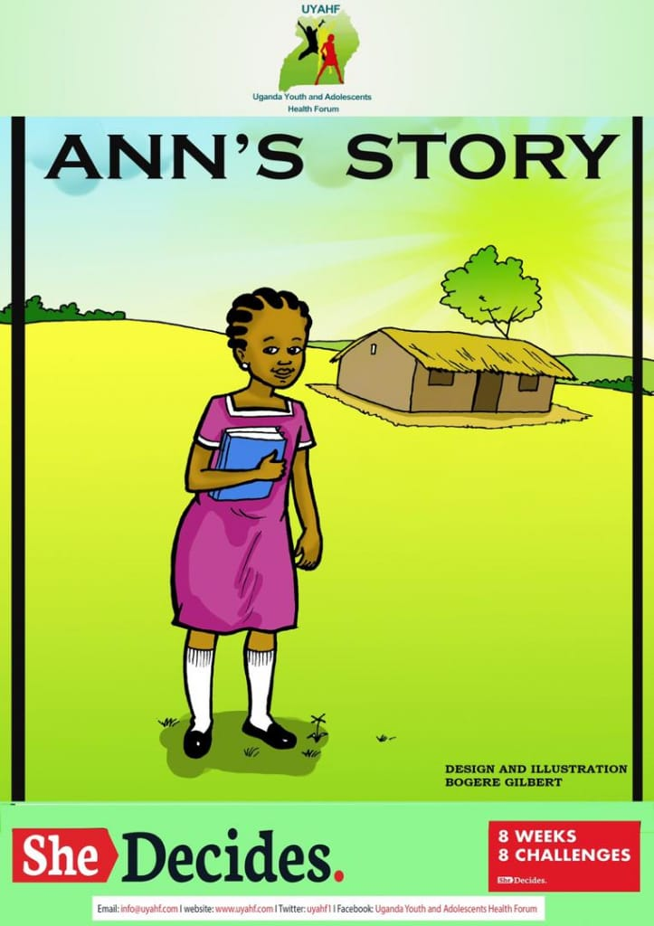  IEC materials used to encourage girls stay in school
3.0. challenges.
- High number of girls that need to be supported to remain in school, despite donor low contribution to the project
4.0. Lessons learnt
- Keeping girls in school help to improve their self-esteem and life skills hence resisting pressure from cultural norms which infringe on girl’s rights especially early marriage leading to drop of school
- There is a huge need for psychosocial support to be provided alongside education programmes in order to ensure that girl children, the majority of whom have been subjected to extremely traumatic experiences, are able to learn again.
- RECOMMENDATION.
APPCO will keep mobilizing to girls to have hope for education, be in school which in turn will affect the entire community through training girls and boys to act as peer leaders about reproductive health, Train on reusable sanitary pads to girls in school and stock girls changing rooms and more so continue holding positive parenting sessions.
Empower girls and increasing rural girl's access to education while reducing their vulnerability to external shocks and can drastically improve their decision making, resist pressure from cultural practices which has eventually provided for their family’s health and economic well-being

