Project: Save Hope of 6,800 Girls drop out of school in Uganda
PROJECT NARRATIVE PROGRESSIVE REPORT
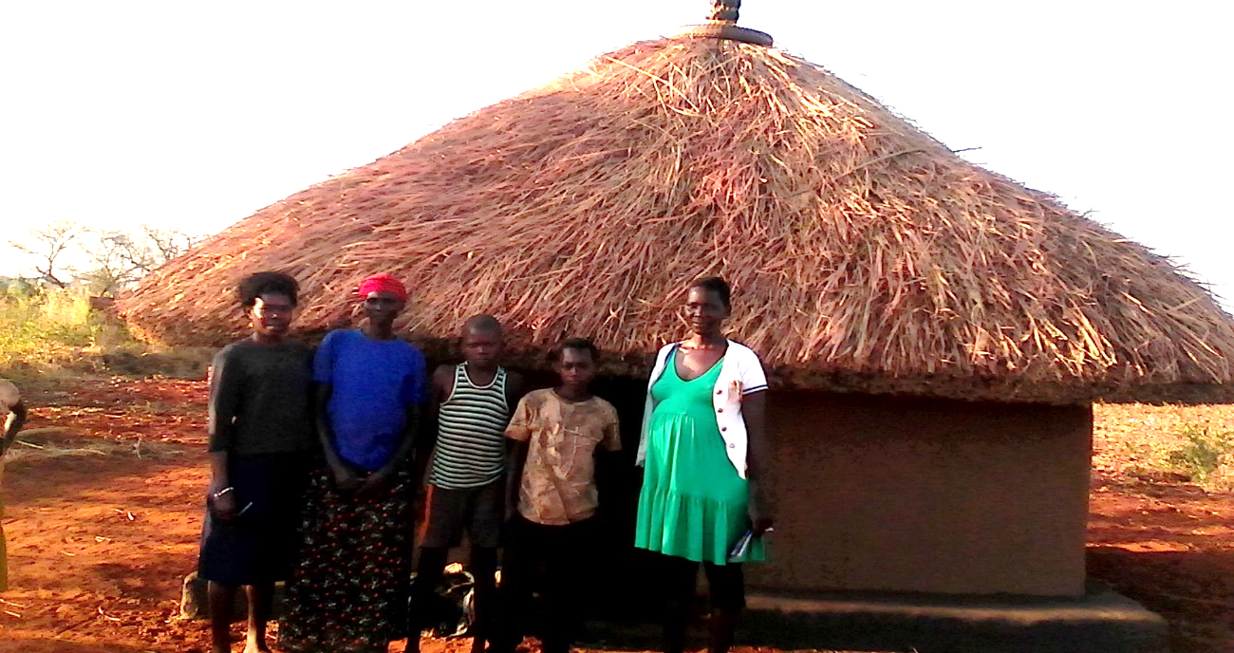
A follow up visit to families of girls supported by the project

1.0. PROJECT SUMMARY:
The project will save 6,800 vulnerable girls from dropping out of school by providing a Package of scholastic materials, Uniforms, school fees and training on sanitary pads making as Menstrual Hygiene and management approach for girl child school retention in Eastern and Northern Uganda. The project targets 24 schools to boost education of girls affected by Poverty, war trauma, and cultural practices including early marriage. 12 boreholes will be drilled in 12 schools and nearby communities.
APPCO empowers girls by providing scholastic materials to boost their education, support rural girls with school fees to resist financial pressures from parents and training on making re-usable sanitary pads as Menstrual Hygiene Management. We will construct girls changing rooms and latrines in rural schools to reduce time spent in walking back home to change during periods. Those rural girls walking long distance will be provided with Bicycles to reduce risks of sexual abuse and training girl Clubs (GEM).
This project is using an integrated and holistic model of interventions that combines strategies to
Provision of psychosocial support aims at working closely support community support structures activities including household economic strengthening, parenting education and Strengthen community-based child protection mechanisms, and mobilize communities to support and monitor children’s wellbeing and parenting skills.
2.0. ACHIEVEMENTS
Action | Target | Achievement
Conducted family group conferencing together with trained girl Mentors | 17 families reached through family conferencing | - With support from APPCO staff, the trained girl mentors were able to conduct a family group conference that drew the clan leader, LCI of the area, elders, relatives, neighbors from the community and the probation officer. A total of 711 (M=36, F=35) people attended the meetings conducted. The meeting was moderated by APPCO staff. This conference was organized to form a network of support to the families of girls supported by the project to facilitate their education and health needs. The families received psychosocial support and parenting Education. The family members pledged to be close to support the children in terms of basic needs at home including love and guidance while the mentors have the role of follow up to offer psychosocial support.  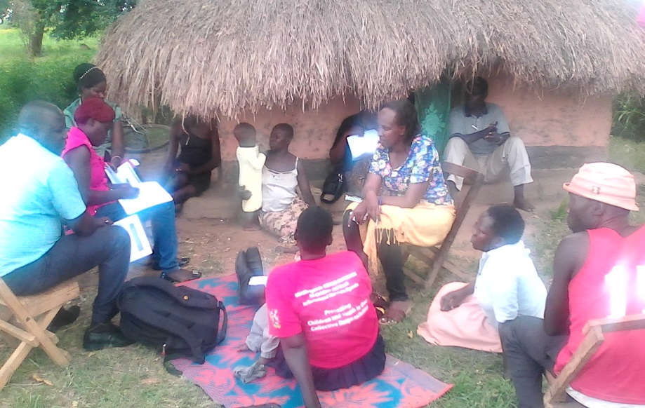  Trained girl mentors participating in the family conferencing activity.
Conducted community awareness assemblies to dialogue on WASH selected issues  and COVID 19 pandemic campaign within the communities | School girls | 24 sanitations clubs were supported to raise WASH awareness in schools and neighboring communities. School clubs raised awareness through games, sports, poems, songs, music, dance and drama. Occasionally sanitation clubs organized a whole school cleaning campaign. During this activity, onlookers and passersby pupils are invited to join or volunteer to support in keeping the school clean. This ensured that pupils gained the mindset that sanitation activities are fun and for everybody which is what awareness campaigns are all about. A strong impact of mindset change is witnessed over the course of the 3 months of the extension as pupils became less resistant and rebellious to cleaning activities.  School clubs also organized sports competitions and debates, inviting other children to attend. The event is started by introducing a specific topic on WASH practices and concluded with more messages on different WASH practices. The fun ensured that children grasped the message better that classroom lecture mode of delivery.  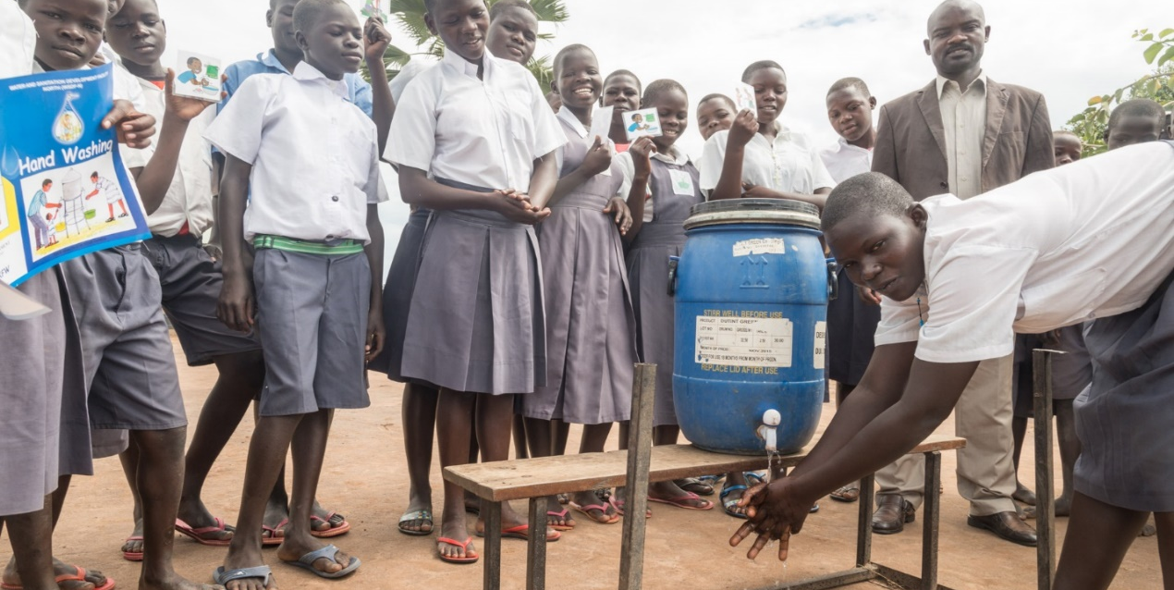  Pupils Practically demonstrate handwashing with soap to their peers within school.
Trained girls on basic Menstrual Hygiene management and making of reusable Pads | 80 Girls in 8 schools. | The girls hope project this reporting period had activities of training girls on menstrual hygiene management and making of reusable pads. This activity for two years did not have sufficient budget to buy materials for making of pads and as a result most schools received only theoretical training. This project extension provided a budget provision to train 80 pupils on practical hands on skills of making re-usable pads for proper menstruation management. Across 8 primary schools 40 pupils (Both boys and girls) made their own reusable pads in practical training sessions with APPCO staff. Menstrual hygiene management remains a crucial challenge in schools leading to school dropouts and poor performance. The outcome of the training is the practical skills gained by the pupils and their patrons/matrons. These skills will give girl child more confidence during their menstrual cycles, reduce school absenteeism, dropouts leading to improved academic performance in schools. Proper MHM will also reduce infections that arise due to poor management of menstruation. Involvement of boys in this training will ensure that they support their female counterparts during these times instead of laughing, mocking and teasing them. This will remove stigma associated with menstruation, giving more confidence to the girl child to be more involved in school activities when they are menstruating.  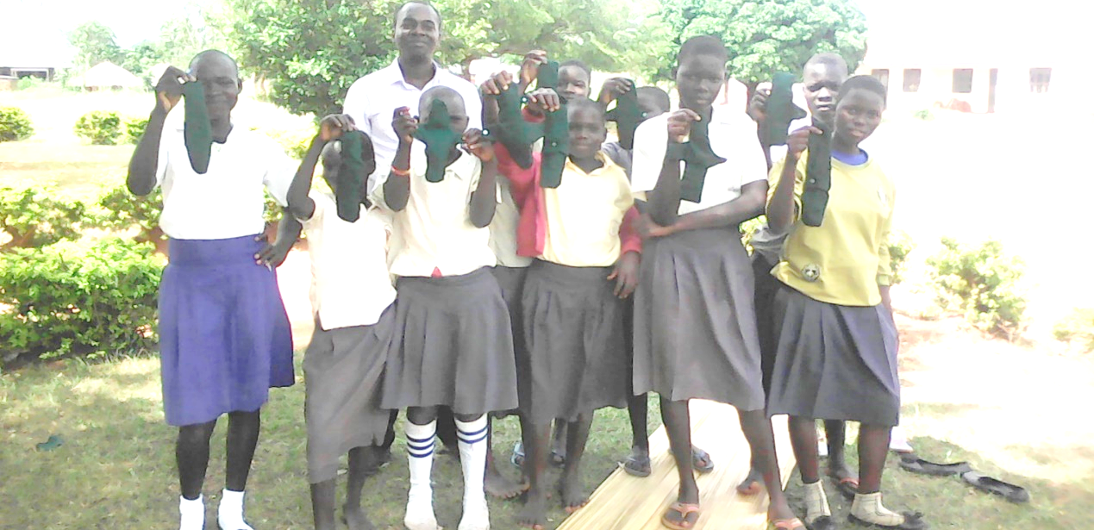  Trained girls show off made re-usable MHM pads
Review meetings with stakeholders to document best practices, communicate progress and closure of schools due to COVID 19 outbreak | SMCs, PTAs, parents, teachers and district education department. | 4 review meetings were conducted to document best practices, communicate progress, closure and possibility of a new phase of the project. During these review meetings, participants (school, district officials, subcounty officials and partners) were asked a number of questions compiled to specifically look for responses that communicate the weaknesses and strengths of the project and its implementation. The meetings were highly participatory and interactive bringing out many issues from members.  During these meetings the following was reported:  - Handwashing behavior has improved among the students.  - After the latrine rehabilitation, latrine usage of the boys improved. They feel now more comfortable to use the latrine because they are kept clean.  - Rehabilitation of facilities would highly improve the general wash practices in the schools.  - Training on Menstrual hygiene management was regarded as a very important training that should be done from time to time  - The school health clubs are working well and pass on WASH messages to others (e.g. during general assemblies).  Some of the suggestions put across during these meetings included:  - Construct girls’ latrines with changing rooms would be ideal.  - Provide more training to the girls and boys on making reusable pads.  - Training of school health clubs needs to be more regular.  - Training of the matrons/patrons has to be more regular.  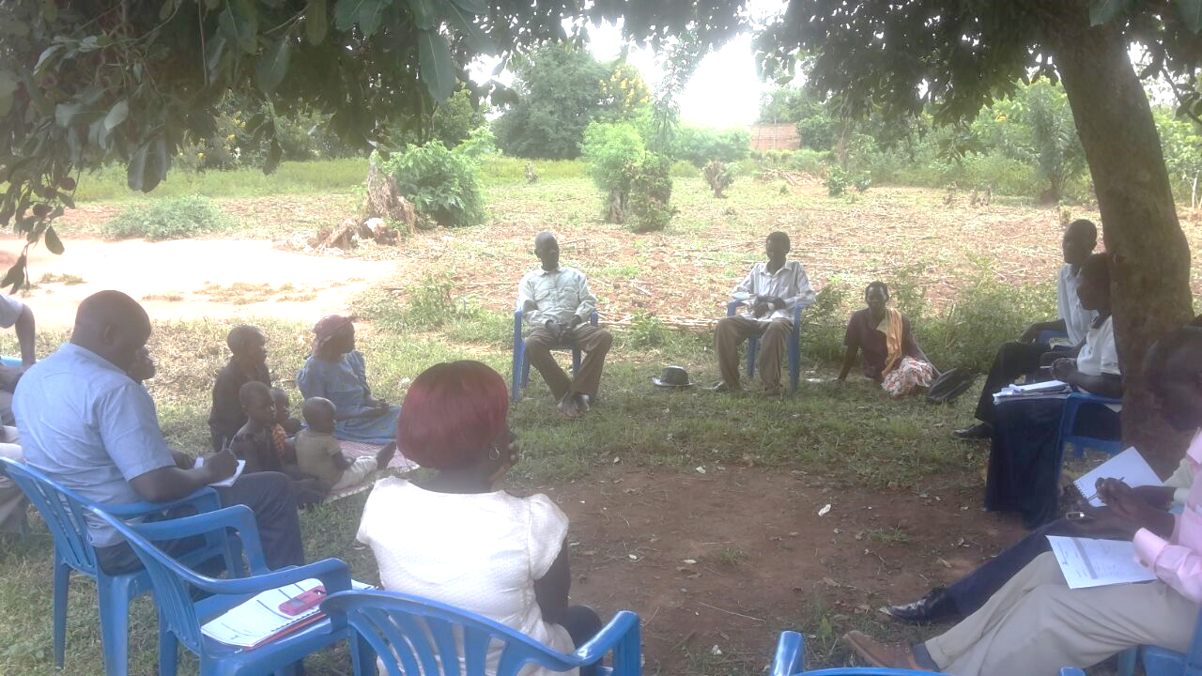  Participants during School and community project review meetings

3.0. CHALLENGES.
- Worries on the outbreak of COVID 19 with anticipated school closures
- Funding support per project respective output areas is minimal this hinders meeting their respective needs. However, APPCO has advocacy and lobbying strategy for the wellbeing of a child.
- Much as the trainings have been conducted with the schools, there is still low prioritization of repair and maintenance of sanitary facilities. This means that the children still lack the enabling environment to practice the WASH knowledge gained through trainings when these facilities get broken down completely.

4.0. LESSONS LEARNT
- Male child involvement in trainings of making reusable pads has helped reduce stigma in girls because they feel the boys are part and parcel of their challenges.
- Community assembly provide a platform for community members to generate their own ideas and small doable actions which are incorporated into their action plans. This is guided by their local leaders and facilitated by the project staffs.
- Involving parents and teachers during discussion of issues that affect children in schools enable them to identify areas of their responsibility and action. This process also allows children to openly express their issues to parents and teachers and for teachers to learn more about how children are treated at home.
- Strengthened referral mechanisms to address this issue of school dropout. With increasing go back to school, handwashing campaigns.
5.0. RECOMMENDATIONS.
- Plan to have community sensitizations on child protection integrated into Menestarl hygiene management and education campaigns.
- Community dialogues to impart parenting knowledge and skills including family conferencing with households should be strengthened.
- Form Psychosocial support groups and parenting groups to support girls and families identified with psychosocial problems and support their families and care takers care and protect them.

Report submitted by
Martin osuwat
Programme coordinator
African partners for child poverty-APPCO

