Introduction and activities held in last 3 month:
This report contains actions and activities that have been implemented in the project target location in the past three months since inception of the project; Save Hope of 6,800 Girls drop out of school in Uganda. The donations from different donors have helped APPCO to conduct vulnerability assessment for girls in 12 primary schools. The schools identified host girls that were born from captivity as a result of sexual violence and abuse by the Lord’s Resistance Army (LRA).
We have successfully held Menstrual Hygiene and Management (MHM) training for 22 girls mentors in the 12 schools identified. I am inspired to support my fellow girls affected by stigma since they can confined in me. Girl mentor said during the training. This training that also attracted 10 mothers as education advocates willing to support their girls stay and complete school.
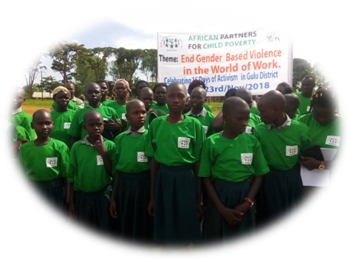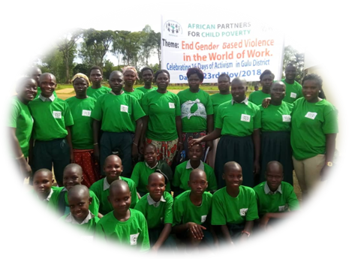
Girl mentors trained and their mothers with hope of change of girls situation in schools.
Through the discussion’s girls were able to articulate a number of issues that affect their education and stay in schools. Some said, Girls who have blood on their clothes are often teased by teachers, boys or other girls scaring them and they end up dropping out of school. Social norms may lead women and girls to feel that menstruation is dirty, shameful or unhealthy. These issues mainly result to girls dropping out of school but because of this project most girls already are hopeful that they can stand stigma through their peers and access to sanitary pads.
Compiled by
Michael Anyeko Enyakoit – Executive Director - APPCO

