PROGRESS NARRATIVE REPORT FOR SAVE 6800 GIRLS EDUCATION PROJECT FOR AUGUST 2025
GLOBAL GIVING PARTNERSHIP
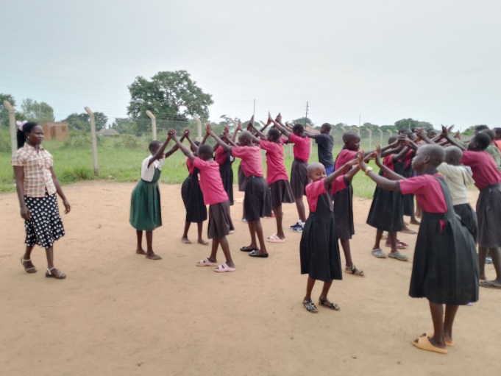

Summary of the project
The project will save 6,800 vulnerable girls from dropping out of school by providing a Package of scholastic materials, Uniforms, school fees and training on sanitary pads making as Menstrual Hygiene and management approach for girl child school retention in Eastern and Northern Uganda. The project targets 24 schools to boost education of girls affected by Poverty, war trauma, and cultural practices including early marriage. This reporting APPCO is conducting parenting education, VSLA trainings, Advocacy campaigns and trainings of teachers and care givers as structures that support education of girls within the targeted schools
Progress Activities implemented
Activity 1.0: To conduct Sexual Reproductive Health and Rights Advocacy Campaigns
APPCO played a lead role in organizing SRHR advocacy initiatives that brought together different stakeholders, raised awareness and empowered adolescent girls and boys to become drivers of their own advocacy. These initiatives included; SRHR awareness campaigns that empowered adolescent advocates, dialogues on gender and social norm change which prompted a total of 215(125m, the stakeholders to rethink and support positive social change that challenged harmful social norms and thus increasing the uptake of SRHR services by adolescent girls and boys. The Girl’s Parliament Forums were also APPCO’s initiative to promote SRHR advocacy for adolescent girls and young women out of school. In these forums, the girls had direct interface discussions tabling their issues to the relevant stakeholders herein referring to the government officials who have the mandate for implementation of national policies, with some influence too, because of this, the girls were allocated time in the local radio stations where they now participate in radio talk shows along with local leaders advocating for the protection of their rights as adolescents and increased access to SRHR services for adolescents.
APPCO created relevant networks with different stakeholders and development partners at the district and sub county level and this made the duty bearers to take up their role in the promotion and protection of SRH rights for adolescents. For girls in school, APPCO staff worked along with teachers (school club patrons) and the club members. specifically with the debating clubs, child rights clubs, health clubs and the Girl Equity movement to spearhead advocacy initiatives in schools through awareness creation and empowerment, the debating clubs organized school debates with topics on SRHR, GBV and MHM. Through this, adolescents were able to highlight the issues affecting them, participate in decision making and advocate for improvement in provision of SRHR services and facilities in schools as well as push for the promotion and realization of their SRH rights.
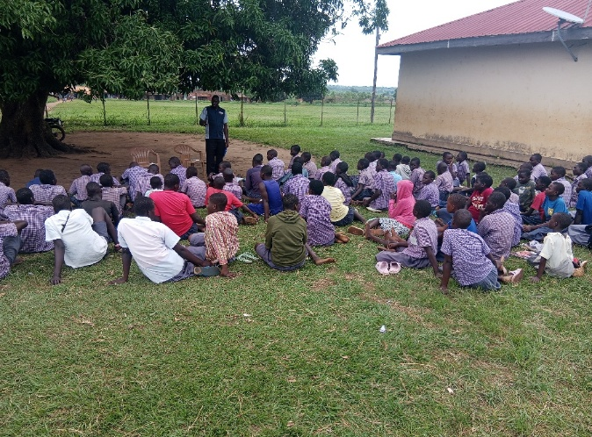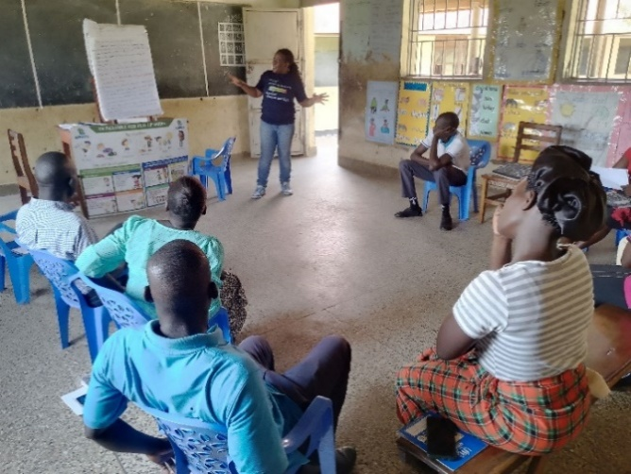
SCHOOL CLUB SESSIONS FOR ADOLSCENTS GIRLS IN AND OUT OF SCHOOL
APPCO built capacity of staff and community structures including Y-CBTs, Peer educators/mentors, teachers, health workers and VHTs, religious leaders among others to effectively implement project activities. Capacity Building Training for Teachers, Caregivers, CMCs, and SMCs on the APPCO Play-Up Model for Play-Based Learning. The training aimed to strengthen the capacity of community formal and informal structures to acquire knowledge and practical skills for fostering children’s development through play. The training emphasized supporting children’s cognitive (interpretation, attention, memory, learning, problem-solving, decision-making), emotional, physical, and social growth. The activity was conducted in nine (9) schools of Unity, Dicwinyi, Likiliki, Gem Medde, Kapeeta, Padwat, Gem, Labworoyeng ECD / P/S and St. Andrews ECD
Activity 2.0 Training of adolescent girls and boys on safe spaces VSLA methodology
This is enhancing opportunities for income generation and micro-enterprise development for adolescent girls through inclusive business and financial digitization. This reporting month of June 2025, we have been focusing on training VSLA group members on financial literacy and entrepreneurship training aimed at equipping 137(119f,19m) VSLA members with the knowledge, skills and confidence to manage their finances effectively, make informed decisions and improve their economic well-being. APPCO staff delivered topics like budgeting and saving, credit and debt management and we used methods like presentations, group discussions, practical budget exercise among others and by the end of the training. 85% of the adolescent girls demonstrated improved understanding of budgeting and savings principles, many committed to revising their saving goals and creating individual budgets and feedback indicated strong interest in continued training on entrepreneurship and business planning however varying literacy levels among participants required more time for explanation.
In conclusion adolescents girls and boys are are eager to save and borrow money, the financial literacy training was a success with active participation and positive feedback from VSLA members and continued education will be essential in empowering individuals to make sound financial decisions and strengthen the impact of VSLA in the community to meet school based needs.
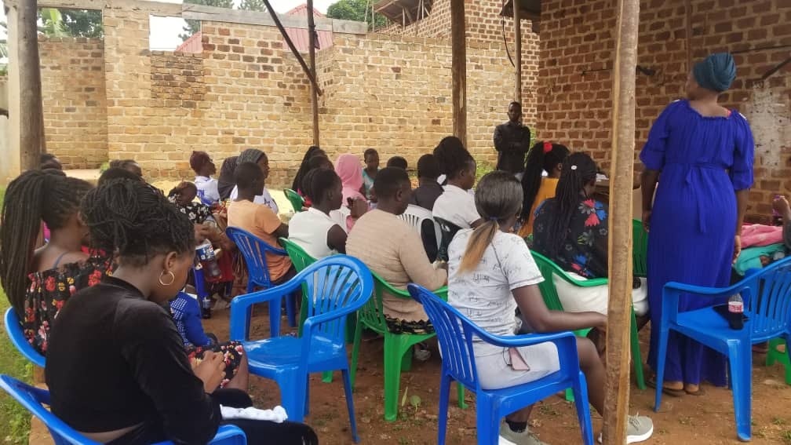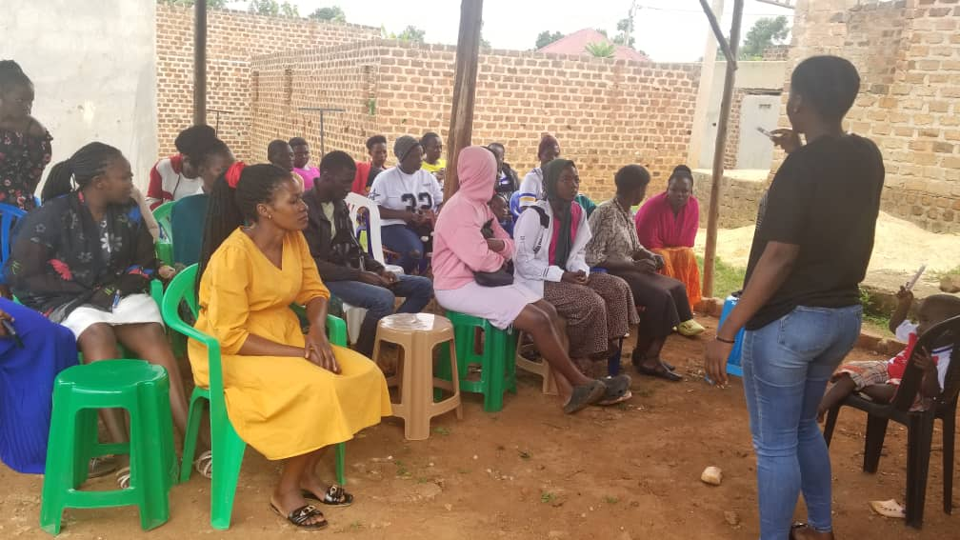
Training of adolescent girls on VSLA Methodology

Activity 3.0: conduct girls parliamentary forums in schools and community.

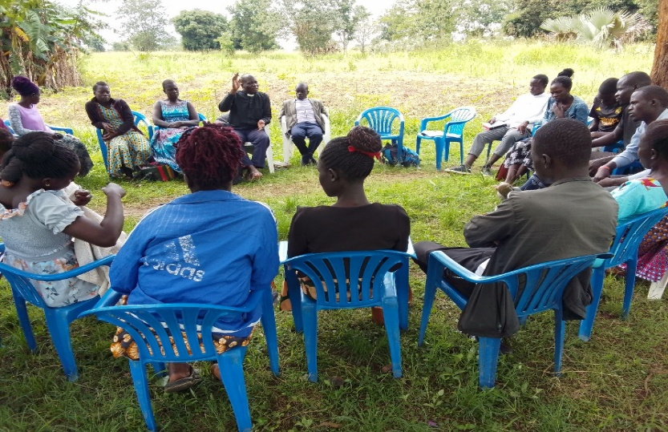
This activity entailed adolescents’ engagement in Girls’ Parliament Forums (GPFs) to deliberate on key advocacy issues, it took place in one group out of school. The GPF as a model provided a framework for engaging adolescent girls and young women in decision making processes and foster the empowerment of the girls to voice their concerns and also be a voice for their peers, develop plans for collective action to challenge harmful norms, SRHR concerns and GBV related issues. It also enhanced networks with community leaders, government and partner organizations to promote and realize their SRH rights, prevent and respond to GBV issues affecting them and other vulnerable girls in the wider community. The girls invited the local leaders that included the CDO, LCs and youth leaders to be part of the sessions purposely to lease get the 20krespond to issues deliberated as well pledge their commitment as duty bearers. The stakeholders pledged to join the girls in their efforts to end GBV and teenage pregnancies, according to the CDO, Atiaba parish where the GPF is located has the highest rates of teenage pregnancies; therefore, the initiative to have the GPF in that particular parish will help reduce it, he also added that the concerns raised in the GPFs will be included as priority areas in the sub county plans.
GIRLS DISCUSSION IN A PARLIAMENTARY FORUM ON SRHR ISSUES
Table showing participant attendance
S/No | Location | Activity date | Participants | M | F | Total
 | Panykworo (Dero Wa YG) |  | Adolescents | 00 | 34 | 34
TOTAL |  |  |  | 00 | 34 | 34

Activity 4.0: to conduct safe spaces play up sessions with adolescents in schools
This activity targeted adolescents in and out of school, it was done in one school and three groups out of school applying the play up models that enabled the adolescents reinforce and strengthen the knowledge and skills they acquired from the SRHR awareness sessions and apply them in their lives fostering behavior change and healthy relationships, adopt positive stress relief mechanisms that do not perpetuate GBV as well as reduce SRH related risks. The mentorship sessions empowered the adolescents through guidance and support as they navigate the challenges of relationships and reproductive health in their day-to-day life and be able to make decisions regarding their SRH rights. It created a safe and supportive environment for adolescents to feel comfortable discussing their SRHR concerns and experiences. The play sessions not only helped the adolescents build social connections but also fostered their coping skills, adaptability and resilience to SRHR and GBV related experiences. The sessions also gave room for the girls to monitor and track the progress of the individual action plans earlier made by the adolescents and guided them accordingly.
Table showing participant attendance
S/No | Location |  | Participants | M | F | Total
 | Lalweny YG |  | Adolescents | 10 | 07 | 17
 | Wanenu Anyim |  | Adolescents | 00 | 10 | 10
 | Loktek YG |  | Adolescents | 00 | 15 | 15
 | Tel-Ladwong P/S |  | Adolescents | 58 | 29 | 87
TOTAL |  |  |  | 68 | 61 | 129

Activity 5.0: conduct psychosocial support sessions with school structures.
In collaboration with caregivers and teachers, staff facilitated psychosocial support session for marginalized children in Likiliki P/S. These sessions included a variety of engaging activities such as group games, music, dance and drama. These child-friendly and inclusive activities were designed to promote emotional expression, social interaction, and physical development. These activities were plan and aligned with the learning objectives and therefore teachers facilitated play, provided guidance and support as needed.

During the sessions the teachers ensured that the environment was safe and inclusive which promoted respect and empathy among the learners. This kind of environment therefore facilitated physical activity, gross motor skills and overall health. This was done with interest and love for what they were engaged in. During music dance and drama, the session encouraged creativity, imagination and problem-solving skills for instance at the time they were using the xylophone, African thumb piano and African harp.
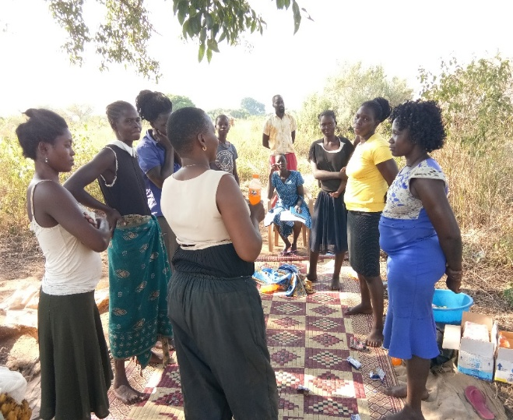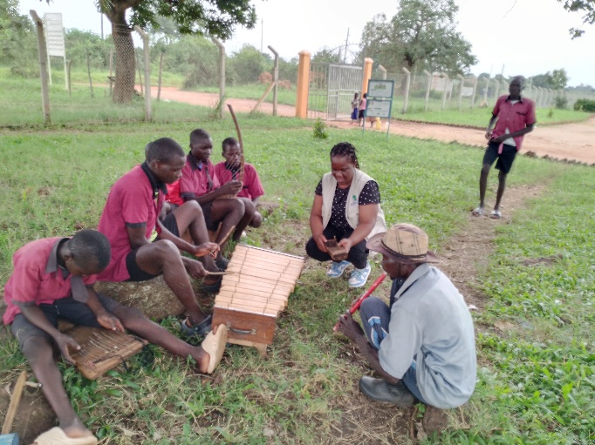
Adolescents and their teachers in school and community on play up as means to reduce school drop out rate

ACTIVITY 6.0: Conduct capacity building on play up methodology
The training on play-up model was conducted to explore the benefits and application of play during learning (play based learning strategies) and how play promotes mental wellbeing in children which was done using role plays to promote emotional release and self-expression.
The training on play-up model was conducted to explore the benefits and application of play during learning (play based learning strategies) and how play promotes mental wellbeing in children which was done using role plays to promote emotional release and self-expression.
Key Issues Raised by Schools:
- Some classroom environments are designed to encourage play, exploration and creativity for instance some classes have pictures of different types of animals, shapes, maps and body parts which encourage learning.
- Requested for continuous refresher trainings so as to reinforce previously learned concepts and techniques which will boost confidence in suing play up model.
- There is need to provide schools with play materials to support play which help teachers to create engaging and interactive lessons and this provides opportunities in assessing pupil learning and development. Play materials foster creativity, imagination and problem solving which encourages social interaction, cooperation and communication and this caters for different learning styles and ability.
- Children are able to make play materials using locally available materials like ropes, pots, motor and piston this therefore triggers imagination and creativity among learners. Though some play materials have a cost implication attached to it like timber and car tyres.
- There is need for Livelihood support because children need food so as to play. Livelihood support increases access to play opportunities which promotes healthy development and wellbeing.
- Care givers and teachers observe children’s play and facilitate when necessary, proving guidance and support while allowing children to learn and explore. Therefore, children take lead in play, making choices and decisions about their activities.
- Teachers and care givers always provide open ended materials such as clay, sticks and stones for a child to be in control of an activity and make what they want which encourages creativity and imagination.
- Due to reduced funding some caregivers and teachers who were trained on play lost their jobs because there was no other organization to pay their salaries.
- Table showing schools reached for the training on the play up model
NO. | Name of school | Date reached | Male | Female | Total
1 | Unity ECD / PS | 3rd / 7 / 2025 | 04 | 05 | 09
2 | Dicwinyi ECD / PS | 7th / 7 / 2025 | 02 | 07 | 09
3 | Gem Medde ECD / PS | 8th / 7 / 2025 | 04 | 05 | 09
4 | Likiliki ECD /PS | 8th / 7 / 2025 | 03 | 06 | 09
5 | Kapeta ECD / PS | 9th / 7 / 2025 | 03 | 06 | 09
6 | Padwat ECD / PS | 10th / 7 / 2025 | 06 | 03 | 09
7 | Gem ECD / PS | 14th / 7 / 2025 | 03 | 06 | 09
8 | St. Andrews ECD | 15th / 7 / 2025 | 01 | 03 | 04
9 | Labworoyeng ECD / PS | 16th / 7 / 2025 | 05 | 04 | 09
TOTAL |  |  | 31 | 45 | 76

- Conclusion:
- The training concluded with the powerful slogan: “When children play, they learn.”
- The training on play-up model was informative and engaging that is to say participants gained valuable insights and practical strategies for incorporating play into teaching.
Report compiled by
Martin Osuwat
APPCO

