PROGRESS NARRATIVE REPORT FOR SAVE 6800 GIRLS EDUCATION PROJECT FOR AUGUST 2026
GLOBAL GIVING PARTNERSHIP
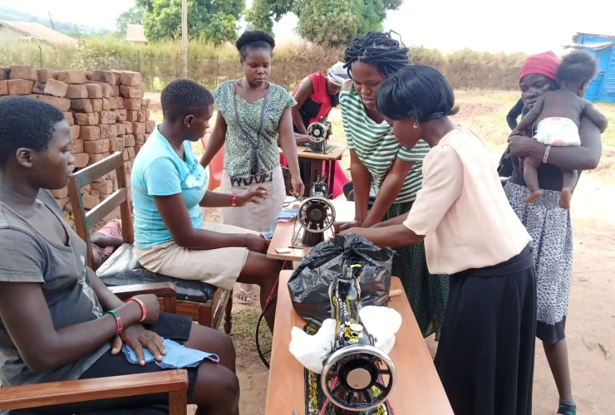

Summary of the project
APPCO Girls empowerment projects in Uganda focus on education, menstrual health, life skills, and economic self-reliance to protect vulnerable youth from early marriage and poverty. In this reporting quarter, APPCO put emphasis on this program to train adolescent girls ages 12 to 15 in central Uganda on life skills, self-esteem, and disease prevention including vocational skilling.
Through peer-to-peer initiative led by Girl mentors/champions they work to address menstrual hygiene, mental health, and gender-based violence for thousands of young women especially those affected by conflict, poverty and early marriages and pregnancies. On the same note, they are supported to produce affordable reusable menstrual kits and providing startup support to ensure safe lives and improved wellbeing.
As we celebrated the International Women’s Day in March 8th 2026, APPCO took it as crucial to recognize that ensuring women have access to basic needs is more than a matter of fairness but it’s a vital step toward societal progress. When women have access to food, shelter, healthcare, and education, they gain the foundation they need to thrive. Supporting women strengthens families, boosts economies, and enhances communities worldwide. Therefore, training girls on vocational skills and life skills ensure women have access to economic assets and improved livelihoods including increasing their access to education.

Health and Safety: A woman’s ability to maintain her health and safety is essential for her personal development and the well-being of her family and community. Lack of access to food, shelter, and healthcare places women at increased risk of malnutrition, chronic diseases, and vulnerability to violence especially Gender Based Violence (GBV).

Safe Shelter is Essential: Homelessness and unstable housing situations place women at higher risk of abuse and exploitation. A lack of safe housing can prevent women from seeking employment, attending school, or raising their children in a secure environment. APPCO ensures community support for girl child to access local housing.

Education: Educated women and girls earn higher wages, have healthier families, and break the cycle of poverty. Yet, many girls still lack access to education due to financial constraints or a lack of resources. APPCO provides girls with opportunities to education at all levels, primary education, secondary education, skilling for employment and income generation including accelerated education programs for those who have issed.

Report compiled by
Michael Anyeko Enyakoit
Executive Director - APPCO

