PROGRESS NARRATIVE REPORT FOR SAVE 6800 GIRLS EDUCATION PROJECT FOR April 2026
GLOBAL GIVING PARTNERSHIP
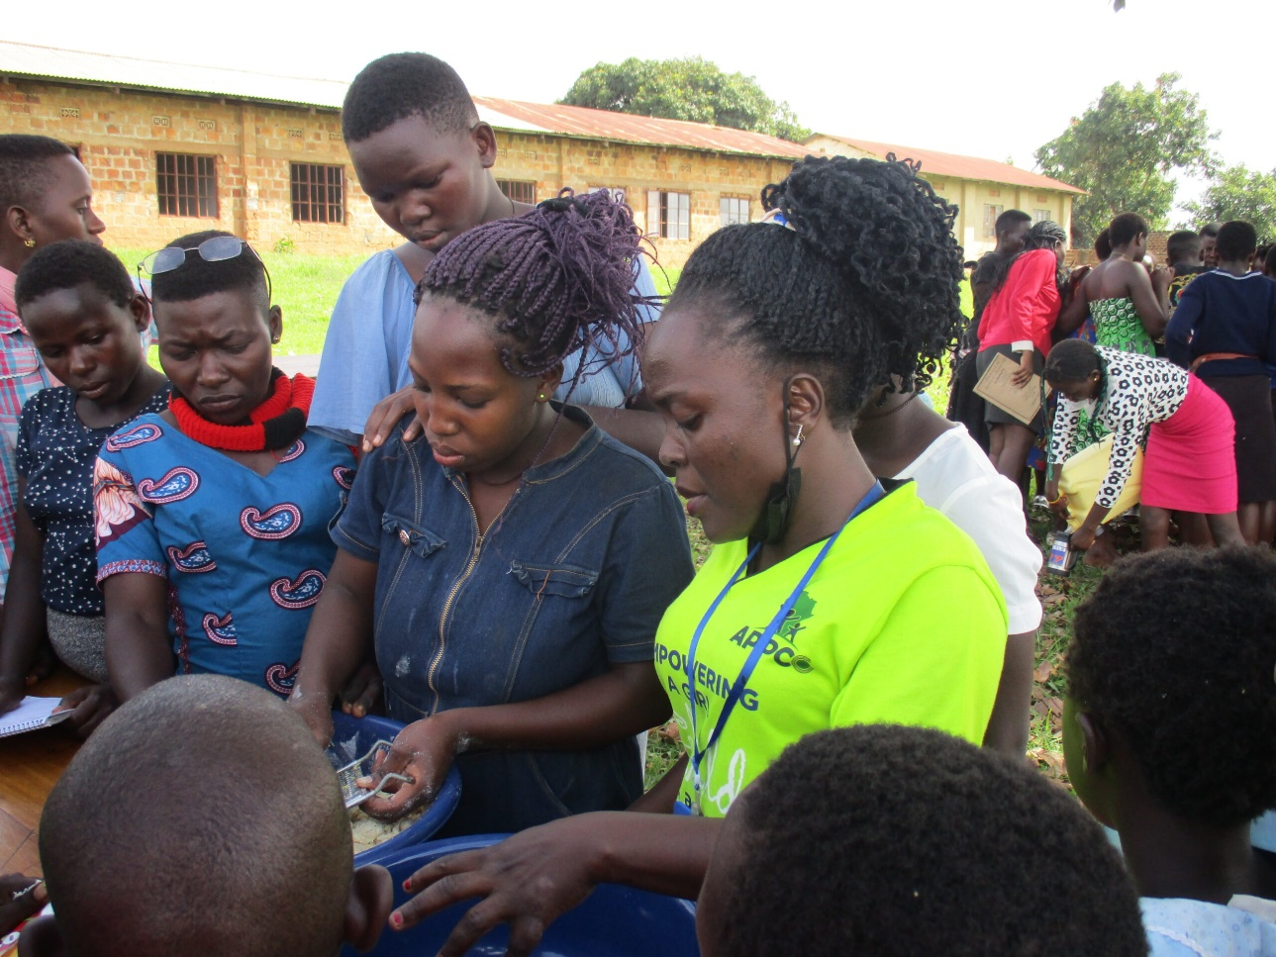

Summary of the project
This quarter report outlines key activities that APPCO field team performed with vulnerable girls focusing on empowerment, education, and physical well-being. Effective initiatives include girls' clubs to combat social isolation, sports, and digital literacy training. Key goals include addressing gender inequalities, improving retention in school, and providing safe spaces for development.
The Empowering the Girls Boot camp is an advocacy campaign carried out by APPCO towards gender equality and protection of the girls’ rights in target communities in Northern Uganda. The boot camp subjected 154 girls residing in Gulu, Amuru and Lamwo districts to an intensive training in life and business skills with the goal of awakening their potential to take active roles in advocating for their inherent rights subsequently improving their livelihoods and the developing their communities.
Key Focus Areas for Girls' Activities
- Girls Clubs and Empowerment: Designed to address gender norms that restrict movement and limit education, these clubs provide a safe environment for social interaction, fostering confidence and reducing isolation among vulnerable girls in both in and out school.
- Sports and Physical Activities: Programs such as the "Girls Active" initiative promoted through APPCO PLAY-UP methodology encourages leadership, with girls participating in coaching and refereeing.
- Digital literacy skills: Training programs aimed at closing the "digital divide" to enable safe, effective online access for learning especially with girls in school.
- Health and safety improvement: Initiatives like the "Teachers' Action for Girls" focus on providing sanitary supplies and improving school sanitation to improve retention, supported by documentation from UNGEI.
- Safety and protection: Setting up safe spaces for girls, particularly in areas where they are vulnerable to exploitation, as identified in reports from
Empowering the girls Boot camp was mainly focused on capacity building and mindset change through business and life skills training, keeping in mind that programmes combining income generation and life skills training are the most effective in helping adolescent girls succeed in most aspect of life.
The project team enrolled 154 girls aged 18 years and below in to a boot camp training at Gulu, Amuru and Lamwo districts including refugee settlement in Lamwo. The boot camp created a platform for constructive dialogues, group dynamics, mentoring and coaching, in human rights awareness, education, entrepreneurship skills, financial empowerment through women's rights training. This was meant to empower the girls by giving them a voice and power to disengage from the predicaments they are facing in society.
Entrepreneurship training: The Empowering the girls campaign made a comprehension that without equal educational and economic opportunities, girls will never fully realize their potential. In this regard, the boot camp equipped the beneficiaries with practical skills in making paper bags and black books. With these skills, the girls were empowered with the requisite skills and knowledge that they will aptly employ to establish small enterprises that will rescue them from the economic reliance on men for survival ultimately escaping the cycle of extreme poverty.
Menstrual hygiene management: The boot camp educated that girls that Menstrual hygiene is fundamental to the dignity and wellbeing of women and girls and an important part of the basic hygiene, sanitation and reproductive health services to which every woman and girl has a right. The boot camp discussed the many challenges that the girls are facing regarding menstrual hygiene while at school and home and collectively brainstormed ideas that would offer redress to the same challenges.
Impact:
On economic margins, the empowering the girl’s campaign raised the likelihood that girls will engage in income generating activities by starting up small enterprises in line with the business practical skills they were armed with. This in the long run will guarantee self-reliance for the basic social and health needs that otherwise would have been provided by spiteful men with ill intentions. On health-related margins, the girls realized the invaluable importance of abstinence, self-confidence, respect and the combination of other life skills. This will significantly reduce the probability of early pregnancies and the associated demerits while at the same time protect the girls against the vicious STDs and STIs that might claim their lives in their infancy.

Report compiled by
Michael Anyeko Enyakoit
Executive Director - APPCO

