GIRLS HOPE EDUCATION PROJECT REPORT 2024

Progress Report Jan – March 2024:
APPCO Big Sisters Network:
Our Big Sisters Network ensures that Adolescent Girls Program alumni continue to access girl-friendly education and stay involved and engaged after they have graduated from the year-long training program. The network offers the space and support for emerging girl leaders to continue to develop their self-confidence and positively transform their lives and communities through knowledge, leadership, mentorship, and skills building.
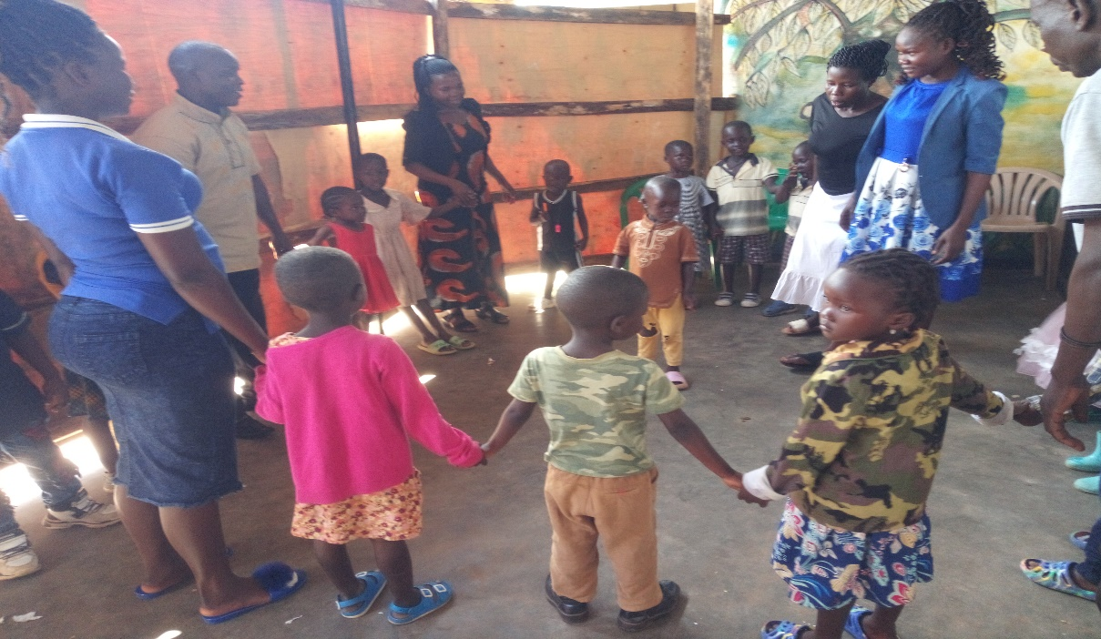

Big Sister Camp - APPCO
In this reporting period, APPCO supported the Big Sister Camp as pilot as a residential camp for 210 Big Sisters, ages 10-16, with funding from Global Giving donations. This immersive four-day overnight camp for adolescent girls comprised of various sessions in leadership, team-building, sexual and reproductive health, creative arts, mindfulness and yoga, basic first-aid trainings, and so much more.
APPCO Adolescent Girls Program
Our Adolescent Girls Program, our flagship program, is an in-school program that focuses on building adolescent girls’ capacities for individual empowerment and social flourishment, especially in patriarchal environments that do not value and respect the rights of girls and women. APPCO using our Girl model tackles gender inequalities head-on to ensure that women and girls become advocates for their human rights and build their self-esteem, autonomy, and self-worth.
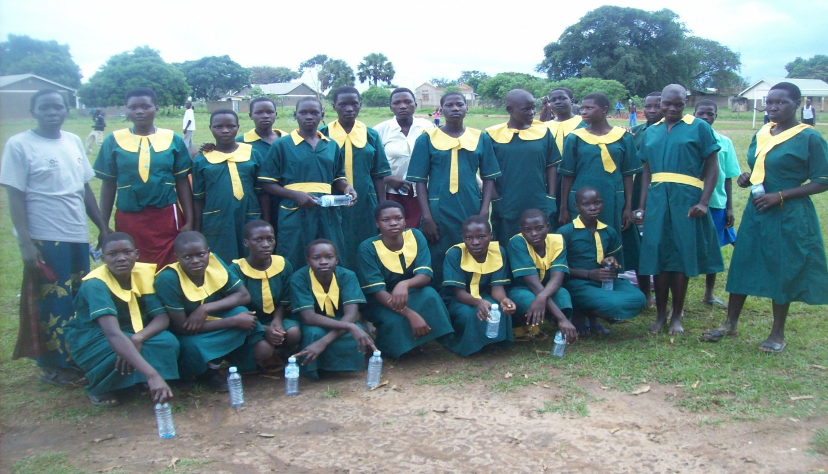

Report submitted by

Michael Anyeko Enyakoit
Executive Director

