GIRLS HOPE EDUCATION PROJECT REPORT
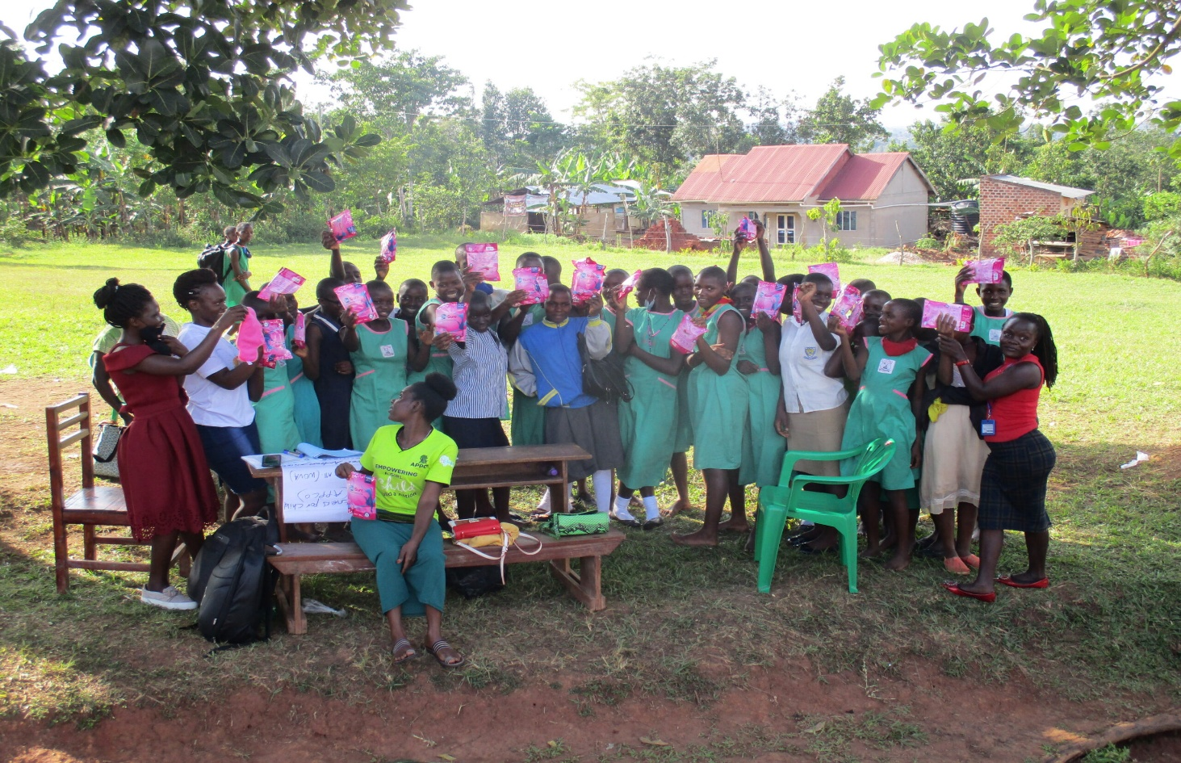

APPCO remains committed to ensuring that every girl has the resources and support she needs to thrive in her education. In a recent initiative, we successfully distributed sanitary pads and school supplies to vulnerable girls, empowering them to stay in school with confidence and dignity.
Menstruation should never be a barrier to education. Yet, for many girls, the lack of access to sanitary products leads to absenteeism and, in some cases, dropping out of school altogether. By addressing this challenge, APPCO in Uganda is breaking down barriers and fostering a future where no girl has to miss school due to her period.
This initiative goes beyond just providing materials; it is about creating awareness, fostering open conversations, and advocating for long-term solutions to menstrual health and hygiene challenges. Through collaboration with stakeholders, educators, and communities, we aim to ensure sustainable support for girls’ education and well-being.
Supporting girls with sanitary pads involves providing access to products through local initiatives and organizations, which also includes essential menstrual health education and the creation of safe, private facilities. Our focus on reusable pads made locally to ensure sustainability and affordability, and on tackling the stigma and lack of information surrounding menstruation. Donations to organizations like APPCO can help fund these programs in a more sustainable manner.
Support local initiatives: APPCO takes interest to innovate for and support girl’s grassroots efforts that produce and distribute pads locally, like the one in Yumbe, Uganda under APPCO innovative hub.
Provide reusable pads: Through the donations from Global Giving, APPCO has supported the production of reusable pads through girl’s groups trained, which are more sustainable and environmentally friendly.
Fund educational programs: Donations have also supported APPCO initiatives of providing educational materials like books, uniforms, school bags and workshops on menstrual health and hygiene.
Advocate for better facilities: We have supported programs that help build private latrines for girls in schools, ensuring they have a clean and safe space to manage their periods.
Amplify the conversation: Help break down the stigma surrounding menstruation by supporting initiatives that promote open and honest conversations about it
Followed YVSLA savings groups and conducted SRHRH awareness sessions in Kalturu group Nywal Con Lit group, and Payibi villages groups of Together we can group and Can miyo diro groups.
Monitoring of the saving groups in Pabbo town council Nywal con lit, together we can and Can miyo diro groups in Pacilo west village and Agoro village.

Together, we can make a lasting impact. Let’s continue supporting and uplifting young girls, ensuring that they have every opportunity to succeed in their academic journey and beyond.

Compiled by
Michael Anyeko Enyakoit
Executive Director
Email: Michael_Anyeko@appcoug.org

