**GIRLS HOPE EDUCATION PROJECT REPORT**

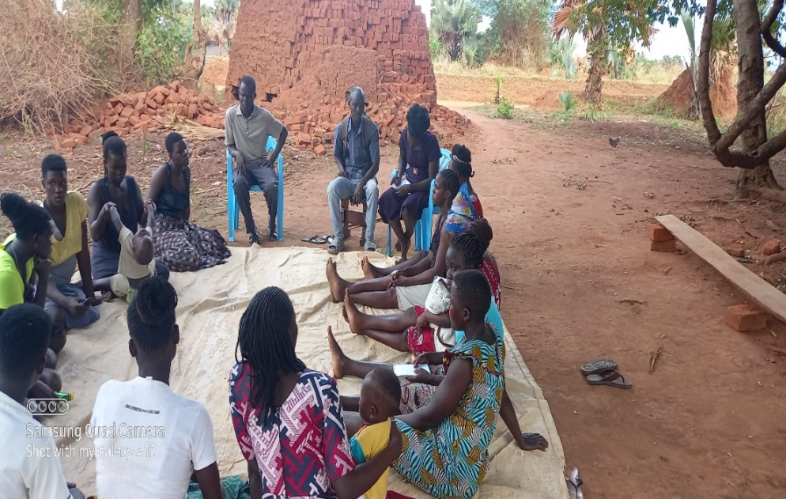 This activity was conducted with adolescents in two (2) schools and one (1) group out of school. With the CSE model, SRHR knowledge was provided to adolescents to increase access to services, empower them develop life skills and make decisions regarding their SRH rights.

The topics handled included; puberty, adolescence and its related vulnerabilities, skills required to deal with vulnerabilities, behaviour change and action planning. The sessions were participatory and enabled the adolescents to develop the life skills that enhanced their ability to come up with action plans to resist the pressures of puberty and adolescence, adopt healthy behaviours as well as reduce SRHR related risks such as teenage pregnancies leading them to drop out of school, infections among others.

The sessions also enabled the adolescents develop help seeking attitudes and behaviours. The action plans they developed will be monitored during the follow-up and mentorship sessions.

**Table showing participant attendance**

|  |  |  |  |  |  |
| --- | --- | --- | --- | --- | --- |
| **S/No.** | **Location** | **Participants** | **Male** | **Female** | **Total** |
|  | Pawel-Angany P/S | Adolescents | 22 | 29 | 51 |
|  | Bungatira Central P/S | Adolescents | 68 | 119 | 187 |
|  | Lubanga Aye Yero YG | Adolescents | 10 | 19 | 29 |
|  | Oru Kitam YG | Adolescents | 06 | 16 | 22 |
| **TOTAL** | | | **106** | **183** | **289** |

This activity targets adolescents in and out of school, it was done with adolescents in one group out of school applying the CSE model that enabled the adolescents reinforce and strengthen the knowledge and skills they acquired from the SRHR awareness sessions and apply them in their lives fostering behaviour change and healthy relationships.

The mentorship session empowered the adolescents through guidance and support as they navigate the challenges of relationships and reproductive health in their day-to-day life and be able to make decisions regarding their SRH rights.

Along with creating a safe and supportive environment for adolescents to feel comfortable discussing their SRHR concerns and experiences, the session also gave room for the YCBTs to monitor their progress especially the individual action plans they earlier made and guided them accordingly.

**Table showing participant attendance**

|  |  |  |  |  |  |
| --- | --- | --- | --- | --- | --- |
| **S/No.** | **Location** | **Participants** | **Male** | **Female** | **Total** |
|  | Patalira (Lubanga Mamiyo YG) | Adolescents | 00 | 17 | 17 |
| **TOTAL** | | | **00** | **17** | **17** |

