GIRLS HOPE EDUCATION PROJECT REPORT

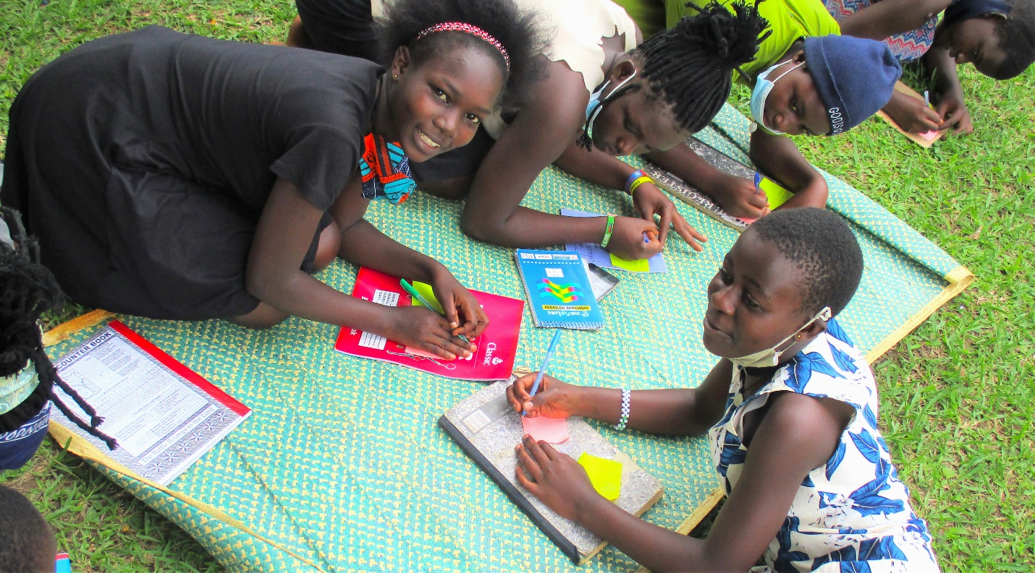The project will save 6,800 vulnerable girls from dropping out of school by providing a Package of scholastic materials, Uniforms, school fees and training on sanitary pads making as Menstrual Hygiene and management approach for girl child school retention in Eastern and Northern Uganda. The project targets 24 schools to boost education of girls affected by Poverty, war trauma, and cultural practices including early marriage. 12 boreholes will be drilled in 12 schools and nearby communities.
APPCO this period managed to train 30 girls on different MHM topical areas. Through the discussion’s girls were able to have an understanding that
Girls who have blood on their clothes are often teased by teachers, boys or other girls.
• Social norms may lead women and girls to feel that menstruation is dirty, shameful or unhealthy.
• APPCO procured and distributed to 3 schools an assortment of hygiene sanitary materials like pads, pampers for babies, and liquid soap. It was observed that attendance of girls during menstrual period has improved. 1,84 girls have been supported through MHM activities.
A total of 100 girl (70f, 30f) have been reached directly through awareness campaigns. This has created and this has led to improvements in attendance of learners while the dropout rates are getting reduced through the joint stakeholder’s involvement in mobilization of children to attend school and complete school.
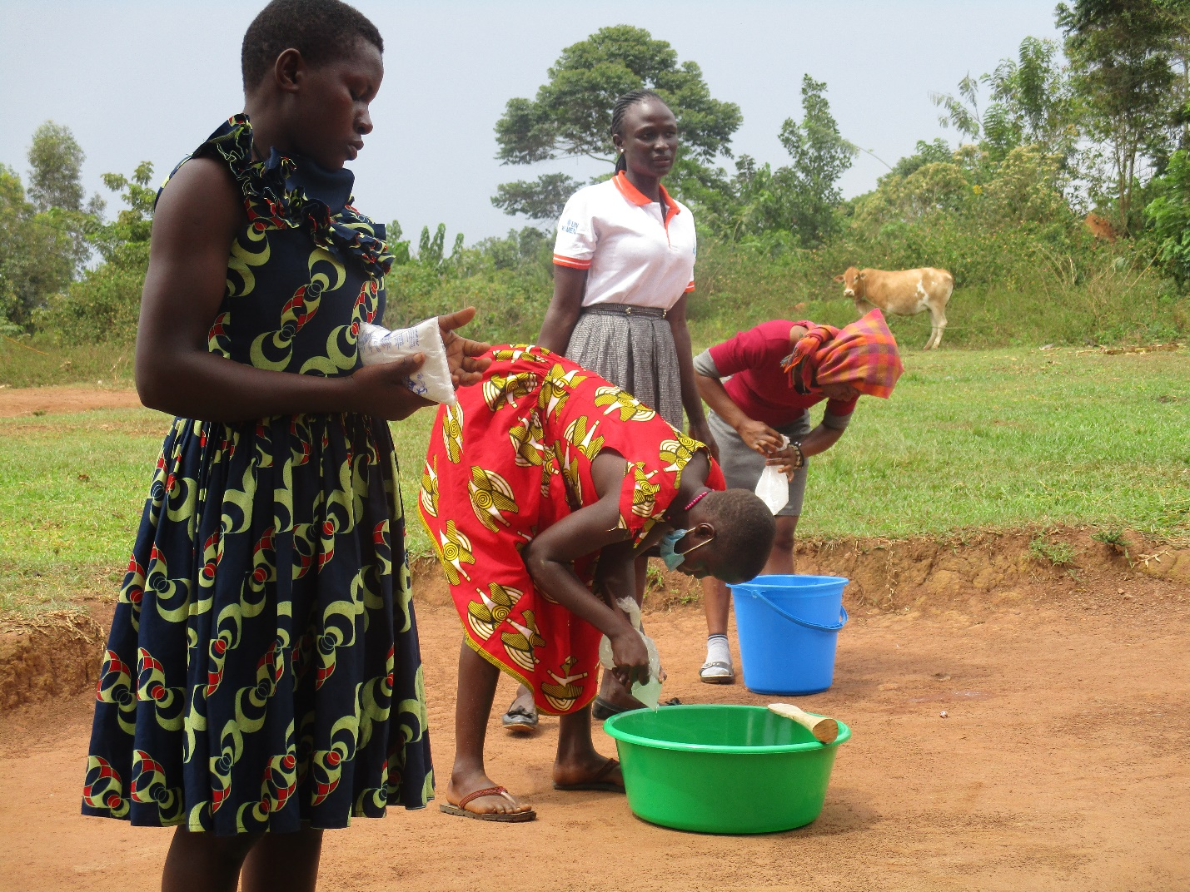
Girls supported in making liquid soap during COVID-19
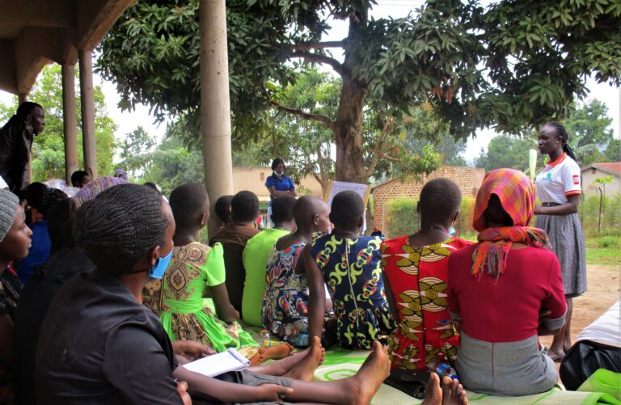
Training girls on key topical issues

