GIRLS HOPE EDUCATION PROJECT REPORT

The girls' hope project implemented by APPCO is working towards saving 6,800 vulnerable girls from dropping out of school by providing a Package of scholastic materials, uniforms, school fees, and training on sanitary pads making a Menstrual Hygiene and management approach for girl child school retention in Eastern and Northern Uganda. The project targets 24 schools to boost the education of girls affected by Poverty, war trauma, and cultural practices including early marriage. 12 boreholes will be drilled in 12 schools and nearby communities.
Outside of schools, families are the main place where young people learn the skills they will need to succeed as adults. Education equips girls with the tools they need to postpone sexual initiation, marriage, and childbearing; earn an income, and play an active role in decisions that affect their lives. Educated women also choose to have fewer children, and those children tend to be healthier. However, all these are achieved holistically with the family in the center of this growth rendering the necessary support and guidance through the journey. Our approach for continued service delivery given the closure of schools involved the active participation of the project supported girls, their parents, and community local leaders to continue delivering on key objectives of the interventions within their communities to promote safety and exposure to the covid-19 virus.
Despite the interruptions in most social activities including the school calendar brought about by the covid-19 pandemic, our commitment to transforming lives in the communities in which we work is a key driving factor for our un waivered community service and as such we were able to conduct and register results from the number of activities, we conducted with project beneficiaries. Core activities implemented in this reporting period include; -

Activities Implemented | - Maintenance and training of water user management committees on sanitary hygiene.
Activities Implemented | - Community sensitization of school-going children and parents on home learning.
Activities Implemented | - Capacity development of beneficiary girls on life skills and sanitary pad making.

Maintenance and training of water user management committees on sanitary hygiene.
APPCO has been able to carry out maintenance activities on 4 communal water points in total, 2 of which are in Bungatiira and Layibi in the northern part of the country as well as 2 other water points in Madera and camp Swahili in the eastern part of the country specifically Gulu and Soroti districts respectively.
We have also been able to train 80 water user committee members of the above-mentioned water points on water quality and its impacts on public health, during the same session’s participants were oriented on member committee formation, management, roles, and responsibilities for proper management of water points for sustained community service provision by the water points.
“ I’m delighted APPCO has all of us gathered here today for this discussion which I consider very fruitful, often the members in the community attack us when we try to enforce some of the hygienic practices such as sweeping of the water points that initially had been the role of the school pupils while schools were open and overall maintenance of the state of the water points through repairs that so much call for communal involvement, however, am very happy that through our inclusive participation members have learned proper hygienic practices to uphold and I do believe so much given that we are currently even under covid-19 attack, that calls for so much hand washing, members will be more cooperative and follow the directions of the waterpoint user committee thankfully due to this engagement we have had”- Chairperson Madera water user committee
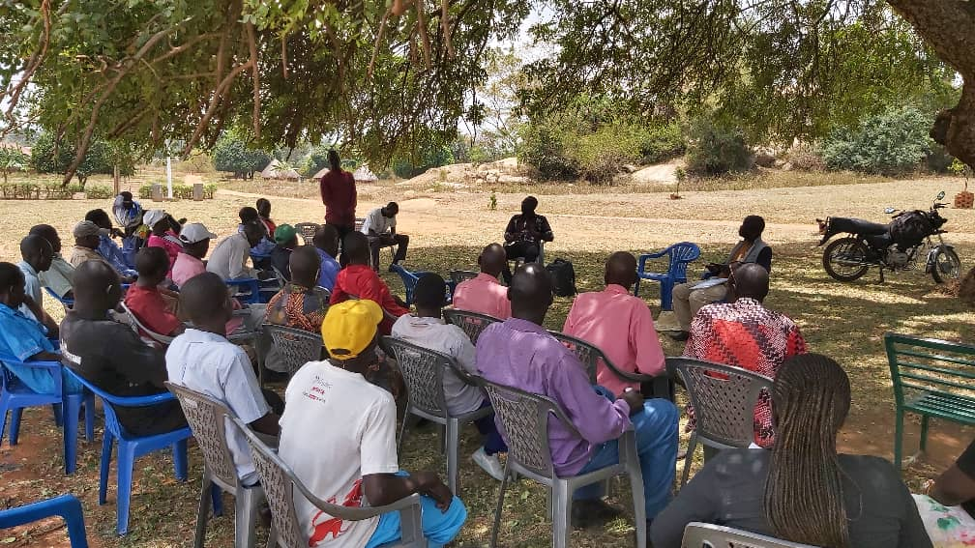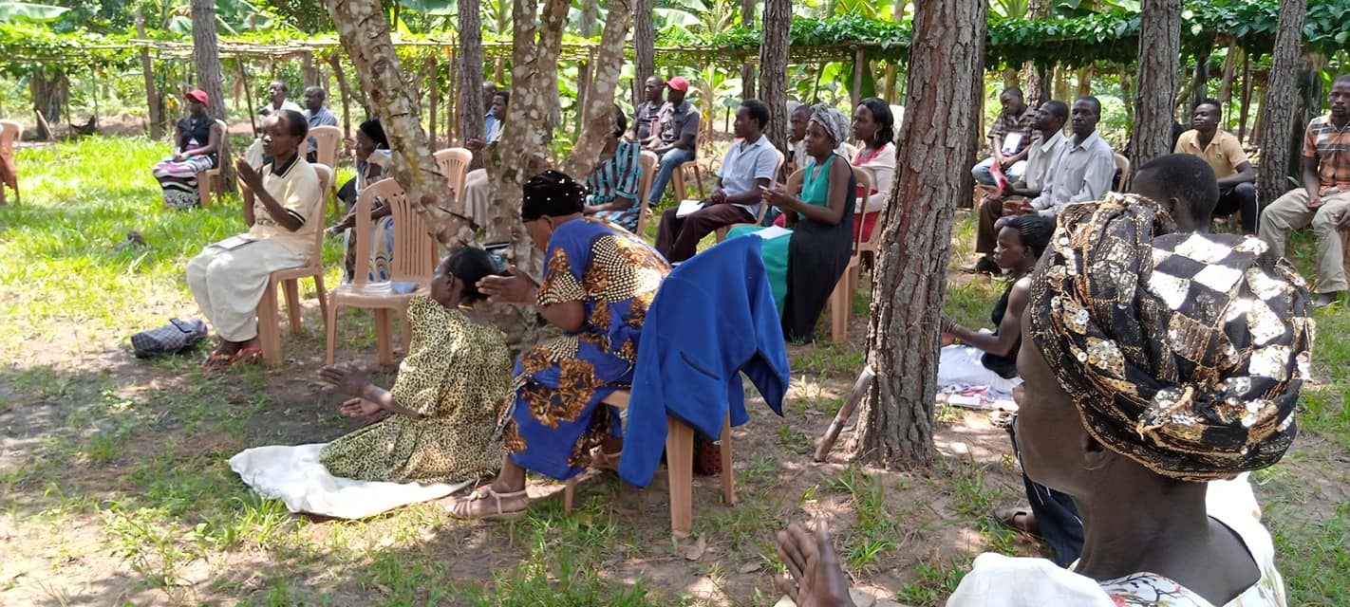
Water user committee members during the training
Through training of committee members on water points management and sanitary hygiene, there has been a reported reduction in conflicts between waterpoint users during implementation of guidelines outlined for the maintenance of the water points as well as a reduction in technical hiccups in certain water points such as the boreholes that had earlier on frequented getting spoiled due to misuse from users. There has also been an observed adherence to sanitary measures such as hand washing driven by both government campaigns in the prevention of Covid-19 and community sensitizations conducted by the trained water user committee members.
Community sensitization of school-going children and parents on home learning.
There has been a global alteration on the education calendar to which some of the most affected nations to that effect are African countries. In the same sense Uganda has had its schools closed for the larger part of covid-19s existence and as such most of the project-supported girls have been staying at home and exposed to much of the negativities that are bound to take the chance of such long stay at home. Recent national and global reports depict reducing hope in most girls returning to school once schools open due to the growing rates of teenage pregnancy and biting poverty among households that may further constrain their abilities to provide the little, they have been providing to see to it that these girls can stay in school.
APPCO therefore in this reporting period has been able to conduct several community sensitization meetings with parents, schoolgirls, and community local leaders to enlighten them on the idea of home learning as a means of continuous learning among the young girls as a deterrent from engaging in negative behaviors that may hinder their continuation in school learning once schools reopen as well as keeping their minds refreshed ready for continuation.
To date, we have been able to conduct many such sensitizations and supporting parents with some home learning materials such as question booklets to ensure the availability of learning materials for the girls while at home. Parents have also been encouraged to carry out close monitoring to prevent the children’s engagement in negative vices that may affect their resumption of school when the time arrives since it’s a far-fetched assumption given the ravaging impact of the covid-19 pandemic yet in a sense our conviction to community well-being we strive to ensure that once schools resume these girls are equally able to resume with their other male counterparts without being held back by challenges that may occur in the course of the wait.
During the 8 community sensitization meetings conducted in the school communities of Layibi and Madera all done with observance of the covid-19 standard operating procedures as passed by the countries ministry of health (MoH) with a participant limit of 20 people per social gathering, we were able to have a participant total of 351 disaggregated as visualized below.
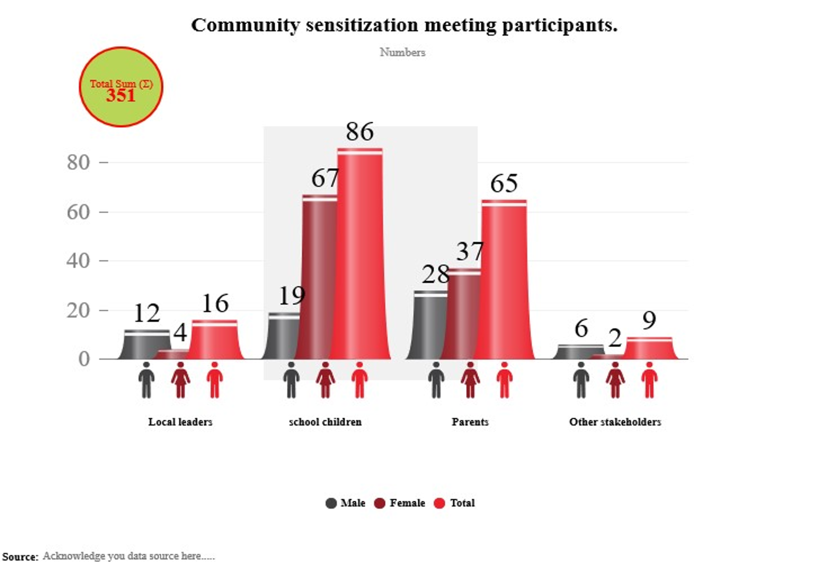
Immediate results as observed in the above-mentioned communities and as stressed by parents and the girls is the continued engagement of the girls in revision sessions with their other colleagues in the communities through discussions which is a positive indicator of results due to the intervention. I this reporting period we have been able to support 102 girls with home learning kits comprising of books, question banks, and answers to support their home learning.
Further recommendations from the area local leaders are that there is a need to spread the sensitization meetings to other communities within the project scope while aiding school girls with learning materials for their learning engagement during their stay at home in this period of school learning disruptions.

Capacity development of beneficiary girls on life skills and sanitary pad making.
Menstruators around the world, especially in low-income communities, often face a lack of access to menstrual products. Without proper sanitary supplies, they may resort to using alternative sanitary material that may not be good for their health an example in our setting of the most alternatively used materials are rags, and even leaves to manage the periods. The combination of period poverty, stigmatization, and inadequate reproductive and sexual health education has major consequences for menstruators’ wellbeing. It can also prevent menstruators from staying in school, thereby ending their education. APPCO thus has been able to engage beneficiary girls on a skills capacity development initiative to develop low-cost and accessible sanitary ware for the schoolgirls and young women in the communities of Bungatiira and Layibi.
The girls were taken through a step-by-step process in the making of the homemade re-usable pads to promote menstrual hygiene having observed the aspect of sanitary pads costs limiting the girls from accessing the pads when in need. During the same sessions, the girls were taken through a recap of prior learning sessions focused on menstruation, maturation, and physical and emotional changes that occur during adolescence, as well as other topics already covered during the project’s educational sessions. Given the closure of schools, the sessions were conducted at the community level with both schools’ girls and women in participation.

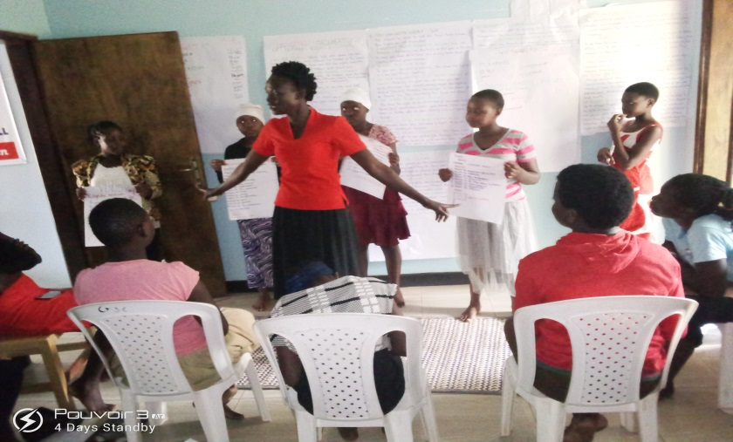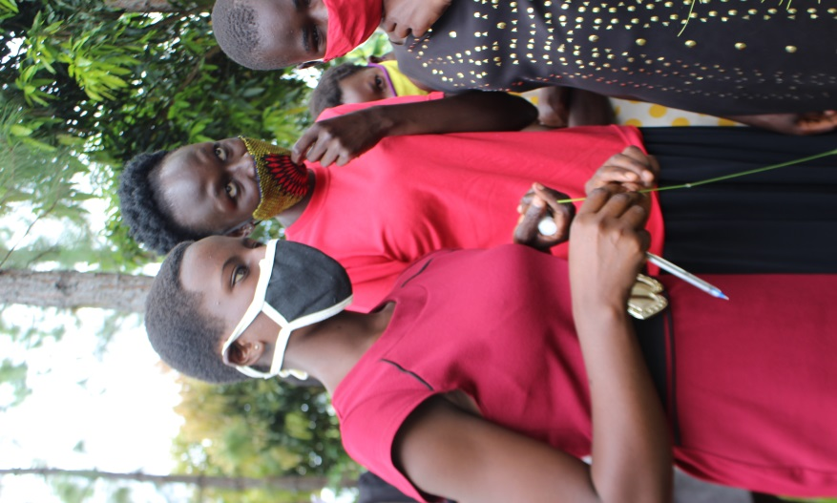

APPCO staff and beneficiary girls during skills capacity development training
Key in all our sessions was a continued reminder to the schoolgirls to engage in positive actions that are not detrimental to their physical and mental well-being, guided by the rampant cases of violence and early teenage pregnancy in the communities brought about the scarcity of resources to enable access to sanitary and other basic needs that accounts for one of the major reasons that the teenage girls end up engage in early sex bringing about cases of teenage pregnancy. Our well-thought response mechanism towards curbing the vice called for the capacity building to enable the girls to make cheap and re-usable pads with locally available materials like cotton cloths, bed wetter’s, hand sewing needles, and thread which materials the girls easily have access to at their homes.
From the capacity development sessions, girls were appreciative of the initiative testifying that the outbreak of the pandemic has not only constrained incomes of their parents and guardians to support their access to sanitary towels but has also brought about a growing burden among households for daily survival and thus supporting them in making the re-usable pads would enable them easily make the pads for individual use as well as sell for economic gain and in a way raise incomes to support their access to other basic needs as they wait to resume schools.
Appco conducted 4 capacity development pieces of training on re-usable pad making and sexual education in the Bungatiira and Layibi in Gulu districts 86 girls were equipped with the necessary knowledge from design to ready use homemade sanitary pads as well as knowledge on sanitary hygiene.
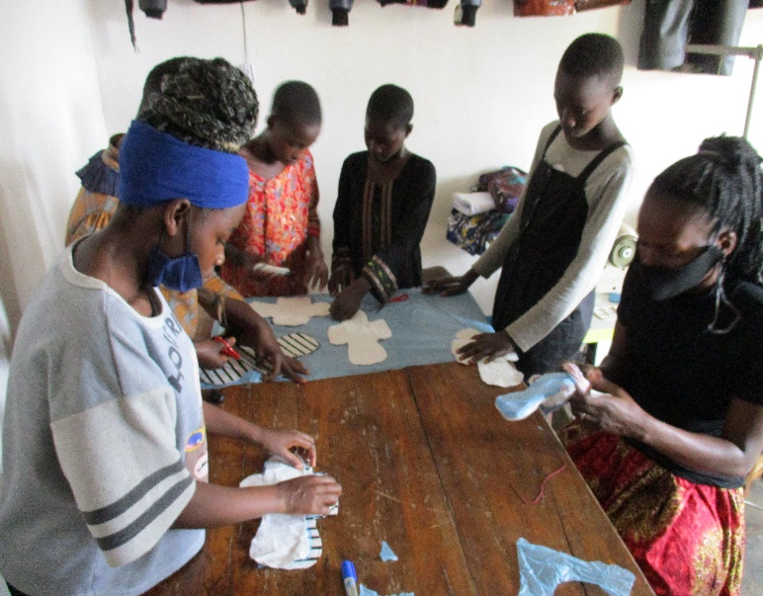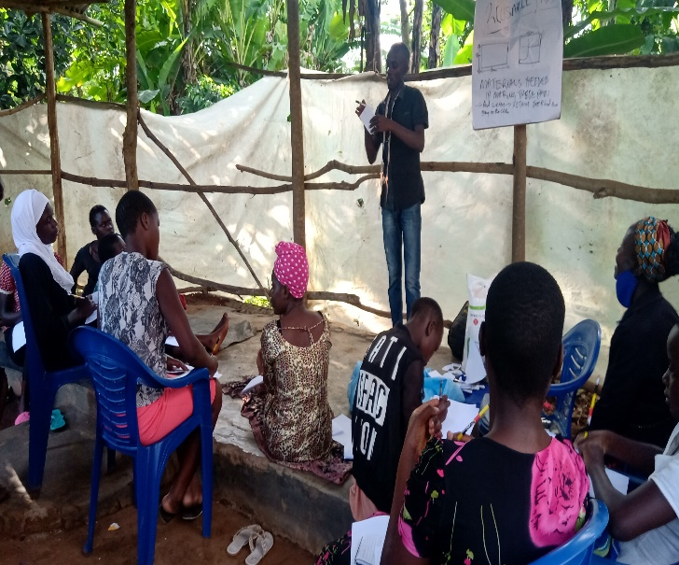
Girls during the capacity development training on making reusable pads.

Conclusion.
Despite ongoing challenges on social gatherings brought about by the covid-19 government-imposed standard operating procedures that have greatly affected target achievement quantitatively, our commitment to serving the community and the girls we support through the project has seen a growing sense of innovation amongst us, and such were able to achieve maximum intended impact to the participants through the activities implemented, the numbers gave room for active participation and involvement in the learning process and as such there is demonstrated practice and learning in the communities from the intervention activities implemented during this reporting period.
“I have attended a number of trainings on sanitary pads but never been able to grasp the procedures like I did in the previous training we had, as you can see, I have been able to make mine alone at home and my mother and I are very happy for this”. - Max, a beneficiary girl
