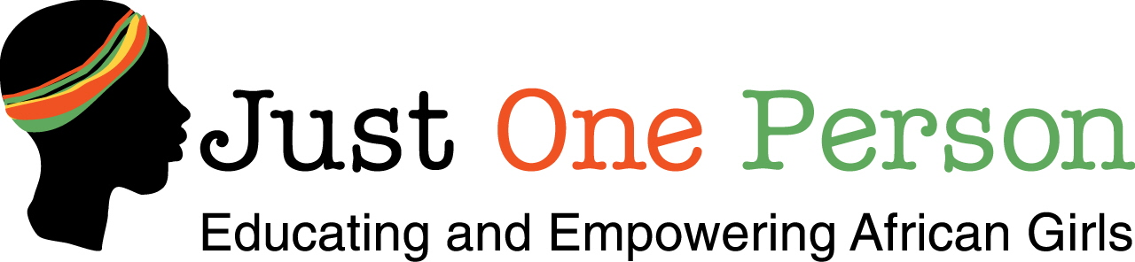

PROGRESS REPORT
JUNE 2008-JULY 2009

Women and Girls Served:

In the 14 months of operation, JOP programs have directly served 875 secondary school girls and 42 parents.

- Partial annual scholarships were awarded to the initial 25 girls participating in our pilot MPower Camp. These girls will continue to participate in our programs throughout their secondary education and during their “gap year”, the year between secondary graduation and their pursuit of post secondary opportunities
- JOP has sponsored 3 MPower Camps. During these 3 day residential camps, the girls attended life skills training workshops, learned to use the computer, and learned a handicraft skill
- JOP has sponsored 4 Mini Camps. During these afternoon seminars held at partnering secondary schools, facilitators led presented and led discussions on such topics as peer pressure and study skills
- JOP has sponsored 1 parent training workshop. Topics addressed were baking of scones, roasting groundnuts and processing Passion juice at home using very simple locally available technology.
- JOP donated 14 laptop computers and 3 wireless internet modem and provided 18 hours of computer training for 25 girls.
- 60 girls attending 5 different schools have received awards recognizing their achievement in math and science
- 2 Trophies provided by JOP were presented by the District Education Officer to the girls school that scored highest in science
25 girls have learned to make reusable sanitary napkins. 180 girls have received a 3 month supply of disposable sanitary napkins

JOP’s Next Three Years Top Priorities:

During the next 3 years, an additional 75 girls will join the program. The girls served will be enrolled in Forms 2-4 and will continue participating JOP activities during their “gap year”. Subsequent to 2011, the Kakamega program will maintain a membership of 100 girls; as 25 girls move on to post secondary opportunities, 25 girls from Form 2 will join.

Once the Kakamega program has reached maximum capacity, Just One Person will establish a second program in neighboring Busia District.

Currently, the benefits of JOP’s educational and empowerment programs extend beyond the secondary girls and the 7 partner schools that we are now serving in Kakamega. The innumerable indirect beneficiaries served are their families, communities, and country who will ultimately benefit from the long term investments that educated women make in education, healthcare, and gender equity as they take their place in Kenyan society.

The focus of JOP’s general strategic plan for the next three years is:

- Capacity building
To facilitate increased participation, it will be necessary to purchase additional training equipment, computer hardware and software. Fortunately, because there is a high demand by other institutions in Kakamega for the rental of training and presentation equipment, purchasing this equipment will not only allow us to expand the reach of our services, but also has the potential to provide a sustainable income stream for funding future operations.

- The establishment of a small centralized community center
Our staff currently works out of their homes due to limited funding for rent and administrative costs. In addition, we currently rent facilities for conducting our MPower camps and Parent Training Seminars.

In June of 2009, a small parcel of land was donated to JOP by the family of one of the girls participating in the program. As the program grows, we plan to build a small community center on the property:
      - To provide our staff with a permanent place to coordinate and operate our programs and securely store our training equipment and records
      - To develop a girls’ resource center that will make technology available to girls in the community outside of our training camps
      - Create a facility for our MPower Camps and Parent Training Seminars
      - Provide a safe, centralized location for the girls to gather outside of school to discuss issues that are important to them as they transition to adulthood
      - Increase community awareness about our services and the wide ranging benefits of educating girls

- Creation of a “Gap Year Program”

*Service learning internships
We will partner with businesses throughout Western Kenya to arrange 3 month service internships. Prior to starting their internships, JOP will provide job training to the interns to ensure a smooth transition from student to internship and to enhance the interns’ value to their host business.

*Volunteer internships with Just One Person
Girls that are not placed in service learning internships will participate as JOP volunteers. Their duties will include:
- Facilitators of Mini Camps at partnering secondary schools
- Camp counselors at MPower Camps
- Staffing at the girls’ resource center
- Organization of Just One Person “Neighborhood Clubs” for girls
Preteens

- Development of Sustainable Activities

JOP U.S. will continue to conduct fundraising events, write grants and solicit individual donors as the JOP Kenya program grows and becomes an established Kenyan institution.

JOP Kenya will begin instituting sustainable activities in September 2009. The local office is currently recruiting potential associate members and community members to form a JOP Kenya Board of Directors. The Board will be responsible for investigating and implementing means of supporting JOP program activities. Potential sustainable activates to be implemented within the next 12 months include;

- Planting a tree nursery on the JOP owned plot
- Coordinating local women’s groups in the manufacturing of reusable sanitary napkins. A strong potential market being investigated is the Provincial Education Office, who would then distribute the products to the schools and subsidize the cost to the students
- Various fundraising events
- Production of Kakamega hand made products for sale locally, in the US by the JOP U.S. office and internationally through the JOP website

Our goal within the next 5-7 years is that the JOP Kenya office will have established a sustainable income flow that will cover 70% of program costs. The JOP U.S. office will remain a source of funding for the remaining 30%.

