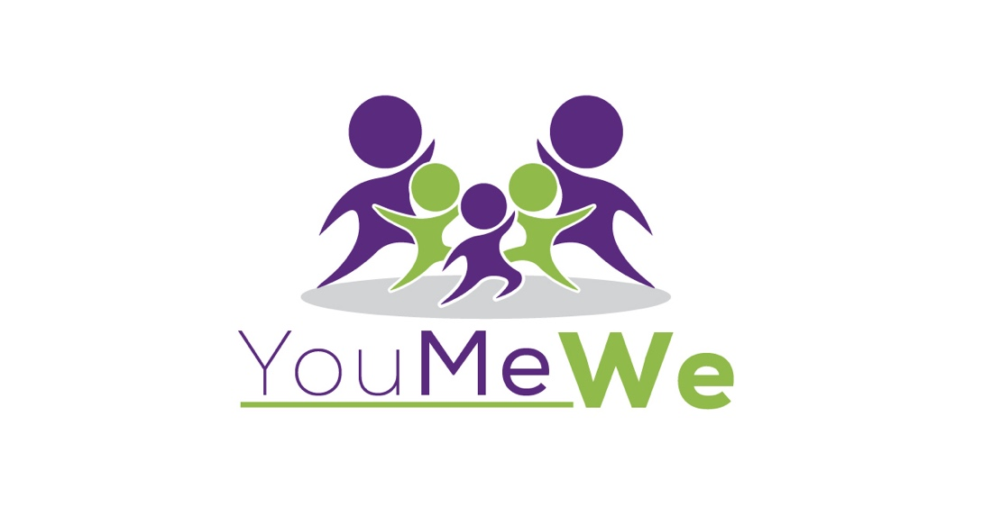

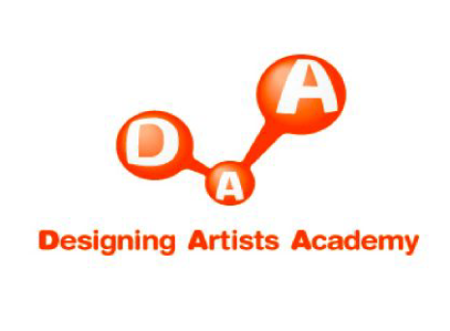
Designing Artists Academy Overview & Impact 2009-2017
Tokyo, Japan

Why an arts camp?
Designing Artists Academy (DAA) is an annual summer camp program in Tokyo that offers kids living in children’s homes (orphanages) a unique opportunity to experience different forms of art taught by professional artists from all walks of life – and from all over the world.

Today, there are close to 30,000 children living in 600+ homes across Japan. Many kids living in these homes have faced some sort of abuse at the hands of a family member and struggle with PTSD, decreased motivation, lack of confidence, and a distrust of adults. A majority of kids spend their formative years in an institutionalized home until the age of 18, with little access to consistent 1:1 attention and support. About 35% of school-aged children are scholastically two grade levels behind their peers. With the stigma and challenges of living in a children’s home, 15% of children go on to attend university (compared to national average of 60%) and most struggle to become independent members of their community. With these challenges in mind, we view this summer arts camp as a vehicle for kids to be exposed to new perspectives, positive messages, and mentors – all in a fun, safe and therapeutic setting.

Since the first camp back in 2009, our goals for the annual arts program have remained the same: encourage kids to think freely, discover new interests, and foster potential through mentoring moments. These goals are kept in clear focus through photography, painting, illustration, fashion design, craftwork, dance and music - each workshop planting seeds of hope for a brighter future.

Impact/reach
By recruiting talented and compassionate artists, kids develop collaborative and creative-thinking skills, and further, they learn how to use art as a positive expression of themselves.

Since 2009, many statistics can be shared on our nine years of DAA, but perhaps one of the most notable benefits is the sense of care/attention kids feel after attending camp. Year after year, we see an intense desire for 1:1 attention by many of the campers. Although most children’s homes have kind and caring staff members – most often there’s simply not enough time to provide consistent 1:1 time with each child in the home. Child to staff ratio is often 6:1 and higher – leaving little time to bring focused and individualized care to each child - which is especially needed for kids dealing with the trauma of abuse and separation from family.

With our camp model, we create small groups of 10 kids who are assigned 1-2 group mentors who guide and support the group throughout the entire camp. This is in addition to their workshop artists and other adult volunteers who work with the group. So on any given day, each group is exposed to continual attention from 4-6 adults. Difficult to measure precisely, but we have witnessed the profound positive effect this mentoring aspect has had on the kids. With just a little bit of encouragement and attention, something is sparked inside a child. In 7-10 days time, for those kids who start to ‘feel noticed,’ it goes a long way towards feeling they are not simply stigmas of society. It is this kind of breakthrough that opens up perspectives and we’ve seen new interests and potential developed because of their experience at DAA.

Historical statistics/summary 2009-2017
- Approx. 320 kids have participated (primarily from the same four children’s homes in central Tokyo)
- Age range 6 y/o – 17 y/o (average age 12)
- Average of 4 homes participate in camp, with between 30-50 kids
- Approx. 200 artists have volunteered their time – incl. Japanese, Australian, American, French, Canadian and Vietnamese
- Children have experienced painting, illustration, origami, body percussion, dance, music, magic, yoga, fashion design, paper-cutting art, iMovie, performance art, animal educational craftwork, graphic design, cake decorating, gyoza-making, journaling, face painting, storytelling, songwriting, special guest artists performances – close to 1,000 pieces/performances created over the years
- Regular lessons at the home that have continued after DAA based on new interests include dance (hip hop) and music (guitar)
- Themes over the years include We Love Dance, We Love Music, The Art of Storytelling
- 14 companies and organizations have supported DAA including Barclays Capital, Coca-Cola, Costco, FEW, FIT for Charity, Herbert Smith Freehills, JP Morgan, Mori Art Museum, Nihon Sogyo, Run for the Cure, Shinsei Bank, The Foreign Buyers Club, Tokyo International School
- More than 350 volunteers have supported DAA
- 5 Temple University Japan interns have participated in planning and execution of DAA
- More than 6,000 hours spent planning, preparing for camp
- Special DAA field trips to Mori Art Museum, Apple store, Kidzania
- Japan Times, Metropolis, Tokyo Families media coverage

Feedback from kids, home staff members and volunteers
- "The children were able to enjoy various workshops in a relaxing atmosphere, and it was a good experience for us staff members, because through those workshops, we were able to observe the unique character of each of our children." - Kiyose Kodomono Ie staff member
- "The children were given the camp t-shirts and backpacks as presents, which was very memorable. All of the children continued to use them after DAA was over." –Kiyose staff member
- “Some children can’t go back to any family during the summer holidays, so it’s good for them to attend a program like this to refresh themselves. We really appreciate the support of the camp staff.” – Staff member at children’s home
- “I was looking forward to this year’s event, I felt sad when camp ended last year.” – 12 year-old who took part in DAA 2010 & 2011
- “Camp was really fulfilling, the teachers and volunteers were nice and we made friends with kids from other homes too.” -13 year-old girl who participated in 2011
- “I really enjoyed making a veil! We don’t have the same kind of materials at our home and we can’t make art freely at school either so I find it exciting to be able to make something with so much material.” – 13 year-old girl
- “I felt many of the children were craving for loving care. Kids would often hold my hand and some would suddenly hug me – even the older kids.” – volunteer and artistic consultant
- “In my DAA workshop, I was able to choose pieces of cloth to make my own dress from scratch, and I had makeup put on my face to look like a real model, and we all walked down the runway.” – Primary school girl Kiyose Kodomono le children’s home
- “We used shells and beads to create our own summer dresses.” – Primary school girl, Kiyose Kodomono le
- “There was a gym and a playground at DAA and I played a lot with balls and hula hoops.” – Primary school girl, Kiyose Kodomono le
- “I was really happy to meet everyone at DAA. My favourite memory is how we learned a dance choreographed to the theme from the movie, Big Hero 6. I also got to make cushions in my DAA workshop and we also did yoga. It was really really fun.” – 6th grade boy, Port Kanegaya
- “My favourite DAA workshop was the short film-making workshop. We got to work with kids from other children's homes, which was really cool too. It was also my first time interacting with foreign people, and it has encouraged me to participate in many other events involving foreigners.” – 6th grade boy, Port Kanegaya
- “We are very happy to hear that DAA is coming back as the full camp format. We understand that DAA was not possible the last few years due to lack of funding, and we came to realise after not having DAA just how much of an amazing camp it is, and a rare opportunity in Japan. I believe the concept of the Designing Artists Academy camp goes beyond the imagination of most Japanese people, and our children absolutely enjoyed it. DAA was one of the great memories of their summer holiday.” – Ishigo-san, St. Joseph’s children’s home

DAA 2019 Program

Next year's Designing Artists Academy will be a special one, as it marks the 10th anniversary of the camp's existence. Back in 2007, DAA was just a bubble of an idea. The hope in creating an arts camp for children's homes was ultimately to connect these children with the community and help open up new perspectives through artistic workshops. In linking artists with kids, our aim was to help them discover new truths and potential within themselves. Our goal for our 10th camp is the same as ever: create a therapeutic camp led by positive role models in a fun learning environment.

This year’s theme is Stories of Tokyo: kids exhibit the heART of their city. Kids will share what Tokyo means to them in their own unique narrative. Kids will see firsthand how each of our stories connects us – through tears, anger, laughter, and hope.

Format
- Camp will be 8 days (TBC) at the end of July, into early August. Weekdays only. Exact dates TBD. 9:00-3pm daily.
- 30-40 kids will participate, ranging approximately in ages 8-15
- Kids will be organized by age, in groups no larger than 10, with group mentors assigned
- Each morning will include focused art workshops, followed by afternoon sessions that kids will have a chance to choose from (examples- mural painting, yoga, taiko drum, obon dancing, bamboo stick jumping, other sport games, smaller craft activities)
- At the conclusion of camp, there will be a special exhibition party to celebrate the children’s creations/completion of camp. Date TBC.

We have been fortunate to continue this arts camp due to the support of so many in our community. Corporate sponsorships, local businesses, schools, and countless individuals have taken this journey alongside us—and the children's homes. Without this group effort and incredible support, DAA would not have touched the lives of hundreds of kids who have participated in this program.

At the heart of it all, absolutely nothing beats seeing a child emerge out of their shell and discover a new and promising identity. Thanks to our community - our sponsors, our artists and countless number of volunteers - children are finding positive ways to communicate their own story. And in the process, they are healing and realizing exciting possibilities for their future.

DAA 2019 is also a special one as it’s the first year DAA will be executed under a new non-profit organization in Tokyo. For the first nine years, DAA was one of Living Dreams (livingdreams.jp) core programs. DAA founder, Amy Moyers-Knopp, started the camp with colleagues while the executive director at Living Dreams. We were able to grow DAA with lots of love while under the Living Dreams umbrella. However, the past two years we had to make program cuts, holding smaller workshop sessions at the children’s homes due to a lack of funding. Now in a new chapter, we are looking to bring our original camp format back as an annual program under You Me We (youmewenpo.org) – with its founder and director, Michael Clemons, being the very first sponsor of DAA while he was managing CSR activities at Barclays Capital – a beautiful full circle of sorts.

So for this 10th anniversary celebration, we will be telling stories. We'll share stories about our generous supporters and talented artists. And through a variety of workshops ranging from photography, mixed media, and fashion to dance and music, kids will share stories about their special city of Tokyo and what it means to them.

We hope you will join us this year in supporting and celebrating DAA's 10 years of heART!

2019 Support Needed

Financial support
Most years, our camp (depending on the number of days) runs about ¥3-4M to produce. This also depends on the type of exhibition party we host, types of in-kind donations we receive, and venue options. Due to the significant level of planning needed to make the camp successful and honor our commitment to the homes, we must secure full funding of the camp by end of March 2019 in order to move forward.

Venue ¥1-1.2M approx.
- Space with 4-5 breakout rooms for workshops to fit 10 kids, 5 adults with room to spread out with materials, 1 large gymnasium or play area/open space indoors, ideally outdoor playground. For 8 days, + setup day ¥1M approx.

Transportation ¥626,000
- Transportation for children. 3 buses for 8 days approximately ¥500,000
- Workshop artists travel. 5 artists per 6 days with ¥2000 per day limit ¥60,000 approx.
- Special guest artists travel. 5 artists per 5 days with ¥2000 per day limit ¥50,000 approx.
- Exhibition party performers travel. 8 performers with ¥2000 limit ¥16,000

Materials & services ¥450,000
- Workshop group supplies. ¥4,000 per child @ 50 kids ¥200,000 approx.
- Mural paper and paint/supplies, exhibition reception supplies, office supplies ¥100,000 approx.
- Camper/volunteer t-shirts. ¥1500 per t-shirt @100 qty. ¥150,000 approx.

Food & Beverage ¥1M approx.
- Camp setup lunch for volunteers. 15 volunteers ¥15,000 approx.
- Daily bentos for 36 adult volunteers, 3 home staff, 45 kids for 8 days ¥672,000
- Daily ice to keep drinks cold. 4 bags per day ¥32,000 approx.
- Bus snacks. ¥20,000 approx.
- Ice cream on last day of camp. 36 volunteers 3 home staff, 45 kids. ¥42,000
- Reception. Based on 110 people (45 kids, 5 home staff, 40 volunteers, 20 special invites) @2500 per head ¥275,000 approx.

Volunteer support
- Morning workshop volunteers. For sponsors, we allot up to 2 adults per workshop group in order not to overwhelm kids and space with too many adults in each room. The standard for each group of 10 kids, is a maximum of 1-2 artist teachers, 1-3
‘mentors’ - giving a ratio of 10 kids to possibly 5 adults. There will be 4 workshop groups at the camp, possibly a 5th. These slots will be filled on a first-come, first-served basis. Requirements: conversational JP; willingness to actively participate in the workshop session. 8am – 12pm (or through lunch)
- General morning volunteers. These volunteers will help with F&B service, morning setup, bus greeting, chaperones during playtime. Per day we’re looking at 5 general volunteers. 8am – 12pm (or through lunch)
- General afternoon volunteers. These volunteers will assist in the various activities children take part in (yoga, mural painting, journaling, crafts, sport play, etc.). We’ll look for about 5 volunteers per day to help with afternoon activities and cleanup at the end of camp. Requirements: conversational JP; willingness to actively participate alongside children in the session 12pm – 3pm
- Participation of 2 sponsors at Exhibition Party.

All sponsors (financial and volunteer support) who give permission, will be included on our website, social media coverage and included in any press coverage on DAA.

Key Planning Dates

Below is a list of key milestones to occur during the planning process of DAA 2019

- September 2018 - February 2019 – sponsorship recruitment
- March 2019 – 80% of funding secured; venue secured (ideally venue secured January 2019)
- March 2019 – DAA official kickoff with sponsors, volunteers and children’s homes
- Feb – April – Artist recruitment
- April – July – DAA preparations (content & schedule, workshop materials, F&B, transportation, camp communications, volunteer assignments, other logistics/supplies, etc.)
- 1st week of July – orientation camp packets will go out to all sponsors/volunteers with details on location, schedule, volunteer roles, what to expect, etc.
- Possible camp dates – July 23 – Aug. 1 (no weekends, setup date July 22) OR July 30 – Aug. 7 (no weekends, setup date July 29) *last evening of camp is Exhibition Party.
- Camp times (approx.) 9:00 – 2:50pm weekdays only; Exhibition Party 5:30 – 8:00pm approximately.

DAA Management Team

Amy Moyers-Knopp, DAA founder; former executive director Living Dreams non-profit 2008-2012 (remained an advisor until 2017, then joined You Me We)

Mihoko Walker, DAA founding camp director, head of children’s homes communications Living Dreams non-profit 2008-2012

Marie Atsuko-Gray, Hands on Tokyo partner, current volunteer You Me We

Michael Clemons, founder & executive director You Me We

