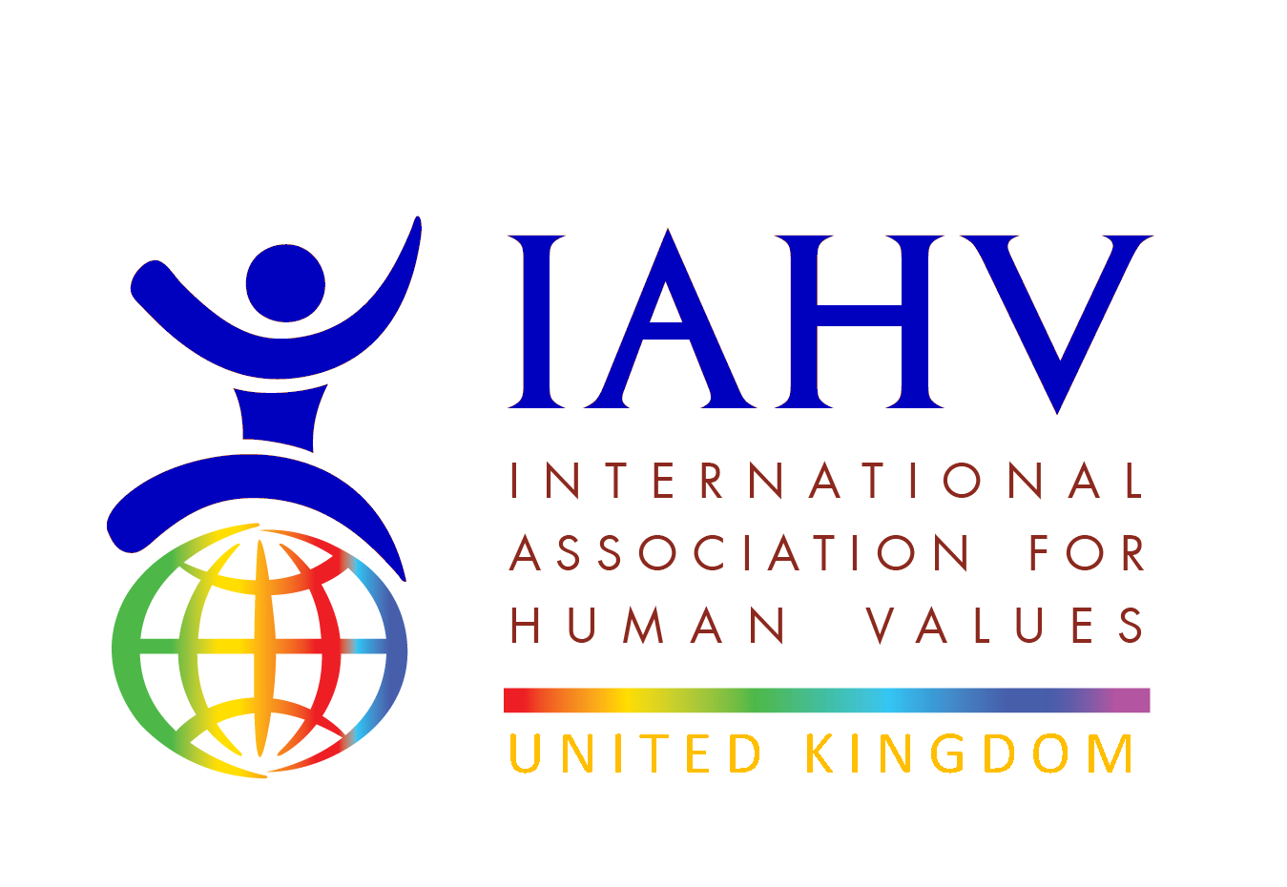
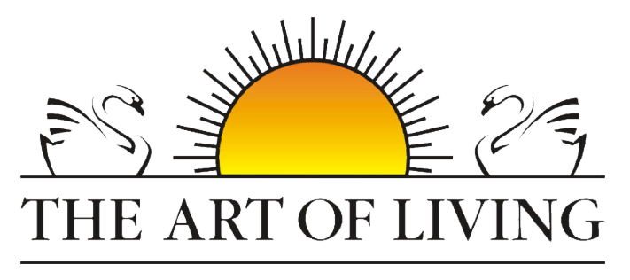
Project Pavitra Report
February 2026

Project Activity and Impact
Since its launch in March 2018, Project Pavitra, a collaborative initiative between IAHV (International Association for Human Values) and the Art of Living, has been dedicated to empowering underprivileged women through menstrual health and hygiene education. Through complimentary workshops, our trainers have reached over 1,78,166 adolescent girls and women. Additionally, we have trained 7010 females to become menstrual health and hygiene champions, spreading awareness across 28 states in India, 11 countries in Africa, as well as in Bhutan, Nepal, Sri Lanka, Cambodia, and Hong Kong.
Through its comprehensive approach and collaboration with The Art of Living, Project Pavitra has made significant strides in empowering women and promoting menstrual education globally.
During the period 1st of January 2025 till 23rd of February 2026 our trainers have trained over 3981 participants in 61 locations across 7 states of India namely, Odisha, Gujarat, Maharashtra, Punjab, Uttar Pradesh, and West Bengal.

Testimonials
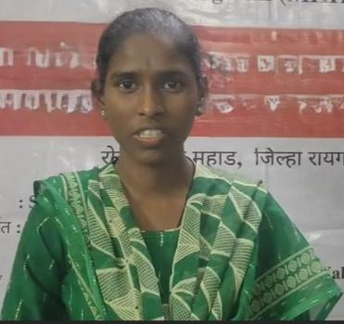 | 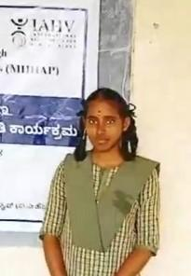
Living in a tribal area where menstrual topics are rarely discussed, I’m grateful to finally learn this important information—it has truly empowered me," says Miss M. (Dr. Babasaheb Ambedkar College, Mahad), who walked 1 to 1.5 hours every day to attend the workshop. | “Earlier, I couldn’t handle my period pain, but meditation and asanas have helped me feel more in control and at ease.” – Miss D. (8th Std from GHS School, Maralakunte, Bangalore rural)

Fundraising Event and activities
In February 2026 we have also been featured in Sri Sri Publications in India, highlight the work undertaken as an awareness project.
Volunteers of Art of Living UK are planning international womens day event on the 8th of March 2026 for fundraising for this beautiful cause. At our local event here in Aylesbury we aim to sell hand made bags made by women in rural india. 100% of sale proceed amount will go towards the charity.

Call to action post the event:
Participants are encouraged to donate via the global giving page which can be found here:
Pavitra-Menstrual Holistic Education-Rural India - GlobalGiving
Or join the Whatsapp group using the following QR code:


Vision:
Below is a mind map with a vision to grow Project Pavitra in supporting Africa.
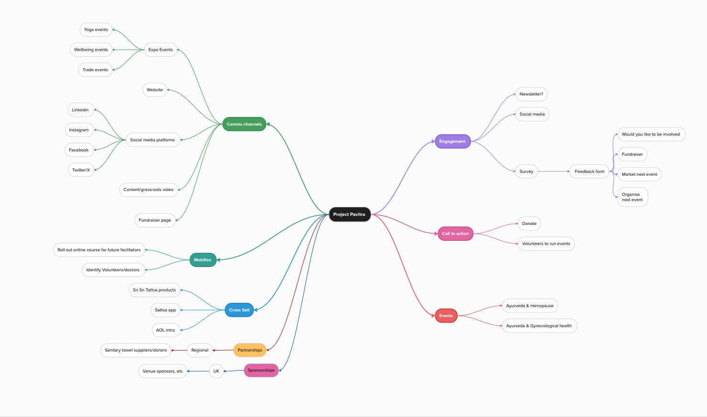

Picture Repository
More pictures from the session in Mozambique
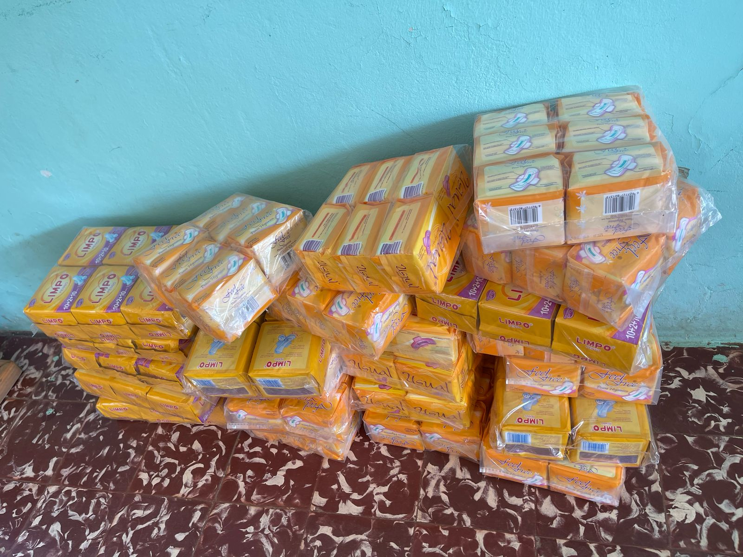
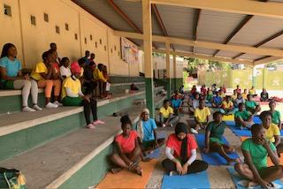

Pictures from South Africa below:
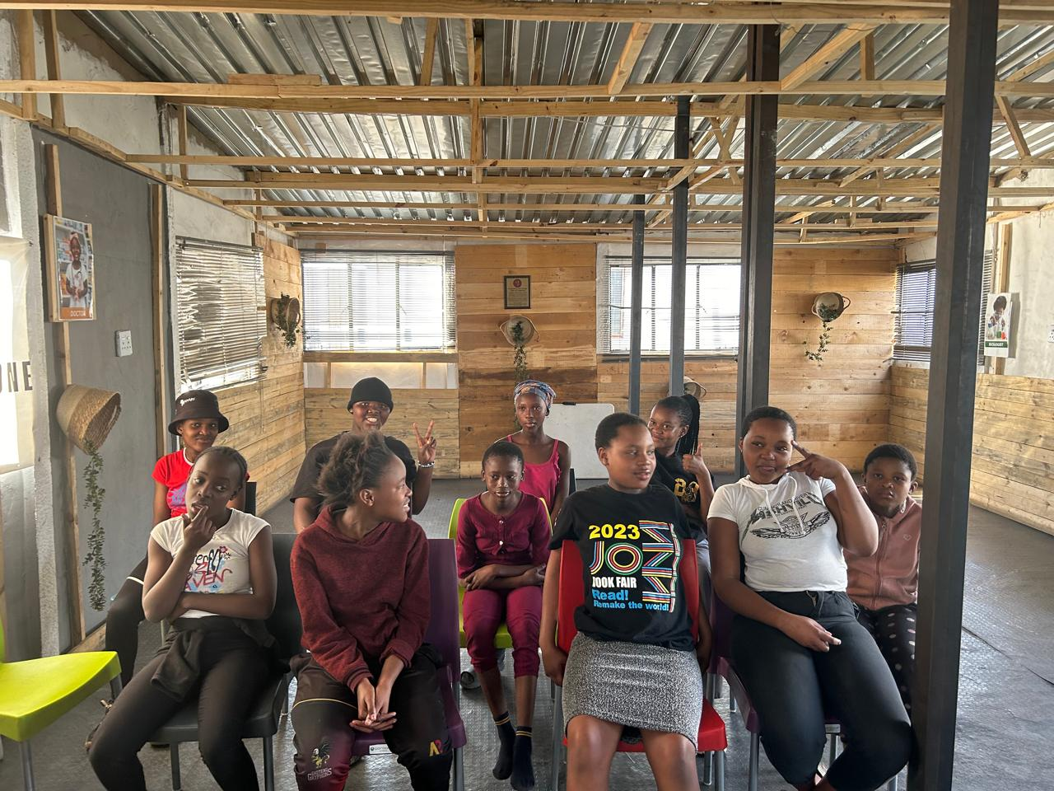
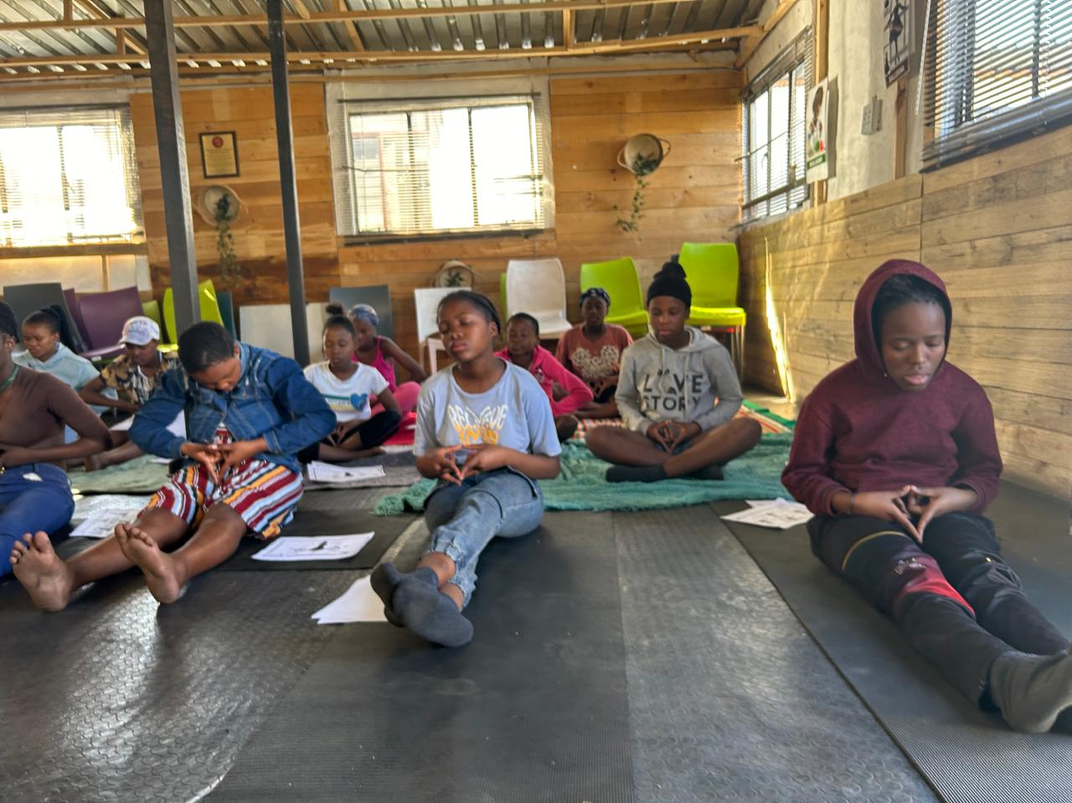

=\

End of report. October 26th, 2025

