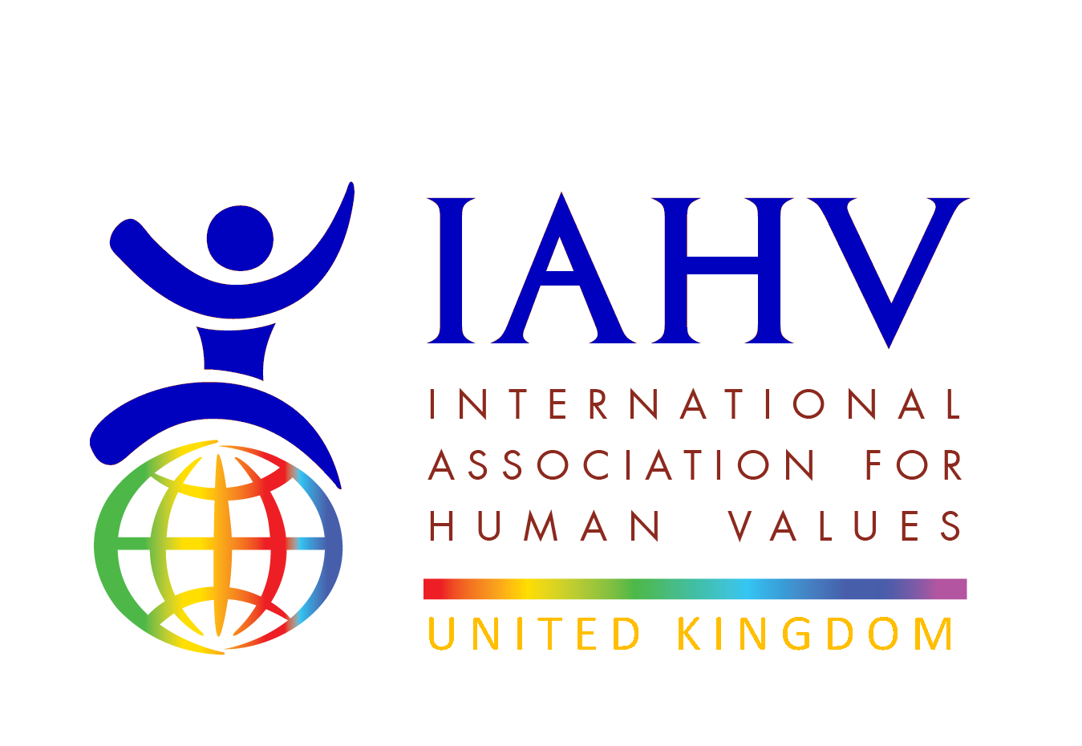
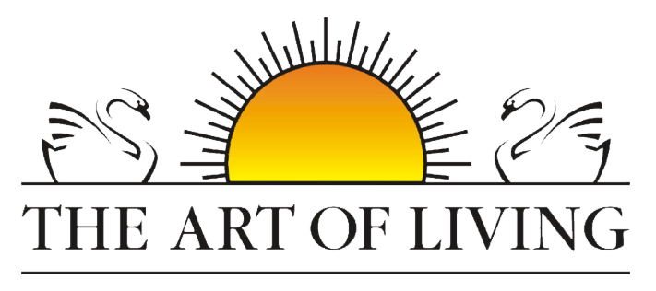
Project Pavitra Report
May to September 2025

Project Activity and Impact
Since its launch in March 2018, Project Pavitra, a collaborative initiative between IAHV (International Association for Human Values) and the Art of Living, has been dedicated to empowering underprivileged women through menstrual health and hygiene education. Through complimentary workshops, our trainers have reached over 1,78,166 adolescent girls and women. Additionally, we have trained 7010 females to become menstrual health and hygiene champions, spreading awareness across 28 states in India, 11 countries in Africa, as well as in Bhutan, Nepal, Sri Lanka, Cambodia, and Hong Kong.
Through its comprehensive approach and collaboration with The Art of Living, Project Pavitra has made significant strides in empowering women and promoting menstrual education globally.
During the period 1st of January 2025 till 30th September 2025, our trainers have trained over 3981 participants in 61 locations across 7 states of India namely, Odisha, Gujarat, Maharashtra, Punjab, Uttar Pradesh, and West Bengal.

Testimonials
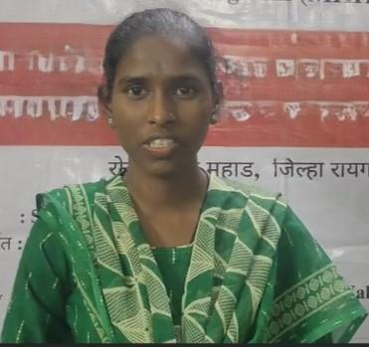 | 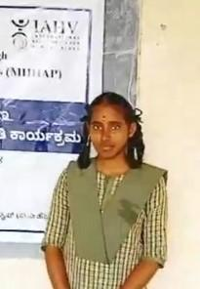
Living in a tribal area where menstrual topics are rarely discussed, I’m grateful to finally learn this important information—it has truly empowered me," says Miss M. (Dr. Babasaheb Ambedkar College, Mahad), who walked 1 to 1.5 hours every day to attend the workshop. | “Earlier, I couldn’t handle my period pain, but meditation and asanas have helped me feel more in control and at ease.” – Miss D. (8th Std from GHS School, Maralakunte, Bangalore rural)

Fundraising Event
Volunteers of Art of Living UK and Nigeria and of International Association for Human Values organised an Open Mic night. Her voice: An open mic on womanhood, on Thursday 17th of July 2025, in London, UK.
The event was attended by 20 participants, and it raised the total funds of over £100. Many participants are keen to join the volunteer team. Follow up emails and phone calls to the participants was carried out to keep in touch with them.
Some photos from the event below:

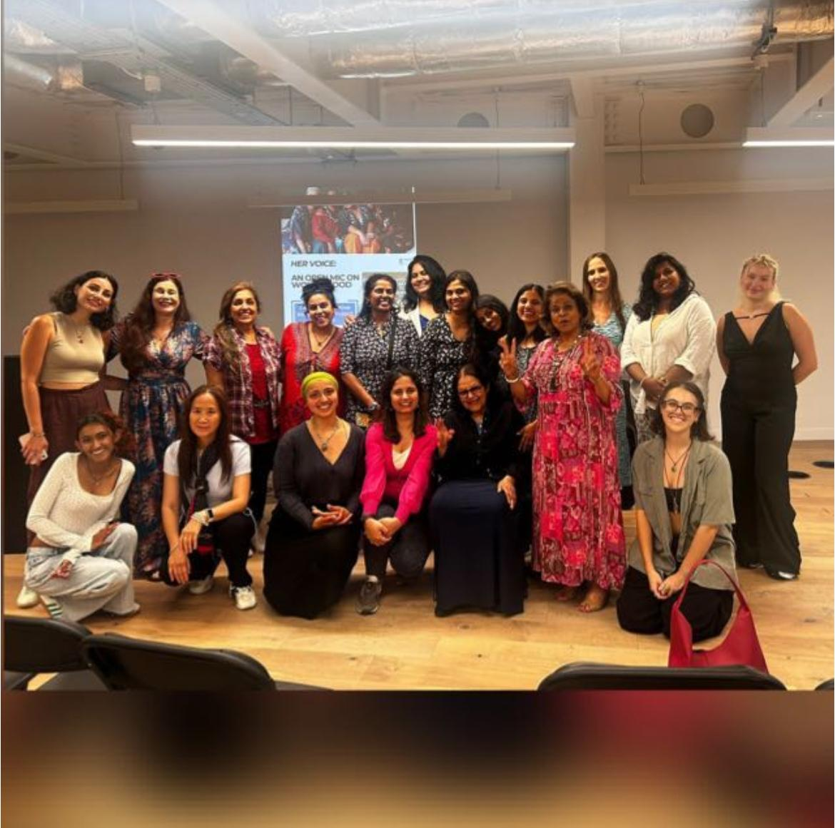

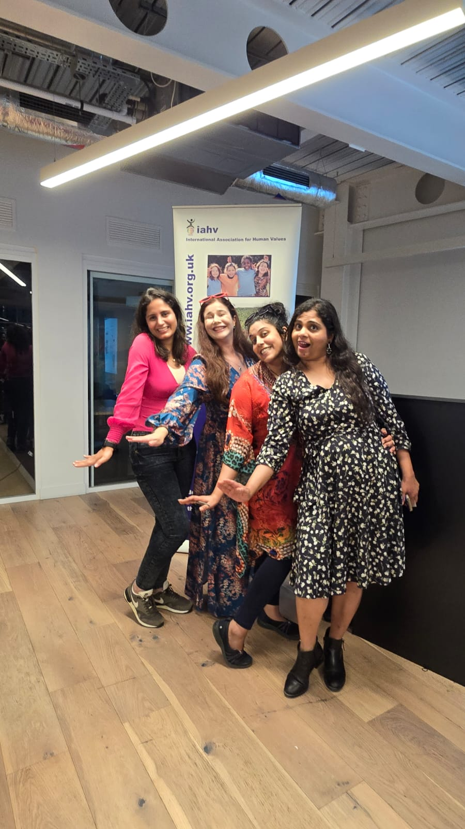
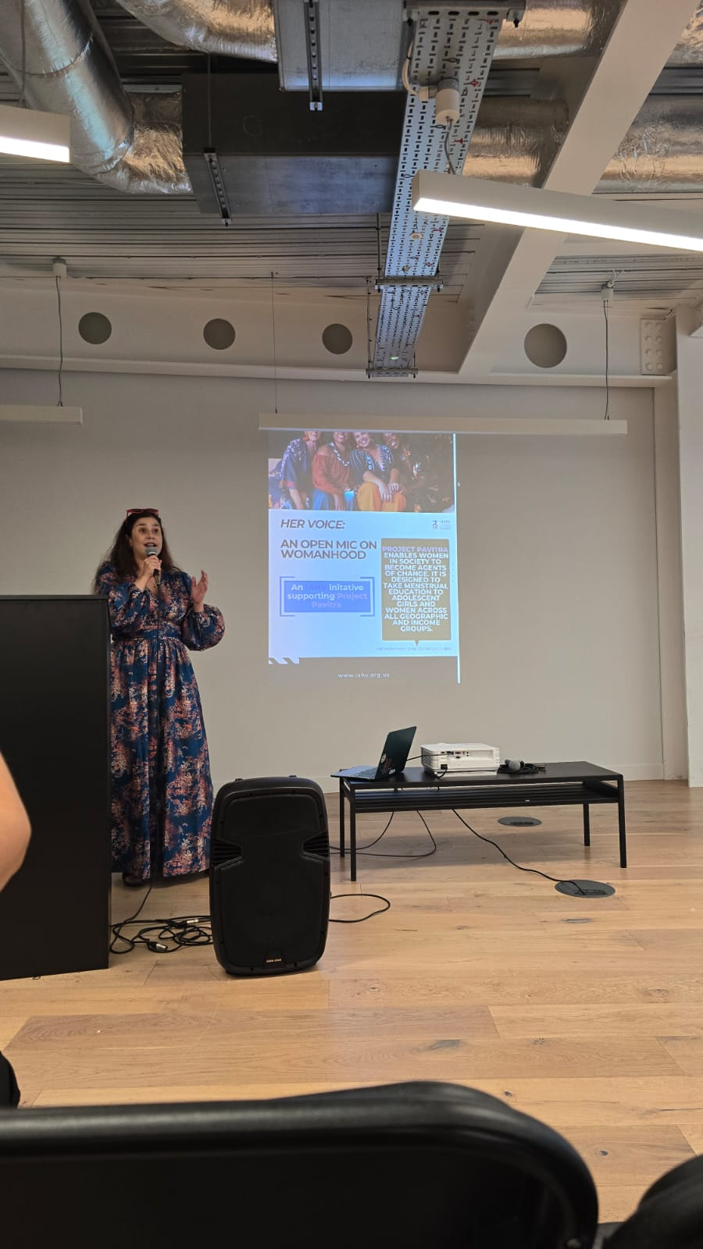

Call to action post the event:
Participants are encouraged to donate via the global giving page which can be found here:
Pavitra-Menstrual Holistic Education-Rural India - GlobalGiving
Or join the Whatsapp group using the following QR code:


Vision:
Below is a mind map with a vision to grow Project Pavitra in supporting Africa.
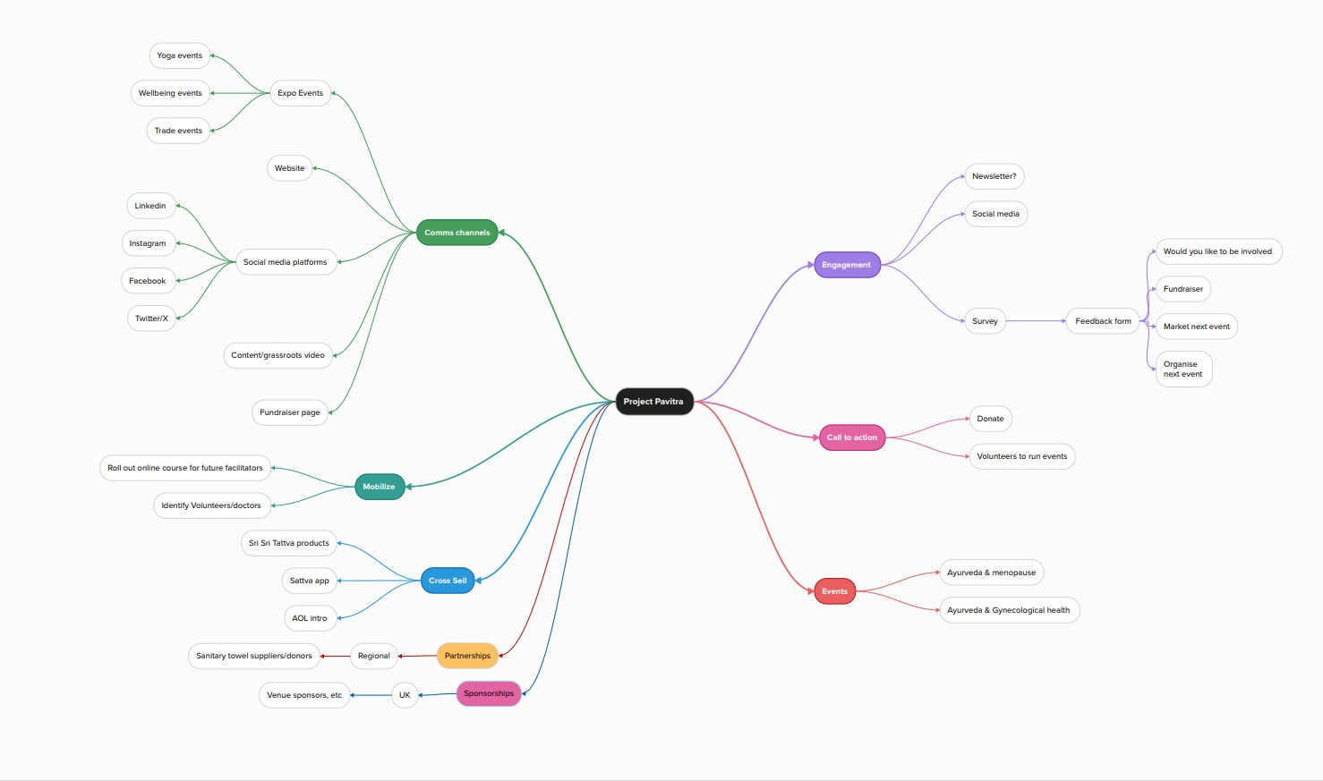

Picture Repository
More pictures from the session in Mozambique
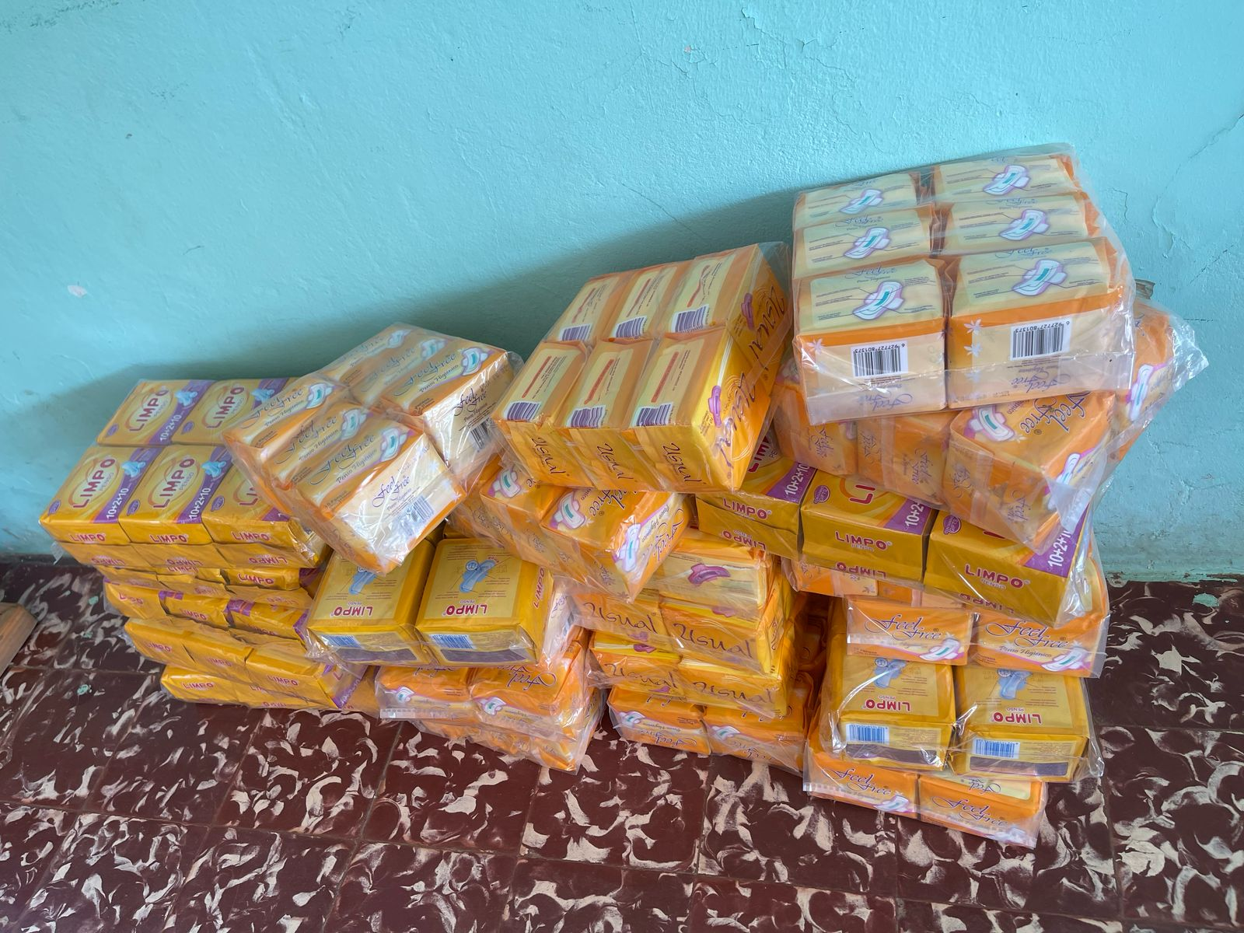
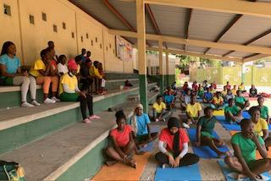

Pictures from South Africa below:
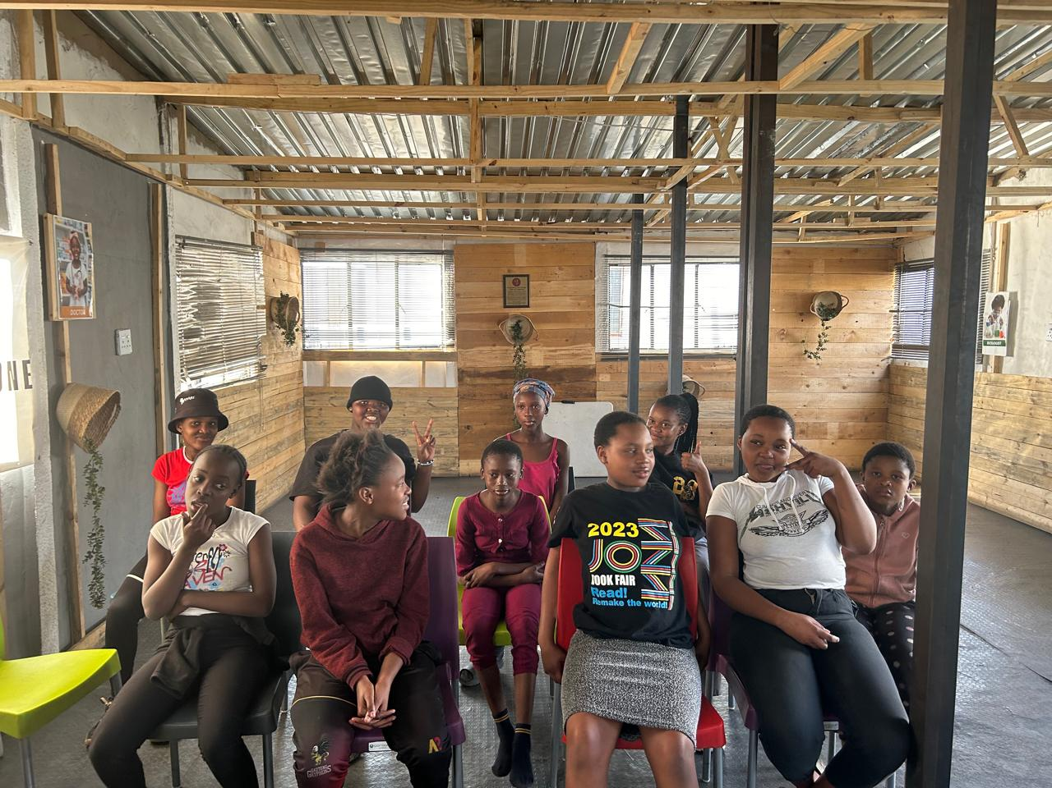
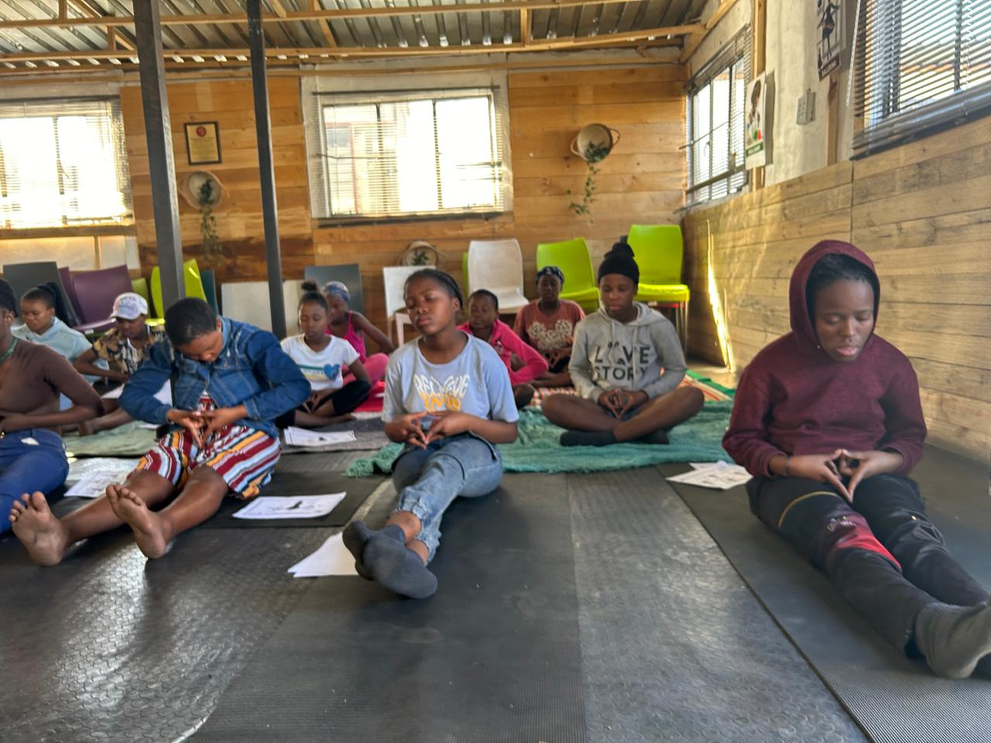

=\

End of report. October 26th, 2025

