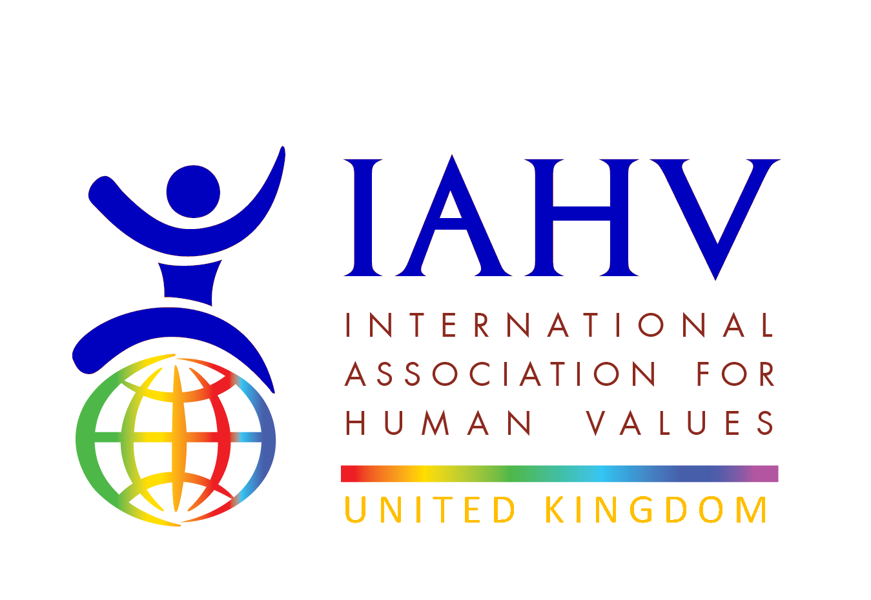
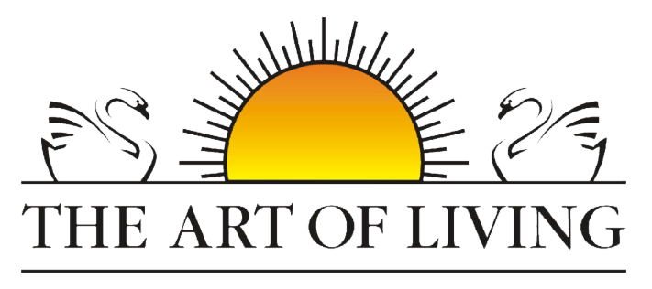
Project Pavitra Report
January to April 2025

Project Activity and Impact
Since its launch in March 2018, Project Pavitra, a collaborative initiative between IAHV (International Association for Human Values) and the Art of Living, has been dedicated to empowering underprivileged women through menstrual health and hygiene education. Through complimentary workshops, our trainers have reached over 1,78,166 adolescent girls and women. Additionally, we have trained 7010 females to become menstrual health and hygiene champions, spreading awareness across 28 states in India, 11 countries in Africa, as well as in Bhutan, Nepal, Sri Lanka, Cambodia, and Hong Kong.
Through its comprehensive approach and collaboration with The Art of Living, Project Pavitra has made significant strides in empowering women and promoting menstrual education globally.
During the period 1st of January 2025 till 30th April 2025, our trainers have trained 3981 participants in 61 locations across 7 states of India namely, Odisha, Gujarat, Maharashtra, Punjab, Uttar Pradesh, and West Bengal.
Additionally, on 22nd April, Project Pavitra facilitators conducted Yoga of women in Prison which impacted 132 women in prison. Pads were also distributed at the workshop.
Some pictures below
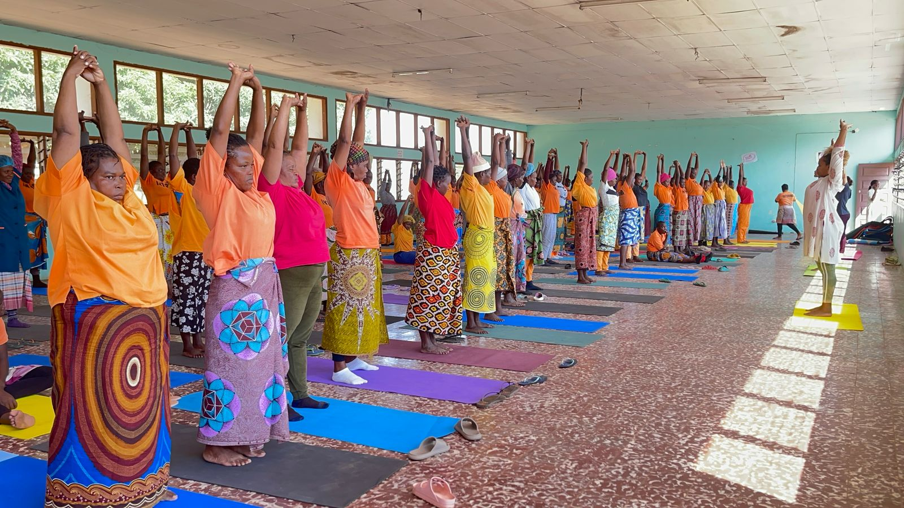
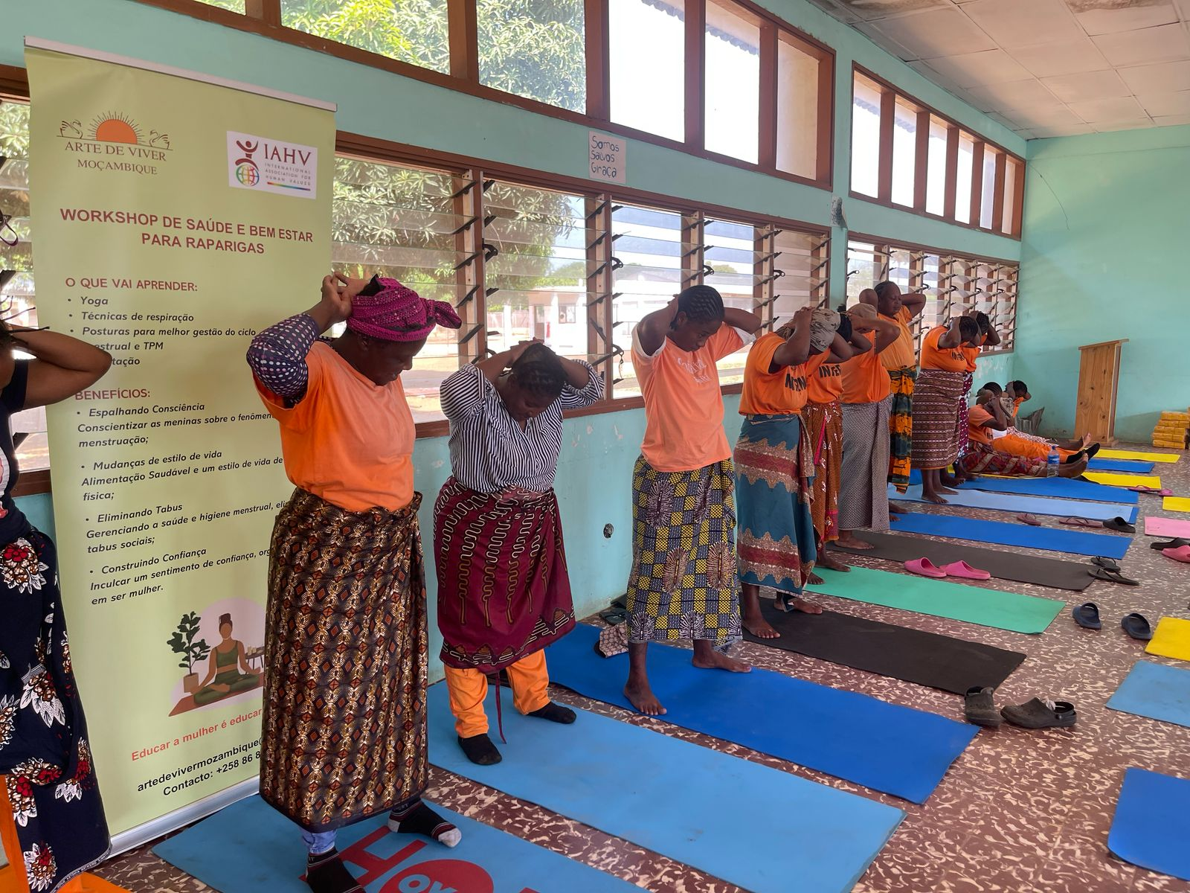
Attached pictures represent programs conducted by Project Pavitra trainers across India, and the testimonials below highlight the impact of the project.
Last but not the least, A course with 20+ participants was conducted in Orlando West, Soweto, South Africa.
Some pictures below:
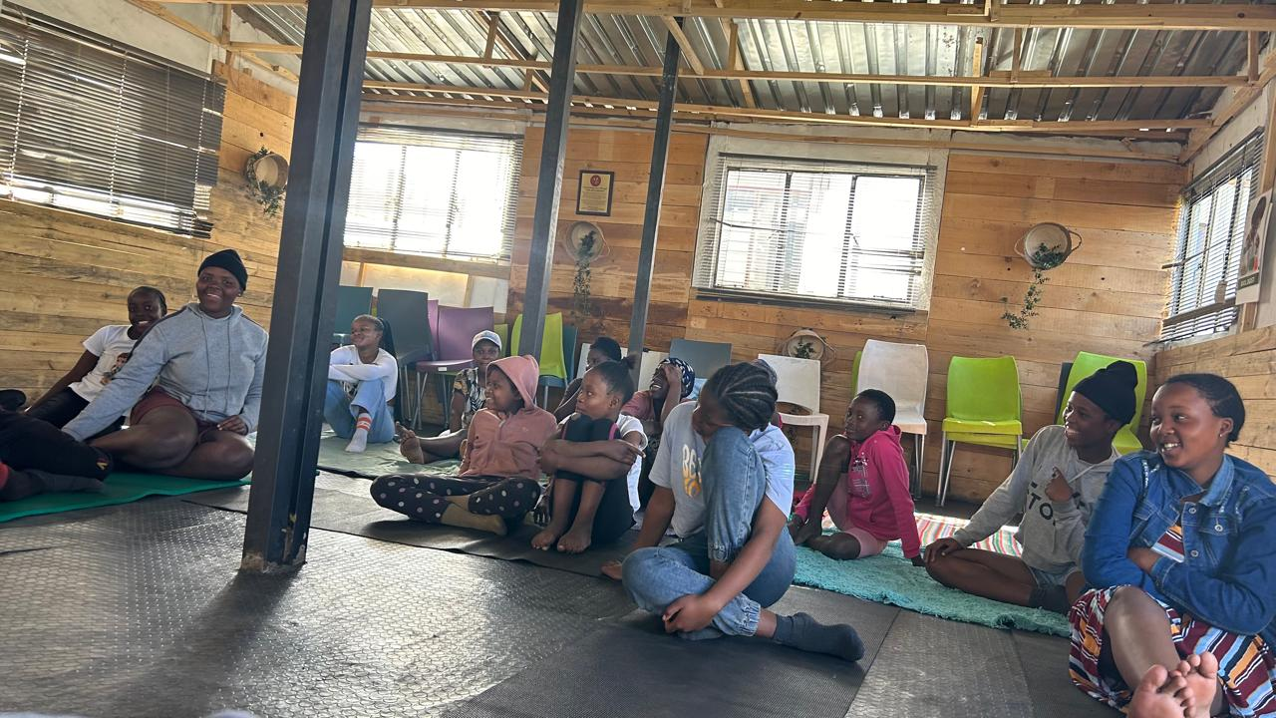

Testimonials
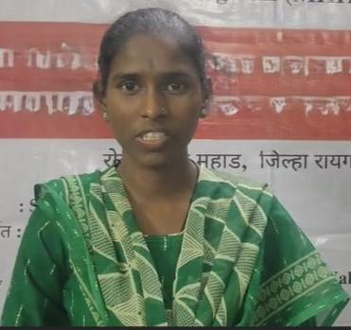 | 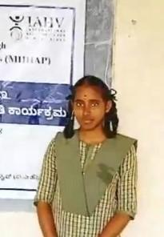
Living in a tribal area where menstrual topics are rarely discussed, I’m grateful to finally learn this important information—it has truly empowered me," says Miss M. (Dr. Babasaheb Ambedkar College, Mahad), who walked 1 to 1.5 hours every day to attend the workshop. | “Earlier, I couldn’t handle my period pain, but meditation and asanas have helped me feel more in control and at ease.” – Miss D. (8th Std from GHS School, Maralakunte, Bangalore rural)

Fundraising Event
Volunteers of Art of Living UK and Nigeria and of International Association for Human Values organised a Wellbeing evening on Saturday 5th of April 2025, which was held at Omnom in London, UK. The event focussed on Introduction to Ayurveda with Women’s health in mind by Dr. Payal Mehta, there was a laughter yoga session conducted by Shalini Beri, A laughter yoga coach and meditation session, followed by food.
The event was attended by 12 participants, and it raised THE total funds of over £350 for the cause in a very short period of time. The interest in women’s health is apparent and many participants are keen to join the volunteer team. Follow up emails and phone calls to the participants was carried out to keep in touch with them.

Some photos from the event below:
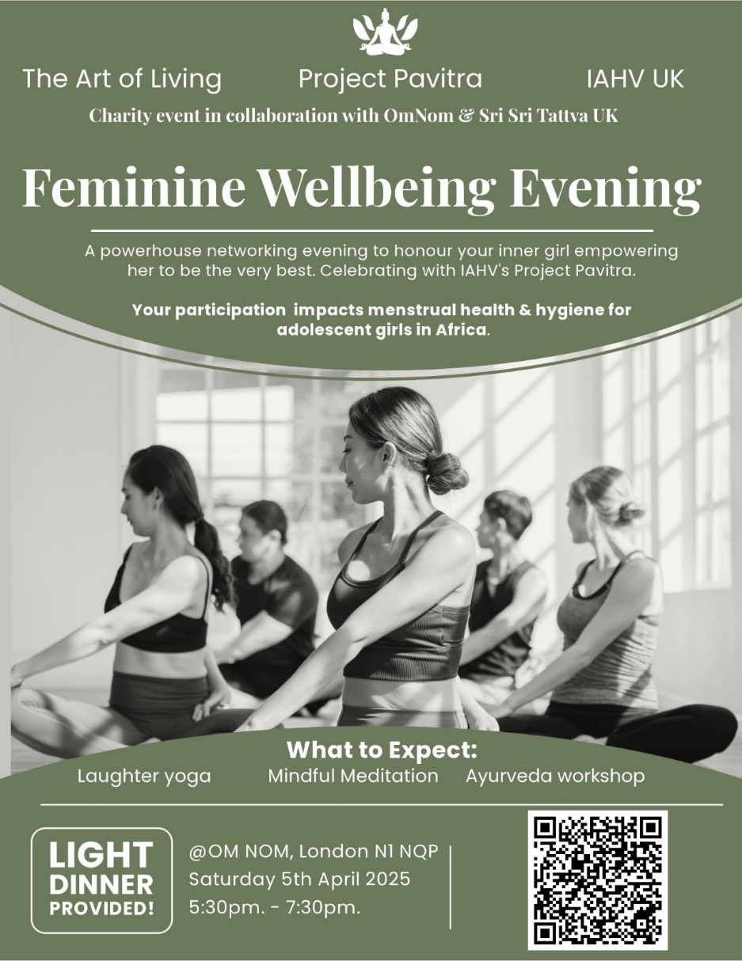
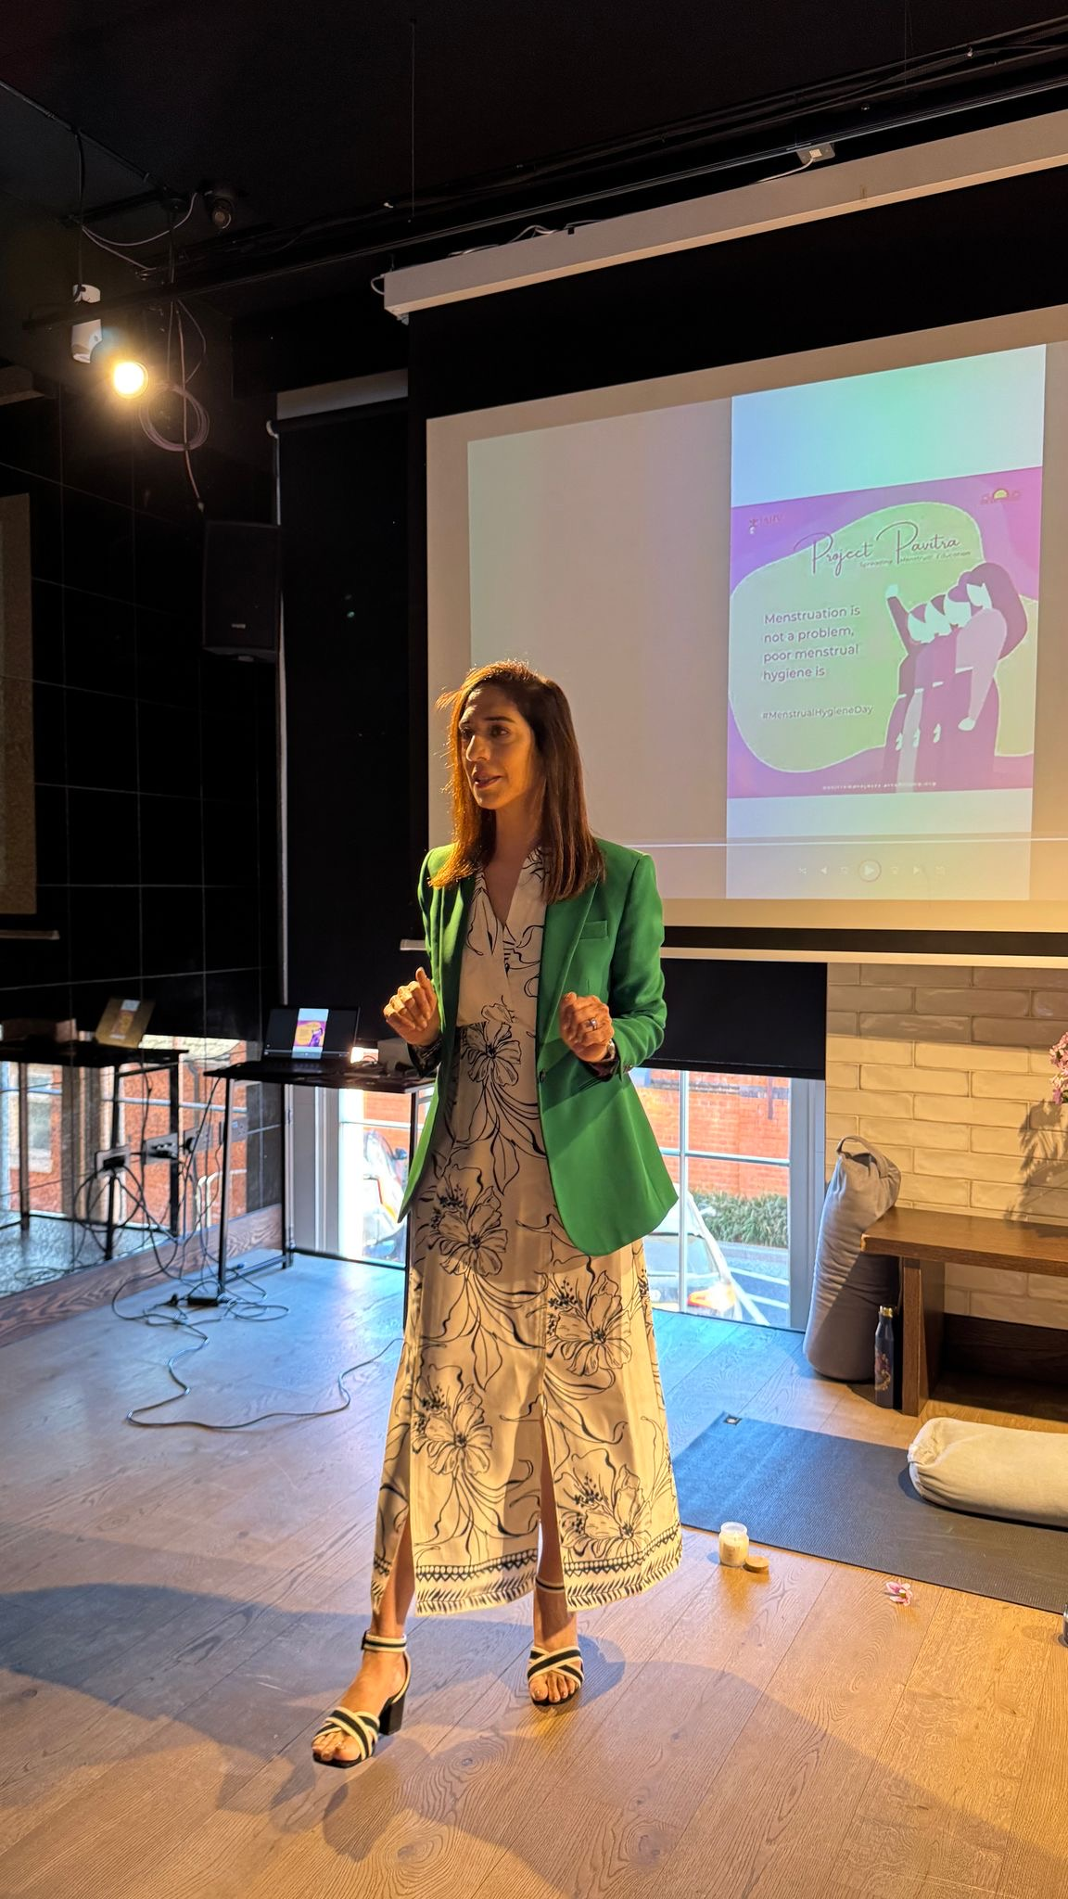
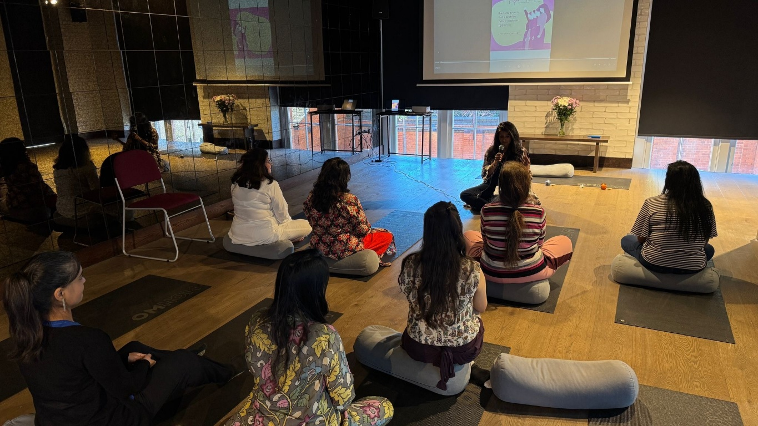

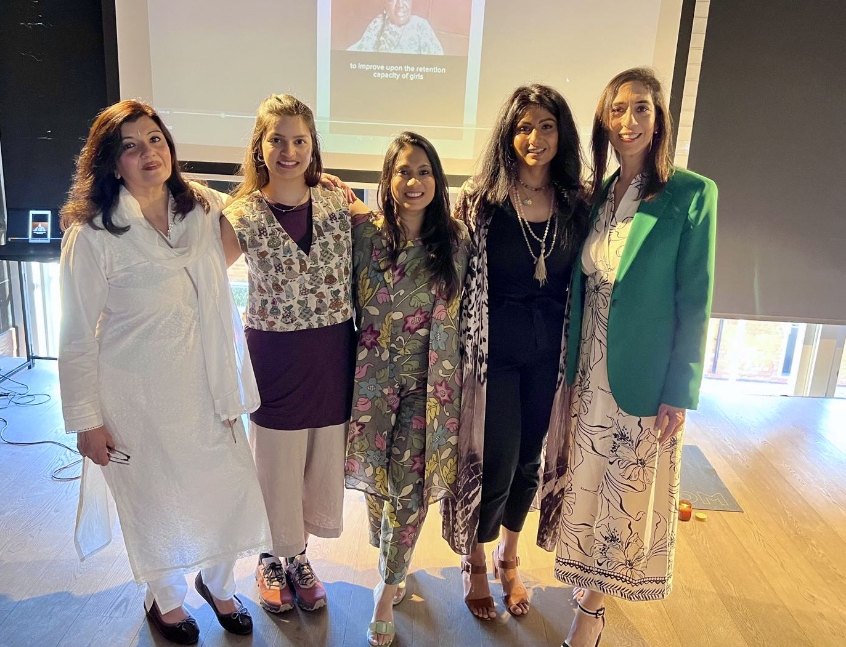
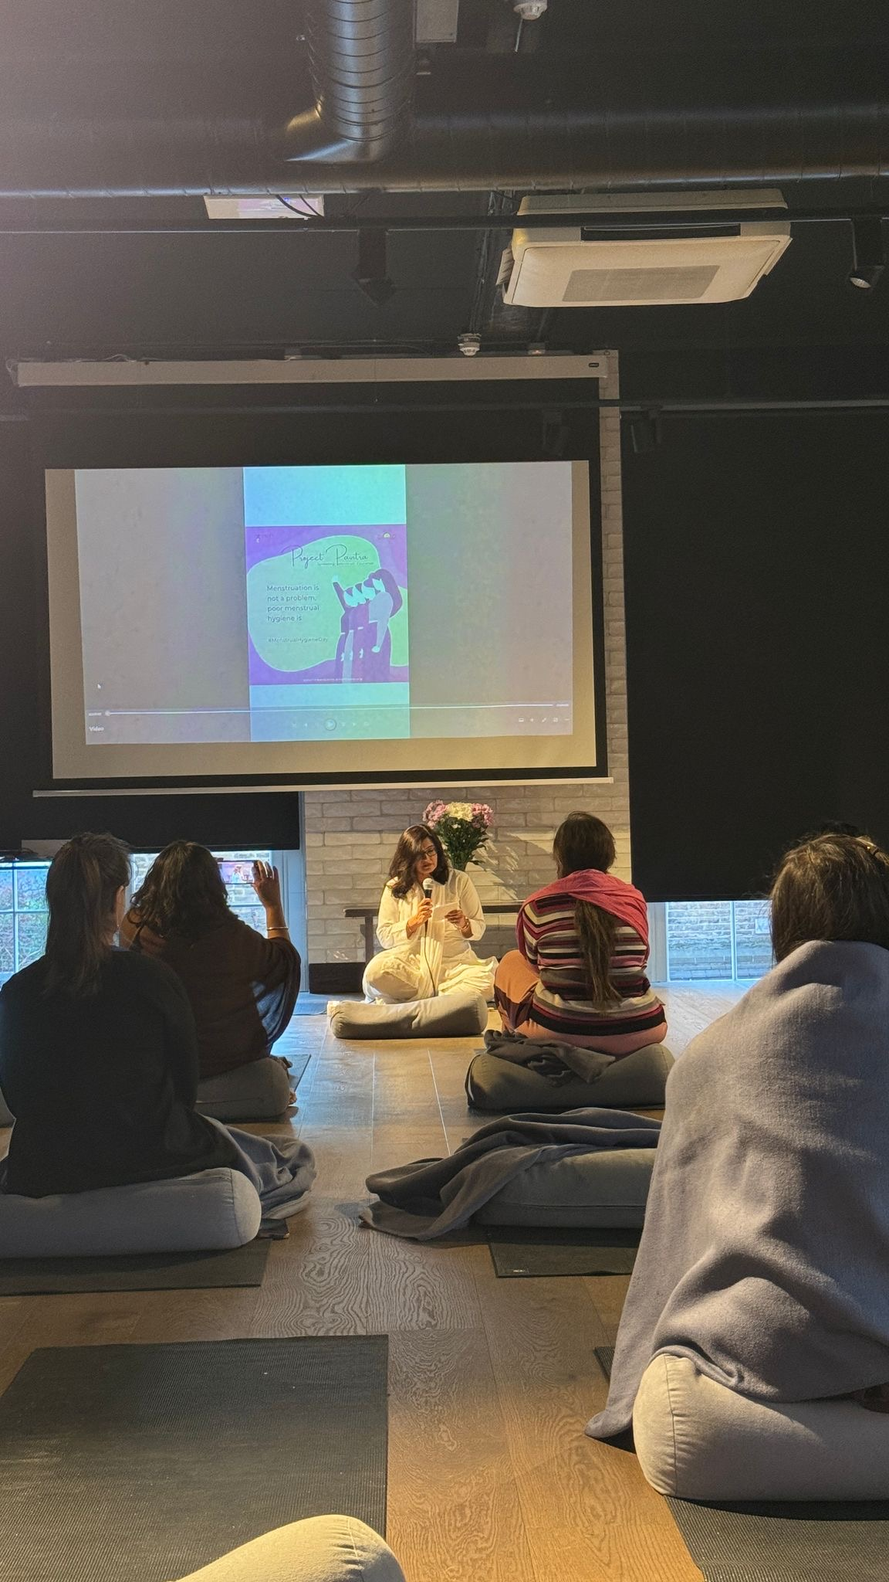

Call to action post the event:
Participants are encouraged to donate via the global giving page which can be found here:
Pavitra-Menstrual Holistic Education-Rural India - GlobalGiving
Or join the Whatsapp group using the following QR code:


Vision:
Below is a mind map with a vision to grow Project Pavitra in supporting Africa.
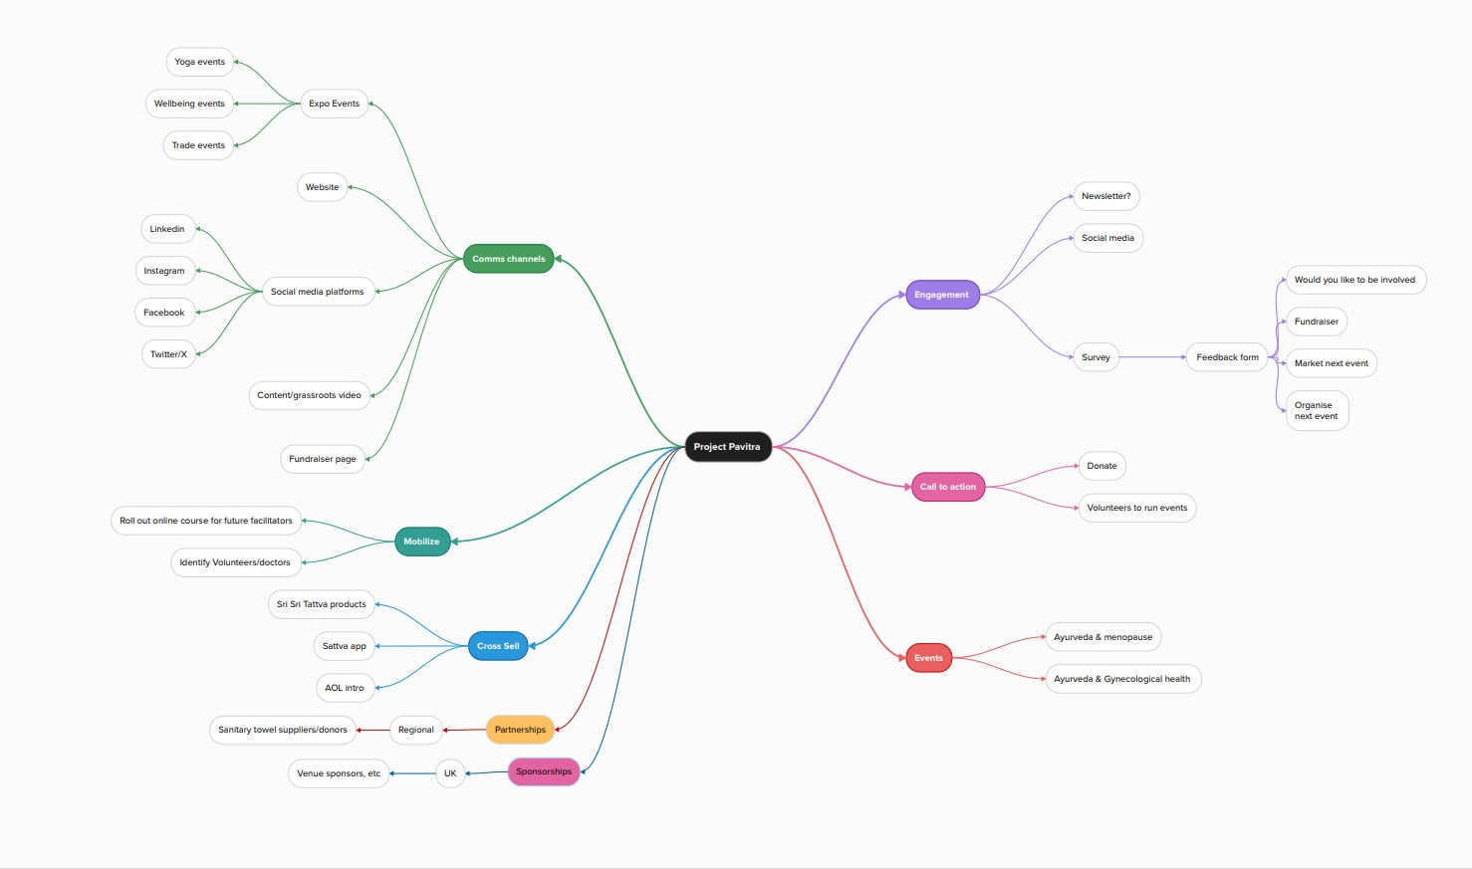

Picture Repository
More pictures from the session in Mozambique
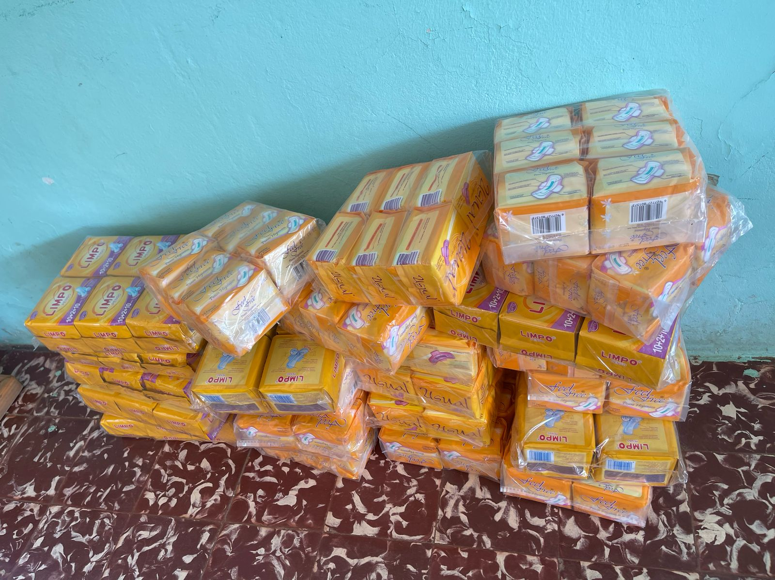
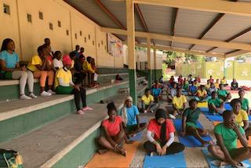

Pictures from South Africa below:
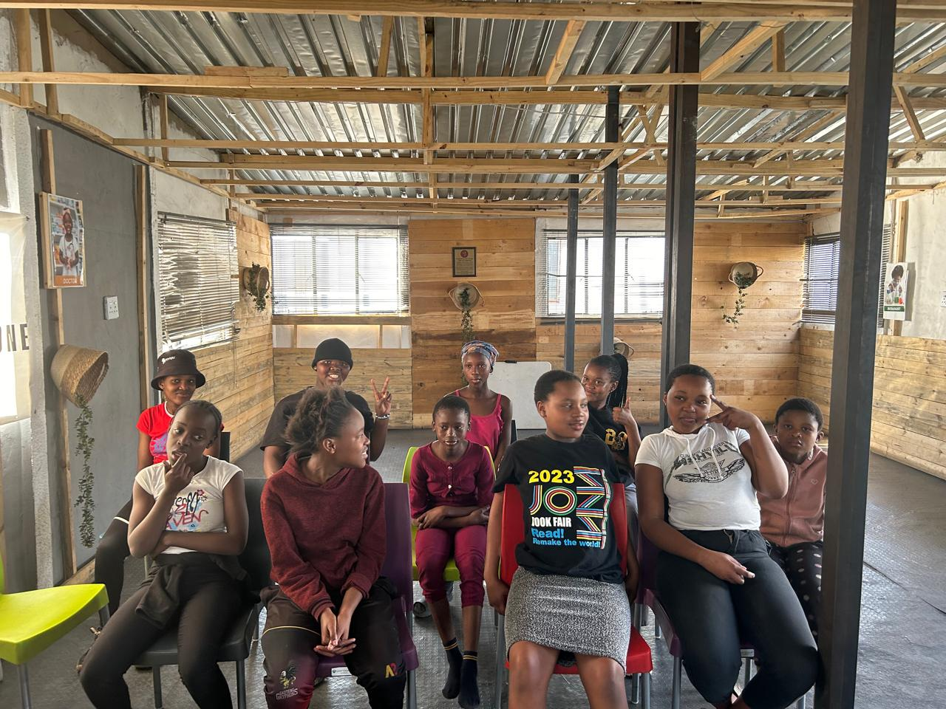
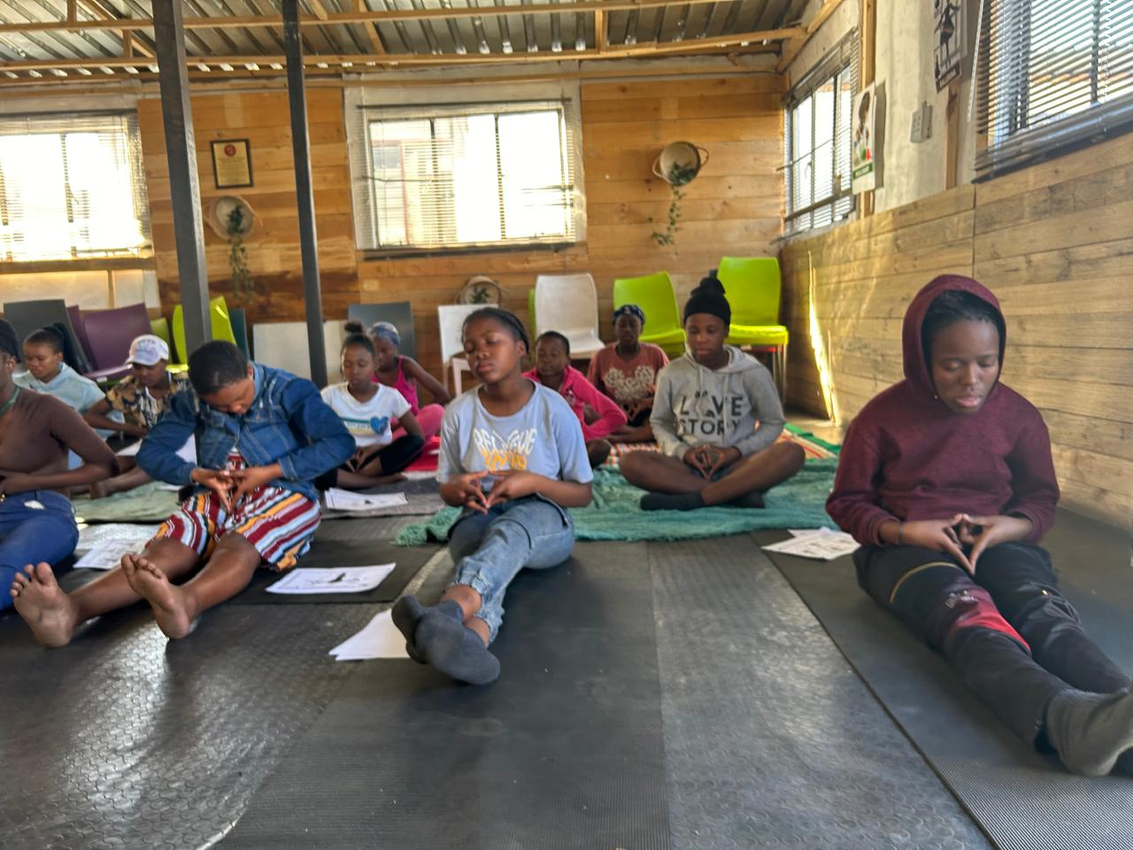

=\

End of report. May 8th, 2025

