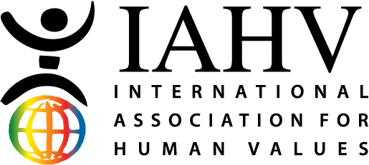

Project Update Report

October – December 2022

Project Pavitra is an initiative of IAHV to empower women through menstrual education. Since the launch in March 2018, our trainers have delivered complimentary workshops on menstrual health and hygiene to over 1,31,465+ adolescent girls. 6,129+ females have been trained to become menstrual health and hygiene champions in 24 states of India, 11 countries in Africa, Bhutan, Nepal, Sri Lanka, Cambodia, and Hong Kong.

