KARMIRHATH
David Company Para, Gaibandha, Bangladesh.
Registration: 1. NGO Affairs Bureau, # 2377/20.7.08
2. Directorate of Social Welfare; # Rangpur 517/86.

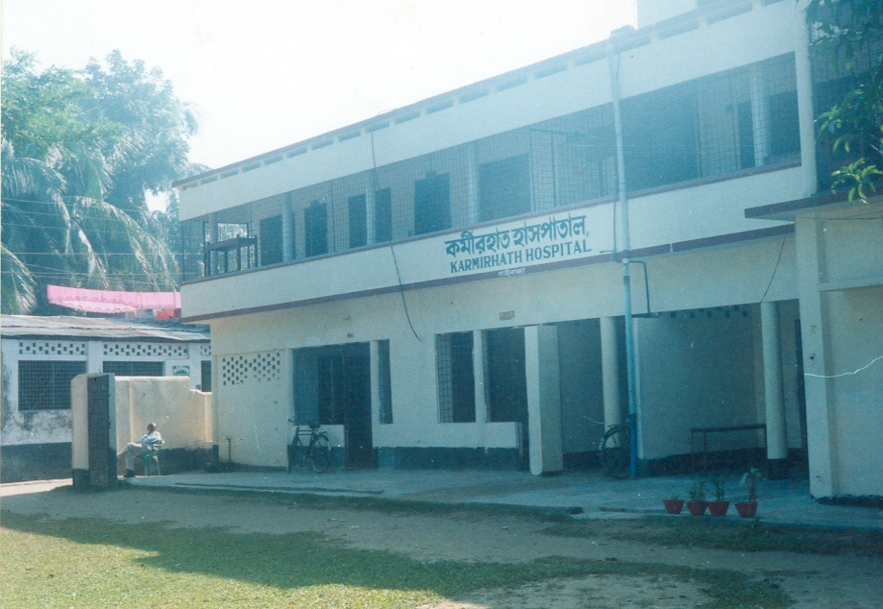
Karmirhath Hospital

Karmirhath, a not-for-profit organization, was established at Gaibandha, Bangladesh, in 1985 with the help of the local people. It serves a population of about 3.0 million covering the district of Gaibandha and the adjoining areas of the districts of Bogra, Rangpur and Kurigram. Floods annually visit this vast area causing serious damages to crops and homesteads.

MISSION:

The Mission of Karmirhath is to raise the socio-economic status of the poor, downtrodden and less privileged people in the society by providing affordable health care, mobility to the handicaps and training to the needy to save them from social injustices.

MANAGEMENT:

A fifteen member executive committee, elected every three years, manages the affairs of the organization.

FINANCIALS:

The projects of Karmirhath run entirely on public donations. Mr. Abdul Wahid Mia, a local philanthropist has been a major contributor since the inception of the organization. Besides allowing us to run the Karmirhath Hospital in his two-story building situated over 28 decimal lands, he has been a regular donor of cash and equipment. The other major donors are North American Bangladeshi Islamic Community (NABIC) who, besides financing three major projects, has so far helped us buy some costly equipment for our Eye Care and Diabetes Care Departments, a Bangladeshi American family who prefers to remain anonymous, bears all costs of the Pregnant Mothers’ Care Department and a group of young men residing in the USA bears the cost of the Children Care Department.

ON-GOING PROJECTS:

1. Karmirhath Hospital: It is the major project of Karmirhath.
As of June 2007,
- The Eye Care Department which is now equipped with most modern equipments for cataract surgery and treatment, has treated over 122,000 patients since its inception in 1985. Using one of the latest techniques of operation, I. O. L. (Intra-Ocular Lens), over 3000 cataract operations have been performed. It regularly holds eye camps in the rural areas. This department is financed from Zakat Fund and other donations from local religious Muslims and philanthropic people.
- The Children Care Department has treated over 7,000 children for different ailments since it was started in December 2004.
- The Department for pre-natal care of pregnant mothers has treated 3, 000 patients since it was opened in January 2005
- The Diabetic care Department took care of over 7,000 patients since it was started in mid-1998.
- The Dental care center has treated about 1000 patients since it was opened in February 2007.
- Pathological Laboratory: Almost all tests for Diabetic department, Eye care department and Mothers care departments are done at the laboratory.

2. Free Distribution of Wheelchairs:
Since 2006, we have been distributing wheelchairs among poor disabled people free of cost. These wheelchairs are donated by the Free Wheelchair Mission(FWM), USA. So far 3,300 wheelchairs have been distributed in 7 districts. Another 6 containers of wheelchairs (3,300 pieces) will reach our port in July 2009.

3. Anti-Dowry Project:
A pilot project to save the poor families from the curse of dowry has been undertaken with financing from our regular donor, NABIC who has shown a very keen interest in the project. A batch of 18 girls aged from 14 to 16 are being given lessons in basic education, health care and training on cooking, sewing, embroidery, cattle & poultry raising. At the end of their one-year training, each will be provided with an income generation program depending on her aptitude. In this project, the local administration, Women’s Affairs Directorate, local UP chairman and Imam of local mosque are involved. The object of the project is to make the girls useful to her family and more qualified as a bride. Karmirhath, with the cooperation of others, will ensure that the girls are married off without dowry.

4. Sports Complex for Schools:
Modern sports equipments have been installed in Bishnupur S. N. Girls school in Shahpara union under Gaibandha Sadar Upozilla. The project has been financed by NABIC. More rural schools will get this facilities.

5. Flood Rehabilitation Project:

Sponsored by NABIC, a few dozens of flood-affected families are being rehabilitated in the ‘char’ areas of Gaibandha upozilla.

LOOKING AHEAD:

To fulfill the growing healthcare needs of the local population, and to provide additional care, the following expansions at the hospital have been planned for the coming years:
- A 20-bed full-fledged modern Eye Hospital.
- A 20-bed full-fledged Maternity unit that includes a delivery facility.
- Providing hearing aids to needy hearing-impaired students.
- Providing sports facilities to poor rural schools
- Training of poor girls in income generating trades.

YOU CAN HELP:

To materialize the planned expansions and to enable the hospital to serve the ever-increasing number of poor patients and the different humanitarian projects, Karmirhath needs more funds. In the name of humanity we earnestly request for your generous financial contribution.

Please send all your donations by check or draft directly to Karmirhath, David Company Para, Gaibandha, Bangladesh, or to its savings bank a/c # 8966 with Janata Bank, Main branch, Gaibandha, Bangladesh. Donations are income tax free.

For additional information pertaining to the hospital, please contact the following:

1. Karmirhath, David Company Para, Gaibandha-5700, Bangladesh.
Phone: 88-0541-62245,
E-mail: asobhan211@yahoo.com

2. In USA: M. Akbar
Phone: (718) 850-7505 (Home)
(917) 400-8124 (Cell)
E-mail: makbar@aol.com

P L E A S E H E L P

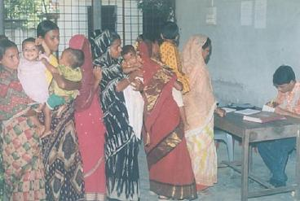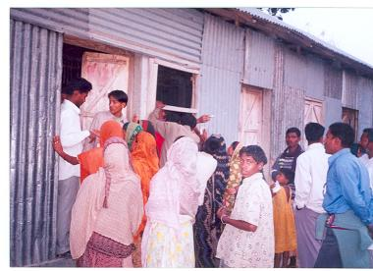

Pediatric Patients Being Registered Eye Patients at a Camp

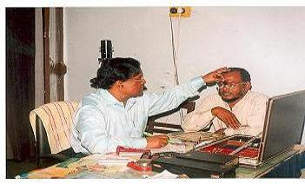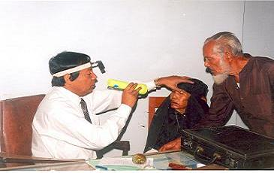
Doctors Examining Eye Patients

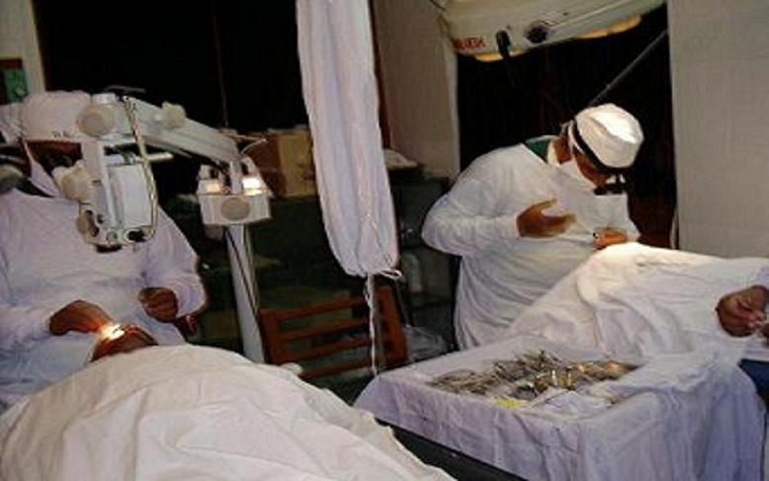
Surgeon Performing I. O. L. Operations (right) while another is being prepared for operation (left)
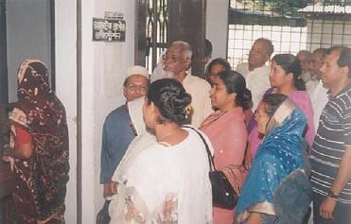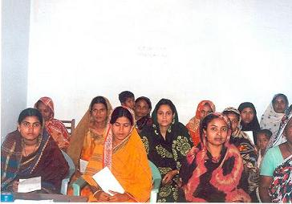
Diabetic Patients Waiting for Registration Diabetic Patients in an Awareness Class

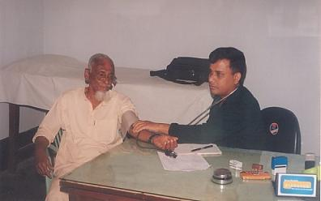
Doctor Examining a Diabetic Patient

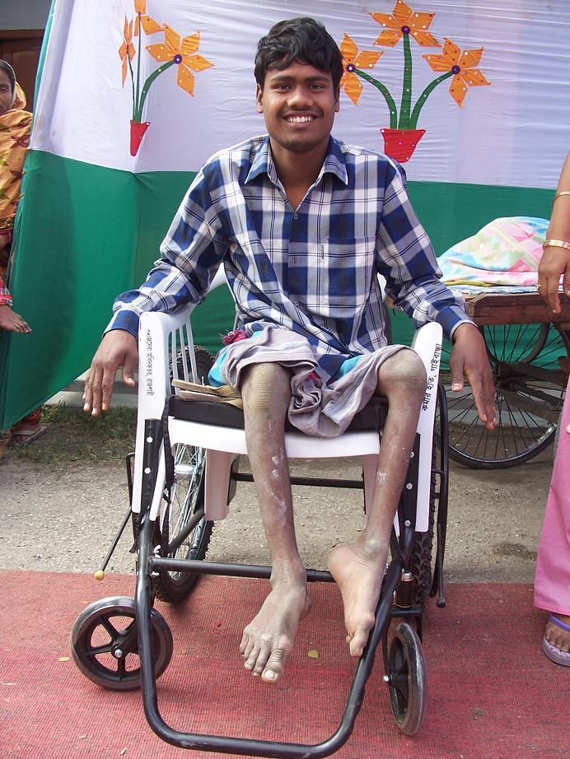
One of 3300 recipients of wheelchairs.

