INCOME GENERATION ACTIVITIES TO POOR PLANTATION WOMEN

1. Name and Address of Individual or association submitting the Project
Miss. Jayathri Mihirani
Secretary
Centre for Human Resource Development (CHRD)
01, Walakumbura Watta,
Raitalawela
Ukuwela
SRI LANKA

Telephone Number: 94 71 548 9964
Fax Number: 94 66 22 45101
E-mail; hrdvisionjm@gmail.com
Website: https://www.humanresourcedevelopment.org

2. Name of Project:
Income Generation Activities to poor Plantation Women
3. Description of the beneficiaries, geographical location, approximate number of direct and indirect beneficiaries, age, group, sex, occupation if any:
The beneficiaries of the project are Tamil Plantation women and girls. They are the poorest of the poor, often the slaves of the slaves because we consider them to be the most oppressed and under-privileged group in our country today.
The beneficiaries are approximately 720 women, who are working as workers of five Tea Plantations in the Matale Divisional Secretary Area of Matale District in the Central Province of Sri Lanka. They are years in age between 18-45. The women are extremely poor living belo the poverty line.
Context:
Women in Plantation trail behind men on virtually every indicator of social and economic status. They work long hours, but earn less income despite the fact that they are responsible for meeting to 40 to 100% of family basic needs. Low level of literacy, skills training bargaining capacity result in women often being compelled to resort to jobs that are low paid, monotonous, seasonal, intensive carry considerable occupational risk. As a result, poverty among women is a more intractable than among men. Coupled with the house-hold poverty that women have to deal with, they also face enormous disadvantages embedded on gender relations, for example domestic violence, the responsibility social reproduction under adverse conditions and lack of access to decision making and power. Deepening poverty among women, a product of both of their low status and general economic declaimed is contributing to a raising prostitution, considered as one of the important reasons for the spread of sexually transmitted diseases and reproductive tract infections in plantations.
They get a little more exposure and some space to share with other women, unlike the rural women, but have hardly any security. In the feudal structure abuse and violence is more common with plantation women.Domestic violence is common with they are victimized in the work place too – receiving lower wages and running the risk of sexual harassment. There are also incident of prostitution and of trafficking – families selling of daughters. Women have very little or no involvement in decision making process, if the women is earning and running house, she may have some say at home but will still is violence at the plantation level!.
Ignorance about health is common amongst all women; they tend to ignore their illness. The resuktt is high malnutrition, high maternal mortality, and high maternal mobility rates. High fertility rates, yearly and repeated pregnancy, and a wide spread prevalence of anaemia and reproductive tract infections. Women have to poor access and control over means of livelihoods like land, property, animal wealth and there is poor awareness of legal rights and issues.
Geographical locations: Five (5) Tea Plantations in Rattota, and Ukuwela Divisional Secretary’s areas.
Approximate number of beneficiaries: Direct: 720 Indirect: 3500
Sex: Female
Occupation: Tea Plantation Workers

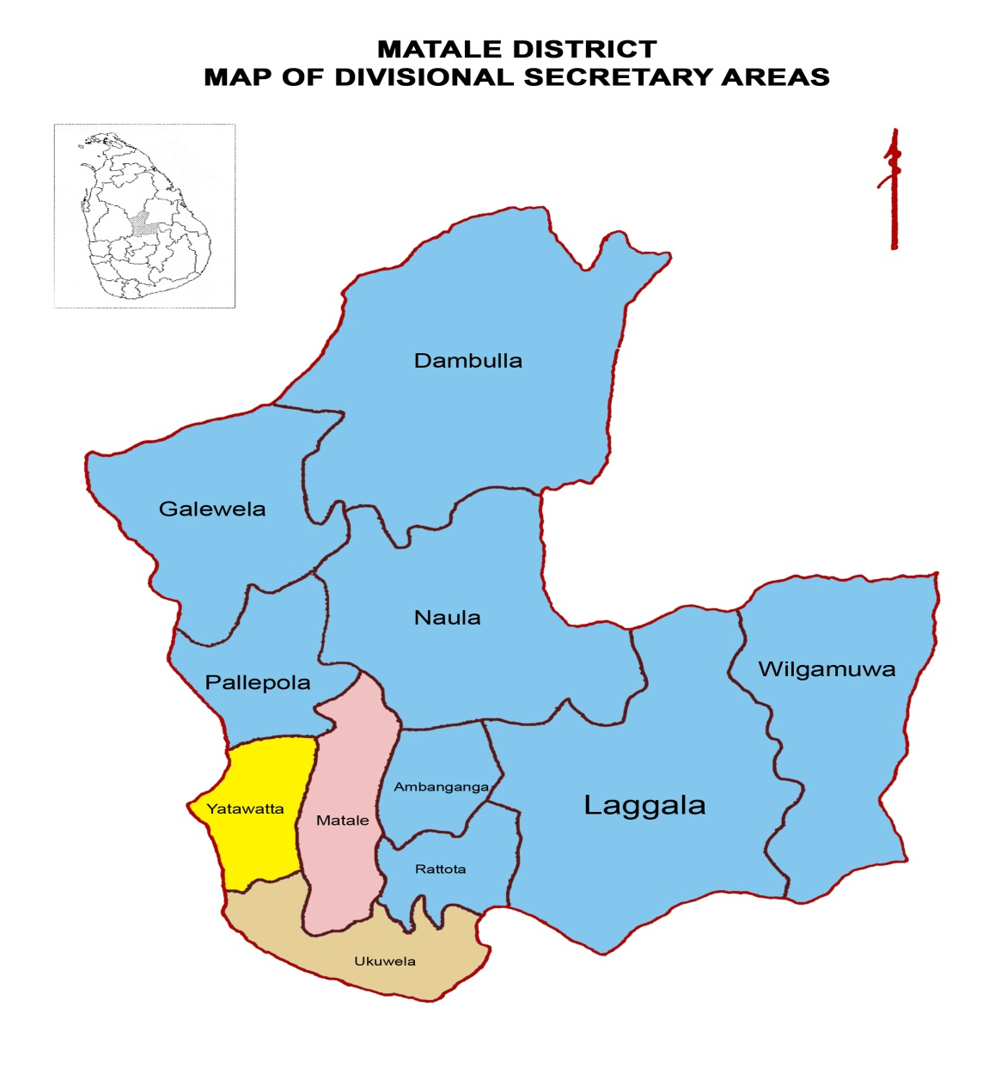
4. What is the relationship between those submitting the project and the project beneficiaries?
Our organization implementing programmes for women upliftment in the plantation areas since 2005. We have implemented the following programme for the beneficiaries.
- Gender Equality
- Tackling injustice
- Violence
- Exploitations and Empowerment of women
In the plantations
As it was discovered the target groups are the poorest, oppressed and illiterate it was made possible to pay special attention to their needs, and the beneficiaries were made the target group their development. After the discussion we had with the beneficiaries’ we decided to submit this project. For their economic advancement.
Furthermore, the beneficiaries are also the members of our organization, and make suggestion and decision with the with the committee members to prepare the project proposals, reports etc.
5. Describe clearly and briefly the problem (s) that the project will attempt to solve and the proposed solution (s):
Problems:
Living condition of the plantation women is very poor. They work on the plantation for 8 hours. After that they work at their homes for many hours. They prepare the meals for the entire family, which consists of approximately 8 members. They look after their children, grand mother, grandfather, father in-low, mother in-low etc. They bring water to their house for the house-hold work. They wash soiled clothes. Many women have to work in their vegetable gardens after their work. When the children fall sick, they take them to the plantation dispensary or the distant town. In some family the women are beaten by their husbands. They do not have proper clothing. They eat poor food. In their work places, they are subjected to untold hardships.
Education:
Most of the women do not get basic education. Their parents do not like send their daughters to schools. They do not know to read and write. Most of the women are not able to put their signature in their mother-tongue. As a result they are not aware what happens outside the plantations. Due to their illiteracy iy is very difficult approach them.
Health:
Since women’s income is limited, they are not in a possible to eat good food. At the same time they have tp hand over their salary to their husbands. As results they suffer from difference diseases. There no toilet facilities in the plantations. There are no proper facilities in the plantation dispensary.
Proposed Solution:
- This project provides skill for income generation among women of plantations. Business development and financial management courses empowering women to control their lives.
- Goat milk allows poor families to improve their economy and give their children animal protein otherwise this will be out of reach goat manure fertilizers gardens providing other essential nutrition Plants grow to feed the goat reduce soil erosion and help improve small farm production.
- The project will provide economic empowerment by teaching marketable sewing skills and providing market for sewing products.
6. Describe the outputs of the project (e.g. in terms of buildings, infrastructure, services provided, training etc.)
1) 300 women will be taught basic education who will finally understand to read and also understand their equal rights
2) under small scale income generation 300 women will be trained in raring goats
3) 60 women will be start rearing goats and earn a monthly income of Rs. 5,000 after 6 months
4) Thrift and credit group will be created
5) Community leaders will be developed
6) Skill development will be created
7) Health and Nutrition to mother and child will be improved

BUDGET

Description | Unit Cost | Total Cost
Salary to 1 Coordinator | @ Rs. 30,000 per month for 12 months 30,000x12 | 360,000.00
Salary to 1 Administrative Officer @ | Rs. 30,000 per month 30,000x12 | 360,000.00
Employees Provident Fund & Employees Trust Fund | 15% from the gross salary | 108,000.00
Travelling to Coordinator | @ Rs. 10,000x12 | 120,000.00
Basic Education for 60 girls using 2 Teachers @ | Rs. 10,000 per Teacher per month – 10,000x2x12 | 240,000.00
Training on small scale income generation @ | Rs. 500 per participants- 500x300 | 150,000.00
Small Scale Income Generation –rearing goats @ | 60X 30,000 | 1,800,000.00
Building of Goat Shed @ | Rs.3,000x60 | 180,000.00
Medicine & Veterinary surgeon charges for 6 months | @ Rs. 15,250x8mths. | 122,000.00
Total Cost |  | 3,440,000/00

US $ 20,000 (1 $ is equivalent to LKR 172.00)

