IRRIGATION TRAINING AND $$ ECONOMIC EMPOWERMENT

Project Title

EMPOWERING 1.3 MILLION MARGINALIZED RURAL WOMEN FARMERS IN 64 VILLAGES OF MWANGA, MOSHI AND KILOSA DISTRICTS, TANZANIA

Policy Context :
The Tanzania Development Vision 2025 of 1999 outlines the long term social and economic development goals and aspirations including (i) a higher quality livelihood, including food self-sufficiency and food security; universal primary education, the eradication of illiteracy, levels of tertiary education and training commensurable with a critical mass of high quality human resources, gender equality and the empowerment of women in all socio-economic and political relations and cultures., universal access of safe water, good governance and the rule of law; a strong and competitive economy comparable to middle-income countries, macro-economic stability and an active and competitive player in the regional and world markets. While it is estimated that between 95 and 97 percent of the food consumed in the country is locally produced, women play a vital role to this end. IRTECO through this project proposal brings ideas to make woman farmer proudful with agriculture as a process to execute a Government Slogan - KILIMO KWANZA
Location(s)

Sixty Four Villages in Three districts of Mwanga (24 villages) and Moshi (39 villages) in Kilimanjaro Region and Kilosa (4 villages) in Morogoro Region, Tanzania

Duration of the action | 36 months (2009 – 2012)
Quality of objectives
Level of gender awareness to the community, women benefits from the project, gender relations in families, emerging of new gender initiatives, self development, PAME tool, Gender Sheet Analysis
Objectives of the action | General objectives  To contribute towards an increase of women-led-household income from US$ 250 to $400 per year per family to raise their capacity to pay for their basic social services by end of 2010 specifically;  - To narrow down economic inequalities of men-women in the community to a minimum possible limit in 4 districts in Tanzania  - To endow poor women with agriculture and water assets for their own farm-base business in effective way to alleviate poverty.  - To contribute towards improving the quality of life of rural women in the 4 districts  - To create income earning opportunities to women-led-families for affording social services mainly health, education and food  - To enhance equitable distribution of income and wealth system that will raise lower income earners and set a bench-mark for effective and broad based social security
Partner(s) of | District councils of Mwanga, Moshi and Kilosa, Tanzania Organic Agriculture Movement, Tanzania Chamber of Commerce Industries and Agriculture (TCCIA), ASP(T) Network, Slow Food International, Asilia Convivium Tanzania, Communities of 64 villages, Community Based Organizations (Formal and Informal, private sector
Target groups | Mwanga 5 divisions, 5 wards, 24 villages, Moshi 4 divisions, 12 wards, 45 villages and 3 divisions, 5 wards and 64 villages in Kilosa districts in Tanzania
Beneficiaries | Marginalized women, children, youths and disables in villages of Kighare, Kilaweni, Kiriche, Kirongaya, Mshewa, Ndambwe, Mwero, Ndorwe and Mbakwe villages, the low land communities of Moshi sparsed between 15-30 people per square km and Iyogwe villages in Kilosa
Estimated results | - Economic inequalities of men-women in the community reduced by 75% in Mwanga, Moshi and Kilosa districts by 2012  - Resource poor women endowed with agriculture and water assets for their own farm- base Business in efficient manner and poverty is reduced by 90% by 2012  - Income earning opportunities to women-led-families live through agricultural products increased by 50% and afford to pay for social services mainly health, education and food by 90% by 2012  - Equitable distribution of income and wealth system in water resource potential areas is enhanced and lower income earners raised by 50% by 2011  - Improved health and sanitation at house hold level by the year 2012  The costs and benefits analysis of the project on 5 years timeframe of this action has been calculated. The cost of the action, the cost of the investing efficient use of integrated water resource packages provides the Economic Net Present Value (ENPV) of US$ 3.080.398, the Benefits- Costs (B-C) ratio of 2.52 and the Internal Rate of Return (IRR) 31%

Results Descriptive and Specifications:

The levels of synergy (1+1>2) and relevance on practising gender perspectives along with planned activities as well as replicability of IRTECO PAME and PAR tools to the women based communities will be the criteria for measuring the impacts of project intervention.

- Economic inequalities of men-women in the community reduced by 75% in Mwanga, Moshi and Kilosa districts by 2012
The following main activities will be organized to realize the estimated result ONE by 2012
- Conduct 3 broad based gender responsive studies in the area for women database - economic problems, guiding principles, methods of operations, resources and policy implications
- Provide training skills, allocate and support women in positions of their abilities
- Provide training skills on socio-economic enforcement systems “justice” and support pay fare remunerations for women works (matching supports)
- Allocate 3 “women compensation funds” centres against unemployment, education deployment of girls, occupational hazards, old age group and other similar difficulties.
- Support opportunities to disabled groups including orphans, mental handicaps and adolescences
- Establish one strong networking on women righteousness and acts against regression, oppression etc
- Integrate data base findings to Local Government Authorities plans for broad government support yearly
- Enhance local supervision and follow up of implementation of projects activities, appraisal and evaluation.
- Facilitate establishment of women-led groups with full trust and confidence skills required for a happy and growing woman in the society (by having a long term plan of investment and implementation)
- Support preparation of women-led-plans to stimulate their needs and establish or/and reinforce by-laws, faith, life intelligent, posterity, property in all 3 districts

Result 2: Poor women endowed with agriculture and water assets for their own farm-base:
- Initiate and support 20 effective agri-business pilots in 3 districts for effective manner and poverty reduction by 90% by 2012
- Conduct 15 trainings on gender integrated water resource management practices for sustainable agriculture in 3 districts
- support conservation and sustainable activities on use of wetlands and environments threatened by high population growth, development pressure and accumulations of pollutants from inland activities
- Promote increased participation and improved integrated water resource management through institutional strengthening and appropriate awareness creation and capacity building Interventions and Research
- training on gender resource allocation and consumers behaviour in 22 villages in 3 districts (60% men participation)
- Set up 4 slow food and human rights mass campaigning in collaboration with associative networks for gender promotion and supports..
- support construction of 9 water harvest techniques and rehabilitate 6 dams for water recharging in selected agriculture potentials
- support establishment of 3 earth-markets and 3 presidia for promotion of traditional and indigenous agriculture practices in 3 districts

Result 3: Income earning opportunities to women-led-families increased by 50% and afford to pay for social services mainly health, education and food by 90% by 2012
- facilitate and support investment in welfare services to 45 women groups – 6 health centres, multipurpose service centre, 3 orphanage centres, 6 groups of women higher generating crops /activities including pottery, sawing, embroidering,
- Set fundraising and women charity days (2 yearly) at village levels for collective funds (to involve fundraisers for undisclosed grants along with priorities in the village)
- Construction of 3descent markets, 3 community libraries and contractual entrepreneurial women in public transport (3 pick ups),
- Train on and support for self help initiatives in building public infrastructure such as roads and markets, schools, community libraries, shopping areas.
- Provide direct supports to old age and disadvantaged groups includes neglected families, buttered women, single parents, poor of the poor, widows and widowers etc to improve their well-beings through promoting their active participation to the community development.

Result 4: Equitable distribution of income and wealth system is enhanced and lower income earners increased by 50% by 2012
- Assess and review legal/traditional/norms and enforcing those acceptable to the community and set bench marks for adoption of successful ones
- Conduct trainings on justice, human rights, social and economic and self justice knowledge to at least 40% of women in the 4 districts
- Strengthening cooperation on shared water resources and set joint action plans within the 3 districts
- Conduct 3 conflict resolutions training on land and water resources conflicts for promoting security and integrity of women in the country.
- Application of demand management principles including economic and legal aspects to promote different allocation, use, serving and recycling of water
- Measures to prevent and control pollution of water resources

Result 5: Improved health and sanitation at house hold level by the year 2012

- conduct mapping on ecological sanitation in rural and peri-urban areas based on zero pollution, water conservation and recycling e.g. compost latrines
- Support water supply integrated women plans with health perspectives and environmental sanitation to meet basic human needs
- School training on health and sanitation though child to child approach
- Support in the construction of improved latrines - Ventilated Improved Double Pit (VIDP). The latrines shall save the problem of fertility management though utilization of the available composite.
- Training of the Health committee in each respective village.
1.5 Project Executing Agency:

The executing agent of the project is IRTECO with its headquarter in Moshi and branch office in Morogoro. There will be a National Coordination Group (NCG) committee of which project funders are invited and the Project Coordination Committee (PCC) that will involve the focal, 3 district coordinators, thematic specialists, Local Government Representatives, community leaders’ representatives and women /youths representatives. The project executing team entails different education background in the field of economics, gender, Information and Technology, processing and agricultural engineering, agronomist with broad experience in both public and private sectors. Equally, all have exposure of sustainable women development issues, farming systems having been actively participated in the several professional trainings, workshops, conferences, seminars and involved in the process of sustainable rural development within and outside Tanzania since 2000.

The team has a potential link with different local and international organizations including REPOA (Research on Poverty Alleviation), Tanzania Organic Agriculture Movement (TOAM), the AGENDA For Environment and Responsible Development, the Africa Stockpile (Tanzania) – a network for International Chemical Conventions Implementation in agriculture, the Slow Food International of Turin, Italy, Tanzania Chamber of Commerce, Industries and Agriculture, ACRA – an Italian International Organization, KFD – Dutch supported project etc. In each district, IRTECO is working with Local Government Authorities where departments of Community Development and Cooperatives are closely linked. IRTECO has also potential Links with Local Government Authorities of Moshi, Mwanga and Morogoro districts, so in each district, the project will have a liaison officer to coordinate the project with close technical support from IRTECO. The major funder(s) of the project will contractually allocate the advisor(s) for ease transfer of both technical and financial skills from different areas in the world.

1.6 Project Justification:

1.6.1 Relevance of the actions and priorities of the project

- The overall goal of these efforts is to contribute towards an increase of household income from US$ 250 to 400 per year per family in order to build capacity of 2400 women to pay for their basic services including health, education and food through strong and fair gender -led-households.
- A total of 1,460 youths in the village, only 30% have seasonal jobs and the rest have to stay in the village with no specific tasks throughout a year. Migration to urban centres is high and this happens seasonally as paid jobs are not available in the village, that lead to a fewer service givers than service recipients in the villages, that always are poorly rendered by unqualified people, though the same migrated youths have basic skills that have never been tapped to productive uses.
- The villages have a potential source of talented young women and youths who have Basic skills on income generating activities, health issues and vocational skills, that is a necessary condition for women projects to be successful. Some groups have already been formed with entrepreneurial initiatives, thus, assumes labor force availability in the village for the Project success.
- Prostitution is not at all “a safe business” as it is the major cause of HIV/AIDs and transmitted diseases, while orphanage problem in the village is no longer tolerable, thus a need for training women and youths on best operative mechanisms of national policies on water, human rights, gender and other related policies for promoting democracy and transparency that are basics for mass development in the villages.
- There is a need for increasing number of professional actors of all human faculties in the village including lobbying and advocacy gender team in implementing the community projects, thus becomes important for new strategies to train the teams at local level.
- There is a silent large number of disabled (with different disabilities) including Albino in the selected villages who have never been considered in development plans, while some of them have in-born skills necessary for their own life if well supported.
- All villages have potential water sources for the development of small scale affordable economic activities including small scale irrigation for sustainable life, thus, an engineer for quality life for women and resource poor families in the villages
- The project is in line with Tanzania Development Vision 2025 priorities and the National Poverty Reduction Strategy Paper in enhancing the access of rural population to water resources and basic socio-economic services, thus the project by end of 2012 will reach 30% of the total population in selected areas.
- There is already action going on and the beneficiaries have already taken part of some activities as dot 3 above, with strong financial and technical promises from the local government authorities that have limited mentioned resources.
- The local civil societies have fundamental roles in supporting loco initiatives for their legal survive and already has formed fundamental pillar to the communities.
- The loco contribution of the beneficiaries is assured in terms of both cash and in-kind contributions
- The project is a multi-sectoral initiative to the majority poor resource population in the selected village, thus assures maximum utilization of resources in the areas.

1.6.2. Clarification of needs and constraints in the project areas:

- The project area is estimated to a 40.671 km2 area with the estimated population about 1,529.629 95% of the mentioned population depends on agricultural for their life and 56% of them live in water potential areas where agriculture is the mainstay of their survival, but poorly developed.
- Project’s beneficiaries do not have the chance to realize autonomous solutions within their economical range in order to have effective use of integrated water resource management apart from different efforts by individuals including the ground ponds, poor utilization of streams or even digging shallow wells in their nearby areas. Apart from women being farmers as well, they still spend a part of the day walking or standing in queue to get not potable water from pits.
- An alternative to this project could have been to develop small and affordable integrated water resource management packages that will assure maximum benefits of water and land for agriculture, and ultimately, agribusiness promotion in the areas.
- Low social status of women in Mwanga, Moshi and Kilosa districts including women and girls normally not allowed to talk before men and are considered to be weak in all development aspects. Majority of men believe in this and agree that women are weak vessels
- Culturally, women in all these areas are less considered necessary in decision making meetings and not allowed at all to participate in traditional worshipping places, the places where secrecy and responsive issues are discussed and measures against some evils are set. This situation is putting women backward in understanding their environment and miss some important protective measures during calamities, shortage of food and even during wars
- Women are not allowed to become rulers especially in spiritual leadership or elderly roles, and becomes more serious during statutory elections where women are considered like potatoes in the sake and thus, remaining supportive vessel to men.
- Though women are key agricultural producers of both cash and food crops, in some areas they are not allowed to eat some nutritious and palatable foods such as ox-liver, eggs etc which are necessary not only for their health, but for children, elders and young girls. In this way, they lack knowledge on the foods for their health and always cook for men.
- Marriage in how applies for paying dower, a system that gives a burden to both men and women. While men find dowry demands by in-laws too high, women suffer for this once they are married. It is a crucial matter to be re-educated to the community and set new ways for marriages.
- There are some practices of female genital mutilation (FGM) in all areas, though at a reducing pace from government laws. However, every time new ways in doing the same action at village levels have been developed and some one needs to be close for the rural community to understand what and how this is really taking place. More researches and education is required to attain a zero practice of this devil act.
- Women lack technical knowledge and skills to run their individual and/or group activities /income generating activities profitably. There is a need for setting environment that would allow women led income generating activities to be recognized and supported by the government.
- Law and order that are function of growth and stability of economy and the inner happiness of the individuals are not fully in place. Brotherhood is lost and human killings especially to women and young girls is everywhere in the country
- Women have lost hope as though several trainings have been conducted in the country; over 65% of these skills remain with urban women especially those live in-door with leaders’ families. IRTECO, being an organization working with rural communities since 2000 sees a need to share these concerns globally for serious support.

1.6.4. The Policy Context on Final Project Beneficiaries

- Tanzania is committed to gender equity and has ratified international and regional conventions eliminating the different forms of discrimination against women. This commitment is manifested in the adoption of a National Gender Policy, the establishment of gender focal points in Ministries, Departments and Agencies and the amendment to the Constitution raising the percentage of reserved seats for women in Parliament
- The Tanzania Development Vision 2025 (TDV2025, 1999) outlines the long term social and economic development goals and aspirations, it aims at achieving by 2025. This will be achieved among others, through ensuring food self-sufficiency and food security; training commensurate with a critical mass of high quality human resources, gender equality and the empowerment of women in all socio-economic and good governance and the rule of law, that IRTECO has means to contribute.
- Concerning social cultural issues, the value systems, beliefs and attitudes of the people, the institutions, systems, mechanism and structures that perpetuate, reproduce and reinforce these values and practices have been well clarified in policies for execution, so importantly is to translate the policies in to actions.
- The impacts and effects of the project implementation will be used to illustrate the structure of the gender relations for a more transformation to more equal opportunities for men and women to be raised and a change
- Creation of self confidence of women will allow access to and control of resources for the benefits of rest of the families.
- Marginalized women is estimated 1,300,185 (85%) are the key targeted beneficiaries of the project. While a total of 987,539 populations in Mwanga, Moshi and Kilosa, districts will be involved in the project, 553,022 marginalized women will be directly reached by project services. However, because women a re the key custodians of family population, girls, children and disabled groups will also be involved.

1.6.4.. The Project Contribution to the Targeted Achievements:

- The Low Road Strategy (LRS) that involves reformism and modernizing the existing women local movements will be emphasised including women revivalists,
- Supporting motivative techniques, incentives to women leaders of change and to the community in general. Some Interventions among competing strategies will also consider successful traditional initiatives,
- Support women-led-planning and executions that stimulate needs for establishment/ reinforcing of by-laws, faith, life intelligent, posterity, property etc will be highly encouraged during the project implementation.
- Support old age and dis-advantaged groups includes neglected families, buttered women, single parents, poor of the poor, widows and widowers etc to improve their well-beings through promoting their active participation to the community development.

1.6.5 Subject Priority Areas:

- Time saving infrastructure for women and increase woman per capital income is a priority of this proposal as core factors towards elimination of Gender Disparity at all levels.
- The proposal is developed from Tanzania commitment to gender equity, and proposal aims at easening execution of ratified international and regional conventions in eliminating the different forms of discrimination against women.
- IRTECO is implementing the National Gender Policy that addresses a need to eliminate gender imbalance in many spheres of society. Women play a vital role in agricultural production; they have less access to credit, markets, inputs and labour savings technologies.
- Though women are de facto heads of 25 percent of the total households, their average income is 45 percent below that of male-headed households; and an estimated 69 percent of the female headed households live below the poverty line.
- The above facts make IRTECO to confidently share this proposal with GlobalGiving for funding possibilities.

1.6.6. The Organisation’s Motives for Submitting the Proposal
- Since its inception in 2000, IRTECO has a potential and practical experience, with broad and useful partnership local and international that shows the following facts;
- The traditional consumers’ behavioural tendencies of population in operational areas lie on conventional economics, while motives and goals of consumers do not allow women equality and equity to be in place. .
- Income allocation (IA) and final spending (FS) decision in these districts remains under men hands, and normally women have no roles to play in setting the final spending investment criteria, thus, a serious action for a IA and FS bench mark
- The men-led communities are covered with wastage of wealth for short term pleasures by men including drinking, smoking and additional marriages, while over 70% of men income does not come back to the family, thus a need for the creation of incentive womanish activities in the areas.
- Religious initiatives are normally men-led idea with very few ideas from women, thus need for repositioning religious centres of intelligences (mosques and churches) gender equity
- Some practical concepts of fair interest banking are mainly in urban areas, and for all decades, none operates in the villages. Need to establish a model of Women-led-charity banks. A thorough study on the concept will be required including review of SACCOs set ups and its intelligentsia, study the modern western financial institutional systems on women supports and demonstrate possibilities of running our financial centres without too much interests

From the above facts, IRTECO, its partners mainly communities and local government authorities have confident that through this proposal, it will be able to;
- Facilitate establishment of women-led groups with full trust and confidence skills required for a happy and growing woman in the society (by having a long term plan of investment and implementation)
- Improve provision of welfare services including
- Health centres /dispensaries
- Multipurpose service centre
- Orphanage centres,
- Women Income Generating Activities including pottery, sawing, embroidering, horticulture gardening, food processing.
- Facilitate fundraising strategy and women charity days at village levels for collective funds (to involve fundraisers for undisclosed grants along with priorities in the village)
- Create awareness on existing legal/traditional/norms and proposing ways to improve and/or enforcing those acceptable to the community

1.6.7 Project Risk Analysis

- Conflicting interests of policy makers in supporting the projects who always support the policies that the governments need to be reviewed.
- Laying down effective and broad women based social security require a community leaders and politicians who needed to get well furnished with project concept.
- How best the project will be able to compete with outdated and conservative way of considering woman, a vessel of man in all development, with less rewarding
- IRTECO, being a water and agricultural organization with broad participatory knowledge is strongly lying on poor resource farmers’ base different from those specialized gender issues, that are very necessary for any gender project, but can be easily undermined by less know ledged groups who have insufficient skills with problems related to this category.
- Women who are dejure and de facto heads of households and women who manage their own farm business alongside those of their male kin need direct access to small scale irrigation water services. However, irrigation agencies tended to exclude women categorically from access to water and related legal service. Some initiatives have been informally developed by indigenous groups that prevailing gender relations in irrigated agriculture. To support these initiatives, a holistic approach suggested by the project that could take time for most of women and men to understand and adopt is required.

1.6.8 Sustainability of the Activity:

- The project shall establish and maintain a women permanent investment fund – WPIF (endowment fund). The fund shall be used for provision of grants, investment it in a sound bank transactions, apart from being used as a guarantee for the organization’s obligations.
- The same funds may be used (with strict plans) to increase its volume through various ways including purchase of government bonds and treasury bills; securities quoted on a stock exchange and of the shares in the open mutual funds mortgage bond and deposit funds and deposit certificates with agricultural oriented banks.
- For small scale irrigation and slow food agriculture, a Water Users Group/ Association shall be establish to control the use and distribution of water within the project area, the leaders (gender balanced) will ensure equal distribution of water resources within the catchment (upstream and down stream). The association shall also be responsible for running and maintenance of the irrigation project and marketing of produced organic products.

1.6.9 Involvement of the Target Group

- Since the concept of building human and social capital takes time, over the period there will be a gradual phase in of reasonably low user fees for extension services and establishment and or strengthening local agro-pastoralist fund at village, ward and district levels.
- Established groups and networks at the same levels and since the district council remains a permanent partner of this project whereby its extension system will intensively be used to build the bottom up sense of responsibility from the beginning, thus, the project supported activities will be scaled up and sustainability will be assured.

1.7 Detailed Description of Activities

The criteria used to measure the availability of resources has been tested by existing willingness and self help initiated activities funded so far by local contribution and efficient use of local resources. The responsibility and influence sheet and participatory tools is as shown in the following chapter.
1.7 Detailed Activity Budget Lines

Technical and Financial Resources

Result/qualitative activity | 2009 | 2010 | 2011 | 2012 | TOTAL | Time
Output/Activity
Economic inequalities of men-women in the community reduced by 75% in 64 villages of Mwanga, Moshi and Morogoro districts by 2012 | 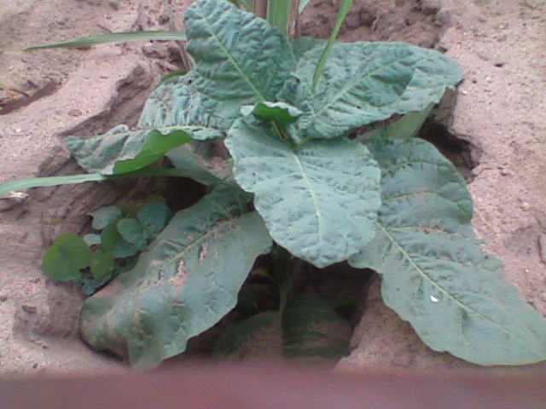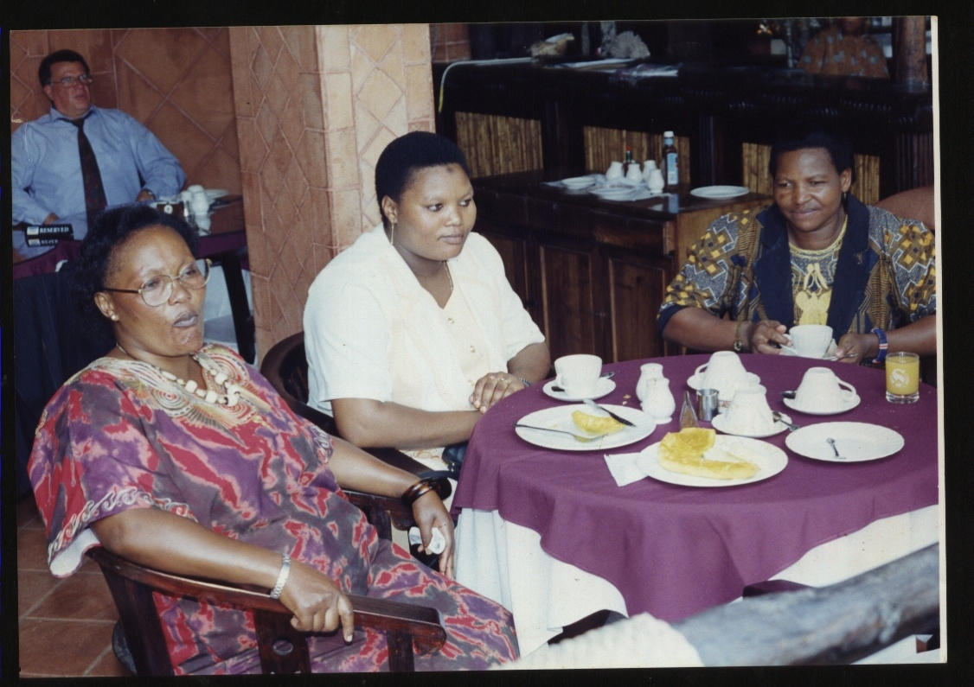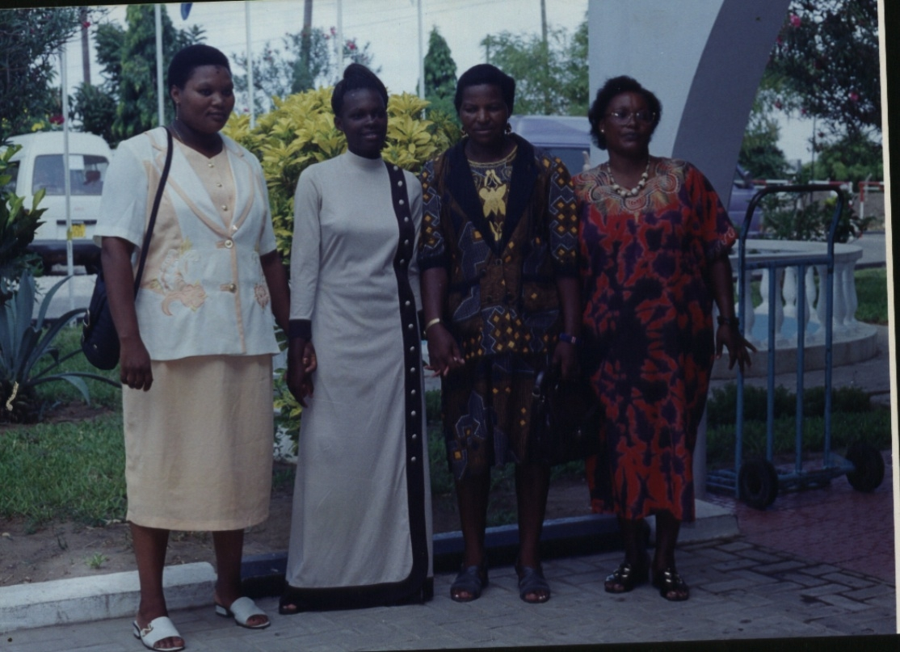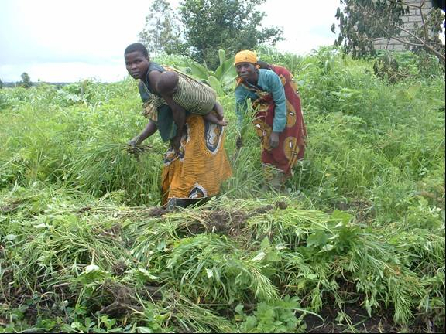
- Conduct a broad based gender responsive study in 3 districts  - training skills to 200 women on Integrated Agriculture business skills  - Training skills on human rights enforcement systems “justice” and “women compensation funds” (220)  - Support opportunities to disabled groups (2 multi-purpose centre in Moshi and Iyogwe)  - Support 3 networks on women legal righteousness and political positions  - facilitate 145 to prepare strategic/ business plans  - support project running administrative costs (communication and study tours)  - Matching grants to 13 women development projects in 3 districts  - Capacity building on use of data and establish Data Bank (4 desktop computers)  - Enhance supervision and follow up 8 campaigns on HIV/AIDS pandemic and STDs  - Facilitate establishment of 3 slow food women-led micro irrigation presidia  - Support participation in public relations events (2 international and 3 local early)  - Support old age and disadvantaged groups includes neglected families, buttered women, single parents, poor of the poor, widows and widowers (forums and skills managed events 2 yearly) | 4,000  2,600  600  5,000  6,000  1,100  6,400  4,000  4,400  2,000  5,500  6,500  3,000 | 11,000  7,600  1,600  8,000  11,600  6,900  12,400  13,000  8,200  9,000  13,300  10,100  7,000 | 6,000  3,200  5,300  12,900  13,400  2,900  12,400  13,300  8,200  11,600  13,300  11,500  6,000 | 9,000  5,600  600  8,000  12,000  2,100  12,400  8,000  7,400  10,000  9,500  12,500  4,000 | 30,000  12,000  8,100  33,900  42,400  12,600  43,600  37,300  28,300  30,600  41,600  40,600  20,000 | Sep 09  Jan 10  Mar 10  Jul 10  Nov 10  Jul 11  Mar 12  Mar 10  Apr 11  Apr 10  Jun 10
TOTAL 1 | 51,100 | 119,700 | 120,000 | 101,100 | 391,900

Poor women endowed with agriculture and water assets for their own farm-base business in effective manner and poverty is reduced by 90% by 2012 | 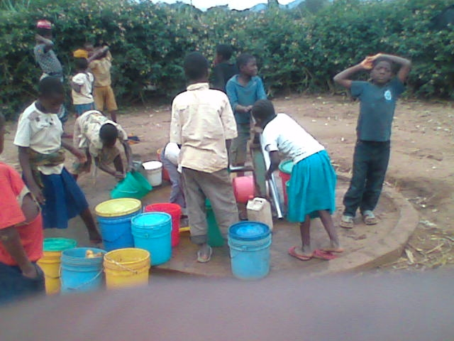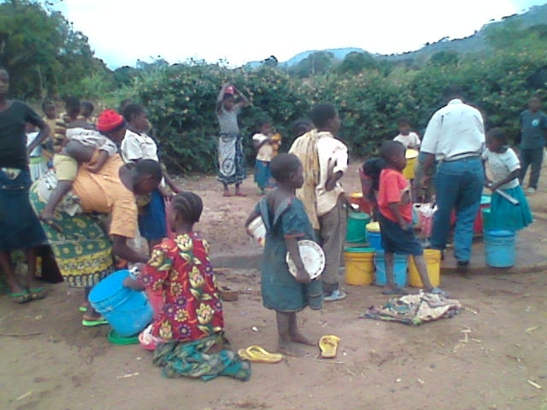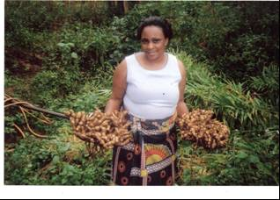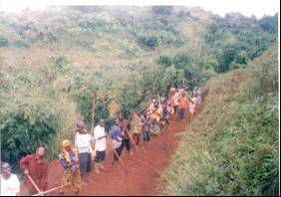
 | Integrated water resource management, the answer for life success !
- Support 20 effective agri-business pilots in 3 districts for effective manner  - Conduct 15 trainings on gender integrated water resource management practices  - Support conservation and sustainable activities (construction of 4 intakes and protection of catchments areas)  - participation and improved integrated water resource management and appropriate awareness creation and capacity building Interventions and Research  - training on gender resource allocation and consumers behaviour in 22 villages in 3 districts (60% men participation)  - Set up 4 slow food and human rights mass campaigning in collaboration with associative networks for gender promotion and supports.  - support construction of 9 water harvest techniques and rehabilitate 6 dams for water recharging in selected agriculture potentials  - support establishment of 3 earth-markets and 3 presidia for promotion of traditional and indigenous agriculture practices in 3 districts  - Trainings skills to gender integrated water resource management agriculture (6 yearly)  - Institutional strengthening and accountability training to 150 women and 50 youths  - Training on Gender Resource Allocation and Consumers Behaviour to 68 farmers in 4 districts (60% men participation) | 1,000  10,000  1,000  5,300  4,500  3,100  2,200  3,100  3,500  3,800  0 | 3,000  20,000  2,000  10,000  7,000  5,000  3,000  5,000  4,000  5,000  4,000 | 5,100  18,000  3,000  11,000  11,700  8,800  5,600  8,300  6,000  8,900  5,000 | 13,000  15,000  3,000  13,000  9,100  4,600  4,900  9,100  5,300  10,200  7,000 | 22,100  63,000  9,000  39,300  32,300  21,500  15,700  25,500  18,800  27,900  16,000 | Oct 09  Oct 09  Nov 09  Jan 10  Dec 09  Jan 10  Feb 10  Mar 10  May 12  Jun 12  Mar 12
TOTAL 2 | 37,500 | 68,000 | 91,400 | 94,200 | 291,100

Income earning opportunities to women-led-families increased by 50% and afford to pay for social services mainly health, education and food by 90% by 2010 | 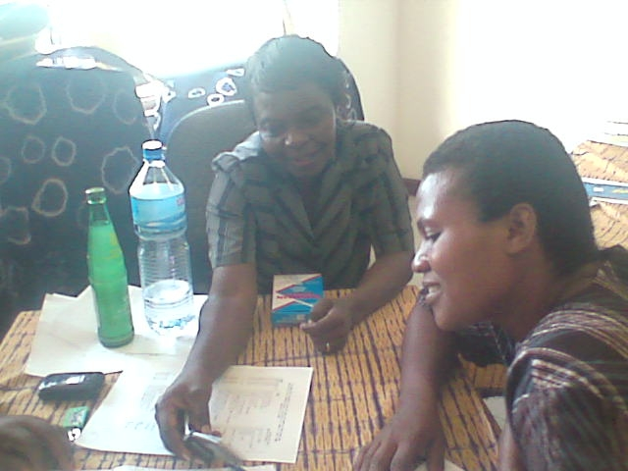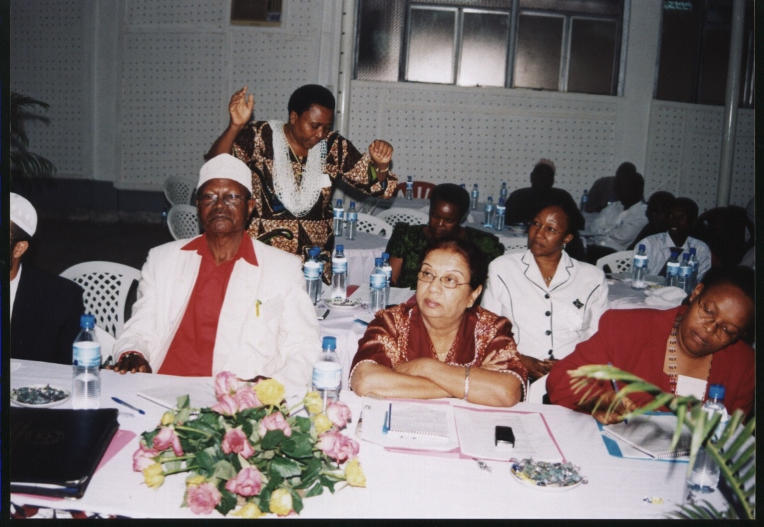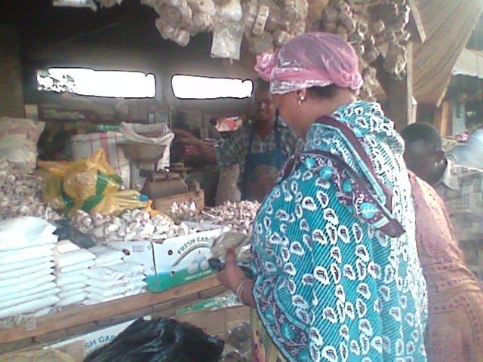
 | Women can own the process if they are economically empowered!
- Facilitate and support investment in welfare services to 45 women groups – 6 health centres, multipurpose service centre, 3 orphanage centres, 6 groups of women higher generating crops /activities including pottery, sawing, embroidering,  - Set fundraising and women charity days (2 yearly) at village levels for collective funds (to involve fundraisers for undisclosed grants along with priorities in the village)  - Construction of 3descent markets, 3 community libraries and contractual entrepreneurial women in public transport (3 pick ups),  - Train on and support for self help initiatives in building public infrastructure such as roads and markets, schools, community libraries, shopping areas.  - Provide direct supports to old age and disadvantaged groups includes neglected families, buttered women, single parents, poor of the poor, widows and widowers etc to improve their well-beings through promoting their active participation to the community development.  - Support investment in women welfare services women charity days at district levels (3 yearly)  - Construct 3 descent earth markets for slow food products and resource base centres for cooks and academia at local levels | 3,100  2,500  2,200  5,000  18,100  3,000 | 7,000  6,000  9,000  16,000  20,500  5,000 | 8,000  7,000  11,000  5,000  35,100  10,000 | 6,000  5,000  3,000  5,000  35,100  10,000 | 24,100  20,500  25,200  31,000  108,800  28,000 | Apr 11  Jul 10  Jun12  Jun 12  Jun 11
TOTAL 3 | 33,900 | 63,500 | 76,100 | 64,100 | 237,500

Equitable distribution of income and wealth system is enhanced and lower income earners raised by 50% by 2012 | 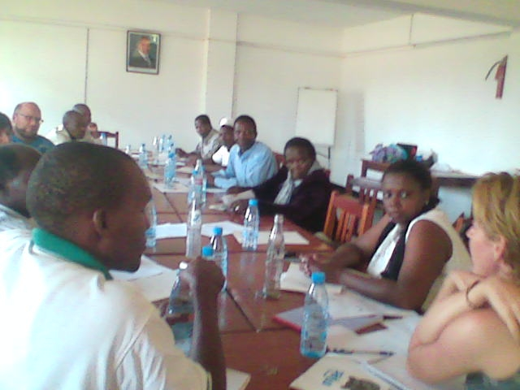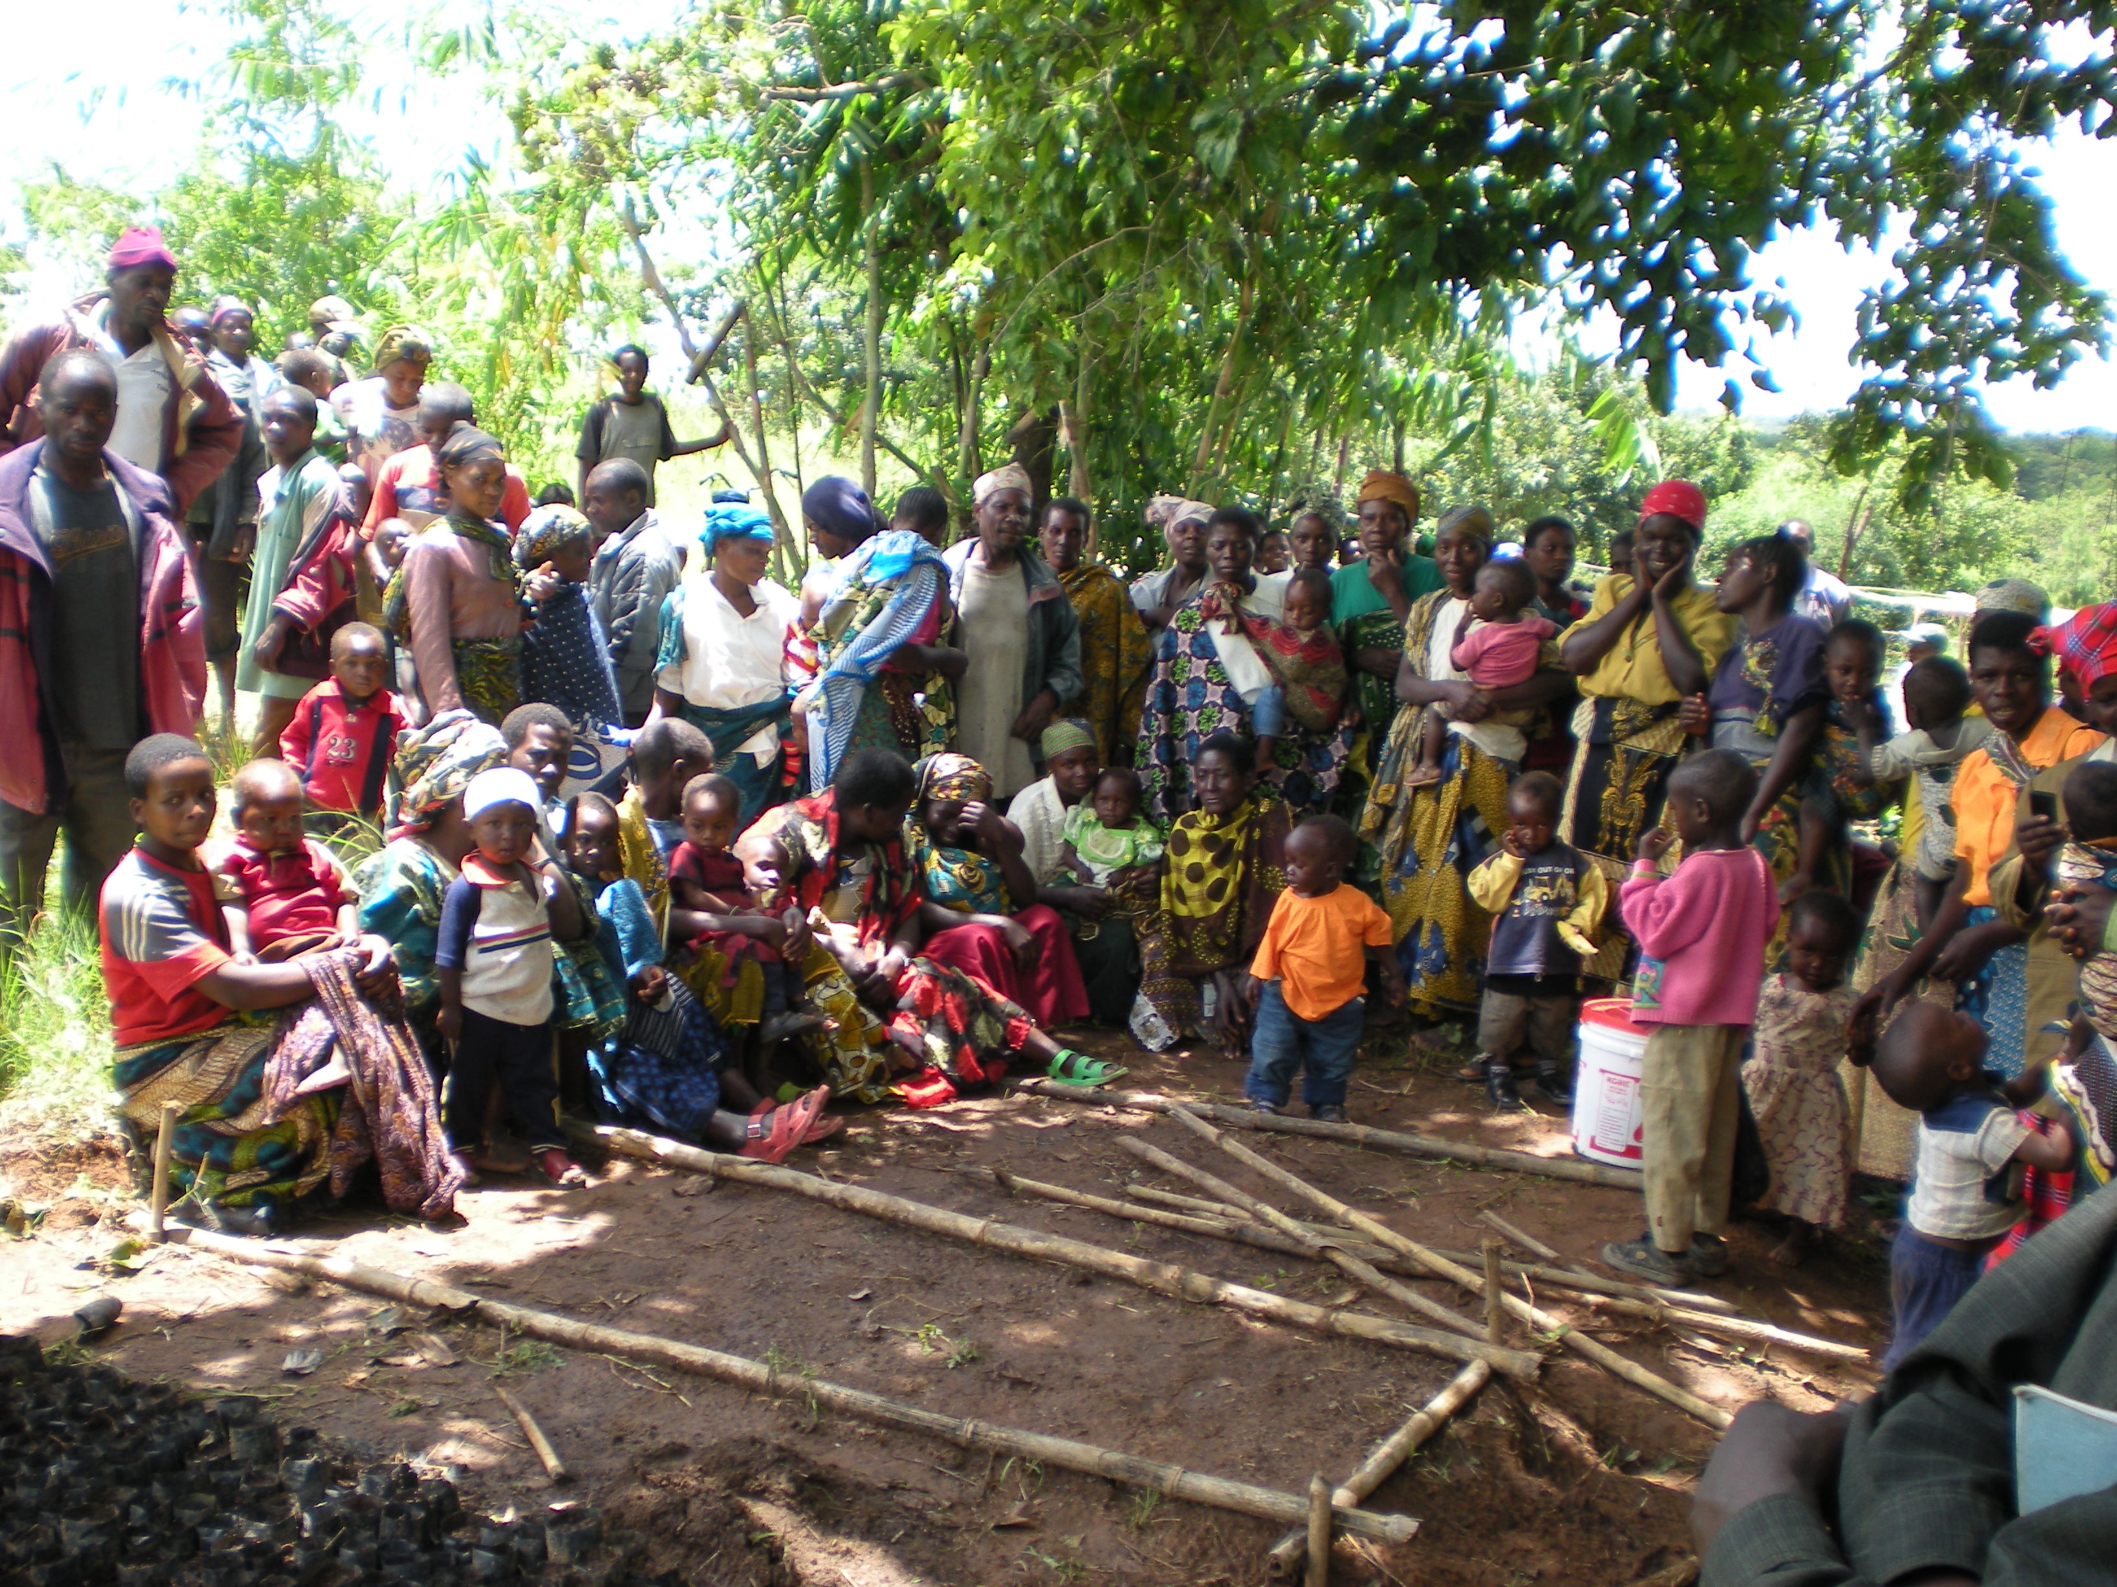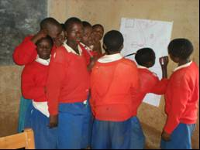
 | Women can do, and girls can cope the way! Together they can do better!
- Review and enforcing legal/traditional/norms (7) as bench marks for actions  - Conduct trainings on justice, human rights, social and economic and self justice knowledge to at least 40% of women in the 4 districts  - Strengthening cooperation on shared water resources and set joint action plans within the 3 districts  - Conduct 3 conflict resolutions training on land and water resources conflicts for promoting security and integrity of women in the country.  - Application of demand management principles including economic and legal aspects to promote different allocation, use, serving and recycling of water  - Conduct research on domestic violence related incomes  - Train on domestic violence law and by-laws (establish protective income mechanism for victims of domestic violence)  - Consultative workshops on research outcome and law/bylaw  - Produce monthly newsletter in Kiswahili on gender equity  - Set a women team for development for science and technology at district levels  - Monitoring and Evaluation (including midterm and conclusive evaluation) | 4,500  5600  5,500  7,000  2,000  3,200  2,500  6,500  4,500  5,200  9,000 | 14,500  7600  9,500  4,000  3,000  5,200  7,500  8,500  5,500  7,200  14,000 | 5,500  3,600  9,500  7,000  9,000  5,200  18,500  11,500  6,500  0  5,000 | 2,500  3,600  3,500  4,000  2,800  4,200  6,500  4,500  2,500  7,200  5,000 | 27,000  19,400  28,000  22,000  16,800  17,800  35,000  31,000  19,000  19,600  33,000 | Apr 10  Jul 10  Jan 11  Jul 10  Jul 11  Sep 11  Jan 10  Aug 10  Sep 11  Ma 11  Jun 12
TOTAL 4 | 55,500 | 86,500 | 81,300 | 46,300 | 269,600

Improved health and sanitation at house hold level by the year 2012 | 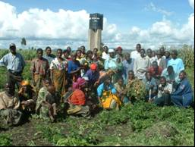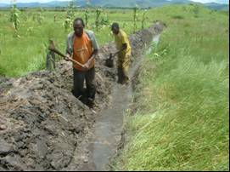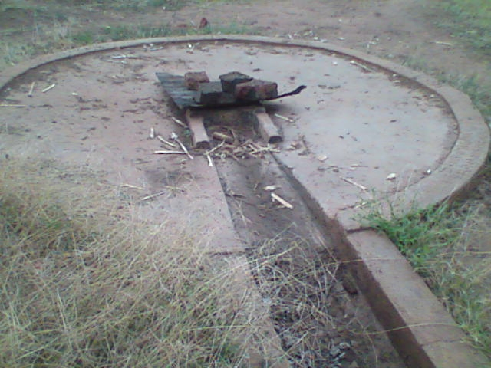
 | Everywhere, water is scarce, poor agri-practices, but a change is a wish!
- Conduct mapping on ecological sanitation in rural and peri-urban areas based on zero pollution, water conservation and recycling e.g. compost latrines  - Support water supply integrated women plans with health perspectives and environmental sanitation to meet basic human needs  - School training on health and sanitation though child to child approach  - Support in the construction of improved latrines - Ventilated Improved Double Pit (VIDP). The latrines shall save the problem of fertility management though utilization of the available composite.  - Training of the Health committee in each respective village. | 7,000  35,500  12,600  22,500  11,000 | 9,000  41,500  13,600  33,500  12,000 | 11,000  65,500  16,600  24,500  13,000 | 16,000  53,500  11,600  31,500  9,500 | 43,000  196,000  54,400  112,000  45,500 | Feb 12  Dec 12  Mar 12  Oct 12  Mar 12
TOTAL 5 | 88,600 | 109,600 | 130,600 | 122,100 | 450,900

Budget summary per result

Qualitative Result | Inception Year 2009 | Year 1  2010 | Year 2  2011 | Year 3  2012 | Total budget per result
Economic Gender Inequalities Reduction Strategies through research, training and supports in 3 districts by 75% by 2012 | 51,100 | 119,700 | 120,000 | 101,100 | 391,900
Resource Poor women Agriculture Endowment and water assets support for own farm-base business to 1.3 women in 3 districts | 37,500 | 68,000 | 91,400 | 94,200 | 291,100
Income earning opportunities to women-led-families and deprived population – disabled/Albino and old aged groups, abused children and street girls (250,000) in 64 villages. | 33,900 | 63,500 | 76,100 | 64,100 | 237,500
Good governance and leadership skills for equitable distribution of national resources to up scale –low income earners raised by 50% | 55,500 | 86,500 | 81,300 | 46,300 | 269,600
Improved health and sanitation systems at 150 house holds and 45 primary schools in 3 districts | 88,600 | 109,600 | 130,600 | 122,100 | 450,900
Total budget per year | 178,100 | 447,300 | 499,400 | 427,800 | 1,641,000
Overhead costs (15% of the total development expenses) | 26,715 | 67,095 | 74,910 | 64,170 | 246,150
Grand total budget | 204,815 | 514,395 | 543,310 | 491,970 | 1,887,150

Requested funding 2009 – 2011
Source of Fund(USD) | Year 0 | Year 1 | Year 2 | Year 3 | Total
Beneficiaries contribution | 10,241 | 25,720 | 27,170 | 24,600 | 94,360
IRTECO contribution | 8,194 | 20,576 | 21,730 | 19.670 | 75,490
Local Government Contribution | 20,482 | 51,440 | 54,330 | 49,200 | 188,700
Other local partners | 2,048 | 5,140 | 5,430 | 4,900 | 18,900
Application from GlobalGiving | 163,850 | 411,516 | 434,650 | 393,600 | 1,509,700
Total | 204,815 | 514,395 | 543,310 | 491,970 | 1,887,150

