
MTENDE HOMECRAFT FOUNDATION

Project title: Promoting quality education in rural primary schools in Livingstonia – Malawi.

CONTACT DETAILS:

Physical Address Postal Address
Mantchewe Location P.O. Box 21
Opposite New Apostolic Church Livingstonia
Along Mantchewe waterfalls, Rumphi
Livingstonia Phone: +265 991 590 510
Rumphi Cell: +265 888 505 339
Malawi -AFRICA E- Mail: mtendehomecraft@yahoo.com
rmwabanga@hotmail.com
www.facebook.com/rockin.mwabanga https://mtendehomecraft.wixsite.com/lvmw

Project background
‘’Promoting quality education in rural primary schools in Livingstonia – Malawi’’ is a community initiative facilitated by Mtende Homecraft Foundation trying to reduce challenges faced by students to access quality education in rural primary schools.
To achieve Millennium Development Goal No 4) achieving universal primary education, Malawi adopted free primary school education inorder to increase enrolment of children in primary schools especially in rural areas where over 90% of the population lives. This has affected the quality of education as there is an imbalance on teacher pupils’ ratio, number of classrooms, inadequate teaching and learning materials and not forgetting poor sanitation among others. The situation has not spared primary schools in Livingstonia – Phoka Primary Education Zones whereby a number of students do not have enough classrooms to accommodate over 9600 learners that have been registered in 10 primary schools. Apart from that, there is inadequate school writing, teaching and learning materials. Every year, there’s an increased enrolment of 1800 pupils in 10 primary schools with limited basic school needs for their education.

Geographically, Livingstonia is located on a hilly and plateau area with full of escarpments and hardly to reach and this situation put Livingstonia as one of the excluded areas in terms of equal distribution of Government public resources and projects. Despite that, schools registered a good enrolment number of learners approximately 9,600 learners have been registered in 10 primary schools.
According to the Education Management Information System (EMIS 2010), dropout rate at standard one declined from 23 percent in 2005 to 12.7 percent in 2010. Survival rate at standard eight improved from 26.1 percent in 2005 to 48.8 percent in 2010.
Despite these achievements, the area is still constrained by a number of challenges which render the education system inefficient and inequitable. Some of the challenges include: high illiteracy rate; limited integration of students with special needs; shortage of qualified teachers; inadequate and inferior physical learning infrastructure; poor participation of school committees and their communities in school management; inadequate teaching and learning resources such as libraries; laboratories and computers; low enrolment of girls.
Recognizing the important role education plays in the country’s development, Mtende Homecraft Foundation with support from partners and friends has embarked on campaigns to raise funds to ease challenges faced by students in 10 primary schools. Currently Mtende in partnership with Spin the Wheel a group of volunteers from Greece and German in partnership with Anike Foundation (www.anikefoundation.org), a US based Charity organization in 2016 -2017 came to partner with Mtende Homecraft Foundation and supported 4500 students with learning and teaching materials including school sporting materials. These volunteers managed to cycle over 2000km from Lilongwe –capital city of Malawi to Mbeya in Tanzania and managed to meet 11,750 school students in selected schools who shared their experiences (visit www.spinthewheel.gr).
Again, Mtende Homecraft Foundation in partnership with US Embassy, World University services of Canada (WUSC) and Pensforkids (www.pensforkids.dk) charity organization based in France support schools with new school infrastructure, sanitation programme and stationery targeting 7500 students in 10 primary schools.
As an on-going programme, there’s need for more support especially to meet the urgent needs for students who are unable to afford writing, learning and teaching materials including school uniform. Currently 1 textbook is being shared by 20 students and two out of ten primary schools have min libraries with limited books in stock.
Education is essential for social-economic development and industrial growth. It is an instrument for empowering the poor, the weak and voiceless as it provides them with equal opportunity to participate in local and national development (Malawi Growth and Development Strategy III).
It is in this background that Mtende Homecraft Foundation is looking for Global support from well-wishers and partners to address this challenge and further complement UN and Malawi government agenda on universal access to education and poverty reduction programmes. Realizing the gap in terms of resources, as the schools now are about to commence, Mtende Homecraft Foundation is looking for partnership to implement the project activities which required about US$ 18,540. This amount will support 5000 students in buying the following school items;

- 20000 Notebooks @ $0.2 = $4000
- 4000 Pens, pencils, sharpener, rubber, and ruler @ $1 = $4000
- 1000 Textbooks @ $5.5 = $5500
- 700 School uniforms @ $6.2 = $4340
- Admin costs (logistics) = $700
Total = $18,540

Project goal
To improve child access to quality education in rural primary schools through education materials support in Livingstonia – Malawi.

Specific objectives
- To improve child learning environment and increased enrolment rate through school material support.
- To increase retention rate in schools especially girl child through supply of school uniform and stationery materials.

Project main activities
- Purchase and supply of teaching and learning materials to 10 schools.
- Provide vulnerable children with school uniform and other basic needs.

Project expected outcomes
Following the implementation of the above proposed project; the project expects to achieve the following key results;
- Improved school learners’ performance for quality education
- Increased girl child enrolment and retention rate in school and poverty reduction

Project Implementation duration
The proposed project is expected to take 6 months starting from October 2018 to December 2018.

Organization capacity and structure
As an institutional mandate to deliver relevant and cost effective programming, Mtende programmes are driven by a qualified team of staff members who manage, lead and implement all programmes. The overwhelming majority of staff originates from the very communities that Mtende serves. All are proficient in local language and familiar with the local culture and customs bringing together a diverse, energetic, committed and competent team that understands the local issues and challenges.
Currently Mtende Homecraft Foundation has Board of Trustees composed of 5 members who provide leadership to Organization Management with sound educational and academic background ranging from holders of Degrees (Up to Doctoral level), Diploma and Certificate. Two of the Board members are reverends, one of whom also teaches at Mzuzu University one of Malawi Government public Universities.
The management team is composed of 8 permanent and 4 part time staff headed by Executive Director and Program manager who are holders of Bachelor Degrees in Education and Public health respectively. These individual technical capacities have been well nurtured over 13 years’ experience with relevant exposure to specific skills acquisition from hands on expertise in Mtende programmes.

Membership organizations
Mtende Homecraft Foundation is a member of Malawi Interfaith Group (MIA), Malawi Scotland Partnership (MaSP), Malawi Aids Networks Services Organization (MANASO) and district NGO network and is registered with District Council and Malawi Government through Registrar of Companies in April 2014.

Organization Structure
General Council

Board of Trustees

Executive Director

Finance and Administration Manager
Programme Manager

Field Zone Officer
Administration Assistant
Accounts Assistant
Field Zone Officer
Field Zone Officer

Community Volunteers
Community Volunteers
Community Volunteers
Security Officer
Office Assistant

Schools & Community
Schools & Community
Schools & Community

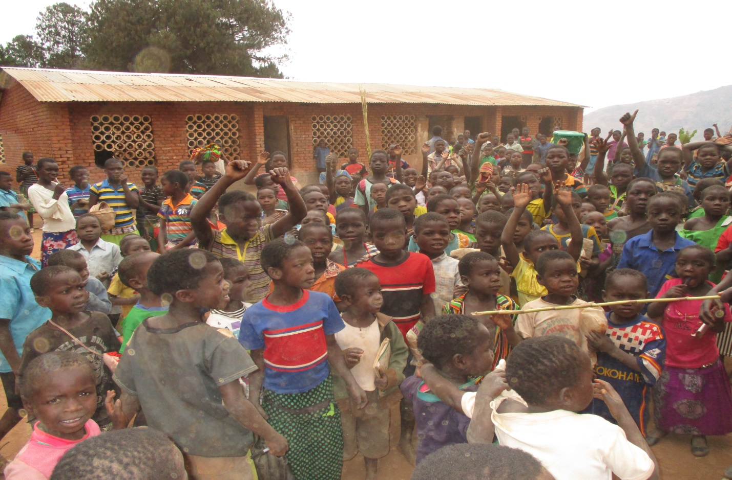
Such learners also need quality education ( Luwona rural primary school one of the proposed beneficiary schools with more than 1100 learners)

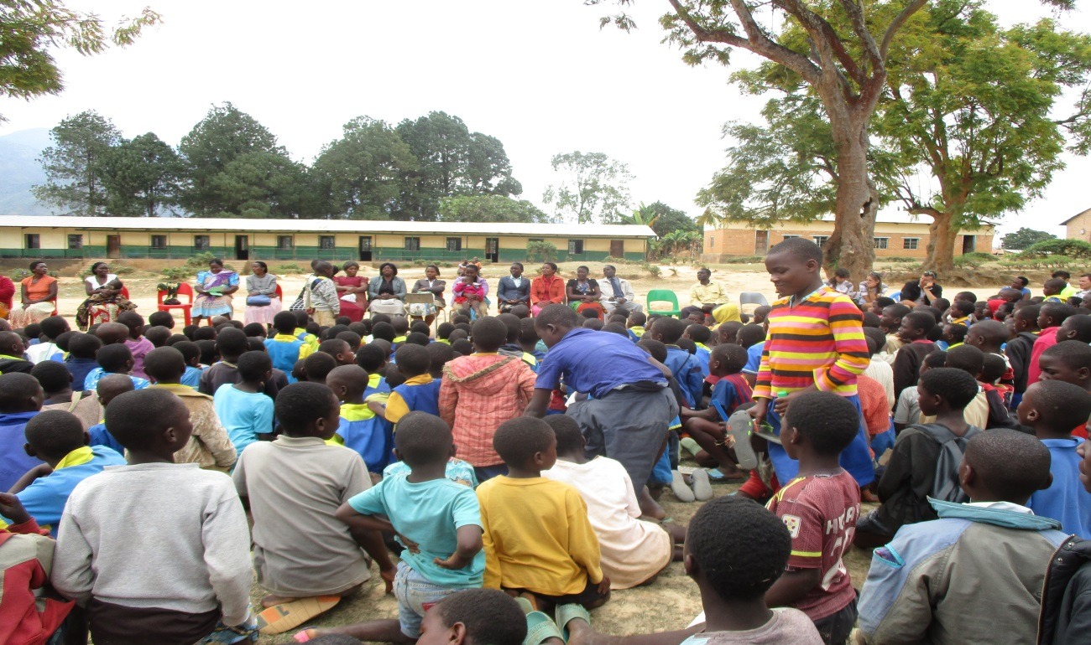
Livingstonia primary school – another beneficiary school with more than 1200 learners

