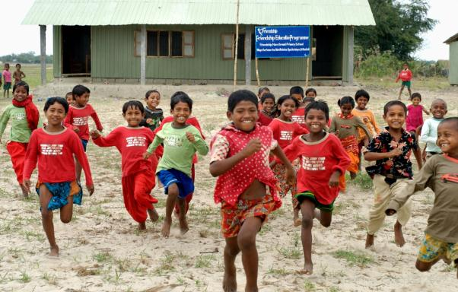
Friendship’s Secondary Education Program
THE FACT!!!
More than 98% of the char children in Bangladesh never completed primary education because of lack proper primary schools in the area.
Friendship is the only NGO that deliberately recruits teachers with below SSC (Secondary School Certificate exam in Bangladesh) qualification for its schools. Friendship recruits these teachers from the very communities in which the schools are located, as they already have rapport with the community and is likely to relocate with the same community in case of migration to a new area.
This recruitment mode has proved to be the only one by which student attendance can actually be ensured, as even qualified teachers recruited from outside the community cannot remedy the overwhelming absentee rates. Commendably, teachers recruited this way from within the communities have shown extraordinary performance upon receiving continuous training Friendship.

Considering the risk of the land being washed away, the schools are built with prefabricated materials so that they can be moved when the land begins to break away from the islands. In an environment where a child’s very home and everything he knows is washed away before his eyes, this ensures a feeling of security and reliance on her/his school. It also makes the programme cost effective in the long run.

Friendship endeavours to offer the best possible cost-effective education to the children and seeks to ensure maximum possible uniformity across the schools

Characteristics of the Secodary Education Program

Need Analysis for Secondary Education in Remote Communities

Though Friendship initially started with only primary education, it eventually expanded to secondary education. The unique set of benefits which are gained from secondary education and those which cannot be gained from solely primary education was a compelling reason for this expansion. These envisaged benefits include:
- Enhanced ability to earn a living: Secondary schooling provides the learners of these remote areas with enhanced capacities, which in turn prepare them to gain vocational training from Friendship or other NGOs. In addition, comparatively higher-level education offers children access to knowledge and resources to look for other livelihood options in the future.
- Reduction in early marriage: In the char areas, girls would normally get married at the age of 13 or 14 as they did not have the scope to do anything other than household chores once they left primary school. However, following the introduction of secondary schools, the girls now have better access to higher education and their parents have a reason not to marry their daughters off as soon as primary school ends.
- Better living standard: Access to secondary schools drastically increases the living standard in char communities, as students receiving education from these schools are better aware of their responsibilities and rights and are more likely to work towards creating a better society. Secondary education will also create opportunities for them and thus limit migration to urban slum areas.
- Increased connectivity: Most char dwellers are detached from the mainland and do not have access to any form of technology. As part of the secondary education implementation plan, each secondary school classroom was equipped with one laptop and multiple monitors on which video lessons are played during class. As such, students now have a chance to experience ICT in meaningful ways and have better access to knowledge and information. Although Friendship’s current secondary education program only provides education till 9th grade and will start 10th grade for the first time in 2020, the experience of connecting with the broader world is expected to give students motivation and enthusiasm to explore higher grades of education (beyond grade X) by traveling to the mainland.
Thus, Friendship’s Secondary Education program gives hope to the remotest communities of the country and gives the people there an opportunity towards a more meaningful and fairer life.

Challenges in Program Development
The main challenges faced while designing the secondary education program are:
- Absence of skilled teachers: The main challenge in implementing secondary education was the absence of skilled teachers, since teachers from outside the chars do not have an incentive to stay in these remote places.
For primary education, this problem was circumvented by recruiting teachers with an SSC degree or less, from the very communities where they would be teaching. They were then put through an extensive training program, coupled with routine monitoring and supervision from Friendship. For secondary education, however, training does not suffice as the concepts in the secondary school syllabus are significantly more complex than those in the primary school syllabus.
- Remoteness of the communities: This is perhaps the biggest challenge encountered, as building a school in the mainland is not even an option which these communities can access. Limitations in their ability to travel thus created certain constraints that Friendship had to abide by.
- Lack of affordability: The students’ families cannot pay for education and hence arranging expensive solutions in the chars is not an option.
- Lack of internet connection: Although the country’s internet infrastructure and access is improving significantly, internet-based video teaching is not a fully viable option yet due to slow/ no internet connection in remote areas like chars.
- Natural Disasters: The islands are always shifting form, and the targeted communities are the biggest victims of flood, or any other natural calamity. Due to the shifting nature of these islands, the people migrate within a time span of 6-7 years. It is always difficult to maintain a permanent structure on these islands. Natural disasters are always a challenge as floods can wash everything away.

Program Strategy
In all of the islands where the secondary schools are implemented, Friendship already had its primary education program operational and selected graduates from only Friendship primary schools were enrolled in the secondary schools. This enrolment restriction was based on the premise that students who did not require primary education access either had access to alternatives or didn’t have the academic preparation needed for secondary level. Girls were given priority since at least few of the primary school graduating boys were able to travel to another island or mainland for getting secondary education, but it was virtually impossible for girls to travel and receive further education.
In each of the classes, around 15 students were enrolled on an average. The demand for enrolment increased due to the opportunity of better employability and an escape from early marriage. As such, around 20-22 students are enrolled for each batch at present.
By the end of 2018, the second batches of students completed Grade VIII and appeared for Junior School Certificate Exam, achieving commendable results, far exceeding the national average. Currently, there are four grades being operated (up to Grade IX) and Friendship envisages to initiate Grade X next year.
The total number of classes operational at the moment:
- Grade VI, Grade VII, Grade VIII and IX: 4 schools
- Grade VI, Grade VII and Grade VIII: 7 schools
- Grade VI: 4 schools
All students in Friendship Secondary Schools are those who have passed from Friendship Primary Schools.
Infrastructure: There are one computer (laptop), two to three monitors (depending on the number of students) and lights in each of the classrooms. There is one solar panel installed in every school for supporting these solutions across the classes.
The classrooms are constructed immediately adjacent to existing Friendship Primary Schools.
Solar grids: This project requires solar panels that provide power up to 8 hours, for all computers in operational classes. Friendship’s own rural electrification program provides the required technical support in this regard.
Primary school teacher as facilitator: The trained Friendship primary school teachers work as facilitators/ shadow teachers and are offered basic subject knowledge beforehand, related to the topics that are taught to the students. During the classes, they answer questions that the students may raise after watching the videos.
Learning method: Videos are made on government curriculum syllabus and saved in portable hard disk drives that are sent to the schools. Prominent teachers from Dhaka have appeared for those videos and concepts have been explained in and easy manner with layman terms for the students. Lessons are recorded and converted into video files for each subject. Teachers from renowned schools of Dhaka, such as Residential Model School & College, BIAM Model School & College, Rifles Public School and College, and Motijheel Ideal College are among those who taught through these videos. In the videos, the teachers focus on conceptual clarity and proper application of learning materials. Each recorded session is approximately 40-45 minutes long.
The videos are shown to the students during class hours and they have the option to ask questions after the classes. The questions are either resolved by the facilitators immediately, or after they discuss these questions with teachers from Dhaka during weekly phone calls.
Call Centre: When students have questions, they are taken down as notes by the facilitator. The facilitators try and understand the solutions to those problems through phone calls with teachers at Dhaka once every week. The teachers also visit the schools from time to time (usually once a year) to understand how they work.
Checking exam scripts: In order to ensure that students get a fair and accurate evaluation of their merit, all the monthly and semester exam scripts are sent to Friendship’s Dhaka head office and are checked by teachers in Dhaka. The checked exam scripts are then sent back to the students.
School Library: Secondary school students are given the opportunity to read different books (novels, fun books, history, etc) from libraries that have been set up in some of these schools.

Special Features of Friendship Education Program
Like the Primary Education Program, Secondary Education has the following features integrated within the curriculum:

- Code of Ethics
In the Friendship education program, building a sense of ethics and citizen rights and responsibilities among students is given highest importance.
Code of ethics plays an important role in the curriculum of Friendship, as Friendship believes that its practice in any field of work and personal life plays a vital role in making people, especially children, better human beings and better citizens.

- Child Rights
Friendship puts utmost importance on enabling students to become good citizens. In the way of doing so, the teachers teach them their basic rights, responsibilities, etc.

- Healthcare for the students
Through the presence of Friendship field level health workers known as Friendship Community Medic - Aides in the chars, the students always receive nutrition related information, behavioural change communication, dental and eye check-ups, basic medication, etc. If advanced or secondary care is required, they are referred to the floating hospitals of Friendship where they can undergo surgeries, if needed.

4 Years of Secondary Education
The journey of Friendship Secondary Education Program until 2018 can be summarised in the table below:
Details | As of January, 2015 | As of January, 2016 | As of January, 2017 | As of January, 2018 | As of June, 2019
Number of Students | 65 | 123 | 249 | 337 | 562
Number of male students | 28 | 49 | 98 | 126 | 251
Number of female students | 37 | 74 | 151 | 212 | 311
Number of schools | 5 | 5 | 7 | 7 | 11
Number of classes | 5 | 10 | 17 | 19 | 33
Number of facilitators | 5 | 10 | 17 | 19 | 33
Cumulative number of video lessons available | 456 | 550 | 1268 | 1546 | 469
Pass rate of JSC | - | - | 100% | 98.43%

A press conference for “Friendship’s ICT-aided Schools in Remote Chars Creates Landmark - 100% pass rate in JSC exam” was held at the Daily Star Centre on the 2nd January 2018. The event was a recognition and celebration of the fact that all students from 7 of Friendship’s innovative ICT-aided secondary schools not only had a 100% pass rate, but their results were way above average when compared even to schools in Dhaka and other major cities. The press conference was attended by chief guest Zunaid Ahmed Palak, State Minister of ICT Division, Government of Bangladesh, who praised Friendship and its students for their achievement. The press conference received wide coverage in several media outlets.

Secondary Education Program Highlights 2018 - 2019
The secondary education program is being piloted in 11 schools in the remote char areas. 2018 has been a year of achievement for Friendship Secondary Education Program.
Students from Friendship Secondary Schools appeared in the Junior School Certificate exam for the second time in 2018. 64 students (26 boys and 38 girls) appeared for the Junior School Certificate (JSC) exam with a pass rate of 98.43% as compared to the national average of 53%.
Based on the most recent updates, an overview of Friendship’s Secondary Schools program is as follows:

1. As of June 2019, 299 students are enrolled in Grade VI, 135 in Grade VII, 91 in Grade VIII and 37 in Grade IX in Friendship Secondary Schools. For the first time, Friendship is offering Grade IX education this year, in 4 of its schools in Gaibandha and Chilmari. The students attending Grade IX are among the 63 students who passed Grade VIII in 2018 from these 5 schools. 562 total VI – 299, VII – 135, VIII– 91, IX - 37

Though Friendship had initially planned to enrol 10-12 students in each of the classrooms, 142 students were enrolled in Grade VI in 7 schools in 2018, which is equivalent to more than 20 students/ classroom.

2. Grade VI, VII, VIII and IX are continuing in 4 schools, whereas there are three schools in which there are only Grade VI, Grade VII and Grade VIII.

3. 4 new secondary schools have been started in Rowmari and Ulipur from provisional structure and are expected to move to permanent facilities upon the completion of construction in late March.

4. In 2018, a total of around 276 new lessons were recorded by subject – wise teachers from renowned schools of Dhaka. As of June 30, 2019, 254 recordings for class IX have been completed and more are in process.

5. In 2018, school visits were made by the subject specialist teachers to 7 secondary schools of Friendship. The students & facilitators at these schools had the scope to share their feedback and suggestions during these visits.

Photos
School Premises

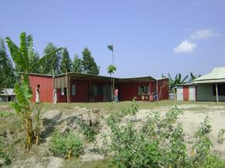 | 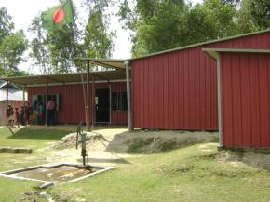
Students

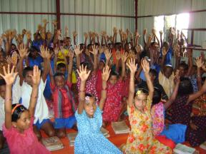 | 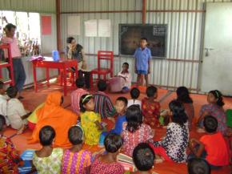
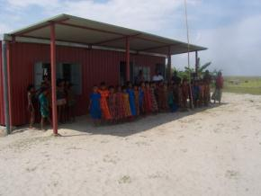 | 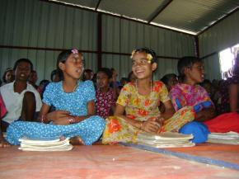

The Junior School Certificate, also known as JSC, is a public examination attended by students in Bangladesh after successful completion of eight years of schooling, i.e. after completion of Grade VIII

