Livelihood

**AAI’s unique Livelihood Development Programs integrate public education with building economic infrastructure**

• Gardens of Peace create self-suﬃciency through schools and farming cooperatives in Mindanao and Visayas.

• Textbooks, vocational manuals, computers, and school supplies were donated to some 40 schools.

• Scholarships emphasize degrees or certificates that improve the economic vitality of impoverished communities.

Director’s Note

Asia America Initiative (AAI) is a catalyst for cross cultural partnerships. We build long-term stability and community self-reliance. Centered on education, our programs integrate social and economic development. We also give emergency aid intervention during natural or manmade disasters.

During 2015, AAI focused on peace building in war torn Mindanao and typhoon recovery in Visayas and Luzon regions. We continue provide training, tools, health, and educational support to more than 120,000 survivors. In Manila, AAI assisted more than 200 children suffering from cancer and rare genetic diseases. In Sulu, Muslim Mindanao war zones, we reinforced peace through some 30 schools with some 35,000 elementary, high school, and college students.

In 2016, instability and international terrorism across South and Southeast Asia is growing. AAI is increasing our assistance to public and religious-based schools in Muslim Mindanao, among the lowest performers in Asia. Since 2003, AAI’s Model Schools build partnerships between teachers, parents, and local government officials in the Departments of Education, Health, and Agriculture to stabilize high-risk areas. Parents and teachers help revitalize classrooms, plant gardens, and conduct daily lunch programs to strengthen the bodies and minds of malnourished children. Our respect for human dignity transcends cultural barriers. Our model of peace building, justice, and ultimately trust transcends fear and violence to overcome poverty and extremism of all stripes.

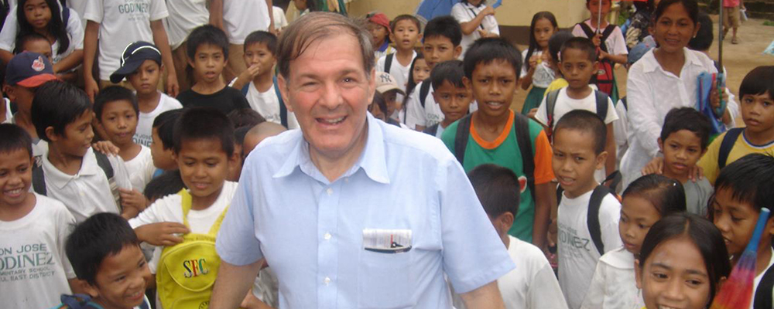

**AAI and our partner communities are creating global model programs, especially in the Philippines where the 7,000 islands are an epicenter of the social, economic, and nature challenges faced by all of humanity today.**

Education

**AAI is revitalizing public and faith-based education**

• Some 50 Model of Excellence (MOE) Public Schools serve more than 50,000 pupils.

• Over 1000 teachers and schools administrators have been trained and supplied.

• AAI backed elementary and high schools have over

90% retention and graduation rate, compared to below 60% regional average.

• School lunches for malnourished children are funded by AAI and cooked by PTA parents and school teachers. Sports and arts are used to promote good character and mutual respect.

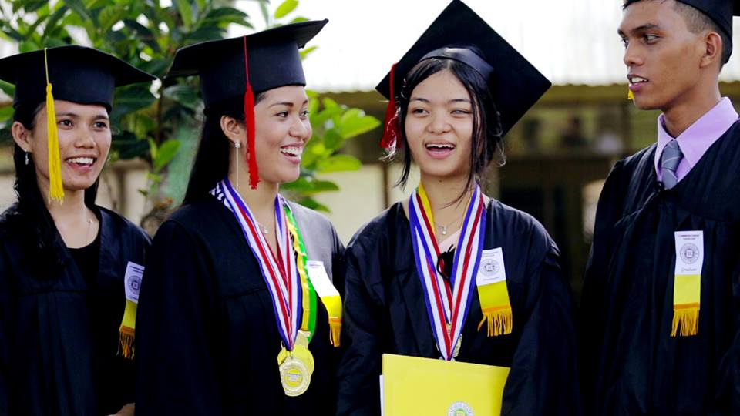

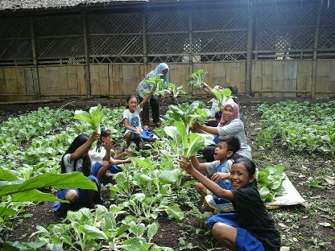

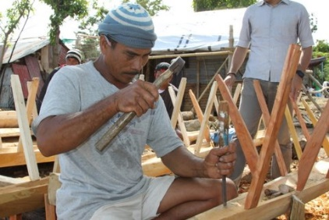

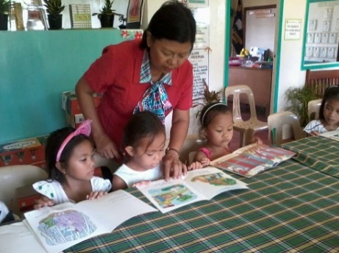

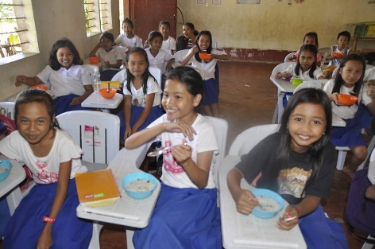

Conflict Deterrence

**AAI programs serve communities affected by inter-cultural and religious conflicts**

• In Sulu, AAI’s emphasis on grassroots education and livelihood projects has helped persuade guerilla ﬁghters to peacefully integrate into society.

• The AAI Catalysts for Peace project has more than 500 inter-faith college volunteers providing relief in armed conﬂict zones.

• Trauma Healing Programs have more than 200 community leaders serving more than 10,000 Christian and Muslim families affected by violence.

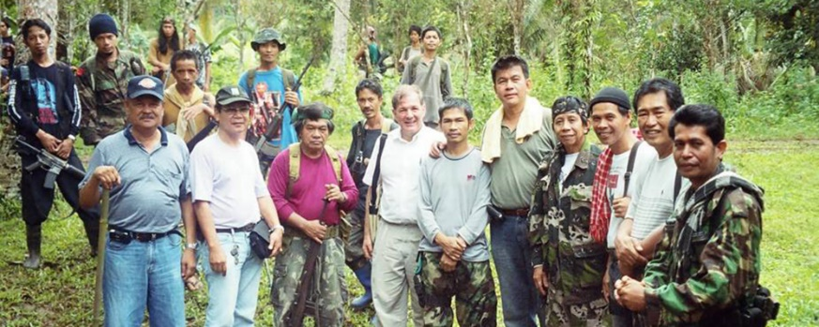

**AAI overcomes extremism by utilizing the natural strength of the community…both men and women. We neutralize destructive political agendas by focusing on equal care to all children.**

Health

**Since 2002, AAI has provided more than $100 Million in donated Medical Supplies to provinces that lacked all categories of public health**

* + AAI donated hospital equipment, supplemental   
    nutrition, and supplemental medicines for school clinics and specialized disease treatment centers.
  + AAI’s Cancer and Rare Diseases Treatment program targets services for more than 200 patients of all ages, particularly supplemental nutrition and medicines.
  + Donated medical care was made available to more than 100,000 war refugees and displaced persons and more than 150,000 typhoon victims.
  + Clean water and sanitation have been made available to some 50,000 children and adults.

**AAI's Development for Peace program is built on our relationship with war-torn Muslim, Christian and indigenous communities.**

**Because we share their hardships, we bring together people of different faiths and backgrounds, traditional leaders and idealistic youth to sustain their human dignity.**

**- Albert Santoli, AAI President & Director**

