Career Connect Programme:

Highlights from Career Connect Programme:

- For the period April 2019 to March 2020 the Career Connect Programme enrolled 5491 young people in various programmes and support systems.
- We have conducted 16 Career Awareness Workshops engaging 1209 young people. These workshops were conducted in 6 Low-Cost Private Schools, 7 Low-Cost Private Colleges, 1 Govt College, 1 Govt School and 1 Aided School.

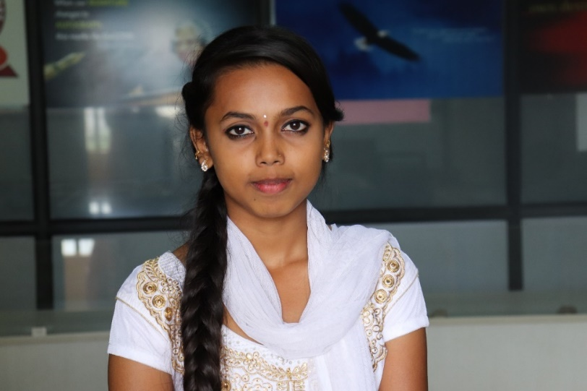
Anitha 16-year-old, 1 PUC student at Sharada Vikas PU and Degree College shared after attending the Career Awareness workshop -

“I always wanted to be an artist but was forced to take up commerce because my parents believe only commerce as a field has potential and I will be able to earn a living.

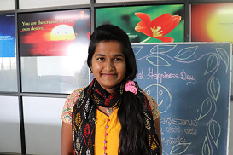
The career awareness workshop gave me hope that even artists can have a bright future; it helped understand what my future options are to become an artist”.

“I was forced to study commerce after I completed my 10th grade. I entered the commerce stream without knowing what the opportunities are ahead of me. I tried to search online for answers but could not fully understand what I was reading; the Career Awareness Workshop helped me understand what are the career paths in commerce, I was also able to understand what are the skills I needed to work on in order to do well in my future.” - says Smitha a 16-year-old, 1st Pre University (or grade 11) student at Sharada Vikas PU and Degree College after attending the Career Awareness workshop

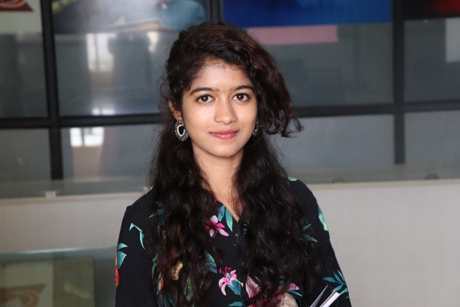
“I am really interested in creating beautiful outfits and dresses my dream is to become a fashion designer due to family pressure I took up commerce and I am hating it. In the Career Awareness workshop to they spoke to us about online courses and weekend course that I can choose from for fashion designing I can’t wait to explore these courses and pursue my dream while also completing my 12nd PUC in commerce”- Shared Tasmiya from Sairam PU college

- In the Life Skill Development Programme, we had 2153 young people engaged in developing life skills through technology-driven modules that help young people thrive in the 21st century.

“The Life Skill Sessions that I attended at Career Connect made more socially responsible; whenever I see something wrong happening around me, I take a stand. In my community, there is a petty shop that sells cigarettes to children I was shocked by this I approached the vendor and told him that what he was doing was wrong and I would complain to the police if he continues to do so; Dream a Dream gave me the courage to ensure my options are taken seriously and my voice is heard.” Says Sashi 19-year-old shared how Life Skill Development Programme helped him become a socially active citizen.
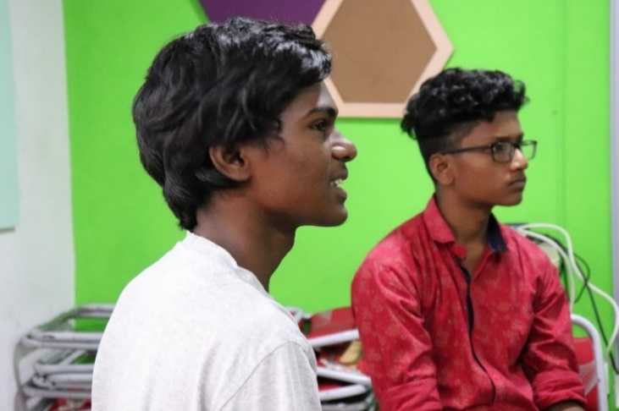
“I was a 2nd Pre-University College (or grade 12) drop out. I had to stop my education due to financial constraints in my family. I wanted a job very badly but every interview that I attended I got rejected as I could not speak properly and didn’t have much knowledge of computers and, at the same time I lacked the confidence to face people. The Life Skill Development Programme gave me space to work on myself - no one laughed at me because of the way I spoke, in fact, they appreciated me and motivated me. Today I have a job working as a cashier in a mall. I am also trying to complete my studies through distance education.” - Kantha, 19-year-old shared how Life Skill Development Programme helped him gain the necessary skills and confidence to thrive in an ever-changing world.

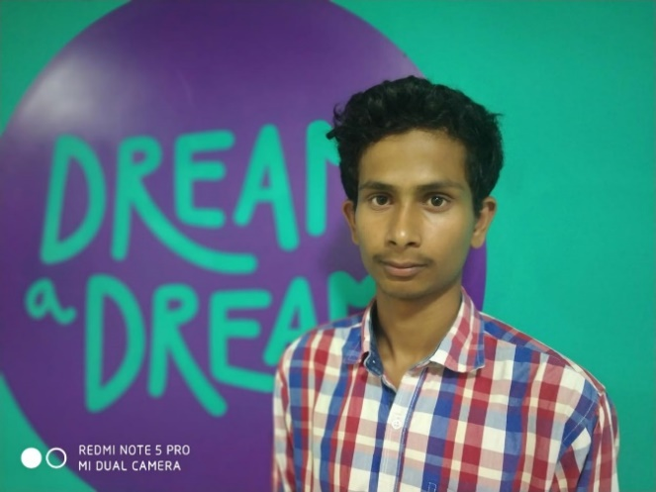
“ With the help of Life Skill Development programme I was able to identify my strengths; I was a person who used to go to college and come back and stay at home; I had no exposure to the outside world, my knowledge was bookish and academic, now I engage in conversations related to my community, politics and social issues with ease with my friends and colleagues” is what Praveen a 19- year-old Career Connect Graduate has to say.”

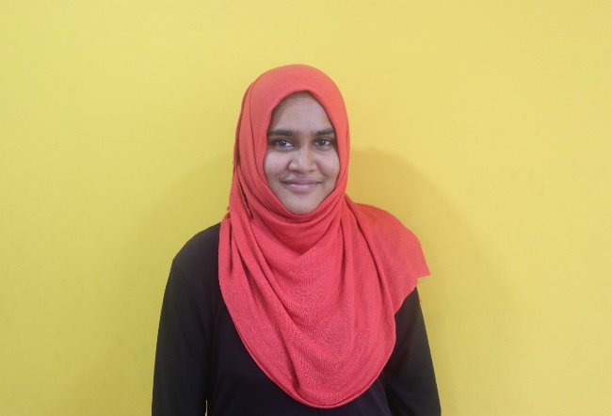

“I come from a family of 8 siblings; I am the 1st girl in my family to go to college by parents wanted be to study only till 12th STD as they cannot afford the education of all my siblings, they prefer the boys studying rather than. The session held here helped me fight for my rights to be educated it made me so strong that I was able to go out and fine a part time job to support my education now I am in my B.com final year and about to complete my education I am so proud of my journey”- Shared Reshma who has been a part of the Life Skill Development Programme and credits they journey to sessions she attended at Dream a Dream.

- In the Skill Development Programme, we had 1502 young people explore different skills like photography, photoshop, robotics and drone development, etc. that help them either look at using their skills for self-employment or gaining employment.

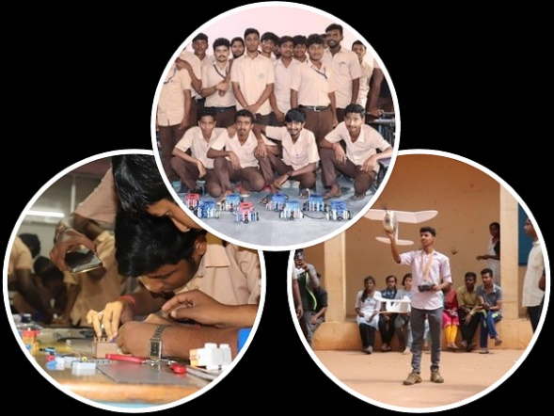
I am passionate about technology and love the idea of creating new things and be as innovative as possible; I dream of working with robots and drones in the future I want to specialize in robotics when I see my father working in the factory and see how manual his work is; I dream of creating robots that will reduce manual labour and give people like my father a chance to explore their own creativity and improve our business/economy. I know it is a far-fetched dream, but I am very fascinated about Robotics. Dream a Dream gave me the platform to explore various skills without the pressure to be successful.” – Darshan, 20-year-old who is part of the Career Connect Programme, shared how Skill Development helped him follow his passion.

The My Step, My Change community project which was a part of the skill development initiative , conducted in association with Reap Benefit and their #SolveNinja platform, helped a group of young people collaborate to provide the Madivala Government College with waterless restrooms for boys that are more hygienic and sustainable.

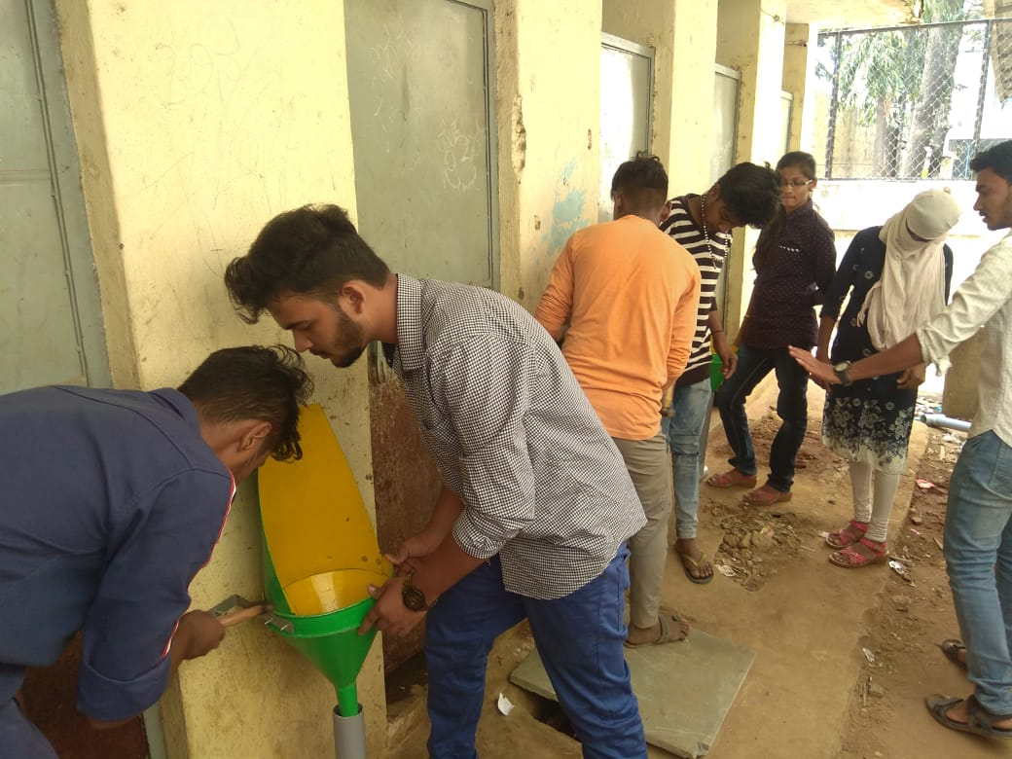
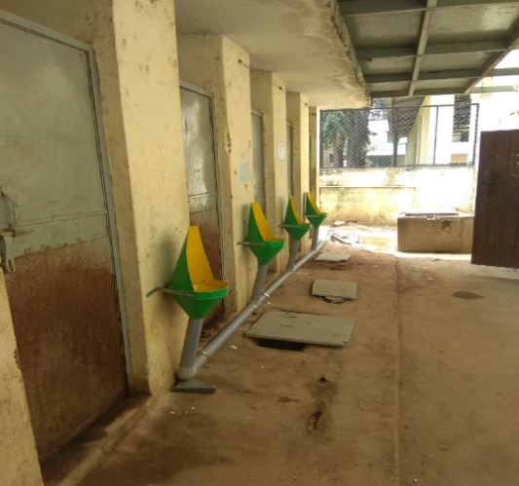

- We have provided scholarship support to 257 young people to pursue their education or a field that they are passionate about.

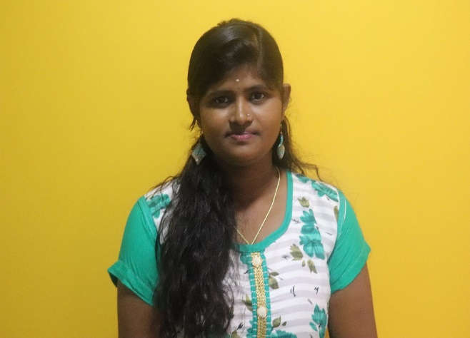
“With the help of the scholarship and the support of Dream a Dream I was able to complete my degree; I can’t believe that there was a time when I believed that I won't be able to complete my education. Today I have completed my B. Com degree with 92% marks. I am extremely proud of the hurdles I have overcome. It was the positivity that I cultivated in the centre that helped me achieve my goal”.
Indraja wants to pursue higher education do M. Com; she is passionate about teaching and wants to become a professor in a reputed University. She feels that by teaching she can help students like her and help them have a good future.

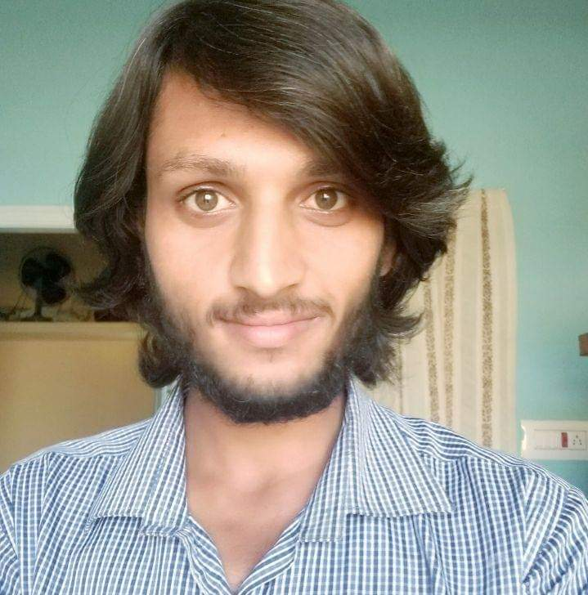

“My passion is to become an Actor in Kannada film industry and I have joined for professional acting classes. As a Hero my inspiration is film actor Rocking Star Yash, because he is a good actor and he knows a lot about acting and he is good in acting and dancing and he knows how to attract people in acting field. I learnt many things in Dream a Dream (Career Connect Centre). As an actor it is important to be confident and have stage presence skill-wise while I was completely the opposite, I had stage fear, was a shy person and could not express. The activities at Dream a Dream helped me gain the skills I was lacking in. My strengths are that I have good communication skill and I know how to face a camera in different angles now I am known for my acting skills”. Unlike young individuals who have dreams of following the mainstream professions of becoming engineers, doctors etc., Akshay wants to become an actor. Akshay has taken up a theatre course to work on his acting skills with the help of the Dream a Dream Scholarship.

- We have provided placement for 146 young people and have enrolled 107 young people in the entrepreneurship programme.

- 113 mentors have been trained in the mentoring programme and 100 young people are benefitting from the mentoring support to help them make healthy life/career choices.

- We had 32 young people explore a self-learning programme called “Come let’s learn” where young people designed their own learning journey for 25 days. The objective was to enable young people to create their own learning journey.

- In Collaboration with PALEDIFY, a software company, we have developed a Mentoring Software which has been released and is in its piloting stage. This software shall enable us to track the mentoring journey and encourage active participation from mentor and mentee.

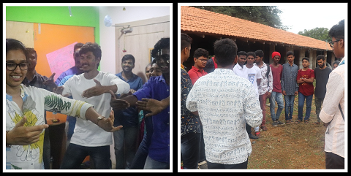
- Young people were given a space to interact with entrepreneurs from varied unconventional fields which gave them the much-needed exposure to deep dive into the life of an entrepreneur. Some of the entrepreneurs were Life Coach trainer, a Yakshagana (a traditional Indian theatre form that combines dance, music, dialogue, costume, make-up, and stage techniques with a unique style) trainer and artist.

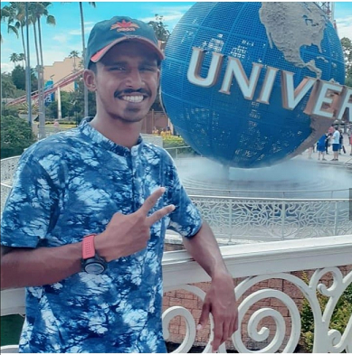
- Alfred Joy, a Career Connect Graduate was selected to a year-long college programme in the US selected through the US Consulate in India. He is currently pursuing a 1-year programme in Business Operations at a community college in the US. This is an initiative of the Department of State, United States of America government programme to support young people to pursue courses similar they are pursuing in any of their community colleges.

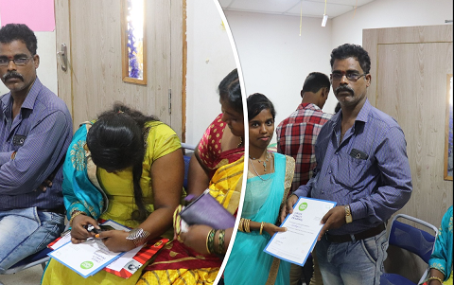

- The ecosystem that surrounds young people plays a huge role in helping young people make meaningful life choices; we were able to engage 90 parents in Career Connect Programme and help them understand the urgency for life skills.

- We have actively engaged 120 volunteers from the corporate sector in the Career Connect Programme

- We have designed a report called “Thriving – Stories of Success Redefined”. In this project, we analyzed the seven-year journey of young people in the Career Connect Programme. The insights we gained from this is that success stories need not only be academic/ professional success, but success can also be the meaningful life choices that young people make.

- 699 young people are thriving and ready to move out of the Career Connect Program and taken on the bigger role to act as Life Skill advocates in the society.

- We had an automation project with Microsoft India Private Limited for tracking young people using Short Message Service (SMS) to support them make healthy career choices. We had more than 50% of the young people respond to our question using this technology.

- Dream a Dream's Life Skills Assessment Scale has been expanded to include defined norms for young people in the age groups 17-19 and 20-22 years. The LSAS has been successfully used in our work over the last decade while engaging with young people coming from adversities. Suchetha Bhat, CEO, Dream a Dream and Vishal Talreja, co-founder Dream a Dream have co-authored a research paper based our learnings to expand it to accommodate a wider age group. The full paper has now been published and can be accessed here: https://tinyurl.com/tc7slzb

- Dream a Dream launched a Career Guide for young people in our Career Connect Programme, a beautifully designed and illustrated book outlining over 50 potential careers that young people can choose from. Please do click on the link below view our Career Guide
https://drive.google.com/open?id=1QN_d3Mzubo3un8UGyLMAOTUYM6Cjzl0V

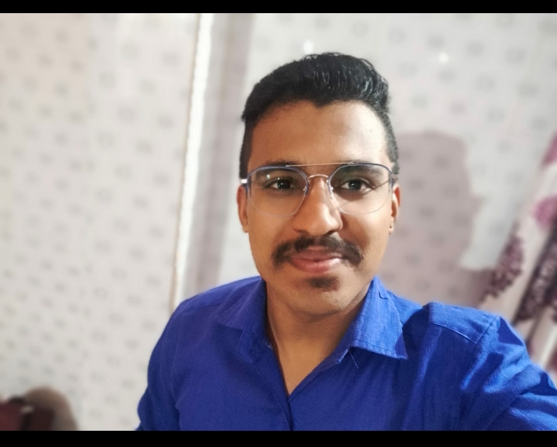
I underwent an Entrepreneurship Course at the Centre, where I learnt that there was much more to starting my own company than I had initially envisaged. To begin with, I realized how to make funders want to invest in my company and the various steps to starting one, on my own. Inspired by these sessions, I started my own informal services of event management, where I help curate small birthday parties, helping out with the venue decorations, photography and catering, helping my father’s business as well. My dream is to formally establish this one day and facilitate sessions, for no fee on how to manage an event for the students who might be interested in the same. That is how I believe I will be able to give back to society. Whatever knowledge I have, I hope to pass it on to others and help them, even if it means employing them in my company, to get more exposure and experience in this field. From my future earnings, I hope to give back a certain amount to Dream a Dream as well, to enable them to help other students like how they helped me. – Shares 20-year-old Kaushik who completed the Career Connect’s Entrepreneurship programme.

