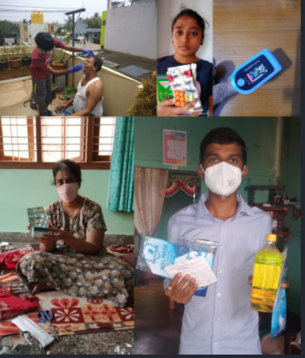
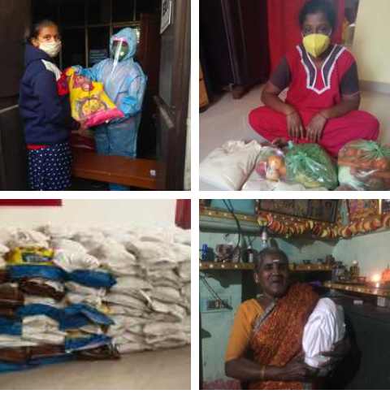
Responding to Medical requests Distributing Ration Kits to help families:
No child’s learning is left behind due to digital divide and internet support:
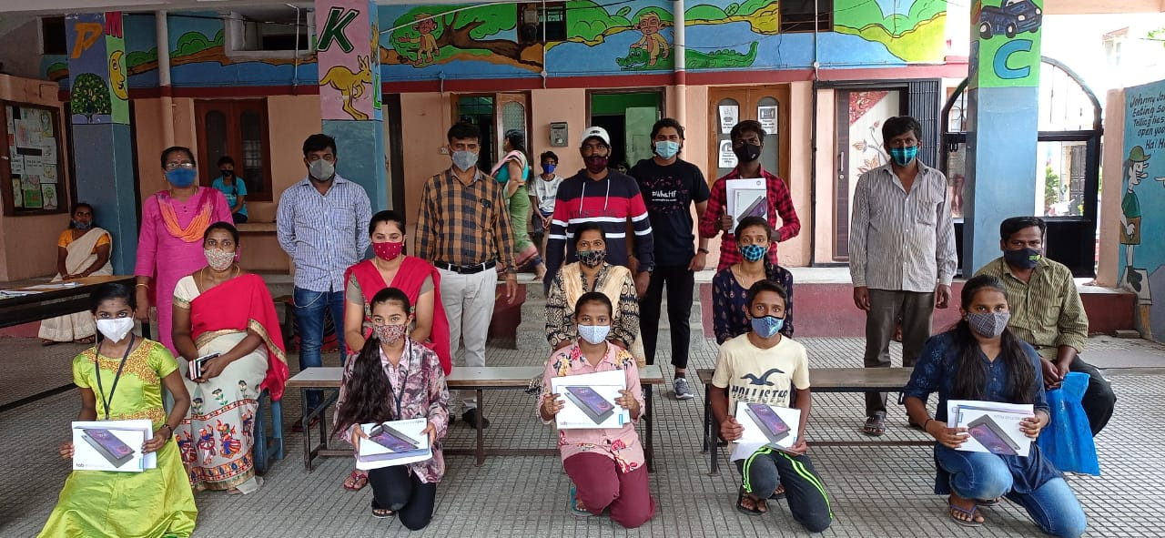
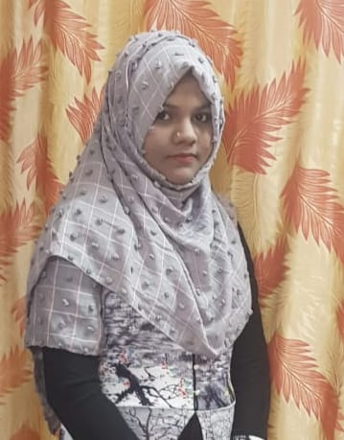
Ruquiya Banu from Florida English school

Nandini an alumnus from Dream a Dream’s Career Connect Programme has been selected to study Business Management and Administration at Kirkwood Community College (Iowa, USA)
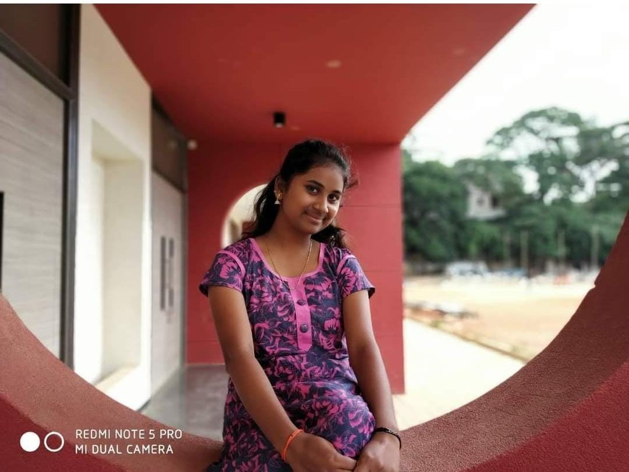

Story of Change - Jayashree from Pragna Vidyanikethan School
