Museum of Slavery Mossuril, Mozambique
OHIA EROHO (Lay Down Your Heart)
Project Proposal
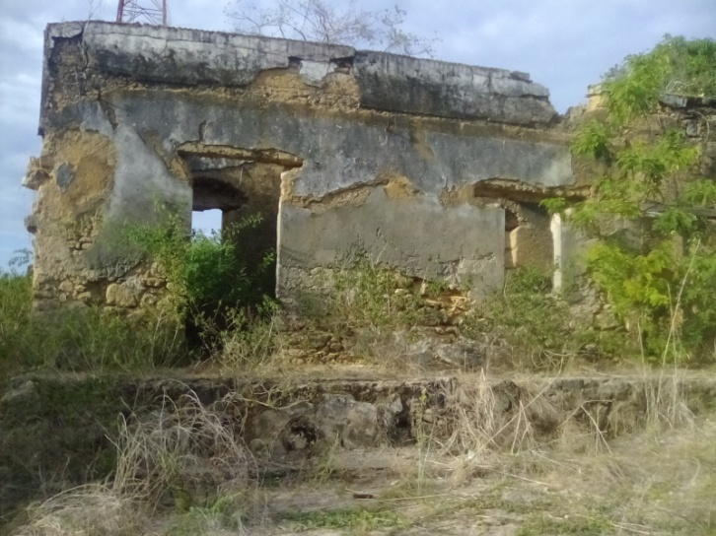
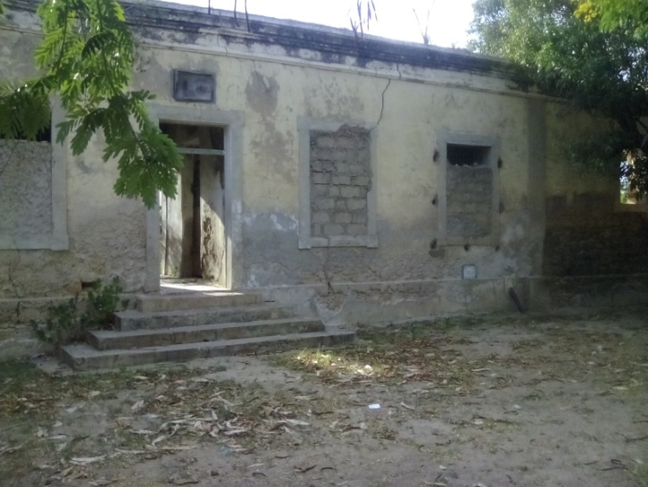
Project Name: Museu de Escravos Ohia Eroho, Mossuril
Project Description: To restore the actual ruined slave-holding prison into an interactive Museum of Slavery with:
- An exhibition hall 14.5m x 6.5m
- A prison exhibit room 6.5m x 3.5m
- To restore one room 10m x 6.5m into a conference room
- To turn the former guard room 2.9 x 3.50 into a reception area, library & archive

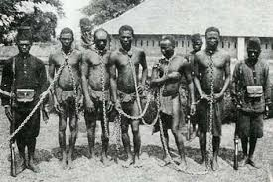
Millions of African men and women were stolen and sold as slaves to the Americas.

Hundreds of thousands of them were Mozambicans

And tens of thousands of them passed through Mossuril
Phase 1: To Create the Eromelo Nursery School
‘Eromelo means ‘Hope’ in Macua
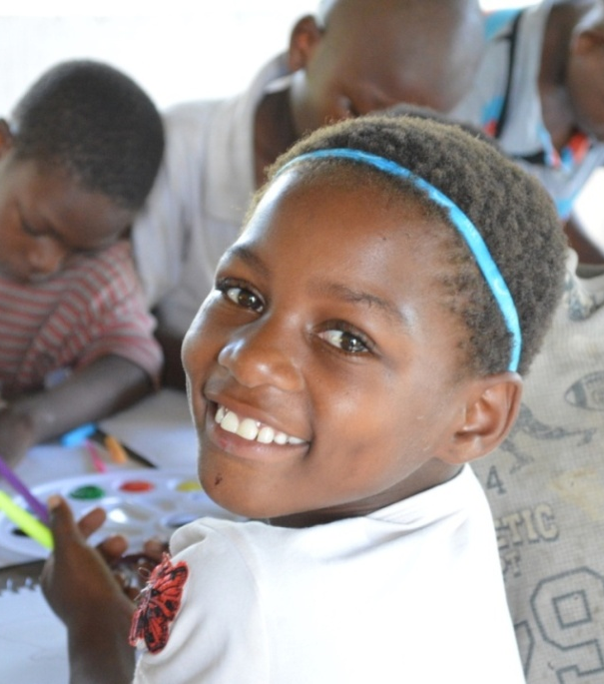
1.a) To restore 2 rooms 6.5m x 4m and a playground behind the museum for 54 local children aged between 3 and 5 years old for use Monday to Friday from 07.30 to 11.45 am
1.b) To build 2 x WCs, a kitchenette, a playground & a separate entrance
1.c) To equip the Eromelo nursery school (by adding to existing Teran Foundation nursery materials)
(NB there is currently no nursery school in Mossuril)

2.) To use the Nursery School Classrooms as workshop spaces from 12.30 onwards for local women and girls to receive IT courses

3.) To create an Arts & Crafts Club for disadvantaged youths
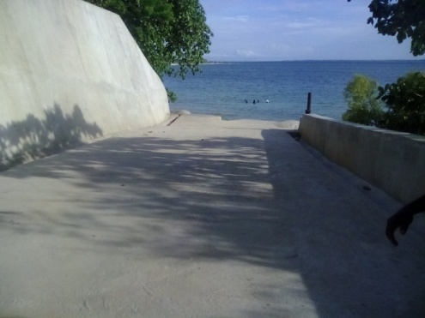
Location: The Feitoria (slave-holding prison) in Mossuril Vila, Via da Rampa de Escravos, Mossuril District, Nampula province, Mozambique
The project has been given the use of the old slave prison to turn into a museum of slavery
At GACIM, the guardians of the historic prison building and also the Ramp of Slaves, experts are concerned that the Feitoria has been badly vandalized.
The Slave Ramp (above) was restored in 2016 by GACIM & The Smithsonian African American Museum after a visit to Mossuril by its Director & founder, Dr Lonnie Bunch.
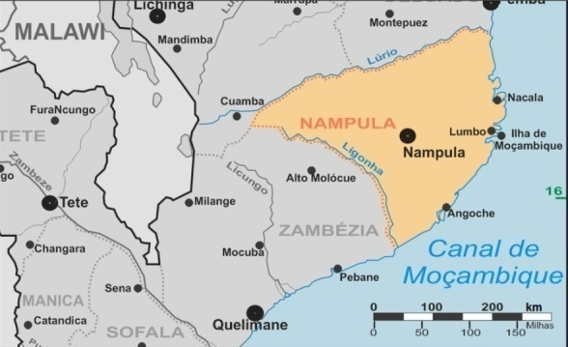
Why Mossuril? For 1000 years while Mozambique Island was the capital of Mozambique, Mossuril was its port and access to mainland East and Southern Africa
Figure 1Mossuril is directly opposite Lumbo (4km) & Ilha (8km) in Nampula Province
The sordid history of slavery in Mozambique stretches back for centuries with Arabs and Indians and finally the Portuguese capturing and selling local people as slaves. Within this network of human trafficking, Mossuril played a major role.
Ten years of War of Independence followed by 16 years of Civil War and over a decade of dire poverty have veiled Mozambique’s earlier history with a collective amnesia. Many local youths know nothing of the Civil War that only ended in 1992. Many local people refer to ‘slavery’ without knowing what it was or how it decimated their homeland.
Nampula City has a Museum of Ethnicity and Mozambique Island’s Presidential Palace was summarily turned into a Museum after an overweight bodyguard of the former President of Mozambique, Samora Machel, sat on and broke a delicate and priceless 18th century Goan bench outside the presidential bedroom.
While displaying the wealth and luxury of the Portuguese colonizers, that palace is not relevant to Mozambicans today in the way that the Museum of Slavery will be.
Mozambique Island also has a Slavery Memorial Garden which has whetted the appetite of many visitors and local people alike to know more.
While the country is once again threatened by internal strife, finding shared strength in common roots would be an important step towards the peace process.
“… but we are only doomed to relive our past if we fail to learn from it. .... If you know whence you came, there are absolutely no limitations to where you can go.” George Santayana
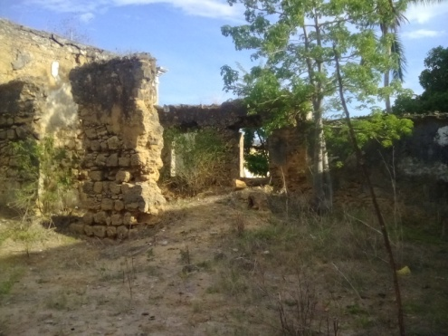
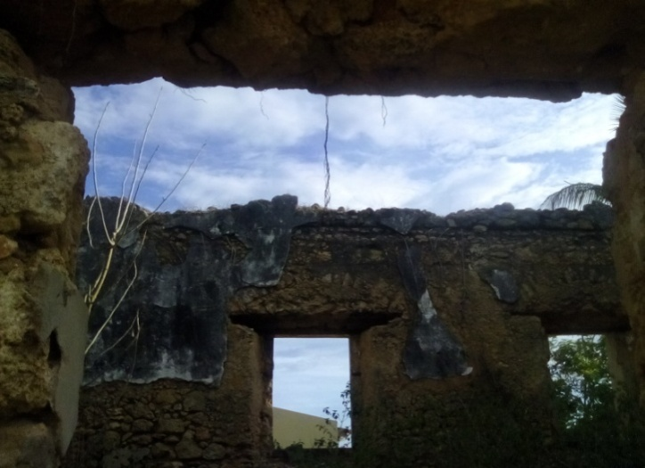
The Building: The museum will be housed in the actual former slave prison of Mossuril where tens of thousands of slaves from South-East Africa were held before being taken to Mozambique Island for sale in the slave market there. Thus, Mossuril was the last place on the African mainland where those captive men and women would walk the soil of their homeland under the protection of their ancestors.
In Macua, the language of the 9 million Macua people who form the majority of the population in North Mozambique.
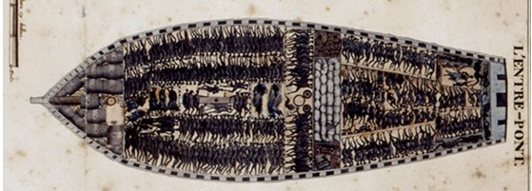
New slaves entering Mossuril and its Feitoria would abandon hope and ohia eroho: lay down their heart.
All the iron wood supporting beams have been stolen from the building, as hove most of the doors and windows. There is no roof and the 130cm-thick walls have been partially destroyed.
However, the building is solid and could quickly be made structurally sound. Unless this takes place soon, the walls spanning the fifteen window spaces and 5 of the existing door spaces will collapse, bringing down much more of the structure.

In the 19th Century, this image inspired millions of free men & women worldwide to campaign to abolish the African Slave Trade.
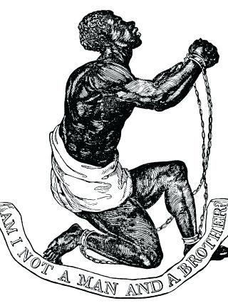
Eromelo Nursery School will use the image as its emblem to inspire local children to respect human rights
This Museum project will not only provide an educational hub, sensitize Mozambicans to their own (mostly) forgotten history, and provide a much needed tourist attraction, it will also save a historic building from destruction.
The conference centre will keep the Museum economically viable irrespective of how many guests arrive in the first two years, thereby allowing the museum to grow and refine its exhibits at a realistic pace.
The Director of Arts & Crafts will be Nequeias Omuine, a local artist and advisor to the District Government
The Museum’s Consultant with be Sr. Bernabé, who works with the Provincial Director of Cultural Heritage for Nampula Province, Mozambique
The Museum will aim both to touch and teach its visitors. There will also be one section to describe the human trafficking that is the bane of Mozambique today,
This is where much of the slave trade happened. This is where people were herded before being shipped and forgotten. The stones of this historic building are being plundered to be broken down and used in the foundations by local builders.
The Museum will also be of especial interest to visiting African Americans.
“The real names of our people were destroyed during slavery. The last name of my forefathers was taken from them when they were brought to America and made slaves, and then the name of the slave master was given, which we refuse: we reject that name today and refuse it. I never acknowledge it whatsoever.” Malcolm X
Those who were taken suffered; & those who were left behind suffered too. And yet millions of descendents of all those victims who are linked by both a shared trauma and by blood have lost touch with each other.
Like many African ethnic groups, the Macua revere their ancestor and believe they are guided by them through their life time before being welcomed to sit among them as fellow protectors of their people.
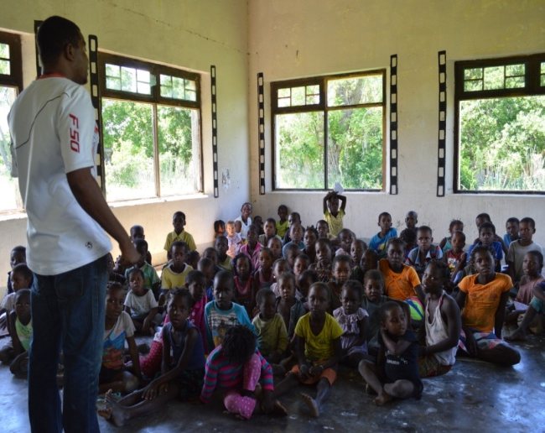
The Eroromelo Nursery School will operate Monday to Friday from 07.00 until 11.45 a.m. It will have a separate entrance, a playground, 2 WCs, and a kitchenette to prepare nutritious snacks. Its 2 classrooms and facilities will also have a second function as workshop space and a much-needed local business center.

The separate prison cell 6.5mx 3m will be used as a craft training centre
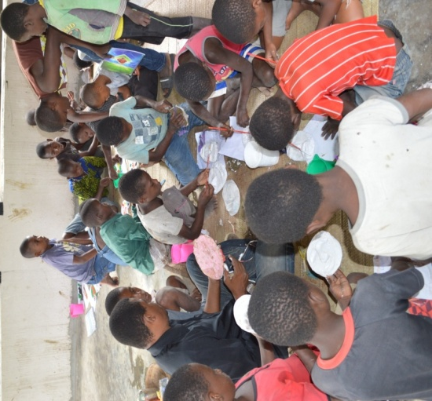
Skilled Makonde wood-carvers and other master craftsmen will help train local youths to make craft items to sell primarily to the Museum’s visitors and to tourists on Mossuril’s beaches.
As soon as Phase 1 starts, The Museum of Slavery will begin to request donations and loans of artifacts, documents, and books to display. Local archives in Nampula Province already contain invaluable future exhibits and with the assistance of the District and provincial Government of Nampula, an impressive collection will be made available to the Museum.

“Slavery is something that is all too often swept under the carpet. The shame doesn't even belong to us, but we still experience it because we're a part of the African race. If it happened to one, it happened to all. We carry that burden.” Lupita Nyong'o
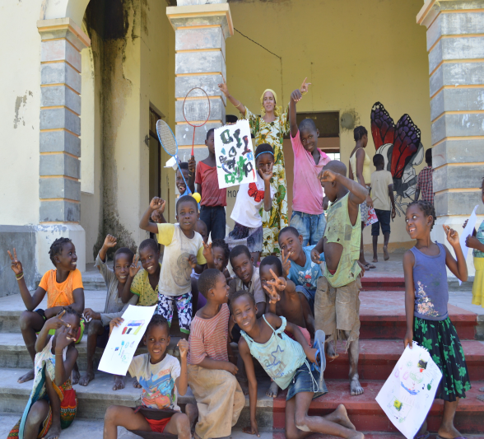

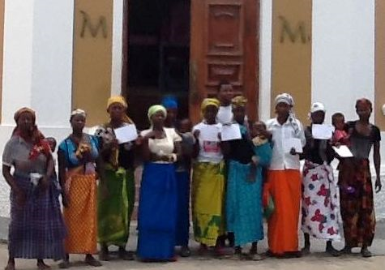
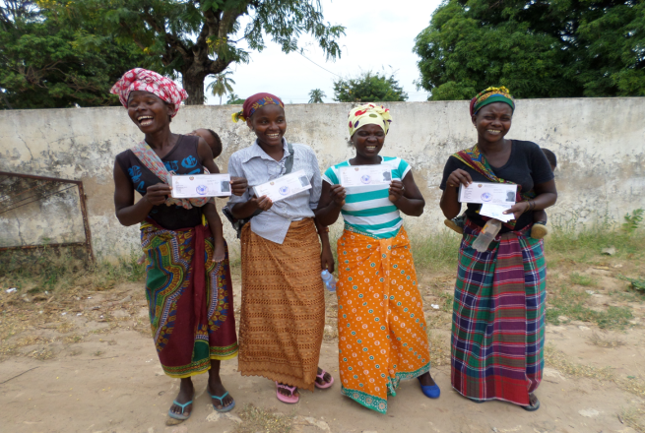
Beneficiaries of Phase 1 of this project;
- 54 pre-school kids per year
- 100 local disadvantaged youths
- 100 women & girls per year at IT courses

Beneficiaries from the Museum of Slavery (which will include numerous school visits):
An estimated 4000 visitors per year

Ground plans of the Museum of Slavery & its Nursery School
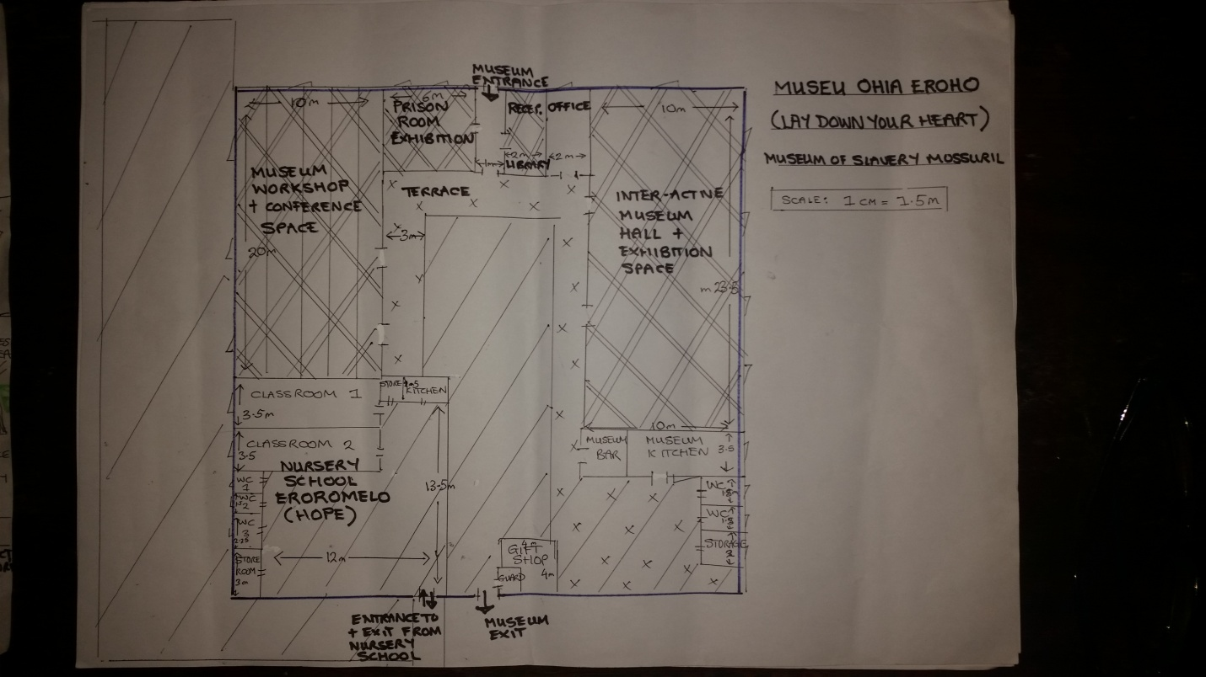

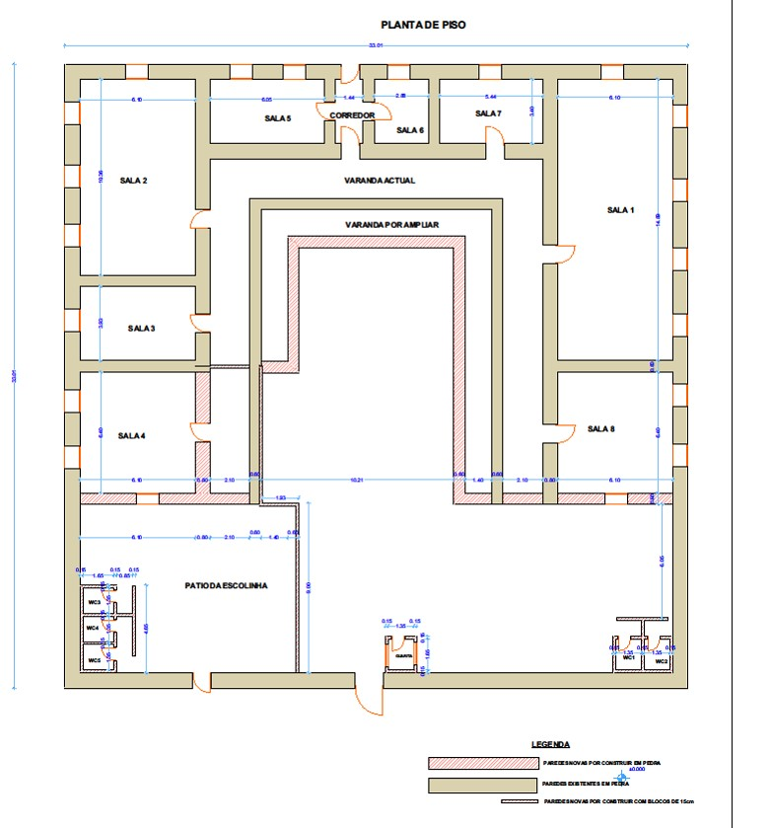

A Ground Plan of Museum of Slavery, The Nursery School, The Arts & Crafts Centre, Parking & Grounds

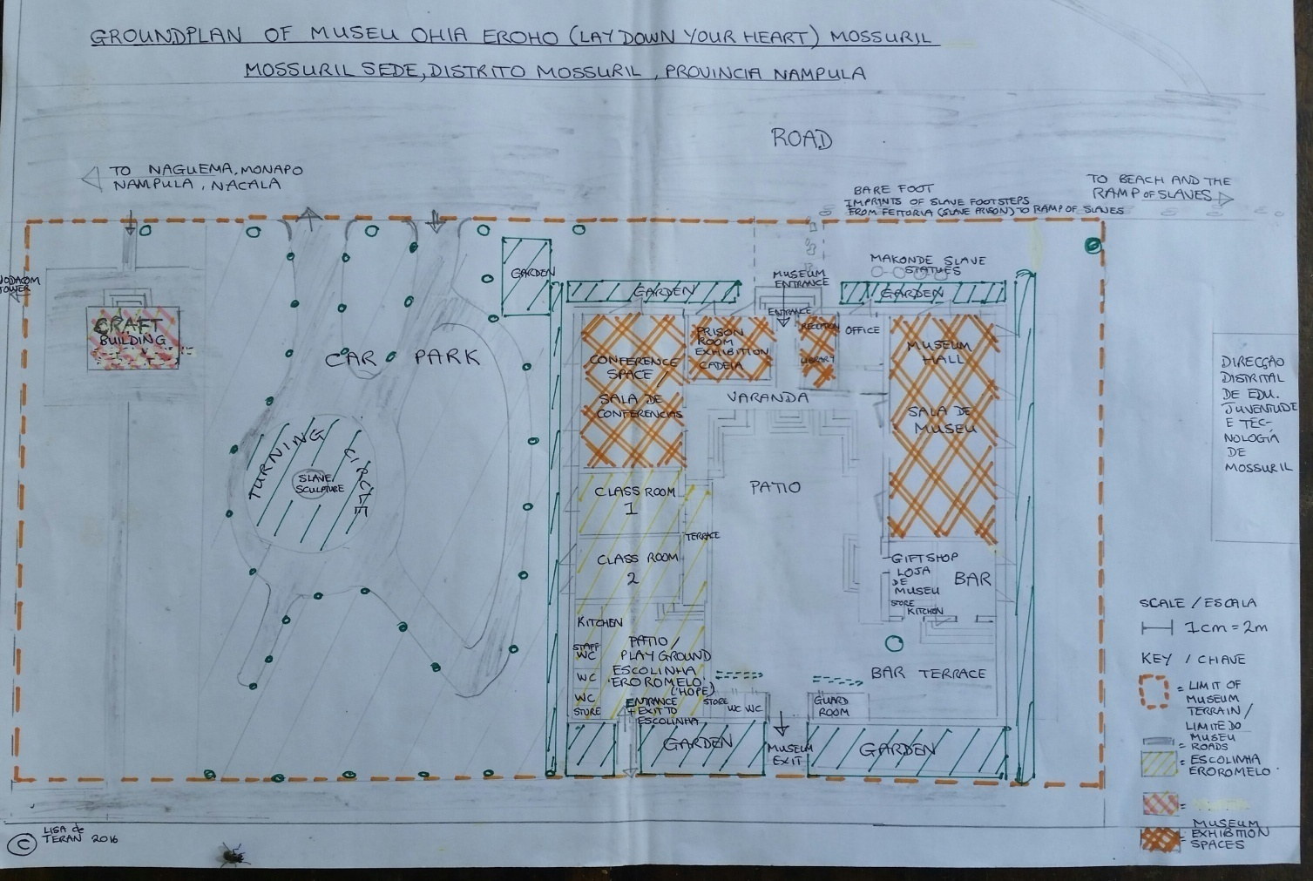

The Museum will highlight slavery past & present, including human trafficking in Africa today
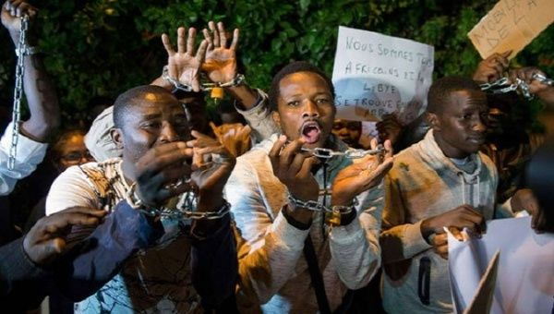

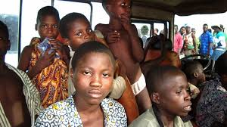
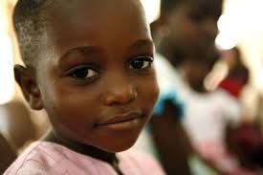
Mozambican children are particularly vulnerable to human trafficking and they should learn about its dangers

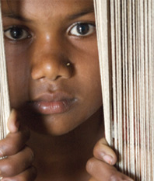
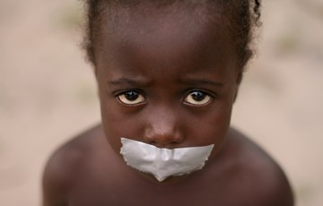

The Budget:
Total Budget: 204.000 USD
Phase 1: 28000 USD (=1.680.000 MZ MTS) To complete 2 large nursery school /IT course rooms, wall off a playground, & provide basic equipment to add to what Teran Foundation has already gathered for the nursery school
We aim to complete Phase 1 by July 2019
Phase 2: 56.000 USD: will be the restoration of the ruined slave-holding prison: 56.000 USD (3.360.000 MTS)
Phase 3: 120.000 USD: Phase 3 will be the fitting & equipping of the Museum of Slavery plus the conference room: 120.000 USD (7.200.000 MTS)
To ensure complete transparency, all project accounts will be audited by an independent registered Mozambican accountant and the audit results will be sent to the donors within 12 weeks of ending the joint project.
The project will also be video-documented with regular updates on the Museum’s own website, and on social media.
Project Partners: Teran Foundation (a charity registered in the Amsterdam KvK / dossier number: 34205619, NL, and embedded in Mossuril serving the local community since April 2004), Teran Foundation Lda. (a company registered in Maputo with a head office in Mossuril), GACIM (Ilha), Africa Leisure Development Lda. (Mossuril), Department of Cultural Heritage (Nampula) The Mozambican Ministry of Education & Culture (Maputo) CPI (Centre for the Promotion of Foreign Investment, Nampula Branch), INAC (Nampula), Stones for Peace Lda. (Mossuril), Fim do Caminho (Nampula), Association ‘LIFE’ (Mossuril & Nampula)
The longer we take to start, the more the building will fall down and current pre’school kids will miss out on nursery education.
To get started, we need your help: so please join us in telling this story which needs to be told.
Behind the grim reality of slavery, there will be a hub of joy & hope.
We hope you will come and visit it one day. Tucked away and mostly forgotten on the edge of the Indian Ocean, the history and beauty of Mossuril are well-kept secrets.

Contact: Lisa de Teran: (speaks English & Portuguese) Email: lisadeteran@gmail.com, www.teranfoundation.org Cell: 00 258 842 995 697
Nequeias Omuine: (speaks Portuguese & Macua): Email: n.omuine@gmail.com Cell: 00 258 848 980 880

