Mossuril Museum of Slavery's Nursery School (35501)
Dear Friends and donors,
Here in Mossuril we are waiting for a particularly heavy rainy season to end so that we can start building and restoring the new nursery school. This has been the wettest rainy season I have known since I first arrived in Mossuril in 2003.
So far, despite several direct cyclone warnings for Mossuril during the past 3 months, we have been lucky enough to escape with nothing worse than torrential rains, gale-force winds and roads blocked by knee-deep mud.
Meanwhile, though, we have been working on the administrative and logistic side of the project. And after some stalling at the District level, the Provincial Governor of Nampula, H/E Victor Borges has kindly stepped in to sweep the red tape out of the nursery-school-to-be’s way.
In Mozambique, the Government has been de-centralized thus projects can only move forward when the relevant District Government actively allows them to.
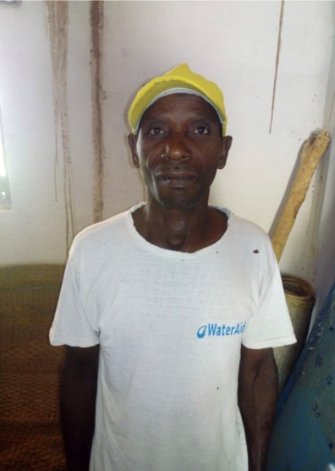
Now, as soon as we get past these last few weeks of rains we will be able to get going under the guidance of the local master builder, Momade (left).
While we are waiting we have adopted a nursery school which is already up-and-running on neighbouring Mozambique Island which has lots of children and staff but no toys or games or equipment of any kind.
Thanks to all your support via Global Giving and in particular to the pro-active enthusiasm of Selina and her friends in Ibiza, we have a lot more nursery school equipment, toys and games arriving in September for our new pre-school. So we have donated 2 boxes of pre-school books, toys and games to Mozambique Island (always known as ‘Ilha’).
And we also have 2 laptops for Mossuril’s nursery school which will help Selina from Ibiza and her two fellow-volunteers to give support and extra pre-school teacher-training to Angela and Fatima when they come out to Mossuril for the month of September 2019. The laptops will then belong to the pre-school.
This year, we are asking all of our volunteers to either pay their volunteer registration fees directly as a donation to the nursery school project or to bring an equivalent value in kind.
We are pleased to now have a collection point in the UK, one in Amsterdam and another in Ibiza for toys and books but especially for Early Learning toys and games. So we would like to thank everyone who has already contributed as well as those who will be helping with gifts, goods, transport and / or donations in the future.
As the storms have also hit Nampula City, both Angela and Fatima are waiting for the weather to settle down before taking up their Mozambican Government pre-school teacher-training course. As both of them have families in Mossuril, they will need to commute weekly to the big city (180km away) and for that Mossuril’s one access road needs to be passable.

And, meanwhile, we are preparing an extra push to raise the remaining budget to make this pre-school a big success.

While sitting around watching the rain is not very exciting, after 16 years of living here, we know it is sometimes necessary.
In fact, it is so common that I wrote a short story about it some years ago. It is called ‘Watching the Rain’ and it is set in Mossuril and based on a true story. This weekend I will dig it out and publish it on Teran Foundation’s facebook for anyone who is interested.
I believe that the greatest good grows out of nursery education and pre-school care and ‘vakani vakani’ (= slowly slowly) we will provide Mossuril with its first pre-school.
ETA is now September 2019.
Best wishes and thank you again from Lisa St. Aubin de Teran on behalf of children and their parents in Mossuril.
Mossuril 05 03 2019

