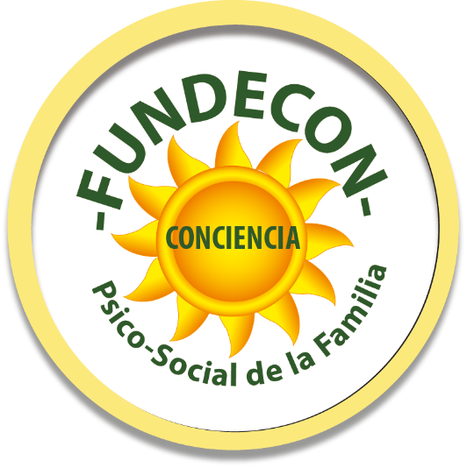
FUNDACIÓN PARA EL DESARROLLO DE LA CONCIENCIA PSICOSOCIAL DE LA FAMILIA “FUNDECON”

GENERAL DATA OF THE PROPOSAL
Project's name | Project: "Homes Without Abuse, A World Without Violence or Drugs"
Location | - Country: Ecuador, province of Guayas, peripheral neighborhoods of the city of Guayaquil and Duran  - • Cantón Durán: Duran  - • Canton Guayaquil: Guayaquil  - • Tarqui Parish: New Prosperina (Housing Partner)  - • Ximena Parish: (Isla Trinitaria)  - • Parish Febres Cordero: Cisne II
Responsible for the execution of the Project | FUNDECON
Direct and indirect beneficiaries | Direct beneficiaries: 420 people  Indirect beneficiaries: 800 people
Jobs created for the purpose of the proposal | Permanent work: 4 positions  Occasional Work: 6 positions
Value of the Project | $64.000,00
Legal Representative of the Organization | Carol Iván Farah Thoma
Address of the Organization | Samanes I -Mz. 122 V. 33
email | fundación@fundecon.org
Web page | www.fundecon.org
Bank Account | 2100149374

INDEX

GENERAL PURPOSE……………………………………………………………………………………………………………1
SPECIFIC OBJECTIVES…………………………………………………………………………………………………………1
EXPECTED RESULTS……………………………………………………………………………………………………………1
THEMATIC CONTENTS TO BE DEVELOPED….………………………………………………………………………2
BACKGROUND OF PROBLEM IN ECUADOR….………………………………………………………………….…3
JUSTIFICATION………………………………………………………………………………………………………………….4
PROJECT INTERVENTION STRATEGY….…………………………………………………………………………….…6
PERSONAL SELF TRANSFORMATION PROGRAM….……………………………………………………….……7
- STRUCTURE OF THE WORKSHOPS….………………………………………………………………….……7
EVALUATION OF IMPARTIED KNOWLEDGE …………………………………………………………………….…8
ASSESSMENT TOOLS………………………………………………………………………………………………………….8
THEMATIC CONTENTS AND THEORETICAL FRAMEWORK…………………………………………………..8
- THE FAMILY, THE FIRST SOCIALIZATION AGENT…………………………………………………………8
- EDUCATION IN HUMAN VALUES……………………………………………………………………….………9
- LINGUISTIC NEURO PROGRAMMING – NLP………………………………………………………..……11
- PERSONAL STRATEGIC LIFE - PLAN PROJECT……………………………………………………….……12
PROPOSAL OF ACTIVITIES….…………………………………………………………………………………….…..…14
BUDGET….………………………………………………………………………………………………………………...……15
APPENDIX 1….…………………………………………………………………………………………………………..……16

GENERAL PURPOSE

Knowing that the main cause of violence and drug use in the community is the high level of abuse suffered by children and adolescents in their homes, our objective is to influence the progressive reduction of this situation in four marginal urban sectors of the population in Guayaquil, through a process of training and community bonding that makes it possible to highlight the problems described above and solve them in the individual, the family and the community.

SPECIFIC OBJECTIVES:

Bring a diagnostic type territorial mapping of the problem situation of the target population: number of children and teenager whose rights have been violated, type of problem, causes, consequences, so that it serves as an input to the entity to propose the solutions.

Joining in the creation of the life project of each of the participants, especially the young people, through workshops.

Deliver methodological tools (through workshops) that allow the community to implement actions that facilitate the active participation of actors linked to the target population, aimed at creating and / or strengthening spaces where they can carry out training activities, playful and recreational. (These actors are: parents, teachers of schools and colleges, leaders of churches, neighborhood leaders, police).

EXPECTED RESULTS:
- Participatory diagnosis of the problem of intrafamily violence and its consequences such as drug consumption and the vulnerability of the rights of children-teenager and young people in the intervened communities.
- A commitment document (drawn up by the participants themselves) that reflects what is internalized and what new practices are willing to be undertaken to reduce domestic violence and drug use.
- Four massive community events of artistic and cultural expression promoting non-violence and the prevention of drug use.

• List of participants by groups (youth, adults, leaders and community references).

• Report on the results of the process.

THEMATIC CONTENTS TO BE DEVELOPED

PROPOSED TOPICS
1 | THE FAMILY, FIRST SOCIALIZATION AGENT | The family and its role as a proactive agent of internal (family) and external (community) solutions. What can be done to address the risk of vulnerability of the rights of the child-teenagers and the teenager´s drug abuse, in the family?
2 | EDUCATION IN VALUES | Values ​​whose practice contribute to the increase of self-esteem, respect and good physical and emotional health and their contribution in the reduction of: A) aggressive behaviors, executed by parents and teachers and B) the use of drugs.
3 | PERSONAL STRATEGIC PLAN | Preparation of a personal life project, to reduce the consequences of intrafamily violence and its incidence on drug use in adolescents.
4 | EFFECTIVE STRATEGIES FOR FAMILY AND COMMUNITY COMMUNICATION | Intrapersonal and interpersonal communication to counteract intrafamily violence and drug use: Neuro Linguistic Programming, relaxation and anti-stress exercises, relaxation, meditation, yoga.

BACKGROUND OF THE PROBLEM IN ECUADOR
• In Ecuador, 56% of children and teenagers have entered foster care institutions due to the cause and effects of violence. Source: State of situation and analysis of the exercise of rights of children and teenagers in Ecuador. 2014-2015.
• By 2012, there were 17,370 reported cases of girls, boys and adolescents who suffered some type of violence, including physical, psychological, neglect and sexual abuse. Source: State of situation and analysis of the exercise of rights of children and adolescents in Ecuador. 2014-2015, MIES 2012.
• In 2015, 33% of children and adolescents between 5 and 7 years old were physically and psychologically abused by persons responsible for their care, including their fathers and mothers. Source: Children and Adolescents from intergenerationally, Ecuador 2016, ENAI 2015, OSE 2015.
• 4 out of 10 girls and boys who suffer violence within their homes, live with parents and / or mothers who were mistreated as children. Source: Children and Adolescents from intergenerationally, Ecuador 2016, ENAI 2015, OSE 2015
• 33% of children and adolescents between 5 and 17 years old say they receive blows from their fathers and mothers when they do not obey or make a mistake. Source: Children and Adolescents from intergenerationally, Ecuador 2016, ENAI 2015, OSE 2015.
• 6 out of 10 girls and boys say they deserved the reactions of their parents to their faults. Source: Children and Adolescents from intergenerationally, Ecuador 2016, ENAI 2015, OSE 2015.
• According to data that account for the intergenerational transmission of violence, 18% of the people who are currently parents and / or mothers suffered violence with their parents when they were children. Source: Children and Adolescents from intergenerationally, Ecuador 2016, ENAI 2015, OSE 2015.

• 30% of adolescents between 12 and 17 years old have witnessed abuse among their parents. Source: Children and Adolescents from intergenerationally, Ecuador 2016, ENAI 2015, OSE 2015.
• Only 4 out of 10 children and adolescents talk with their parents to resolve their differences. Source: Children and Adolescents from intergenerationally, Ecuador 2016, ENAI 2015, OSE 2015.

According to WHO data indicate that victims of violence in their homes, lose their self-esteem, isolate and tend to silence their fear and helplessness, so it is very common to seek "refuge" in drugs. People who suffer some type of abuse are more prone to alcohol consumption and have more risk of using and abusing other drugs.

"Domestic violence is a source of violent individuals who will behave in the same way when they build their own homes. It is a learned behavior that will cross generations if corrective actions are not taken” Bertha de Farah.

JUSTIFICATION
The phenomenon of worldwide violent societies and drug consumption represents a problem increasingly complex, dynamic and multicauline (the same root several trunks) that generates damage to health, social coexistence and public safety. It disintegrates society and above all, its central core, the family. This problematic situation demands an integral, multidisciplinary, immediate and based on scientific evidence, approach.
The criterion of the selection of the four parishes for the intervention of the proposal lies in the concentration of several risk factors that increase the tendency to violence and the consumption of drugs such as: poverty, citizen insecurity, gender and intrafamily violence, high percentage of adolescent population, request for permanent help from educational institutions, alcohol consumption in parents, homes with absent parents and little participation of local authorities on the subject. Next, some data that we consider relevant to mention, on the sectors to intervene:
• Cisnes II: Located on the shores of the Estero Salado in the southwest of the city, it was founded around 1957 by several people who migrated to Guayaquil from different parts of the nation, belonging to the Febres Cordero County.
• Trinitaria Island: On this site, surrounded by estuaries despite having experienced rapid growth, the Trinitaria is still one of the urban sectors with the lowest poverty indicators and where people live in situations of insecurity. Trinitaria is today the place with the largest number of Afro-Ecuadorians in Guayaquil. Together with Fertisa, the Guasmos and El Cisne, constitute an area that concentrates more than 50% of the population of that ethnic group in Guayaquil. This is revealed by an investigation carried out between 2010 and 2011, which reviews the socioeconomic situation of afro-guayaquileños and aspects of segregation in the territory. The study also identified the consolidated area of ​​the south of the city, as well as Bastión Popular and Pascuales, as places with greater Afro-descendant population. It belongs to the Ximena County.
• Duran: Represents 2.0% of the territory of the province of GUAYAS (approximately 0.3 thousand km2), 235.8 thousand inhabitants. (6.5% compared to the province of GUAYAS), its main activity is the manufacturing industry, commerce, agriculture and fishing.
• Nueva Prosperina, Socio Vivienda: Located in northwest Guayaquil, adjacent to the sector of Mount Sinai, is a residential complex created with the aim of solving the problem of homelessness and relocation of people who used to live in the city of Guayaquil in houses made of cane on the banks of the salty estuary. It belongs to the Tarqui County.

PROJECT INTERVENTION STRATEGY
OBJETIVE | ESTRATEGY | LINES OF ACTION
Objective 1: Prevent Domestic Violence and the Use and abuse of Drugs | Strategy 2: Reduce risk factors (intrafamily violence, gender violence, inequality) in the community-family and individual. This strategy includes actions aimed at improving the dynamics of family and community relations, from different angles. | Develop parenting skills and harmonious coexistence of the individual in his family and community, mainly in the prioritized territories.
 |  | Promote assertive communication processes and family discussion about violence and drug use.

For all the above mentioned, the project basically intends to intervene in four marginal urban sectors of Guayaquil Canton and Durán, Nueva Proserpina (Socio Vivienda), Isla Trinitaria, Cisne II, and Durán), through a training process, which with the use of methodology of Experiential Learning for the development of human potential, a process aimed at the formation and transformation of people from their own individuality, as well as in the interrelation with other individuals for harmonious coexistence for a more fair and responsible society. In general, it consists of formation, education and training program, within the framework of a significant learning process that, through professionally guided experiential workshops, the assistants will be able to incorporate deep positive changes in their behavior.
This process will be aimed at young people, their parents, leaders and community leaders, as key actors to influence the decrease in levels of drug and alcohol consumption, especially among adolescents and young people in this population. The themes will be developed within the framework of a participative, recreational and recreational methodology, incorporating gender, generational and rights approaches. The proposal will be developed in the territories themselves.
PERSONAL SELF TRANSFORMATION PROGRAM
STRUCTURE OF THE WORKSHOPS:
Workshops are based on the fact that the individual is the manager of his own learning, for which is necessary that he becomes really aware of the pros and cons of his decisions at a personal, family and community level. For this reason, the workshops are going to deliver methodological tools that allow this to happen through a participative, playful process.

The five workshops have a systemic structure in the concretion of contents, methods and techniques according to each module, with methodological strategies, collaborative and autonomous work guides; technological didactic resources; learning outcomes and achievements with evaluation criteria in collaborative and autonomous work; with practical applications that facilitate the effectiveness and efficiency of the workshops' development.

EVALUATION OF IMPARTIED KNOWLEDGE

Although it is true, changing the way of thinking, feeling and acting can only be evaluated in a qualitative way, the proposal contemplates the application of practical tools to measure whether learning has taken place or not, since the knowledge acquired is evaluated and changes in the behavior of the individual, which are evidenced by themselves and by the people who are part of their environment, be it family, work or community.

ASSESSMENT TOOLS:
• Fun activities to express learning
• Written questionnaires on the subject (some cases)
• Verbal expression of the participants
• Cultural, artistic, sports expressions, etc. At the community level where all the strategies learned in the process are applied.
THEMATIC CONTENTS AND THEORETICAL FRAMEWORK
1. THE FAMILY, THE FIRST SOCIALIZATION AGENT
It is evident from the statistics collected from individuals who had behavioral problems related to violence and drug abuse, in all of them a common pattern was found that has to do with their family environment. We are talking about their parents or those who took care of their children.
The lack of affection, neglect and abuse during their childhood and adolescence, programmed them with dysfunctional behavior patterns leading them to harm themselves and others.
All individuals who have chosen the path of drugs have emotional wounds that have not been worked, and that is why they continue to hurt themselves and for this reason they have created methods and content that focus on this problem will help them get out of drugs.
OBJETIVE:
To know the family environment of each member, that is, to enter into their negative life experiences, to enter into their beliefs so that the origin of the problem can be focused and thus understand and heal so that they can move forward with a life without violence or drugs.
THEMATIC CONTENTS:
The Transmission Family of Beliefs and Cultural Values.
- What it transmits How patterns based on beliefs and how to detect them are reinforced
- the family, what seeds are sowing in its members
- The demonstration of affection and the culture of peace and good treatment (NO violence)
- Forms of violence and how to avoid them
- How the family should intervene when one of its members uses violence or drugs

2. EDUCATION IN HUMAN VALUES

The concept of human values ​​refers to those ideas shared by most cultures with respect to what is considered right. A human value, therefore, is a virtue.
In general values ​​are ways of feeling and acting that lead us to have a life directed towards perfection. The more values ​​we incorporate into our lives, the fewer mistakes will happen and as a result, we will obtain greater satisfactions.
Practicing values ​​is a purely personal decision, that is, each person with their free will will be the owner of their decisions and choices, and also of the consequences generated from carrying them out.

OBJECTIVES:
- That the participants manage to identify what their values ​​and antivalues are
- That they can experience the multiple benefits of practicing values ​​in everyday life
- That they acquire the necessary tools to incorporate the values ​​in their lives.

THEMATIC CONTENTS:
1. What are the values ​​and antivalores
2. Internal motivations that move us to practice them
3. Benefits of your practice
4. List of values ​​and how to practice them:
• The family as a Value
• Love as Value
• Respect as Value
• Responsibility as Value
• Gratitude as a Value
• Work as Value
• Friendship as Value
• Honesty, transparency and sincerity as Value
• Humility as Value
• Generosity and kindness as Value
• Harmony, peace and happiness as Value
• Physical mental and emotional health as Value
• Spirituality as Value

3. LINGÜÍSTIC NEURO PROGRAMMING - NLP
The human being is an unfinished product that must continue to develop according to the challenges and circumstances that arise, and it is only through the knowledge and practice acquired that it achieves its self-transformation.

Neurolinguistic Programming is a different, transformative approach that penetrates very specific areas to achieve profound and definitive changes that improve the quality of life of all those who put it into practice.

OBJETIVE:
This workshop has been designed to transmit to the assistants, the knowledge and the necessary tools, that will allow them to develop skills to reach their personal goals in a faster and more efficient way.

THEMATIC CONTENTS:
NLP: The Tool for Powerful Transformations

  - Creators of NLP as Transformation System
  - Basic concepts
  - What are the Metaprograms?
  - Assumptions in NLP
  - Mental and emotional strategies to produce significant changes
  - Areas of Application and benefits of NLP

4. PERSONAL STRATEGIC PLAN - LIFE PROJECT
The lack of success of a person is directly linked to the lack of planning and implementation of strategies to achieve success in everything you undertake.
The life of the human being is too short to miss all the opportunities that arise on a daily basis and this is due to the way a large percentage of human beings improvise their life and do not plan it. Life should not be improvised, it should follow a plan that covers all the areas that have to do with its development.
Each area has countless resources. Knowing what these resources are requires an introspection exercise where you become aware of what the Strengths are. These strengths are linked to your internal resources and the environment with which you are
linked, be his family, professional, or community. In the same way you must know well what your weaknesses are so that you can convert them into Strengths, and your Threats in Opportunities.
Developing a Strategic Plan of Life will have as a result, if all the steps are followed, the achievement of your proposed goals.
OBJETIVE:
That each individual acquires the necessary tools so that he achieves awareness of the internal and external resources that he possesses and acquire the new ones that are necessary to achieve his objectives and thus fulfill his dreams of an organized and full of satisfaction life.
THEMATIC CONTENTS:
- What is and what is the Life Project
- Self-observation as a basic tool for self-discovery
- Self-discovery as the best self-improvement tool
- Individual SWOT to discover if we have the necessary elements to succeed and what are the obstacles that do not allow it
- The wise use of internal resources to overcome obstacles
- Action plan to achieve the goals
- Making of the personal life plan

PROPOSAL OF ACTIVITIES
Schedule of Activities
Period of intervention | I Month |  |  |  | II Month |  |  |  | III Month |  |  | IV Month (two weeks)
Description of target population | With two groups (parents and youth) |  |  | With two groups (parents and youth) and a workshop with leaders |  |  | With two groups (parents and youth) and a workshop with leaders |  |  | With two groups (parents and youth) |  |  | Closing events and reporting
Weeks | 1 | 2 | 3 | 4 | 5 | 6 | 7 | 8 | 9 | 10 | 11 | 12 | 13
The family, first socialization agent | X | X | X |  |  |  |  |  |  |  |  |  | x
Education in values |  |  |  | X | X | X |  |  |  |  |  |  | x
Neuro-Lingüístic Programming |  |  |  |  |  |  | X | X | X |  |  |  | x
Personal Strategic Plan - Life Project |  |  |  |  |  |  |  |  |  | X | X | x | x
Totals

BUDGET

Theme | # Hours | Sector | Total hours | Cost per hour | Total Costs | An additional workshop with leaders for each sector | Coffee breaks | Job material | Total  Costs
The family, first socialization agent | 6 | 4 | 24 | $400,00 | $9600,00 | $2400,00 | $3000,00 | $600,00 | $16000,00
Education in values | 6 | 4 | 24 | $400,00 | $9600,00 | $2400,00 | $3000,00 | $600,00 | $16000,00
Neuro-lingüístic Programming | 6 | 4 | 24 | $400,00 | $9600,00 | $2400,00 | $3000,00 | $600,00 | $16000,00
Personal Strategic Plan - Life Project | 6 | 4 | 24 | $400,00 | $9600,00 | $2400,00 | $3000,00 | $600,00 | $16000,00
Totals | 24 |  | 96 | $1600,00 | $38400,00 | $9600,00 | $12000,00 | $2400,00 | $64000,00

APPENDIX 1
Characterization of the context
State of Guayas.
It is located in the coastal region of Ecuador whose total population is 14,483,499 inhabitants. It’s the main city is the Guayaquil canton. It is the largest financial and commercial center of the country, as well as the largest industrial center. With its 3,645,483 inhabitants, of which 50% are men and the remaining 50% are women, Guayas is the most populated province of the country, constituting 30% of the population of Ecuador. The province takes its name from the largest and most important river in its territory, the Guayas River.
Guayas is divided politically into 25 counties, from which 50 urban parishes and 29 rural parishes are derived. The main activities of the province are the industry, since it is the port and the biggest factories in Guayaquil and tourism, for its famous beaches.
The industrial sector of Guayas is dominated by agroindustries and food processors. It also presents the textile industry, the tobacco industry, the petrochemical industry and the canning industry. Other industries are metalworking, lumber and cement. The city of Guayaquil that has the following socioeconomic data:
Population: 2,350.9 thousand hab. (64.5% with respect to the province of GUAYAS)
Urban: 96.9%
Rural: 3.1%
Women: 50.7%
Men: 49.3%

Geographic map of Guayaquil; The Guayaquil Canton
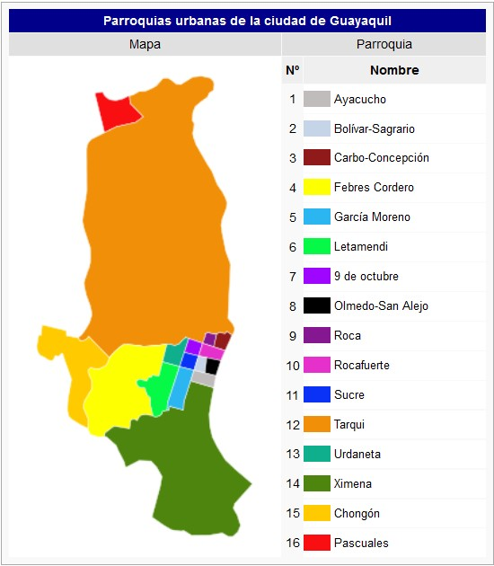
It is located in the province of Guayas, in the Republic of Ecuador, in the central region. Because of its location, it shares boundaries with other cantons and provinces of the republic. To the north it borders Daule, Lomas de Sargentillo, Nobol, and Samborondón; on the south, it borders the Province of El Oro and the Gulf of Guayaquil; with Balao, Durán, and Naranjal shares the western border; and with General Villamil and the Province of Santa Elena in the east. Political map of Guayaquil. This canton has a total of 21 counties, 16 of them are urban parishes, while only 5 are rural parishes. The urban counties are: Ayacucho, Bolivar, Pedro Carbo, Chongón, Febres Cordero, García Moreno, Letamendi, 9 of October, Olmedo, Paschal, Rock, Rocafuerte, Sucre, Tarqui , Urdaneta and Ximena. The rural counties are: Juan Gómez Rendón, Puná, Tenguel, Posorja. El Morro. Guayaquil had 14 urban counties until 1992, after which Chongón and Pascuales, previously categorized as rural, have also been added, since they are located very close to the city of Guayaquil, which is the head of this county. (http://www.mapade.org/guayaquil.html)
The importance of pointing out this last fact, is that because of its characteristics of main port and concentration industry generates more jobs than the rest of the cantons of the states, therefore it becomes an attractive destination for those who need to improve the living conditions , of them and their families. So we have that by 2017 Guayaquil has 2,644,891 inhabitants, which makes it the most populated canton in the country (INEC).

Duran Canton
Location of the Duran Canton.
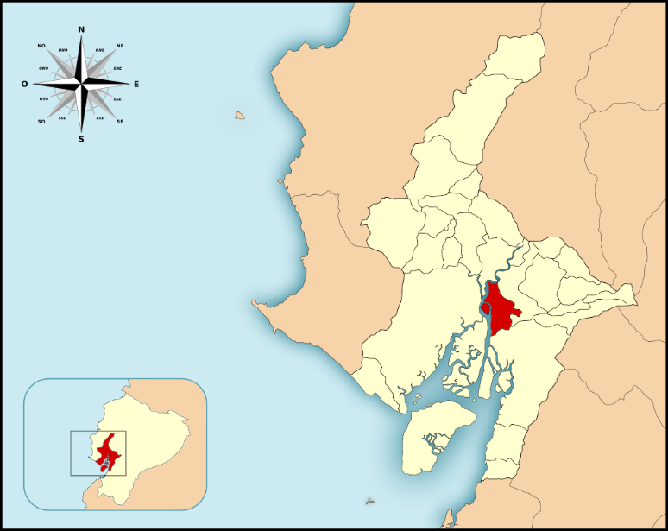

It has a population of 235,769 inhabitants, represents 2.0% of the territory of the state of GUAYAS (approximately 0.3 thousand km2) and has 52.4% (6.5% of the PEA of the state of

GUAYAS). 6 km from Guayaquil is its cantonal head called Gral. Eloy Alfaro. It is at 11 m.s., its average temperature is 25 ° C and its average annual rainfall is 500 to 1000 mm. The eastern part of the Duran Canton is crossed by the Guayas River, standing in front of the Santay Island; On the southwest side there is a small chain of elevations, where Cerro de las Cabras stands out, with a height of 88 m.s.n.m.
PRODUCTION
On the western part there are fertile soil acts for agriculture; in the North, the soil is characterized by being low, allowing the settlement of the largest percentage of the inhabitants of the canton. Although agricultural production is important, Durán has become an industrial area of ​​the first order with a highly developed activity.

