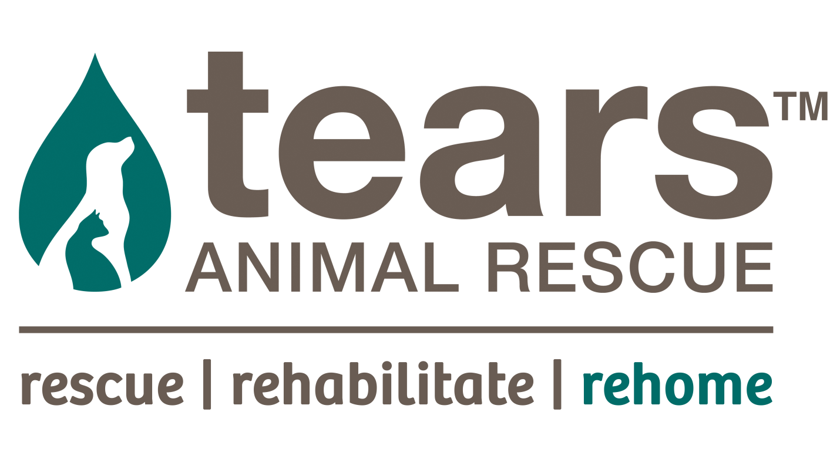

PROFILE

TEARS is a Pro-Life, non-profit Organisation, established in 1999, whose core aims are to rescue, rehabilitate, reunite and re-home lost, abandoned, abused and neglected animals, and to educate our communities, in particular the children.

Mahatma Ghandi said: “The moral worthiness of a nation can be judged by the way its animals are treated”. Sadly, in South Africa and indeed in many parts of the world, animals are treated appallingly, with no regard to the fact that they are sentient beings, capable of feeling pain and emotion.

Our main focus, therefore, is on the sterilisation of companion animals in disadvantaged communities to prevent hordes of unwanted animals being born into a life of suffering, neglect and abuse. In addition, we have a Feral Cat Project which deals with the trapping, sterilisation and return of feral cats in colonies throughout the peninsula and beyond, and we are one of the leading organisations in the compassionate sterilisation and management of the peninsula’s feral cat colonies through this project.

We have two on-site clinics, one at our rented premises in Lekkerwater Road, Sunnydale, and one at our owned property, Wenga Farm, on Kommetjie Road, Sunnydale. Currently, our two vets are sterilising an average of 400 animals a month. This is in addition to the many other services we offer to our local impoverished communities, where, at our clinics we are able to treat animals for any condition, illness or injury and are available seven days a week to care for their pets. Monthly, we treat hundreds of animals for a wide range of conditions.

Our two mobile vans, manned by our Animal Welfare Assistants, are active daily in the disadvantaged communities we serve, namely Masiphumelele, Ocean View, Mountain View, Red Hill, Seawinds, and Capricorn Park (Vrygrond). There is a drastic need for animal education in the townships and we attempt, as best we can, to educate owners of companion animals, on how to care for their pets. However, a sustained humane education programme is needed and one of our main objectives is to initiate this important programme in the schools.

At our shelters, in Lekkerwater Road and Wenga Farm, we care for, at any given time up to 300 animals, providing them with food, shelter and positive interaction with people, until they can be placed in caring homes, and to date we have homed over 17 000 animals. Our Dog Training Programmes focus on rehabilitating dogs in a shelter environment and we have a team of dedicated dog walkers and trainers who attend to the psychological and emotional needs of our dogs.

We respond to calls for help from the general public, rescuing lost and stray animals in our own community and beyond, acting as an unofficial pound by caring for the animals until they are claimed or re-homed. While our prime focus is the rescue of domestic animals, we are also called upon to help “on the wild side”, providing a different and exciting dimension to our rescue work. Other creatures we have rescued include many snakes, otters, porcupines, buck, genets, seals, sea birds, owls and various other terrestrial birds.

To help sustain our clinic and shelter, we have three charity shops, in Retreat, Fish Hoek and Sunnydale and two bookshops, in Retreat and Fish Hoek. These shops are very well supported and we receive an abundance of donated goods ranging from clothes, household items, bric-a-brac, collectables, furniture, appliances, computer equipment, to books, CD’s, DVD’s, records and videos. Our Sunnydale shop serves our local disadvantaged communities, where they are able to purchase a wide range of goods, clothes, furniture, etc., at bargain prices.

From humble beginnings, TEARS has grown into a well-respected organisation and a major role-player in animal welfare in the Western Cape. Going forward, our focus will be on Wenga Farm, our beautiful 3,1 hectare property, which we bought in 2007. We intend building a world-class, eco-friendly, “green” animal shelter and, having received permission from the City of Cape Town to develop the property, will soon be initiating an intensive fundraising drive to develop our animal centre of excellence.

MARILYN HOOLE
01.05.19

