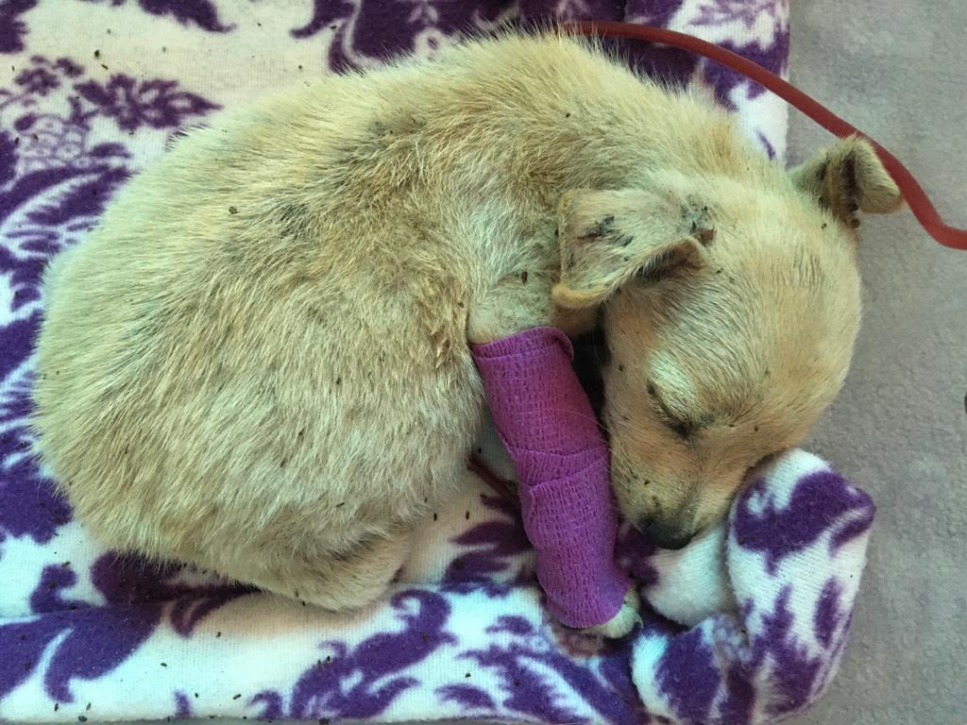

Figure YUKI UNDERGOING A BLOOD TRANSFUSION