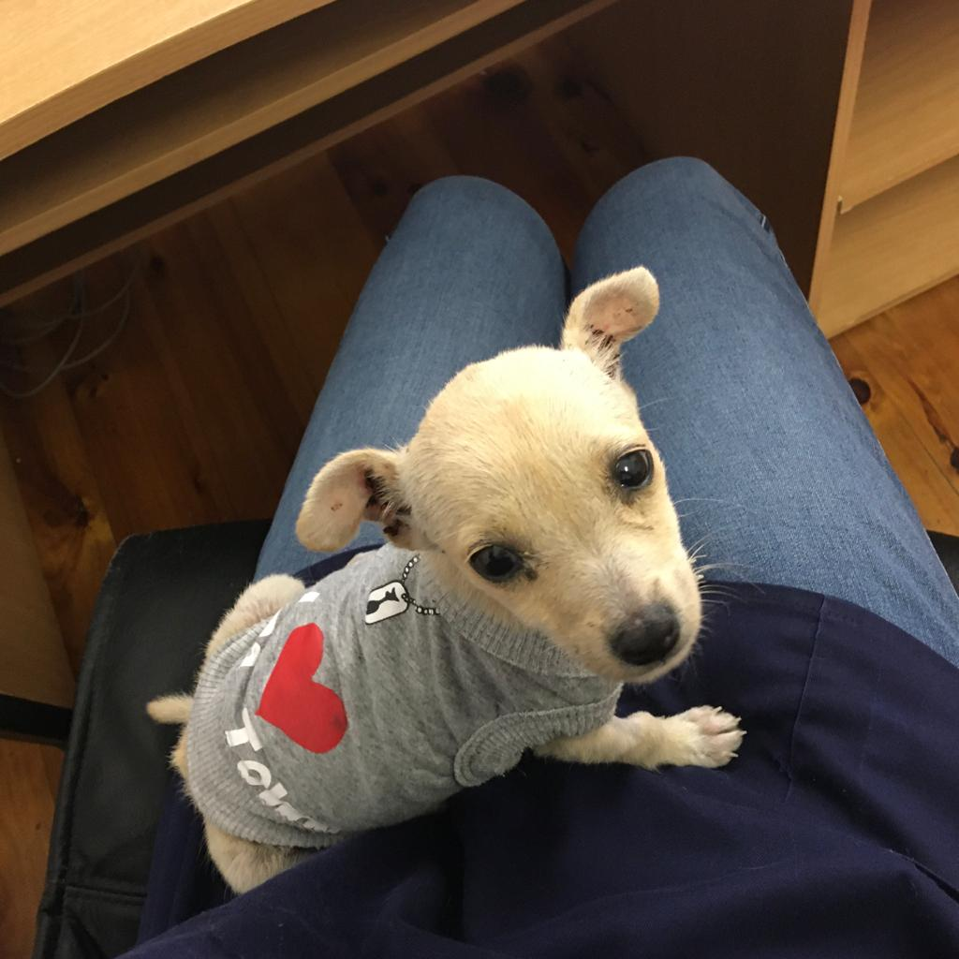

Figure YUKI - RECOVERING WELL UNDER THE CARE OF A VOLUNTEER VET