VRYGROND (CAPRICORN) – MONTHLY PET CLINIC HOSTED BY TEARS ANIMAL RESCUE AND AFRIPAW
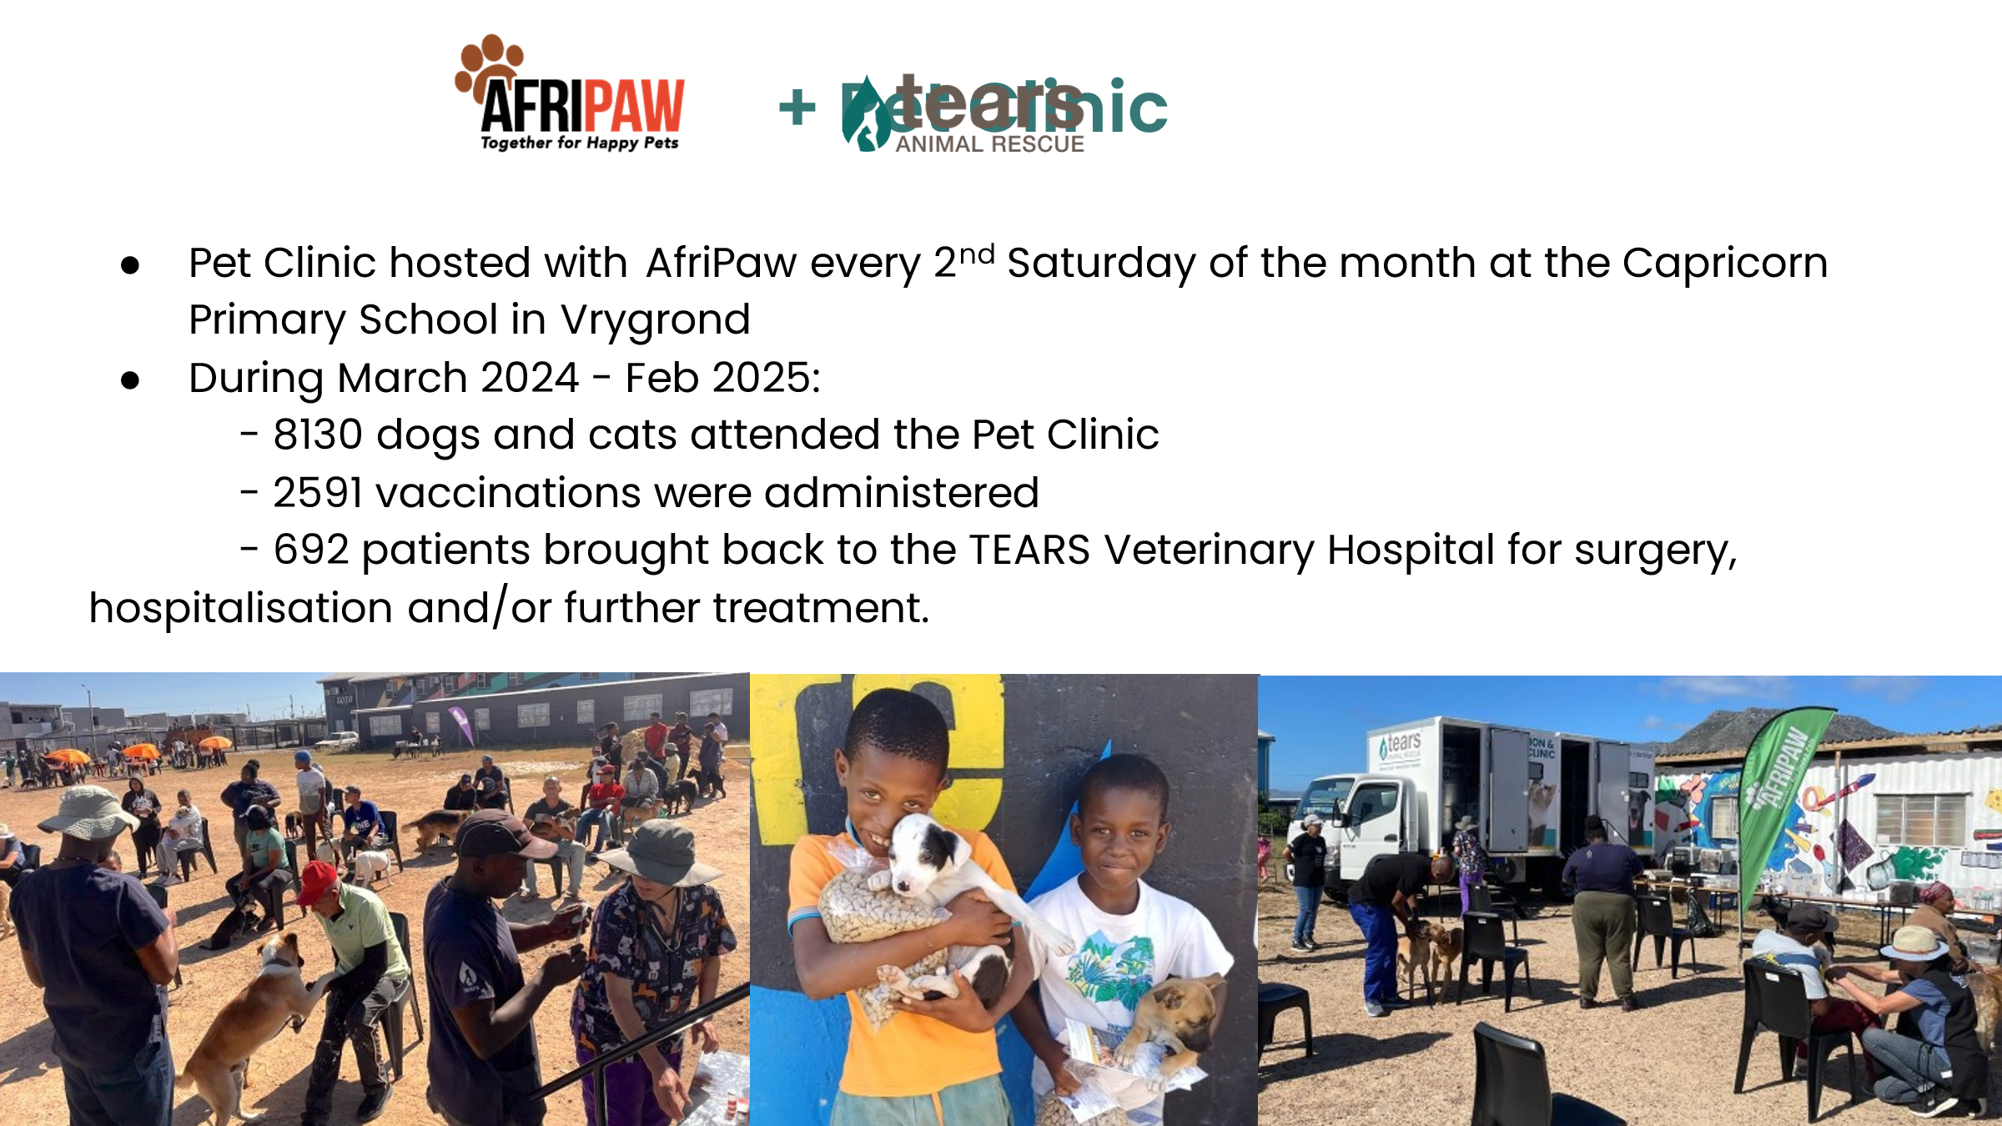

STERILISATION AND PRIMARY HEALTHCARE STATS – MAY – AUGUST 2025
 | AFRIPAW/TEARS community clients in Vrygrond & Surrounds
Date |  | Sterilised Dogs | Sterilised Cats | Vaccs | Tick & Flea | Deworming
May |  | 82 | 66 | 148 | 148 | 148
June |  | 53 | 88 | 141 | 141 | 141
July |  | 105 | 218 | 323 | 323 | 323
August |  | 78 | 82 | 160 | 160 | 160
 |  | 318 | 454 | 772 | 772 | 772
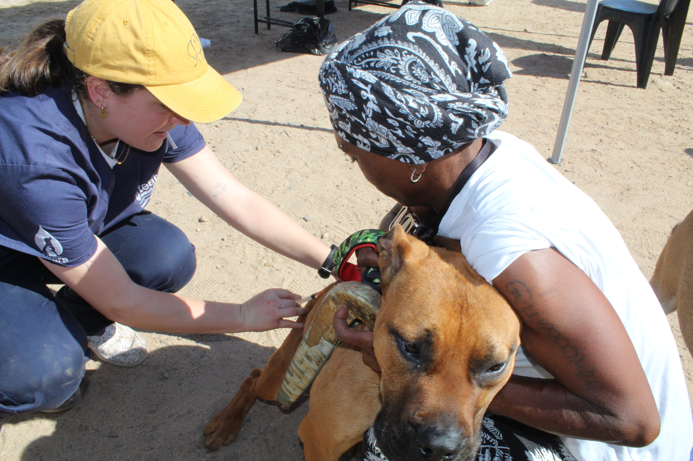
Figure 1 – Volunteer attending to a dog at the monthly TEARS / AFRIPAW Pet Clinic in Vrygrond

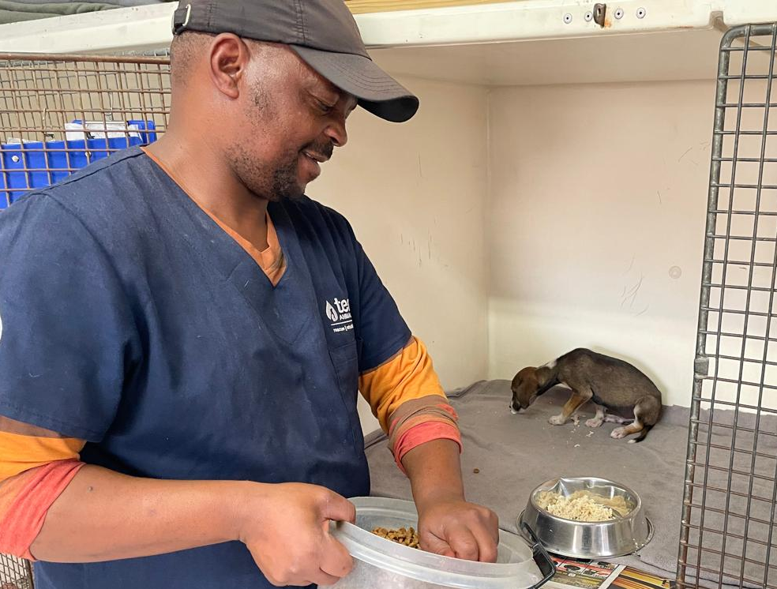
Figure 2 - A TEARS Clinic Orderly cares for a Vrygrond puppy in the TEARS Clinic

Figure 3 - The TEARS Veterinary Clinic

