SOLIDARITE PAYSANNE POUR LE DEVELOPPEMENT INTEGRAL
Areas of intervention: Promotion of Democracy, Fight against HIV / AIDS, Good Governance and Integrated Sustainable Development

Request for project financing
Submitted to

GLOBALGIVING ACCELERATOR
By

SPDI asbl
Nonprofit organization

SOLIDARITE PAYSANNE POUR LE DEVELOPPEMENT INTEGRAL

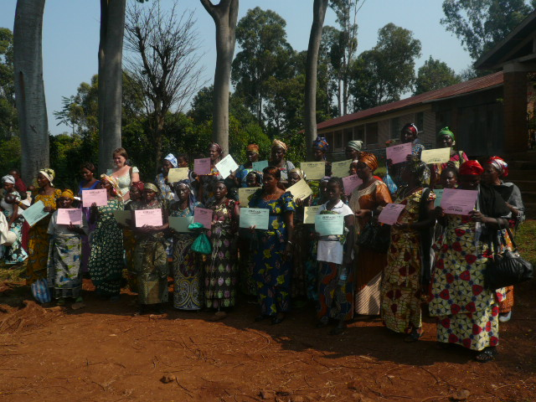

Exercice 2014

Project Title : Women and climate change in the DRC
- Description and problems to solve

- The problem before the implementation of the initiative
The agricultural and rural sector is a priority in the DRC.A neglected priority, with the consequence of increasing poverty and a dramatic nutritional situation. Lack of resources, bad policy and the collapse of seed supply do not help women farmers. In the DRC, the CFSVA survey confirmed and determined the level of food insecurity of rural households in the DRC. The results reveal that 6% of households have poor food consumption. The majority of them are located in Kalehe 11% and South Kivu 12%.
b) Situation of women and girls in Kalehe villages before the launch of the initiative
About 70% of rural Congolese women live in a situation of widespread poverty, mainly caused by a long period of war, rape and sexual violence and residual conflict in the east. The food situation is characterized by the fall of 30 to 40% of food crop production, the decrease in food consumption now corresponding to 1,650 kcal / pers / day against the minimum required in the DRC which is 2,300 kcal / pers and the increase in the rate of malnutrition of children and women.
c) The main problems of gender inequality that must be addressed in Kalehe villages
Women in Kalehe villages benefit less from employment than men, regardless of whether they are self-employed or salaried, recent food and financial crises have slowed progress on gender equality gender equality and decent work for women in the agricultural and rural sectors in recent years. Due to job losses and reduced public spending on infrastructure and social services, women are seeing their domestic workloads and non-pay for work intensify, and their financial contribution to household food security is increasing. likely to decrease. A particularly dramatic situation when women are heads of households.Migration and feminization of rural activities, international trade and diversification of the rural economy, child labor, these are among others the problems and trends that are emerging concerning women employed in the agricultural sector of Kalehe towns.

- Objective of the project

Strengthen the capacity of women farmers in Kalehe territory in the DRC in the context of integrating subsistence agriculture (maize, cassava and resistant rice) that adapts to the risks of climate change;

- The beneficiaries of the project
a) Direct beneficiaries
12500 women farmers
b) Indirect beneficiaries
All the inhabitants of Kalehe Territory and the whole extent of the DRC

- The results of the project

Outcome 1: Climate resilience of cropping systems used by rural people is improved
Output 1.1 An operational supply chain for the production and extension of climate-resistant maize, cassava and rice varieties.
Output 1.1. Adoption by farmers of sustainable farming techniques
Output 1.3 Adoption of diversified and climate resilient income generating activities
Output 1.1 Updated crop calendars and technology packages

Outcome 2: Strengthening the technical capacity of small producers
Output 2.1. Improved skills in climate risk management
Output 2.2. A hydroagro-climate advisory network (back-season support)
Output 2.3. Early warning system
Outcome 3: Good practices are identified and popularized
Output 3.1. Better knowledge of climate change and adaptation
Output 3.2. Encourage irrigation of fields in rehabilitation of 4 community water supply structures.

- Project activities

- Sensitization of 12500 women in the Kalehe and Kabare Territory using resilient seeds in terms of production and disease resistance;

- Initiation to 12500 women farmers in sustainable farming techniques;

- Initiation to 12,500 women farmers in Kalehe and Kabare for income-generating activities,

- Update crop calendars and technology packages;

- Strengthening skills in risk management

- Set up a hydroagro-climate advisory network

- Set up an early warning system

- Rehabilitation of 4 community water supply works;

- Project duration

The project is a year
- Sustainability of the project

Women farmers in Kalehe Terrioire are seeing their productivities grow, an operational supply chain for the production and expansion of climate-resilient corn, cassava and rice varieties. Revenues are diversified and climate resilient with income-generating activities and farmers adopt sustainable farming techniques. The 4 community water supply works are operational during the life of the project and even up to the next generation and best practices for use of climate resilient seeds will still be applied.

- Monitor and evaluate

SPDI will monitor its own activities. SPDI is committed to monitoring results, effects and impacts. To better monitor the actual achievement of project objectives, a self-assessment will be carried out at the end of each semester. Thus, two internal evaluations will be carried out by the project's executive team. They will bring together all the stakeholders in the project implementation with the beneficiaries of the project. On this occasion, the progress made will be pinned, the weaknesses, the difficulties identified and the strategies to improve implemented. At the end of each internal evaluation, business planning and budgeting will be prepared for the next semester. At the end of the year, an external evaluation will be conducted by an independent consultant. And the GlobalGIVING pass for the evaluations after every one year to have the project impacts.

- Role of project stakeholders

Resilient seed studies will be conducted by researchers at the Catholic University of Bukavu and an expert in Rural Development will be recruited to build the capacity of farmers who will practice resilient seeds in their fields for the first time. SPDI still works with the local communities, in the Workshops that had been organized, these peasants were still worried about the non-production especially of maize, cassava and rice. And there is deforestation and forest degradation that influences climate change. This is why this study can contribute to the living conditions of the populations.
- Budget
The project budget is 99750 US dollars
- Risk assessment

INCAPACITY TO RECRUITING AND LOYING APPROPRIATE PEOPLE
Risk: To produce resilient seeds adapted to climate change and Strengthen the capacity of the agricultural sector for planning and responding to the additional threats of climate change to agricultural production and food security in the Democratic Republic of Congo. people with technical expertise, management skills and the ability to act according to local, social and political dynamics. In their absence, quality will suffer.
Activities to mitigate risk: First, the Program Manager will systematically evaluate the individuals recruited to the project.
Secondly, the program will recruit from a long-term perspective, reminding existing or potentially committed staff that they have the opportunity to secure long-term employment, particularly as part of the arrangements for the future transfer of learning.
Emergency Measures: In very limited cases, SPDI will consider stronger measures to have the right people where they are needed.
INABILITY TO INTERVENE IN INSECURITY AREAS
Risk: DRC is a security unstable country, DRC Complex security issues beyond the control of the program could delay expected progress towards project results.Activities to mitigate risk: SPDI introduces multiple strategies at the national level to help ensure the safety of staff and the opportunity to educate a large number. The Congolese Government can invest in political and security analyzes to better understand changing situations; strengthen security coordination and communication among project partners; build capacity for policy analysis and conflict; and continue to explore best practices for dealing with security threats in a humanitarian context.Emergency measures:The Congolese Government could deploy the military in territories where it is not possible to manage the insecurity and where access is difficult for the sensitization to meet the peasants

Mrs. NYIRIMNA MURHIMBO

Coordinator

